Test Summer Semester Year 5

Listening and Reporting
  - What were the Sixties really like?
Listen to the two interviews about people’s personal memories of the Sixties.
What do Mrs. Kootz and Mr. Guthrie say about the following topics. Take notes in the table below:
 | Mrs. Cindy Kootz  former music teacher at GIBS | Mr Arlo Guthrie  son of the famous singer and song-writer Woody Guthrie
favorite memory
a terrible day
the war in Vietnam
role of music
values and lifestyle
Report the main facts from the interviews in an article for the GIBS News. Compare and contrast what the two interviewees have said about the five topics. In the final paragraph of your article discuss what has happened to the spirit of the Sixties. Do you see any traces or left-overs in your own generation? Can we learn anything from the Sixties?
Write about 300 words. You may use the following beginning:
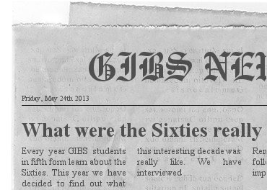
Tip: Watch the use of the tenses when you report what the interviewees said. Use a variety of reporting verbs.


2. Write a Letter
Choose one of the most important events in the Sixties. Imagine you are an American teenager and you have just been there, heard about it on the radio or seen it on TV.

Write a letter to a friend in Europe telling him/her about the event and how you feel about it.
- describe in detail what you know (what has happened) and
- explain to your friend what that means to you and how it makes you feel.
You may of course invent some plausible details to make your letter more realistic.
Write about 300 words.


3. What if?
  - Reading Modern Classics
In each of the novels in our project the main characters have made important decisions that had serious consequences.
If some of your main characters could turn back the time and change some of their decisions, how would that have influenced the course of events and/or the character’s development?
Change two important decisions in your novel and show what would have happened then. Describe the possible consequences in detail. Write about 80 - 100 words for each new decision.

Watch your tenses: If Max had not gone to America, he would not have met Susan and they would probably have… /they might have…/


