Methodology of Teaching Literature and Culture
WS 2014/15
Dr.phil. Elisabeth Pölzleitner

Book project
Racism, Discrimination, Exclusion

Submitted by

Florentina Finder, Andreas Schuch
florentina.finder@edu.uni-graz.at, andreas.schuch@edu.uni-graz.at
Matriculation numbers: 0911658, 1110127

Date of submission: 19 January 2014

Contents
2 Introduction 3
3 General Activities 4
3.1 Pre-reading 4
3.1.1 Text: Melting Pot or Salad Bowl? 4
3.1.2 Discussion cards on key terms 5
3.1.3 Book excerpts 6
3.2 Post-reading 23
3.2.1 Plot Diagram 23
3.2.2 Stereotype Detectives 24
4 Specific Activities 25
4.1 Bifocal 25
4.1.1 If I was… 25
4.1.2 Fear of Terror. Terror of Fear. 25
4.1.3 Telling Passages 25
4.2 Howl’s Moving Castle 26
4.2.1 Good expressions 26
4.2.2 Character Collage 26
4.2.3 Theme detector 26
4.3 Lies We Tell Ourselves 27
4.3.1 Linda’s Column 27
4.3.2 Lie/Truth: 27
4.3.3 Letter to Sarah from 2015: 27
4.4 Shadow of the Dragon 28
4.4.1 My culture – their culture 28
4.4.2 Newspaper Article 29
4.4.3 Red Cards – Green Cards 29
Bibliography 30

Introduction
This reading project is designed for year 6 and upwards. The aim is to discuss and reflect on the topics racism, discrimination, and exclusion. The following pages comprise general activities which can be used regardless of which book students chose to read and also contain several more specific activities for each of the books.
The estimated project time is five to six lessons (50 minutes each). Because the project includes pre-reading and post-reading activities, it is best broken up into two segments: 1) activities which introduce students to the topic of this project and help them decide which book they want to read and 2) activities which help them reflect on the content of the book and make comparisons to the real life after having finished reading their respective books.
The four books included in this reading project are:
- Ellis, Deborah, and Eric Walters (2007). Bifocal. Ontario: Fitzhenry & Whiteside.
- Garland, Sherry (1993). Shadow of the Dragon. Orlando, Florida: Houghton Mifflin Harcourt.
- Jones, Diana Wynne (1986). Howl's moving castle. New York: HarperTrophy.
- Talley, Robin (2014). Lies We Tell Ourselves. Surrey, Richmond: Harlequin.
We tried to include as many different aspects (gender, skin color, culture) as possible when choosing books for the project in order to increase chances that each student finds at least one book appealing. Two of the books (Jones, 1986; Talley, 2014) feature female protagonists, the other two books (Garland, 1993; Ellis and Walters, 2007) have male protagonists. Bifocal (Ellis and Walters, 2007) tells a post-9/11 story which contrasts the attitudes of a `white’ American boy and an American Muslim boy towards each other’s culture. Shadow of the Dragon (Garland, 1993) concerns itself with Asians who immigrate into the US. Howl’s Moving Castle (Jones, 1986) takes place in a fantasy world in which prejudiced rumors are circulated about a magician who is expelled from the city. And Lies We Tell Ourselves (Talley, 2014) is a historical piece of fiction which addresses the integration efforts of the NAACP (National Association for the Advancement of Colored People) in the US in the 1960s.
Note: This project includes the front and back covers of every book as well as a few sample pages. It is suggested to also bring physical copies of the books to class and hand them around instead of solely relying on printouts.

General Activities

Pre-reading

Text: Melting Pot or Salad Bowl?
Read the following text and then discuss the questions below with a partner.
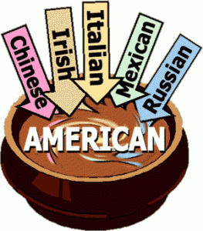
In multicultural societies there are different models of racial integration.
The USA is traditionally called a melting pot because with time, generations of immigrants have melted together: they have abandoned their cultures to become totally assimilated into American society.
But in the UK, where cultural diversity is considered a positive thing, immigrants have always been encouraged to maintain their traditions and their native language. This model of racial integration can be described as a salad bowl, with people of different cultures living in harmony, like the lettuce, tomatoes and carrots in a salad.
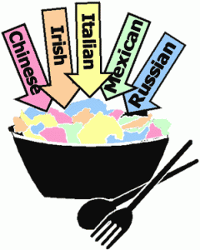
However, managing cultural diversity is not always easy. The world was shocked by the terrorist attacks which happened in New York in 2001. All these attacks involved people from Muslim ethnic communities, who seemed to be well integrated in society.
Both models of multicultural societies have contradictory aspects:
- in a melting pot there is no cultural diversity and sometimes differences are not respected;
- in a salad bowl cultures do not mix at all.
For example, in multicultural cities, some people spend their entire lives living and working without ever learning the country’s language.
Source for article: cglearn.it (2014)
Discussion Questions:
- What do you think are the advantages of a “melting pot” society?
- What do you think are the advantages of a “salad bowl” society?
- Do you think Austria is more of a “melting pot” or a “salad bowl” society? Why?
- Think of examples of when people of different cultures living in the same country creates tensions! Find solutions that make people of both cultures happy!

Discussion cards on key terms
Take a look at the terms below. Which ones do you know? How much do you know about them? Try to explain every concept in one short sentence, or write down terms which are often associated with these concepts, or give some examples. You have fifteen minutes for this task. Afterwards, compare your notes with your partner and extend and revise them if necessary. We will then quickly go through every concept together in class.
Race:

Racism:

Apartheid:

Islamic terrorism:

Foreigner:

Stereotype:

Prejudice:

Gangs:

Skinheads:

Book excerpts
Take a look at all four books. Examine the front and back covers and read the first two or three pages. You will receive excerpts for each book. Take your time with each excerpt, you have at least 40 minutes to read. While reading, try to answer the following questions for each book and fill out the table:
- How many unknown words are there on each page? Can you guess their meanings?
- What kind of book do you think this will be? Do you think it will be science fiction, fantasy, realistic fiction, mystery, a crime story, etc?
- What do you think the plot of the book will be about? Make a one-sentence prediction.
- What kinds of characters do you expect to meet in each book?
Write down your first, second and third choice. If possible, you will be given your first choice.
Book title and ★★★ | New words per page | Other comments about the book
Type of book:
Plot prediction:

Characters:
Type of book:
Plot prediction:

Characters:
Type of book:
Plot prediction:

Characters:
Type of book:
Plot prediction:

Characters:
Adapted version of “Choosing a book” from Pölzleitner (2014a: 44-45).
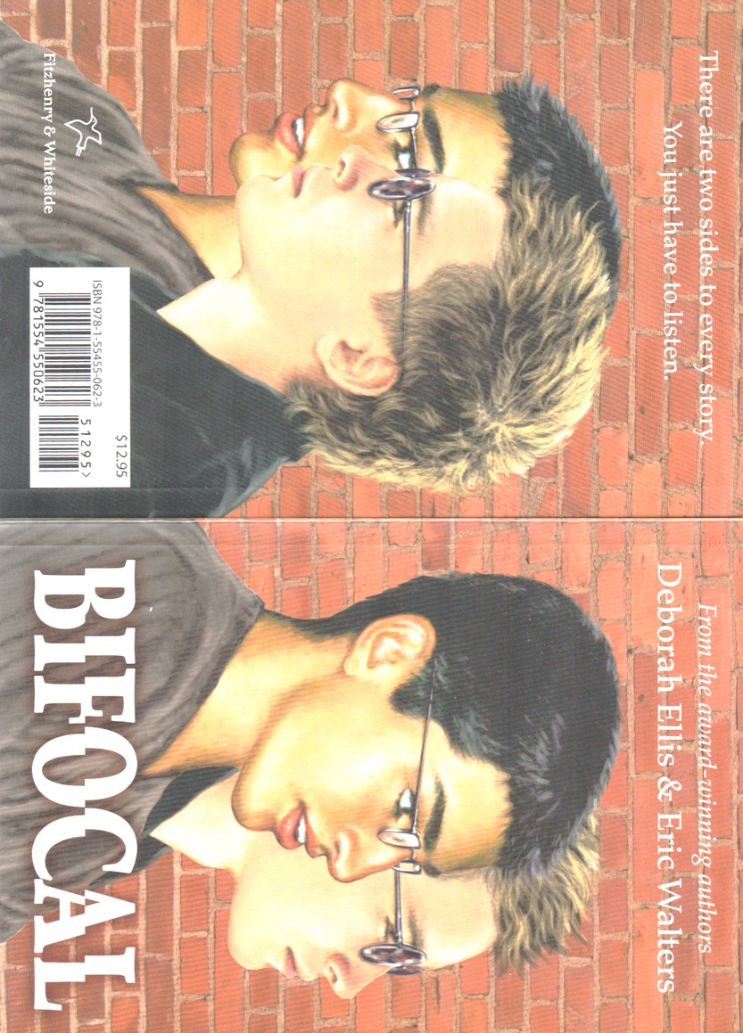
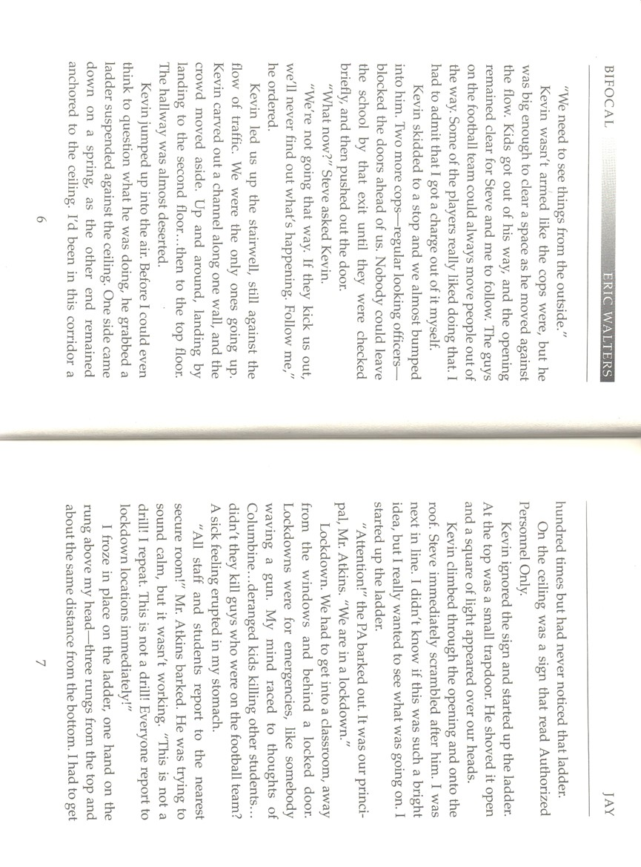
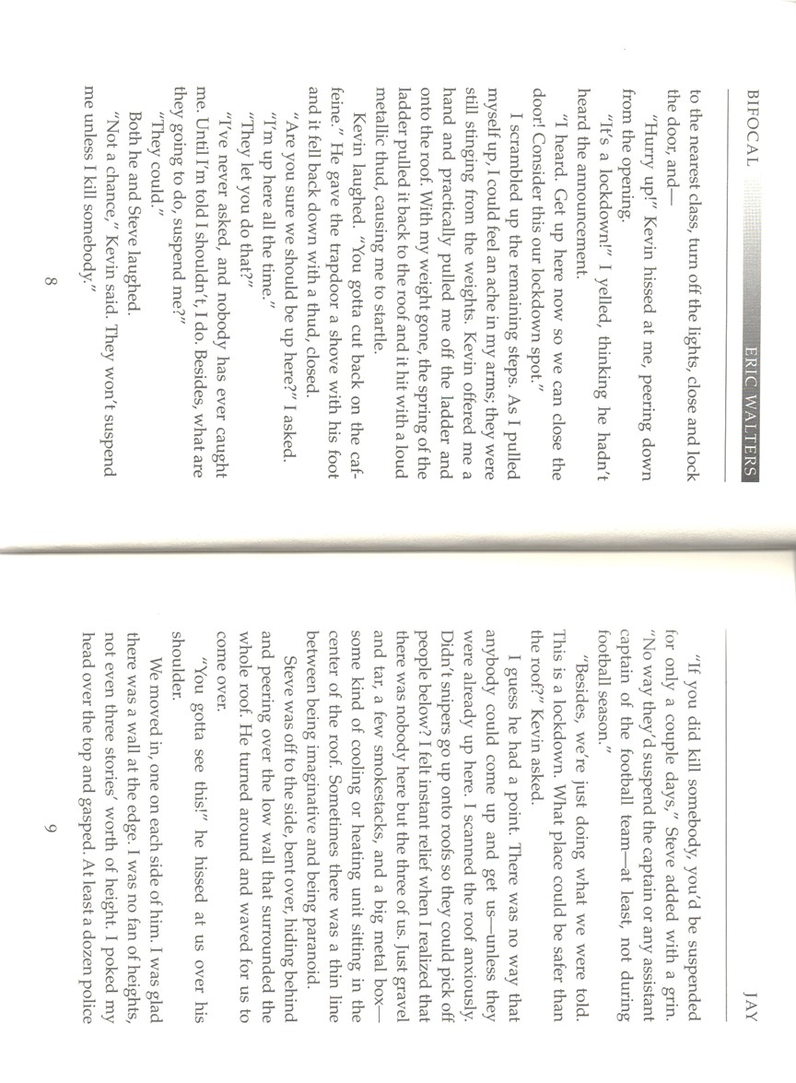
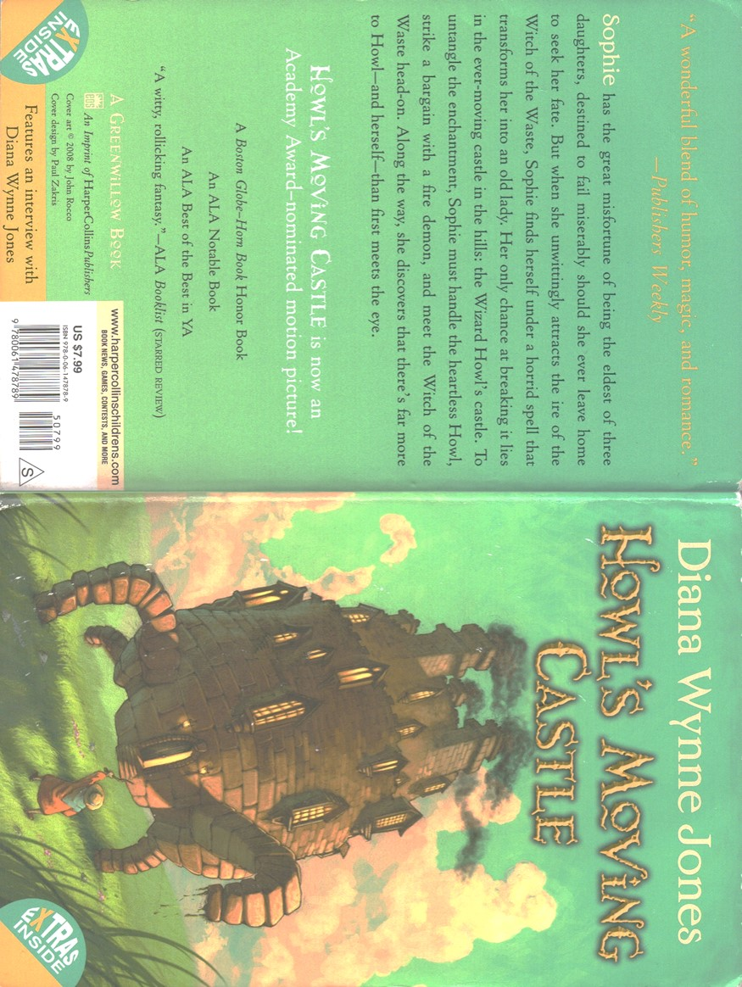
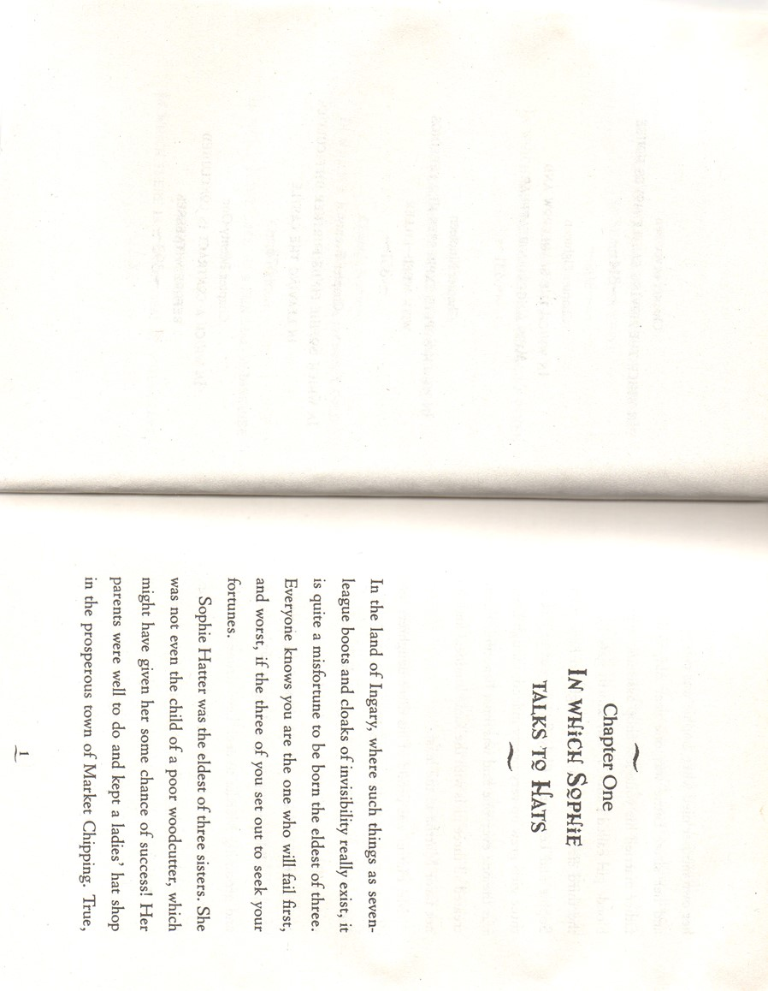
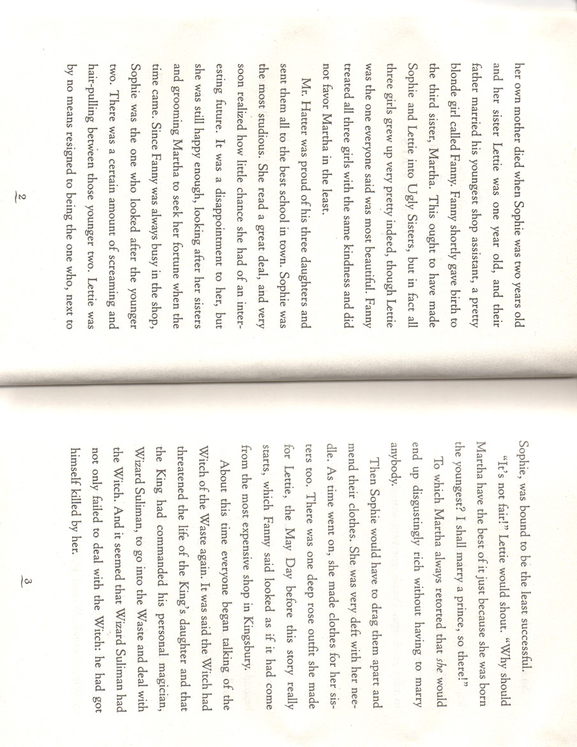
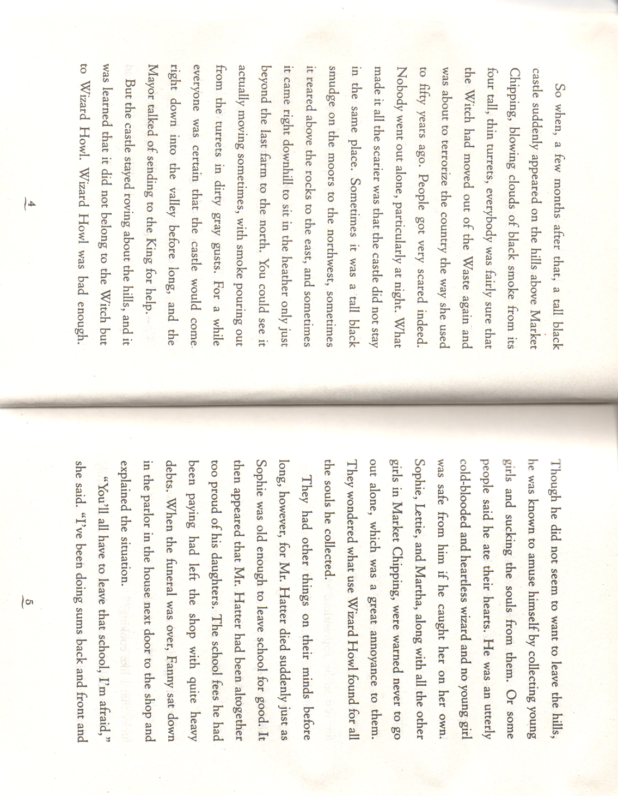
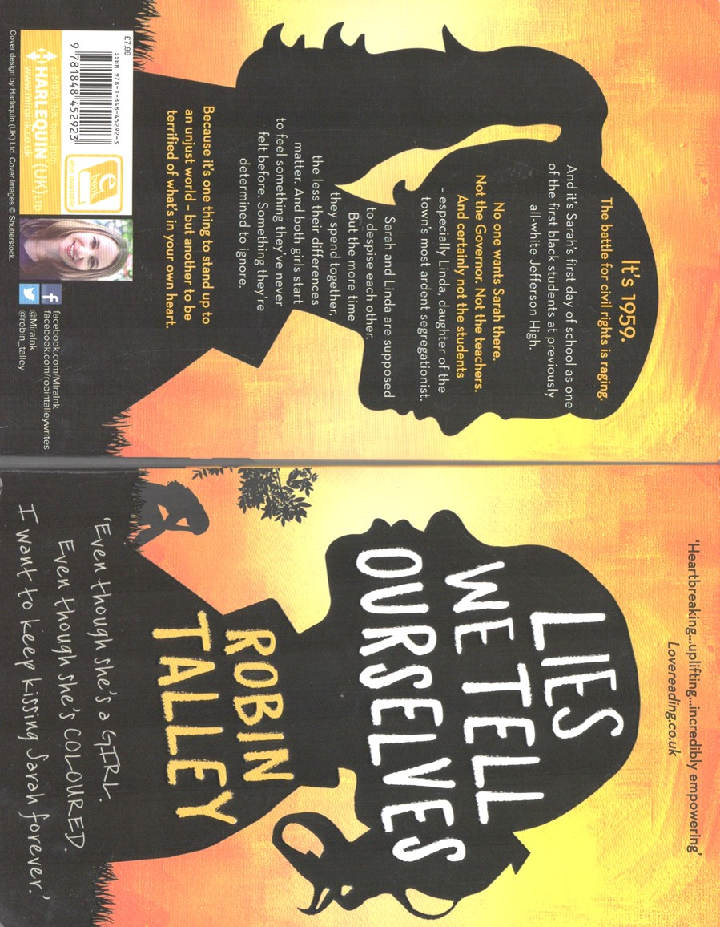
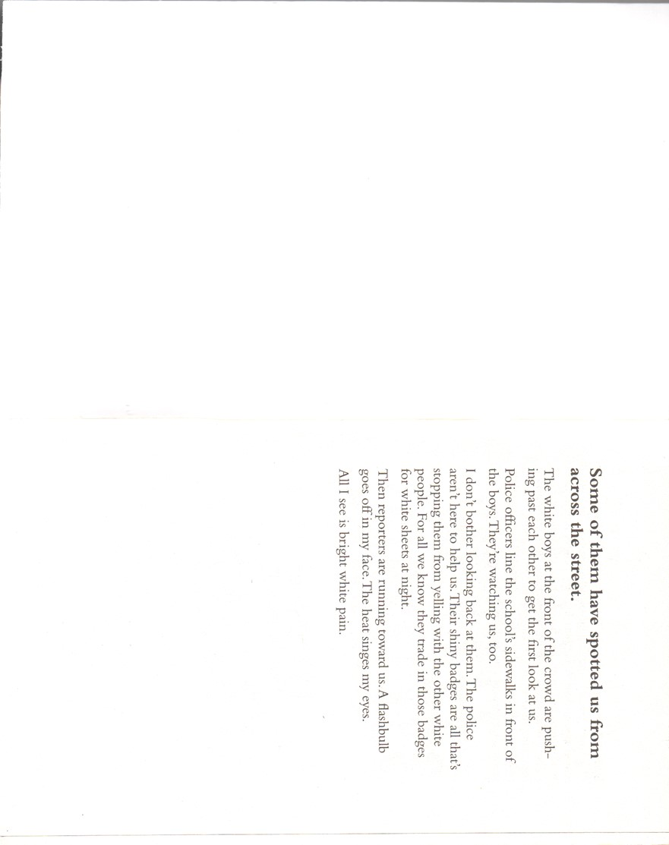
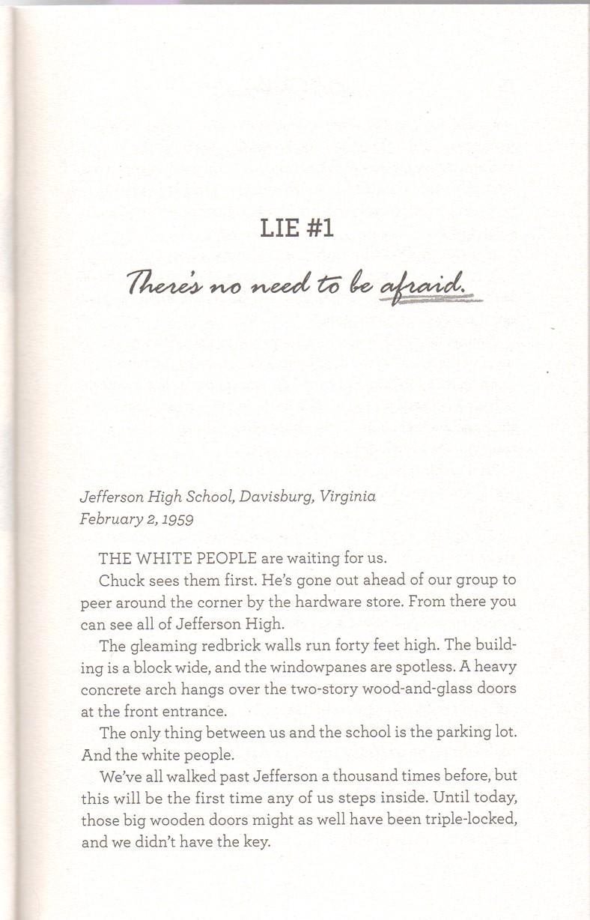
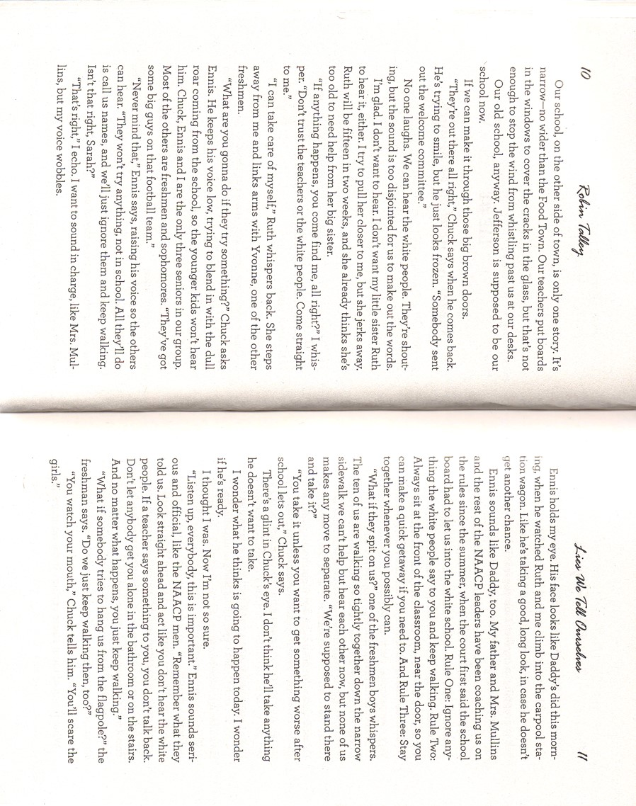
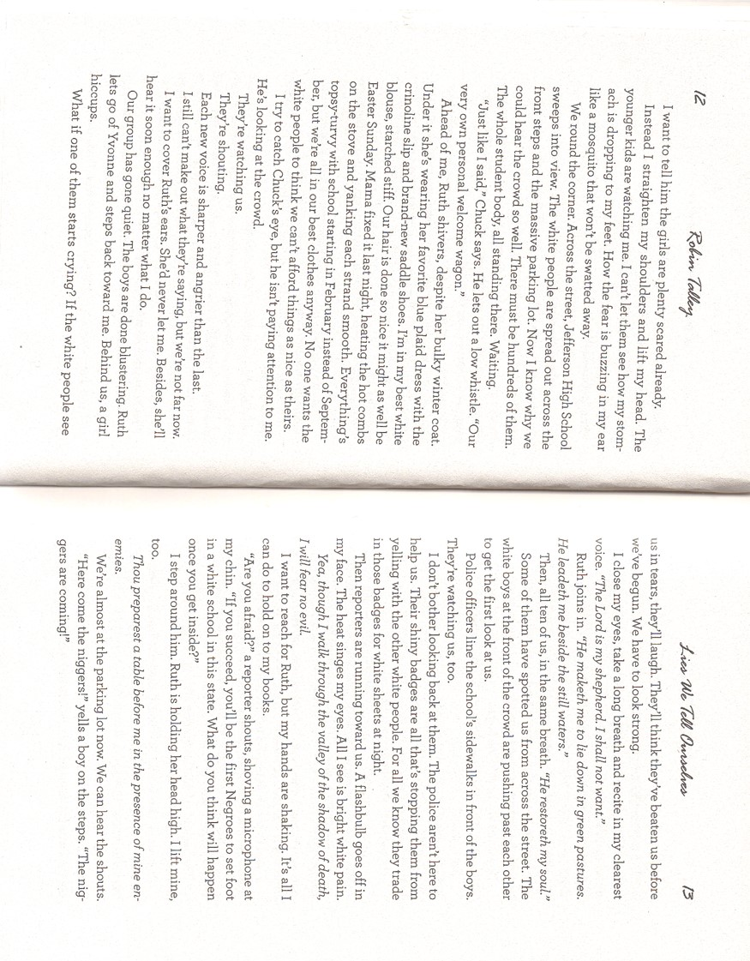
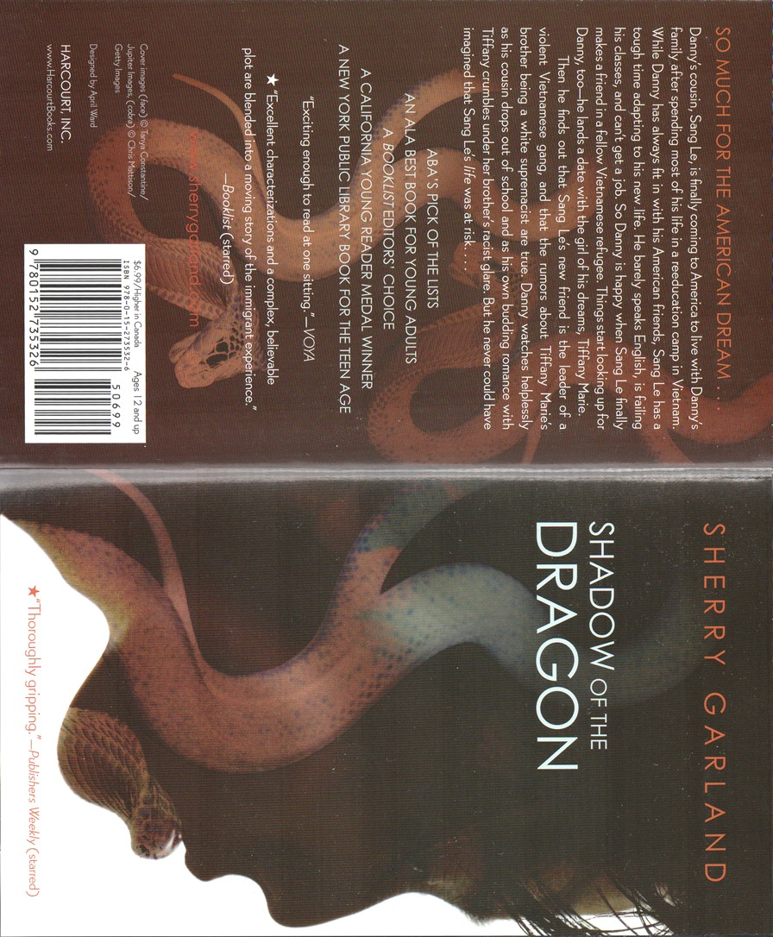
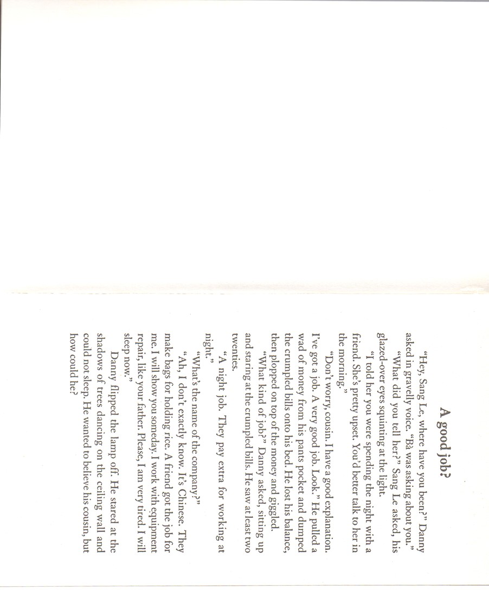

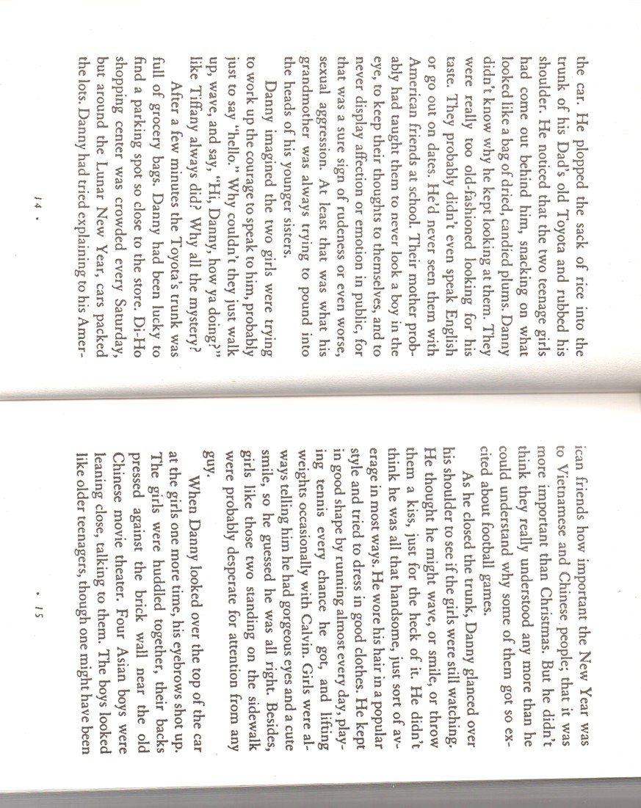
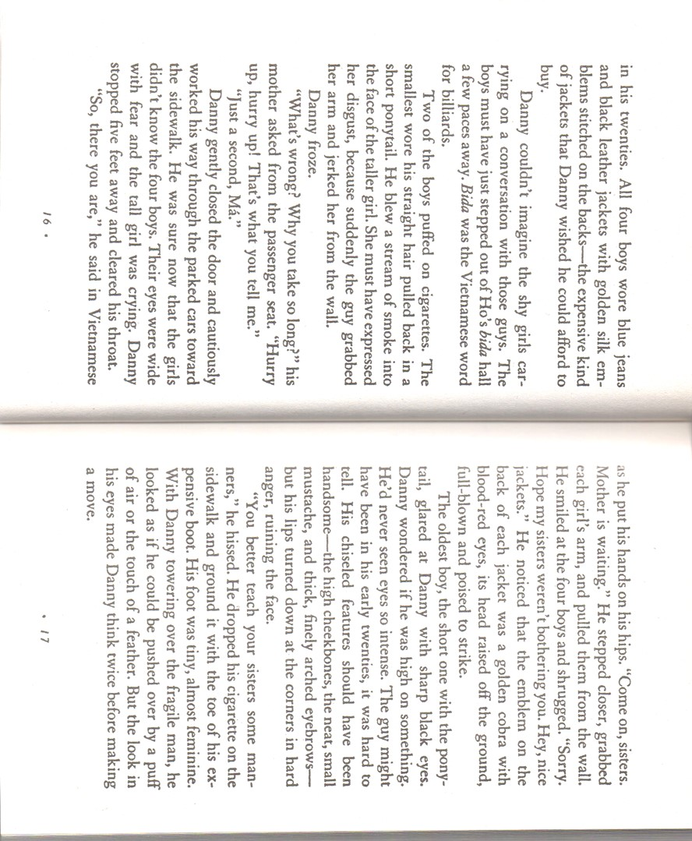

Post-reading

Plot Diagram
Recount the most important events in the story in chronological order and write down some key words. Now write a 50 word plot summary of your novel. Do this in your group and make sure it is a well-structured, coherent text. Do not exceed the 50 word limit.
___________________________________________________________________________
___________________________________________________________________________
___________________________________________________________________________
___________________________________________________________________________
___________________________________________________________________________
Now enter these main events and turning-points into a plot diagram. How does the tension rise and fall?

Adapted from Pölzleitner (2009b: 1).

Stereotype Detectives
Every culture creates stereotypes about other cultures. Your book contains many examples of both positive and negative stereotypes. Chart the stereotypes that you find throughout the book. Try to find both positive and negative ones for each topic and write down where you found the examples.
Topic | Chapter or page | Positive stereotype | Negative stereotype
dwelling
(where and how they live)
job (unemployed, janitor, student, …)
and education (high school, university graduate, etc.)
language
(how do they communicate with others-both in their group and outside)
physical appearance
(generic look, clothes, exaggerated features, how they move, sit, stand…)
compared to other Americans, minority members in your book are… (smarter, more athletic, lazy, etc.)
Adapted from Pölzleitner (2009a: 9)

Specific Activities

Bifocal

If I was…
Write a short text about what you would do if you were in Jay’s or Haroon’s position in a crucial moment of the story (e.g. the football gang’s attack on Haroon’s house, Jay’s interrogation, Haroon’s encounters with the police, or his conflict with his sister Zana). If you were them, would you act differently? If so, why and how would you act differently? Or do you agree with Jay’s or Haroon’s behaviour in this certain moment? Would you react in exactly the same way? Why?
Adapted from Pölzleitner (2014: 53)

Fear of Terror. Terror of Fear.
- Which events and incidents of terrorism have you heard of, read about, experienced (if not directly, then indirectly) in the real world?
- In view of the incidents of terrorism which have taken place in the world in the last few years, do you consider fear of terror relevant for the actual real world? Do you consider it a threat to your own life, to your own immediate surroundings? In other words, is fear of terrorism a legitimate fear?
Think of these questions (and the above mentioned phrases Fear of Terror and Terror of Fear) thoroughly and write a poem based on them, conveying your feelings and thoughts about this topic. The length and form of the poem is free to choose, you do not have to stick to any conventions, but you should include the phrases Fear of Terror and Terror of Fear in some way.

Telling Passages
Choose two passages from your novel which you find particularly compelling, interesting or crucial for the story. What do these passaged tell us about the characters and/or the conflict in the story? Practice reading them so you can read them to your group members clearly and distinctly later on.
Read the passages to your group members and explain why you chose them.
Note to the teacher: reading the passages aloud to other group members can be carried out within the distinct book groups or across groups. In the latter case students who have read different books get together and take their turns reading to each other passages of their various novels. This is to encourage students to read more books on the topic.
Adapted from Pölzleitner (2014: 68).

Howl’s Moving Castle

Good expressions
Sophie wants desperately to break the spell the cruel Witch of the Waste has put on her. Gather together roughly ten or more pieces of vocabulary you previously didn’t know (words, phrases) from the book and write up a recipe and step by step procedure for a potion. Use as much imaginative, fantastical, poetic language as possible! You can also give impossible instructions, recommend using uncommon or disgusting ingredients, and come up with mysterious rituals (this is a fantasy world after all)!
Adapted from Pölzleitner (2014: 69).

Character Collage
Find suitable images, words or other elements in newspaper magazines, online or from other sources and put together a collage of important places, items, or other aspects for at least two of the characters in the book (for example Sophie, Howl, Calcifer, the Witch of the Waste, the king etc.). Explain why and how this collage resembles your character. In addition, describe the characters’ traits, personalities and tell us about other interesting, strange, or surprising details about them and link them to your collage if possible.
Adapted from Pölzleitner (2014: 64).

Theme detector
Find and filter out at least three themes which are addressed in the story and justify your choice by adding one or more passages which deal with this theme. Then write about how do these themes come out in the story? What do they mean to you?
Adapted from Pölzleitner (2014: 59).

Lies We Tell Ourselves

Linda’s Column
In the course of the story Linda gradually moves away from her original strict anti-integration attitude. Because of Sarah she soon questions whether it is not right to discriminate against black people and slowly adopts her views on this topic. But still, she keeps writing columns for the Jefferson school newspaper, in which she decidedly reveals a very pro-segregation attitude because she is afraid of what the others would think of her if she conveyed her actual views. What would she write if she really spoke her mind? Put yourself into Linda’s position and write another column for the Jefferson Clarion where you reveal her real thoughts about integration. How would she go about defending the rights of black people? On the other hand, which arguments would she might still have in favour of integration?

Lie/Truth:
The story is divided into chapters which are labelled “LIE” and “TRUTH” (for example: LIE #5: “I am not brave enough for this”, or LIE #11: “I’m exactly who I want to be”). Look at the various titles of each chapter. Pick three lies you can relate to and think of whether you had a similar situation in your own life where you told yourself such lies. Think of whether those lies were true or whether it turned out in the end that you were actually wrong about them (for example, you might have thought that you were not brave enough for something, but then in the end it turned out you actually managed the situation you were scared of). Write a paragraph for each lie and share your experiences concerning this particular “lie“. Also compare your experiences to Sarah’s: was what happened to you in any way similar to what Sarah experienced?

Letter to Sarah from 2015:
The story takes place in 1959, at a time when segregation was still omnipresent in the United States and black people were fiercely discriminated against everywhere they went. Since then a lot has changed. Nowadays, it seems absurd to us that black and white people shouldn’t go to school together or live next to each other. We can’t imagine that black people should be treated in any way inferior to white people. Sarah doesn’t know then that her efforts will be gratified one day, and thus loses hope at times and doesn’t see the purpose of her efforts of integrating the school. Write a letter from the future to Sarah telling her about the situation between Afro-Americans and white people today (when a lot of progress has been made in terms of equality). Your letter should compare the situation today with Sarah’s situation. What has improved since 1960 in terms of legal rights and society’s attitude towards different races? And what has remained unchanged and is still the same today? Have any aspects become worse?

Shadow of the Dragon

My culture – their culture
In Shadow of the Dragon you see many Vietnamese people still living and breathing Vietnamese values and culture, even though they have been in America for some time now (e.g. Sang Le, Danny’s grandmother, the leader of the Cobra gang). What have you learned about their culture and how does it compare to your own life? What problems are they faced with and what problems do you face? Fill in the following Venn-diagram. In one circle you write important things about your own life, in the other circle you write important things about Vietnamese American life. Use the overlapping parts for the things you have in common.

Adapted from Pölzleitner (2014: 10).

Newspaper Article
Choose an important moment in your book and write an article about this event for a local newspaper. Write between 150 and 200 words.
Remember: The journalist does not know everything; focus on one event – do not tell the whole story and do not include the characters’ private thoughts and feelings. What would the readers of the local newspaper want to know?
Tip: for the layout of a newspaper article use the online Newspaper Clippings editor: http://www.fodey.com/generators/newspaper/
Adapted from Pölzleitner (2014: 57).

Red Cards – Green Cards
Teacher’s instructions: Hand out 5 red cards and 5 green cards per student.
Work with 2-3 partners who have read the same novel.
Red question cards: Write 5 questions that you haven’t been able to answer when reading the book. Think of real questions you have – not boring “comprehension questions”.
Green cards: Write 5 interesting features/elements that you have come across in your novel (e.g. clear statements about themes, characters, plot development, style and tone, setting …)
Sign your cards, then put your cards in the middle and check if there are any similarities … Discuss the green cards first, then try to find answers for your red question cards. Write your answers and discussion notes into your reading diary. If you need additional info, check the internet, the library, or ask your teacher(s).
Adapted from Pölzleitner (2014: 59).

Bibliography
- cglearn.it (2014). Melting Pot or Salad Bowl? [Online]. http://www.cglearn.it/mysite/civilization/american-culture/a-story-of-immigration/melting-pot-or-salad-bowl/. Accessed: 11.01.2015
- Ellis, Deborah, and Eric Walters (2007). Bifocal. Ontario: Fitzhenry & Whiteside.
- Garland, Sherry (1993). Shadow of the Dragon. Orlando, Florida: Houghton Mifflin Harcourt.
- Jones, Diana Wynne (1986). Howl's moving castle. New York: HarperTrophy.
- Pölzleitner, Elisabeth. (2009a). Crossing Borders: Reading Project. [Online]. http://www.polzleitner.com/epep/Reading/YoungAdult/crossing-borders/crossingborders-girls.pdf. Accessed: 11.01.2015
- Pölzleitner, Elisabeth (2009b). Reading Project 5b. [Online]. http://www.polzleitner.com/epep/5form/ValuesReadingProject/Values.pdf. Accessed: 11.01.2015
- Pölzleitner, Elisabeth (2014). PS4 Teaching Literature and Culture.
- Talley, Robin (2014). Lies We Tell Ourselves. Surrey, Richmond: Harlequin.

