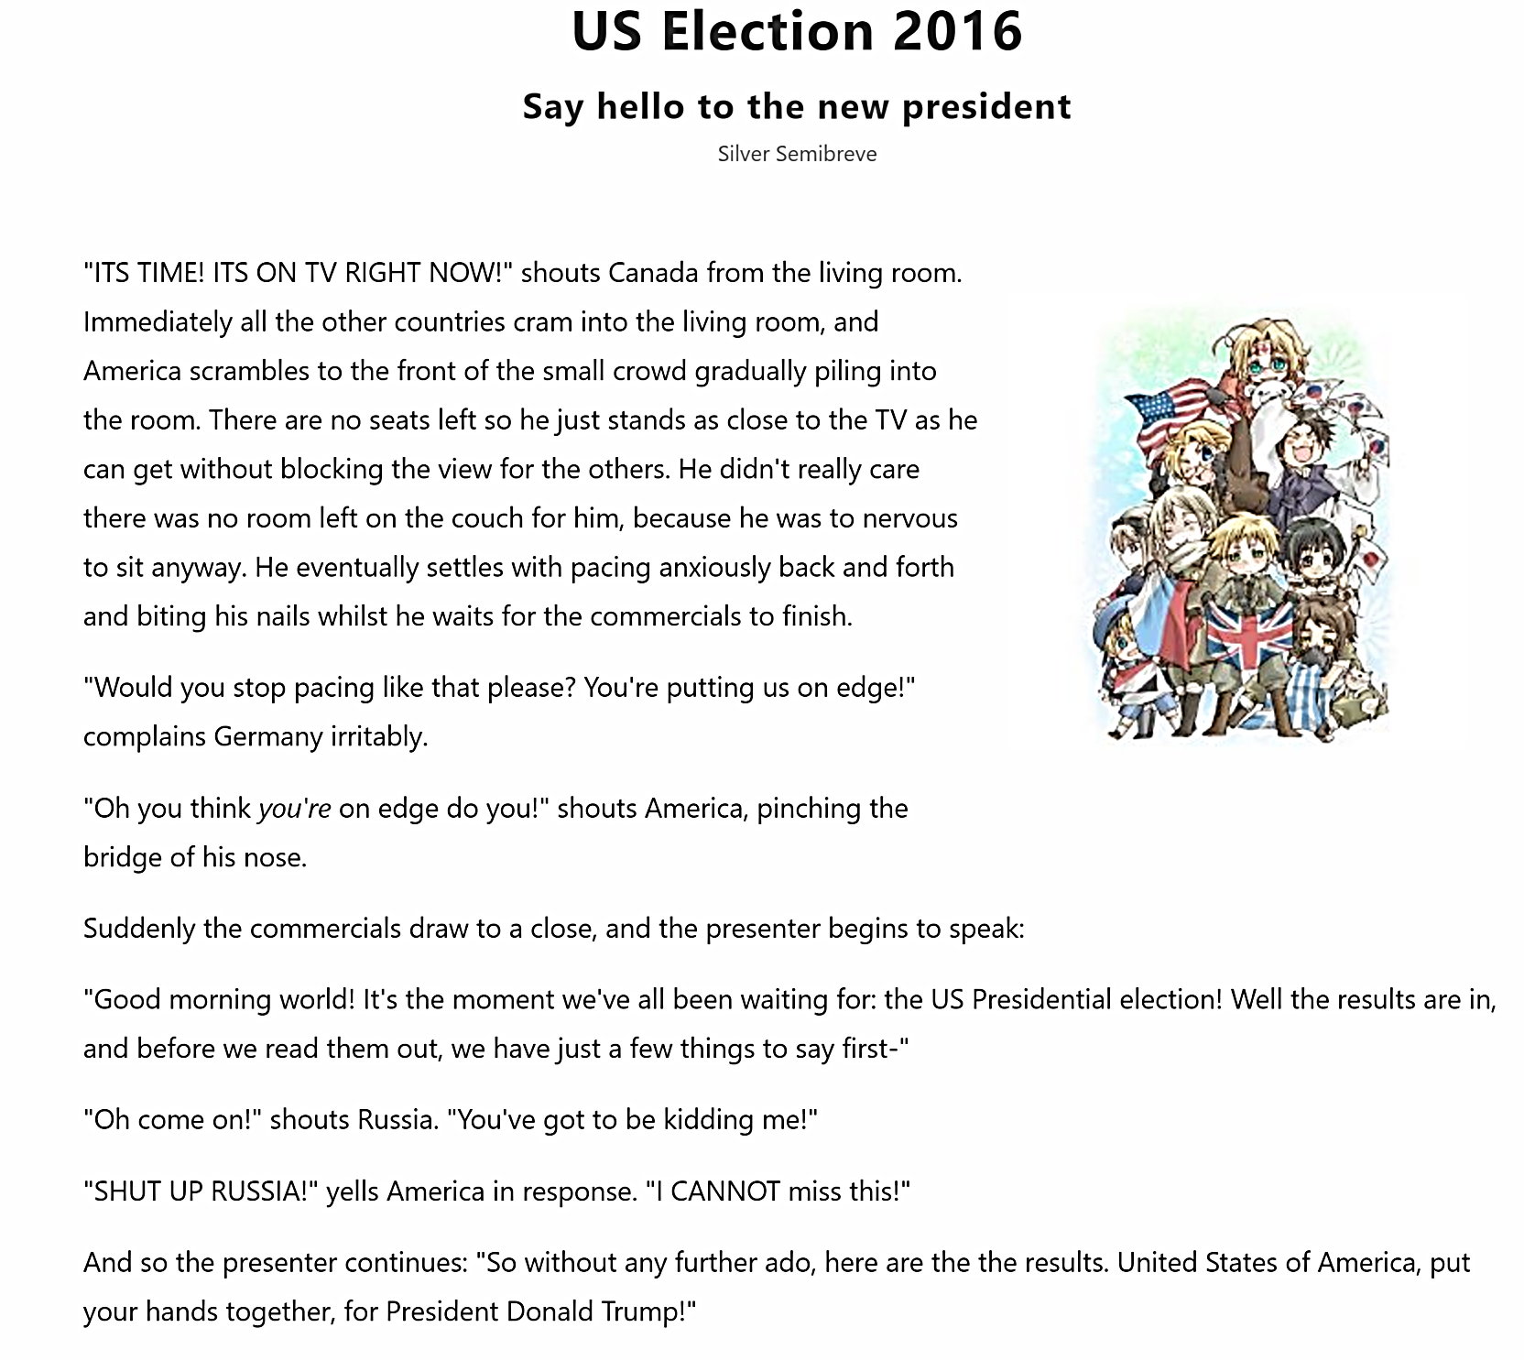 | TASKS  - Work with a partner.  Read the text for general understanding. Ask your teacher for help if necessary.  - Do the next step on your own:  Reread the text and highlight 15 useful phrases. Do NOT show them to your partner.  - Gapped reading: Join your partner again. He/she turns their sheet over. Now read out a part of the text to your partner and stop wherever you have highlighted a phrase. Ask your partner to supply the missing words. Take turns – and go through the whole “gapped” text.  - Blackout: Take a thick black pen and black out parts of the text. Take turns reading it out to each other. See how much you can black out and still read the text.  Homework: Transfer 10 useful vocabulary phrases from this text into your vocab-book. You will find a clean copy on Moodle. For each of the 10 phrases look up a second example on www.vocabulary.com.
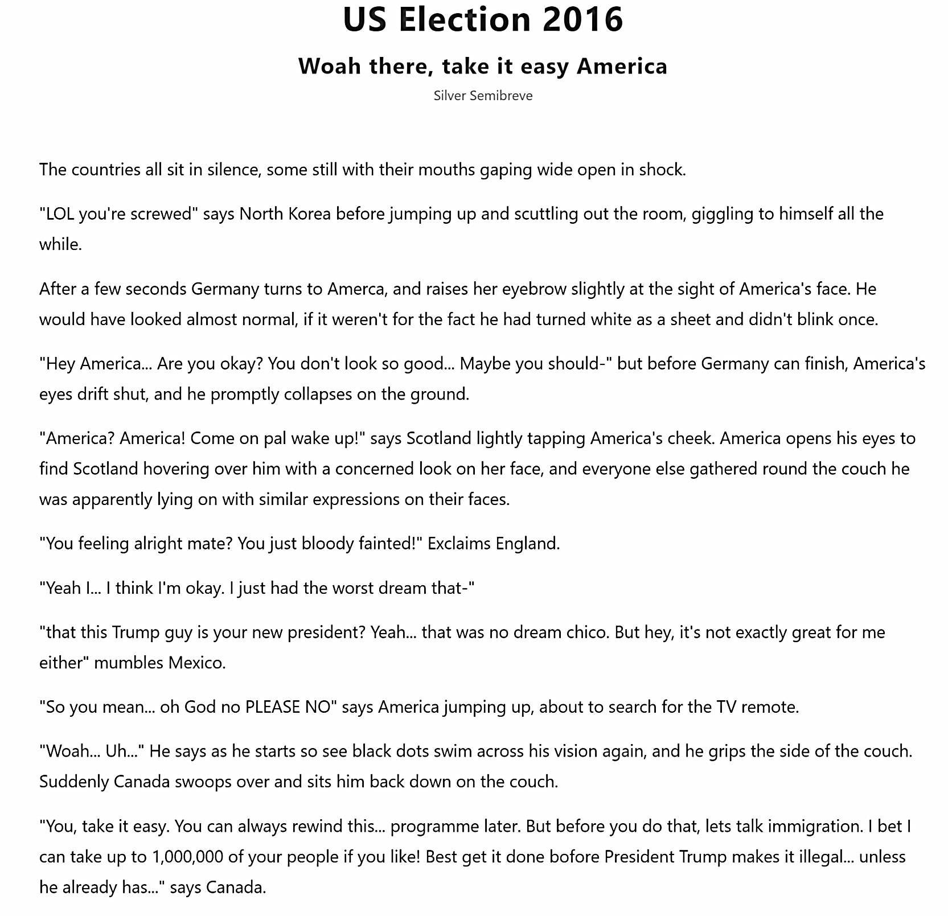https://www.quotev.com/story/8353001/US-Election-2016/1

