3rd Test 5c June 2016

Listening task 1
Name:
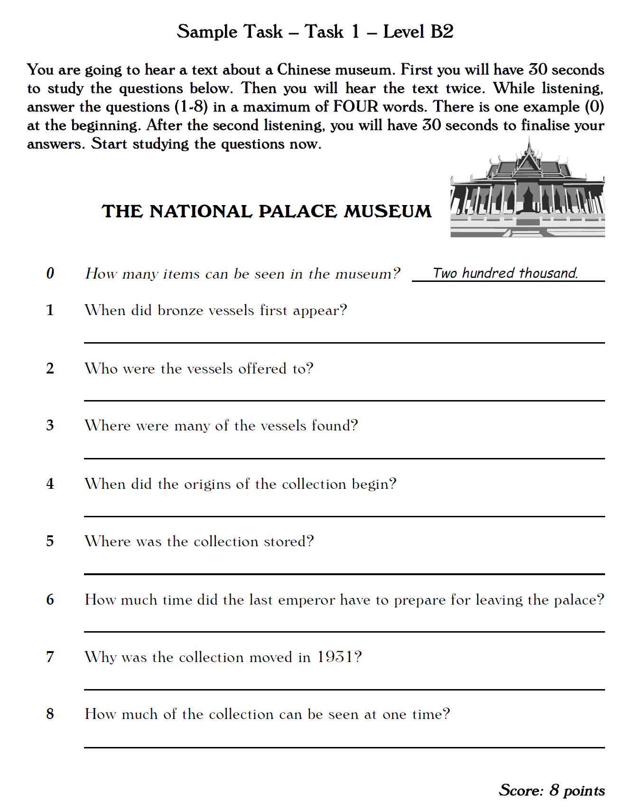

Listening task 2
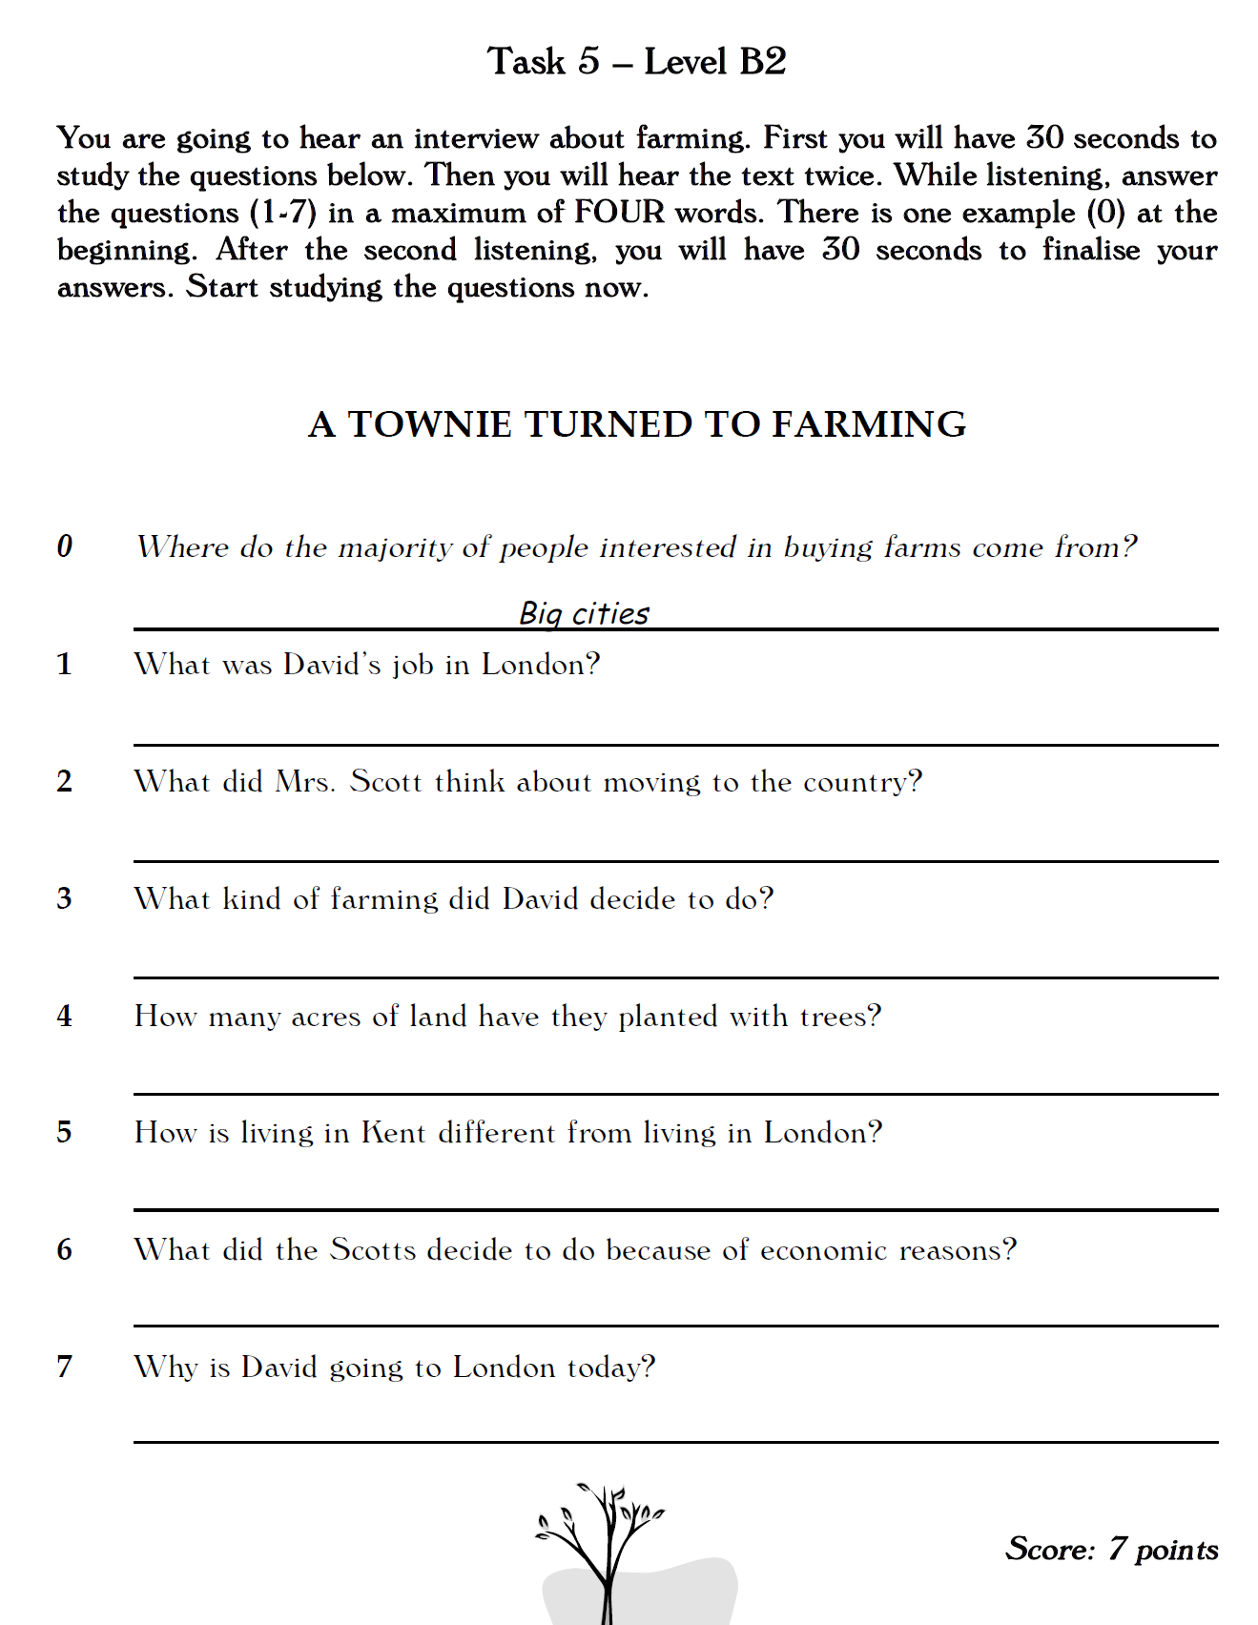

Reading Task 1
Name:
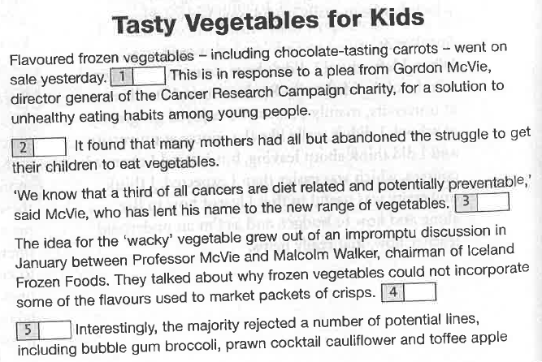
You are going to read an article from a newspaper, talking about a new food product that is aimed at children. Seven sentences have been removed from the article. Choose from the sentences A – H the one which fits each gap (1-7). There is one extra sentence which you do not need to use.

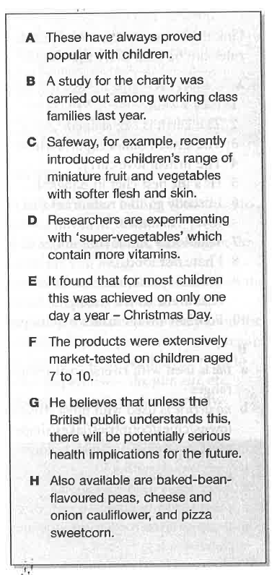
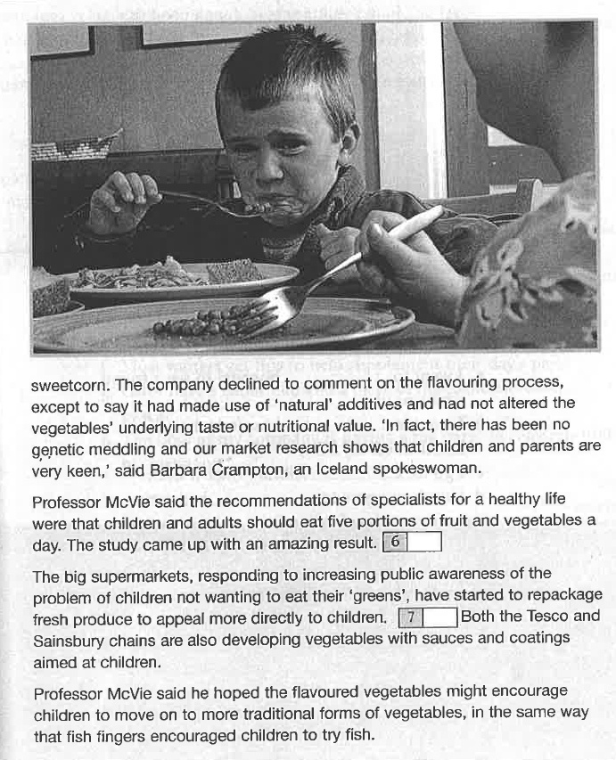

Reading task 2

Read the excerpt from Jenni Murray’s autobiography in which she talks about her relationship with her mother in the sixties. Choose the correct answer (A, B, C or D) for questions 1 – 9. Circle the correct letter. The first one (0) has been done for you.
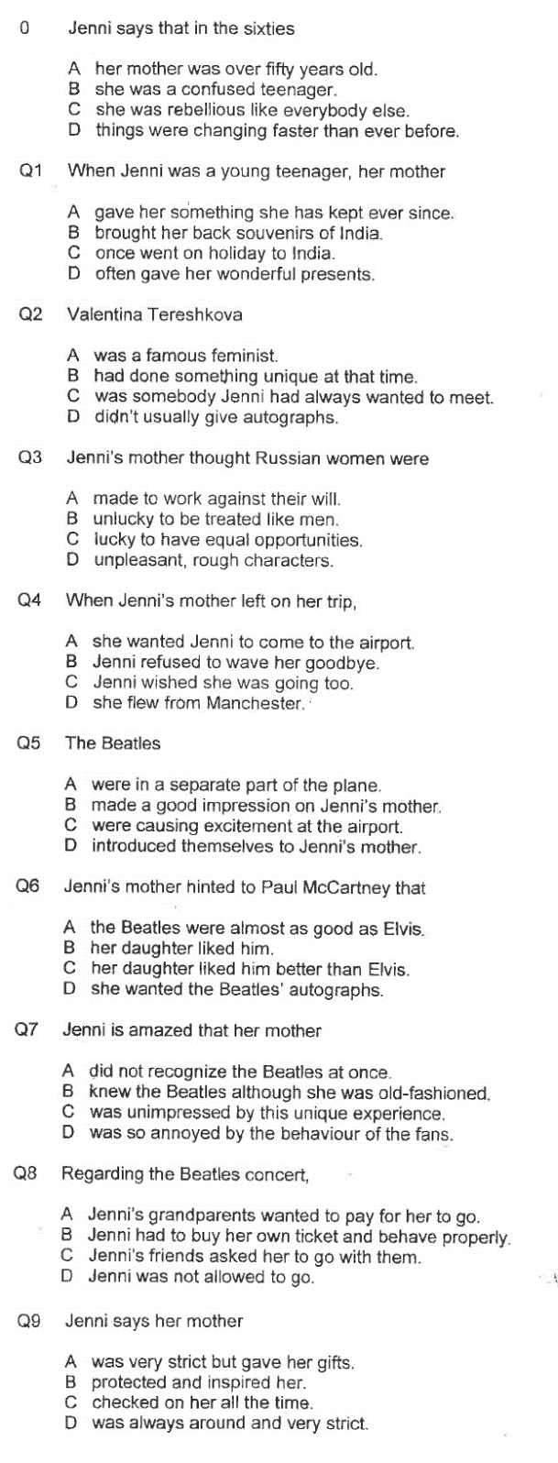
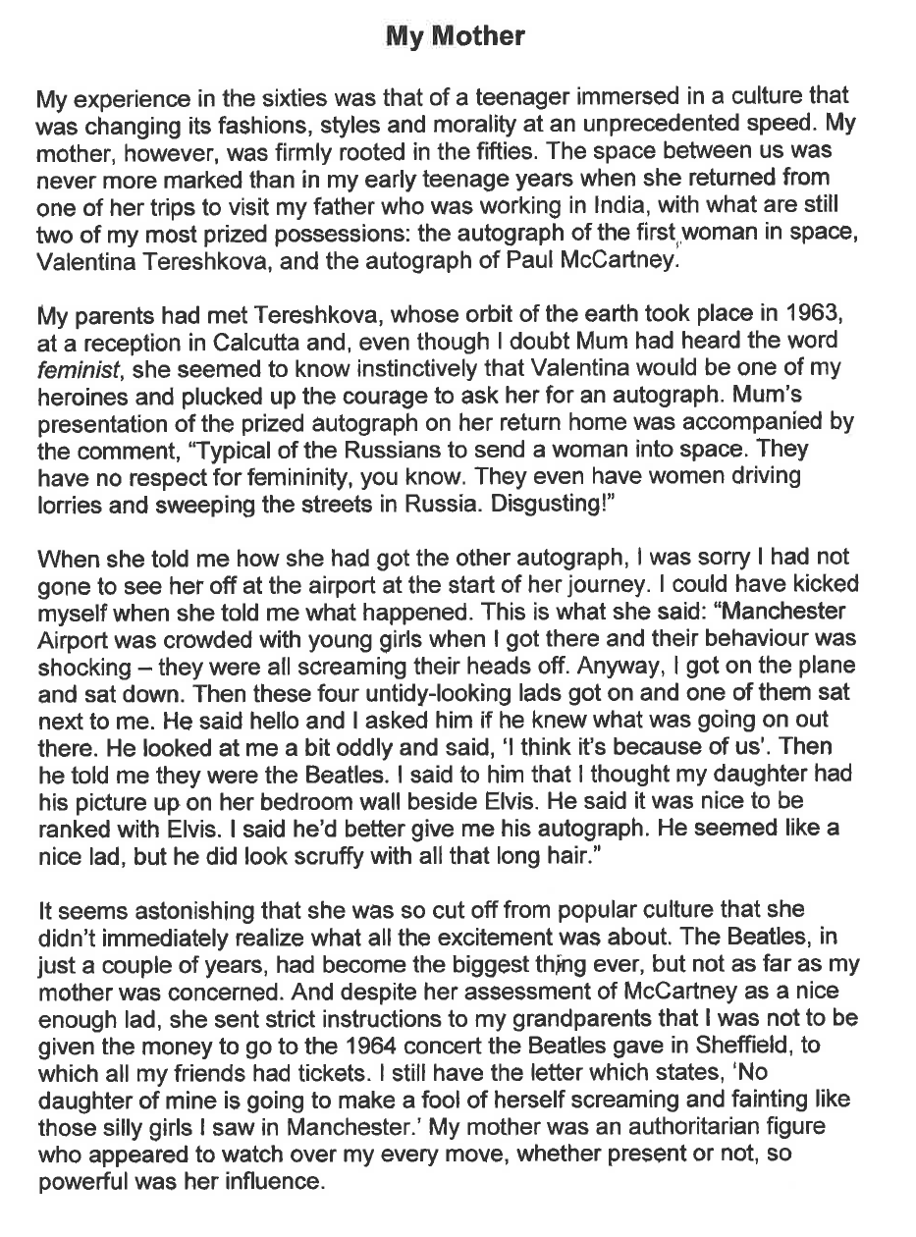

Writing task 1: Book review of your latest novel

Write a short review to be published on Amazon and/or on Reading-is Cool. Your review must
- describe the main character
- his/her main problem(s)
- short info about the plot
- your personal evaluation of the book (be specific: what exactly did you like/not like)
Write about 100 words

Writing task 2
Choose ONE of the topics below and write an original blog entry for gibsters.com. Make sure that you choose a topic you have not already written about.
- Introduce the topic and explain its importance
- Present new and interesting information and tips
- Convince your readers to follow your tips
Do not forget to
- Organize your text into meaningful paragraphs
- Write about 300 words
Healthy Living  Choose any aspect(s) of healthy living and convince your readers to keep fit by following your tips. | 
This Should Be Your Favorite Too!  Choose something that you absolutely love and convince your reader why it should be something they should check out. | 
Issues That Affect Students  Choose any aspect(s) of school life at GIBS that could be improved or should be changed and convince your readers that your improvements/changes would be the best for the students. |   Bullying  Exam Stress  Workload
Call for Social Change  Choose a social issue that is important to you and convince your reader that they can make a difference and help combat the problem. | 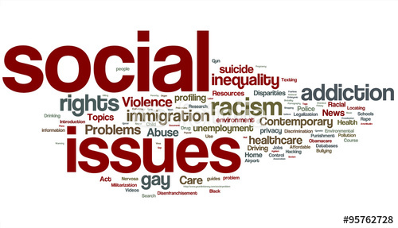

Key:

