3rd Test 5b May 2017

Listening task 1
Name:
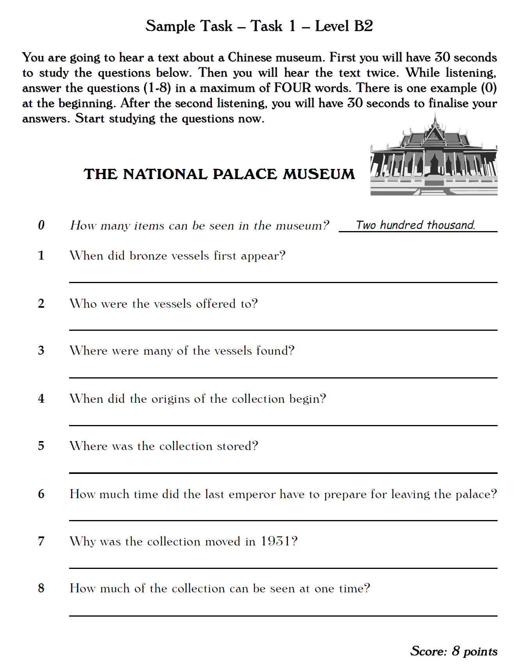

Reading task

Read the text. Parts of the text have been removed. Choose the correct part (A-N) for the gaps (0-11) and write your answers in the boxes provided. There are two extra parts that you should not use. The first one (0) has been done for you.
A they solemnly declared
B without his caste’s permission
C and his mother worried about the corrupting effect
Extra information:
The caste system in India is a system organizing people into different social groups.

D at the age of 19
E often not speaking to one another
F (both forbidden by the Hindu faith)
G which was necessary to study law
H an accepted feature of daily life in India
I which would inspire observers around the world in years to come
J that you should go to England to study law
K without my permission
L Gandhi was determined to go
M caste divisions in India
N his difficulties at school

Transfer your answers into this table:
0 | 1 | 2 | 3 | 4 | 5 | 6 | 7 | 8 | 9 | 10 | 11
H

At the age of 13 Gandhi was married to a local girl of the same age named Kasturbai. Child marriage was-and still is, in some regions- (0) H and although later in life Gandhi called child marriage cruel and inhumane, he seemed to have welcomed his own wedding at the time, and, in his words, "I lost no time in assuming the authority of the husband; she could not go out (1) …… " Needless to say, the adolescent couple went through quarrelsome stretches, (2) ….… for long periods of time.
Gandhi was a shy and fearful child. Short and skinny, he didn't like athletics, and his lack of physical ability was matched by (3) ……. Though in later years he would read the Bible, Tolstoy and the Bhagavad-Gita with great enthusiasm, the young Gandhi labored over the multiplication tables and never rose above academic mediocrity. His religious imagination (4) …… was also decidedly limited in his childhood years.
When Gandhi's father died, his family decided (5) …….: with an English law degree, they assumed, Gandhi would have no difficulty following in his father's footsteps as a local politician. But the journey to Europe was a significant step (6) ……. that England would have upon her son's morals. To calm her fears, Gandhi swore an oath to avoid wine and meat (7) …… while overseas, and after the family had gathered enough money, he made his way to Bombay to sail for Southampton in England.
In Bombay, a remarkable event occurred: the elders of Gandhi's caste, the Modh Banias, a merchant caste, learned of the proposed trip and objected. No member of their caste could go to England (8) …… because such a trip would inevitably involve impurity, and Hinduism could not be practiced in Europe. By this point, however, (9) …… And so he allowed himself to be expelled from his caste. For the remainder of his life, he would be “out-caste”, an appropriate condition for a man who worked hard to put an end to (10) …… All obstacles now removed, Gandhi sailed for England in September of 1888 (11) …… Among the loved ones he left behind was his three-month-old first child, a boy named Harilal.

Writing task: Book review of your latest novel


Write a review of your latest novel for Amazon and/or Reading-is Cool. In your review
- describe the main character
- explain his/her main problem(s)
- give short info about the plot
- share your personal evaluation of the book (be specific: what exactly did you like/not like)
Write about 300 words


Key:

