3rd Test 5c June 2016

Listening task 1
Name:
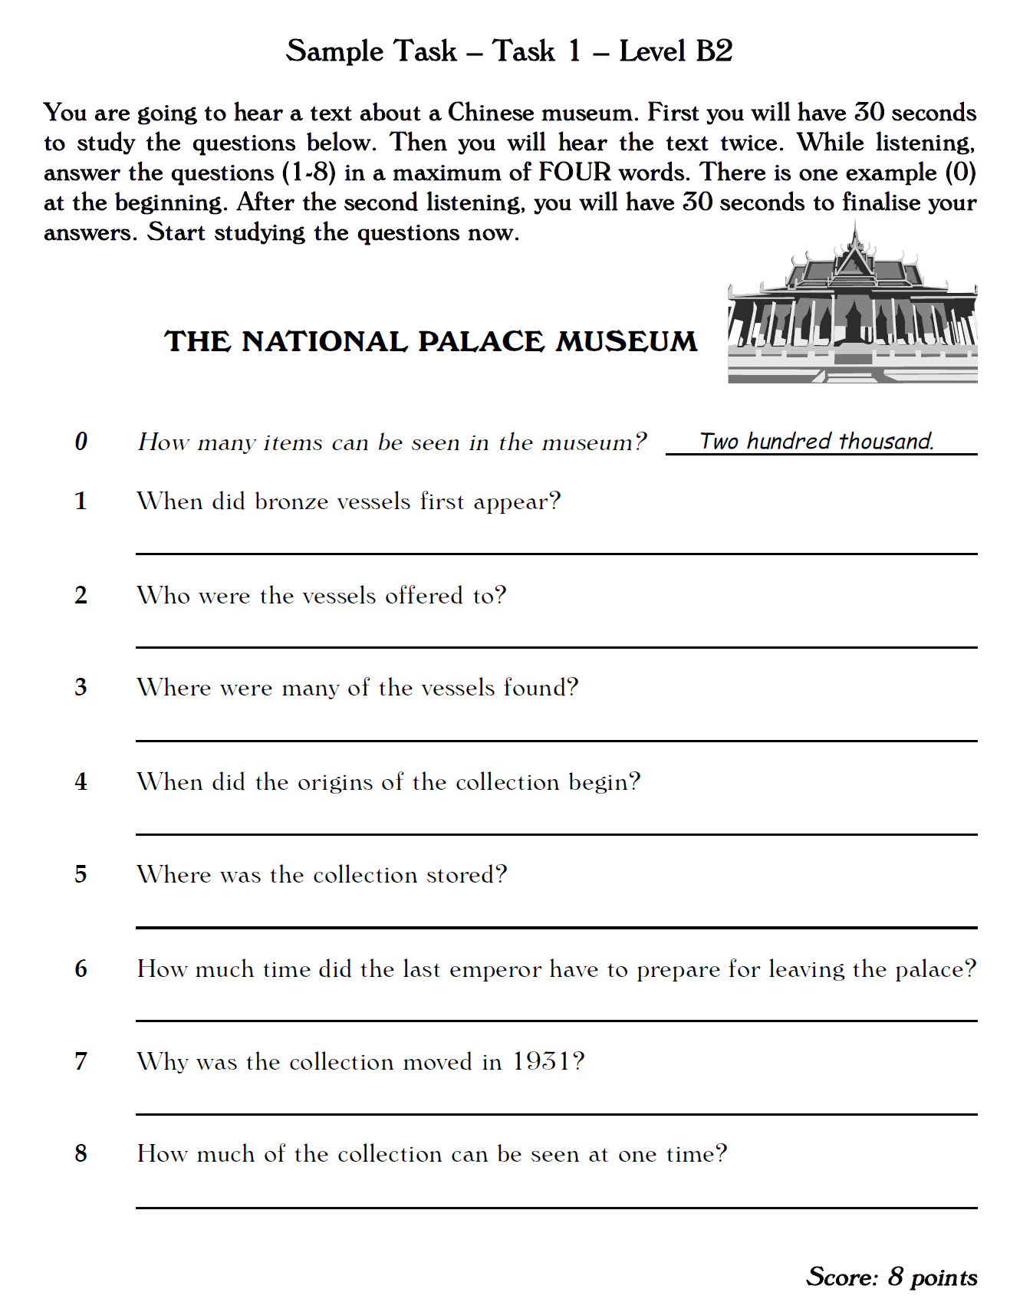

Listening task 2
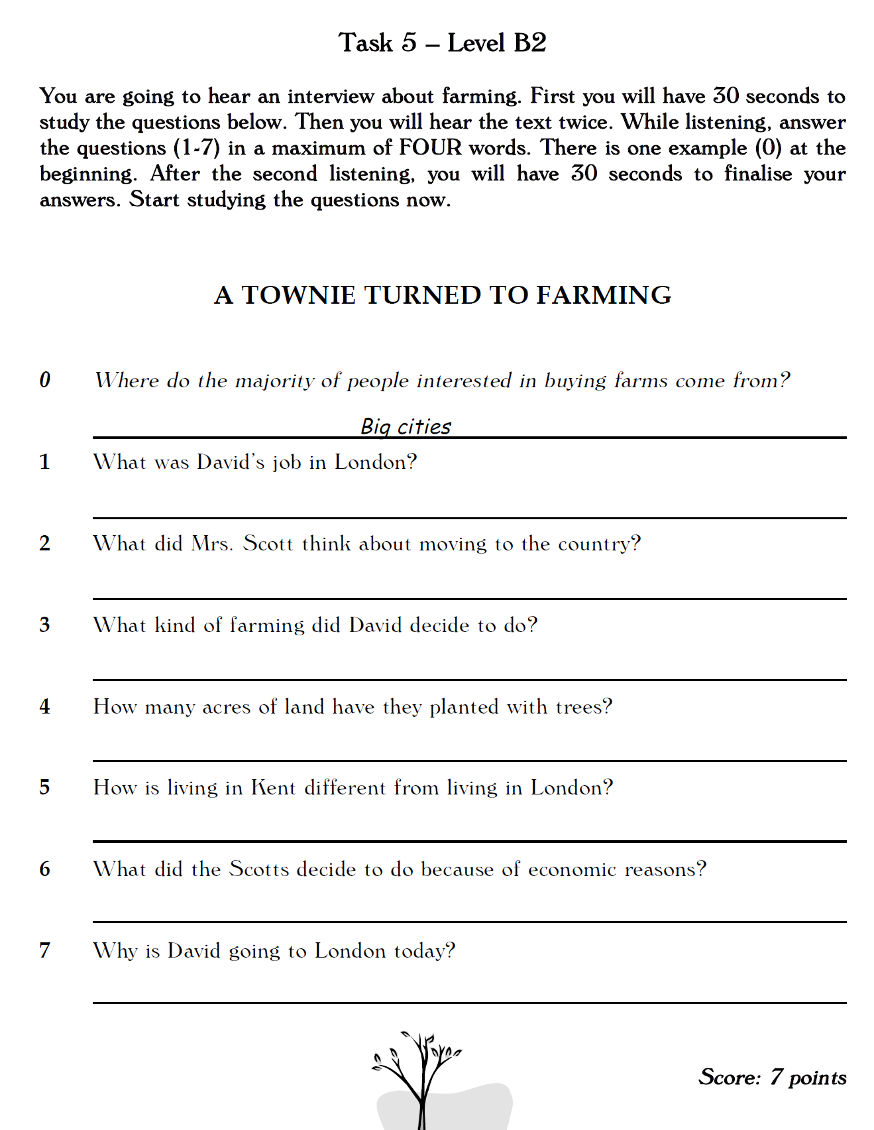

Reading Task 1
Name:
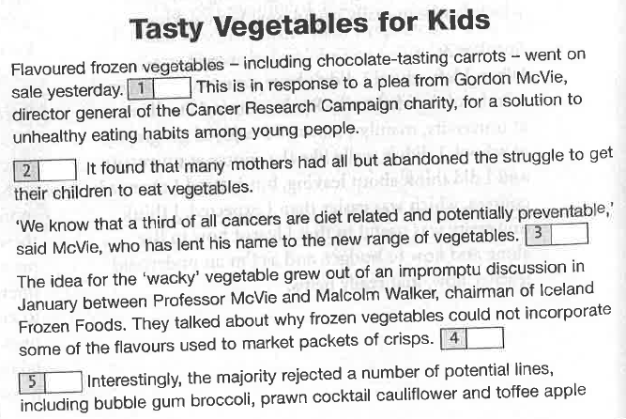
You are going to read an article from a newspaper, talking about a new food product that is aimed at children. Seven sentences have been removed from the article. Choose from the sentences A – H the one which fits each gap (1-7). There is one extra sentence which you do not need to use.

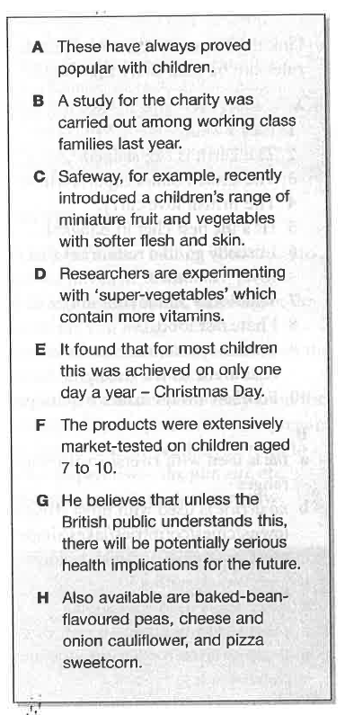
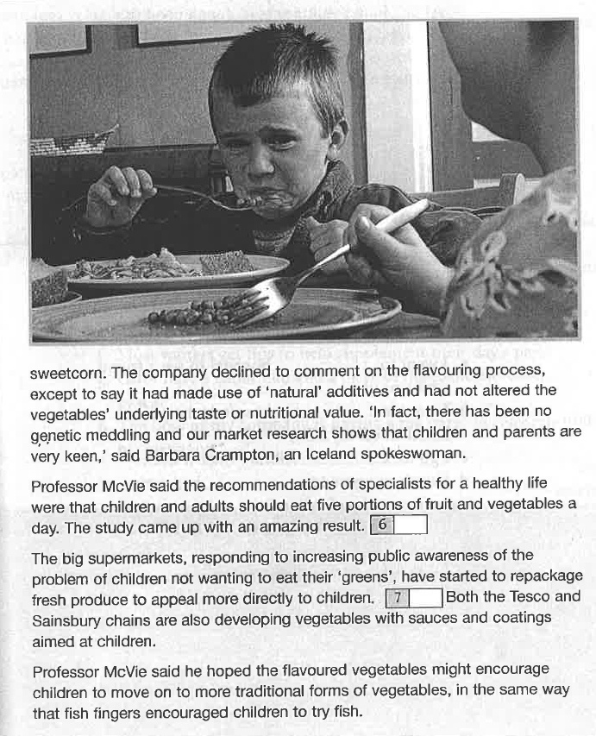

Reading task 2

Read the excerpt from Jenni Murray’s autobiography in which she talks about her relationship with her mother in the sixties. Choose the correct answer (A, B, C or D) for questions 1 – 9. Circle the correct letter. The first one (0) has been done for you.
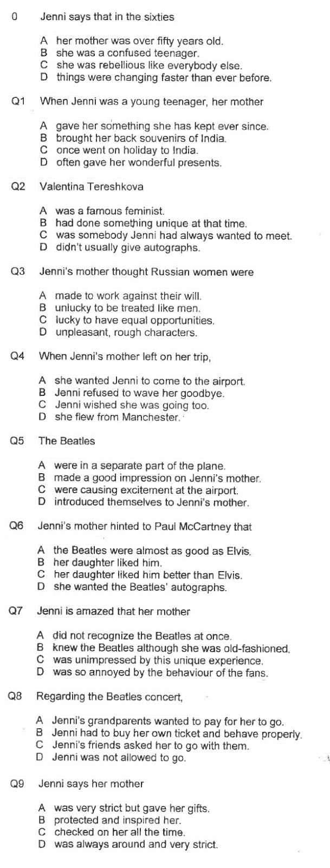
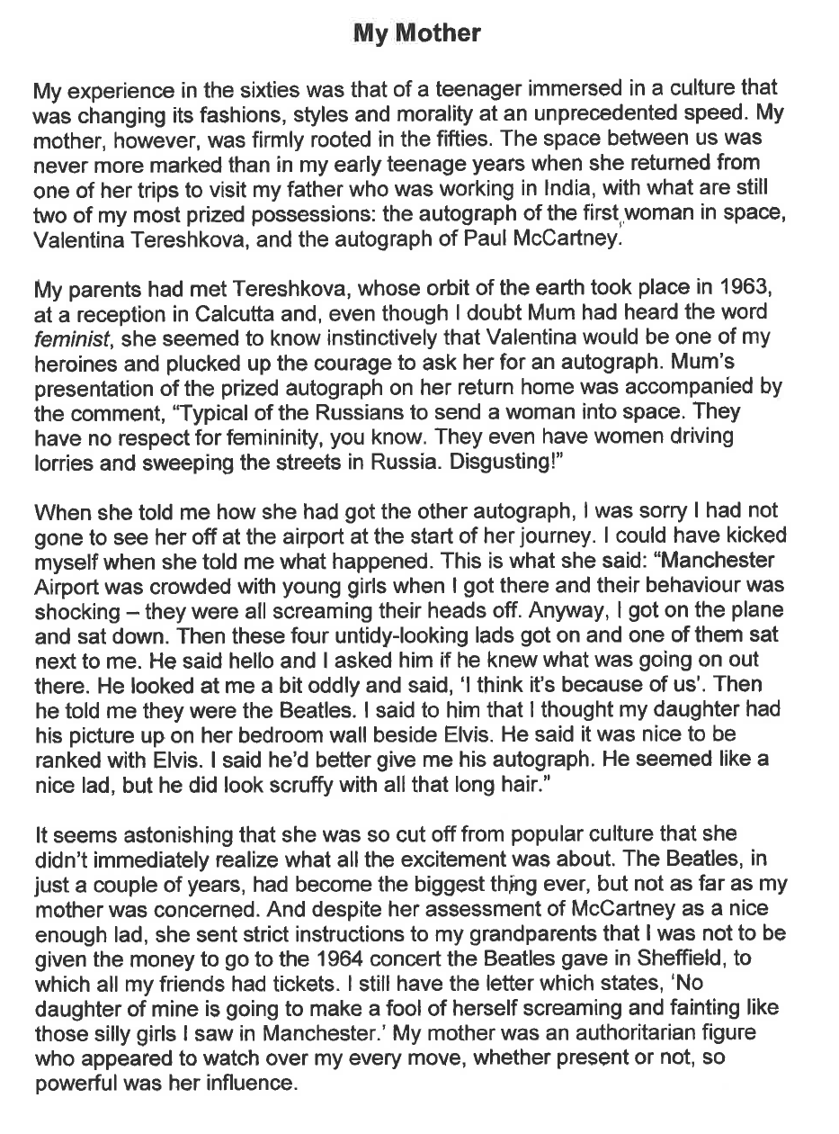

Language in Use: Reporting
Name:


You won’t believe what they said…
During the presidential campaigns in Austria and in America the candidates have presented some rather odd ideas and plans. Report some of their most outrageous statements in the form of tweets for Twitter.
Write 5 tweets

#US-elections
#Austrian-elections

Writing task
Choose ONE of the topics below and write an original blog entry for gibsters.com. Make sure that you choose a topic you have not already written about.
- Introduce the topic and explain its importance
- Present new and interesting information and tips
- Convince your readers to follow your tips
Do not forget to
- Organize your text into meaningful paragraphs
- Write about 300 words

Healthy Living
Choose any aspect(s) of healthy living and convince your readers to keep fit by following your tips.
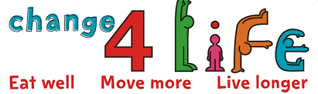

This Should be Your Favorite … too!

Choose something that you absolutely love and convince your reader why it should be something they should check out.


Issues That Affect Students
Choose any aspect(s) of school life at GIBS that could be improved or should be changed and convince your readers that your improvements/changes would be the best for the students.

Bullying
Exam Stress
Workload

Call for Social Change
Choose a social issue that is important to you and convince your reader that they can make a difference and help combat the problem.
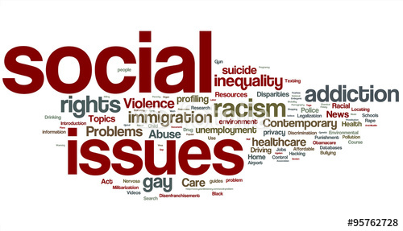

Key:

