1st test 5c Nov. 2015 Name:_________________________
A

1. By and until: Write meaningful sentences (10p)
Use the words in the box to write meaningful sentences using BY or UNTIL. Think of a clear context. Who would say this to whom and why?
borrow 5€ | read book | watch TV, fall asleep
I took out task 3 – in order to give them more time
Which of these events would you prefer? Explain why.
- Today I have to be in school until 8 p.m.
- Today I have to be in school by 9 a.m.

2. Describing a picture (30p)
Describe the picture in detail. Write about 150 words.
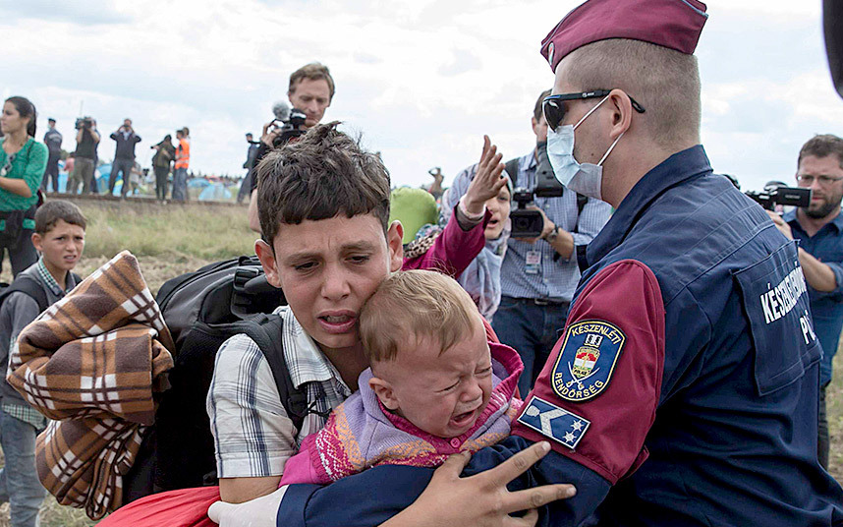

3. Speculating about refugees’ experiences (10p)
Speculate about this boy’s experiences in the last one or two years. What might have happened to him and his friends and family? Why might he have left his home? Write about 50 words.


4. Reading Project: Email or letter (50p)
The character from your book has finally arrived in a safe place and is planning to seek asylum. In order to prepare for this process your character is going to contact the Children’s Panel Advice Service run by the Refugee Council.
Write your character’s letter or email to the Children’s Panel Advice Service. In the letter
- explain your present situation
- describe some of your terrible experiences and briefly explain the background and the circumstances in your home country
- ask for advice and support in order to be granted asylum
Proofread your letter carefully – you want to show your best in order to convince the officials to help you win your case.
1st test 5c Nov. 2015 Name:_______________________
B

1.By and until: Write meaningful sentences (10p)
Use the words in the box to write meaningful sentences using BY or UNTIL. Think of a clear context. Who would say this to whom and why?
eat this sausage | do homework | practice piano

Which of these events would you prefer? Explain why.
Today I have to be in school until 8 p.m.
Today I have to be in school by 9 a.m.

2.Describing a picture (30p)
Describe the picture in detail. Write about 150 words.

Speculating about refugees’ experiences (10p)
Speculate about this boy’s experiences in the last one or two years. What might have happened to him and his friends and family? Why might he have left his home? Write about 50 words.

Reading Project: Email or letter (50p)
The character from your book has finally arrived in a safe place and is planning to seek asylum. In order to prepare for this process your character is going to contact the Children’s Panel Advice Service run by the Refugee Council.
Write your character’s letter or email to the Children’s Panel Advice Service. In the letter
- explain your present situation
- describe some of your terrible experiences and briefly explain the background and the circumstances in your home country
- ask for advice and support in order to be granted asylum
Proofread your letter carefully – you want to show your best in order to convince the officials to help you win your case.

Possible/expected answers

This picture shows a group of refugees who are walking along train tracks. In the foreground a family is being stopped by a policeman. A boy of about 10 is carrying his little brother or sister. The baby is crying bitterly, the boy himself has a scared, tired look on his face. In addition to carrying his little brother or sister he is carrying a backpack and a blanket. Behind the boy there is a woman who might be their mother. She is shouting something at the policeman. A second boy, who looks a bit younger than the boy in the foreground, also has a scared look on his face. The policeman has grabbed the boy’s upper arms tightly and seems to using some force to hold him back. He looks quite brutal with his very short hair, his dark glasses and the sanitary mask that he is wearing on his mouth. Several journalists are filming the scene. Three men are standing right behind the family and are holding large, professional cameras, filming the scene. In the background, along the train tracks several more journalists are observing and filming what is going on….(190wds)

He has probably seen a lot of destruction in his hometown. He might have lost some members of his family. His school may have been closed and he has probably experienced hunger and pain. He has probably walked a very long way and he has been really scared…(48wds)

