First test 5b October 2016

Reading comprehension

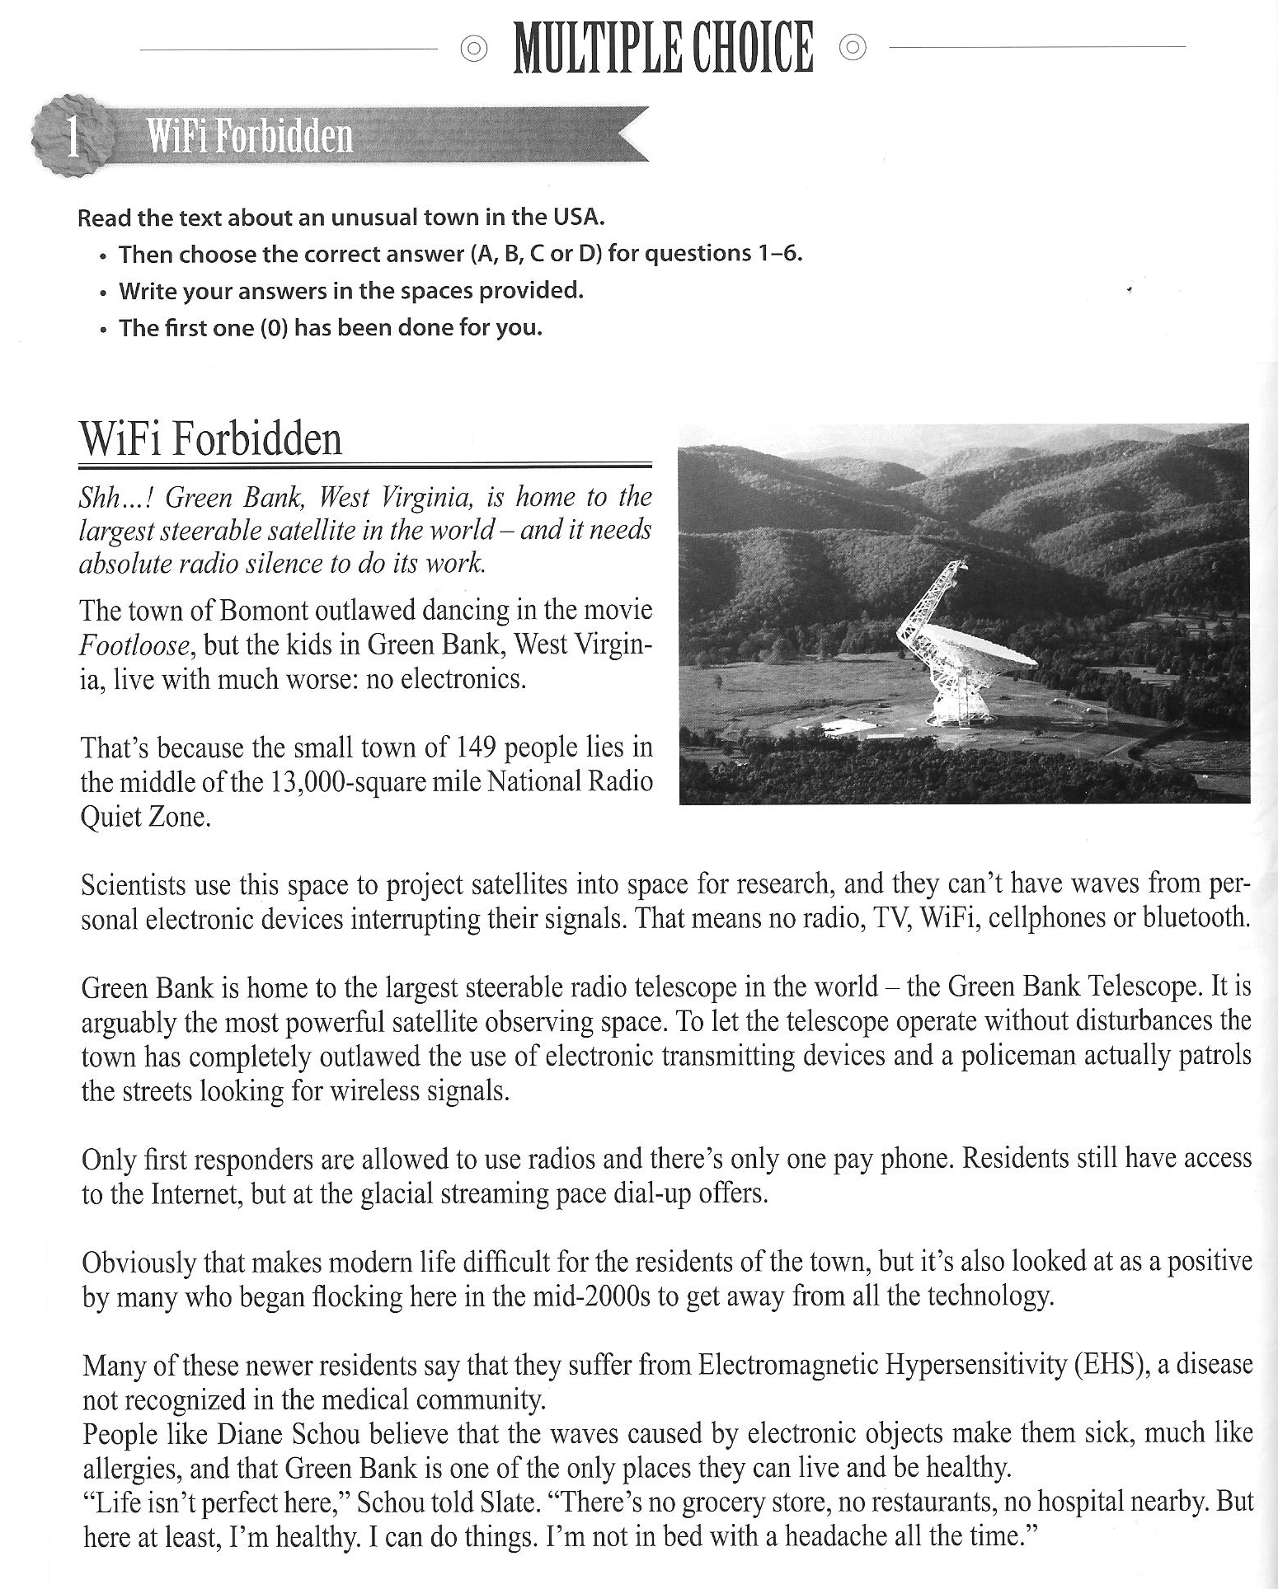
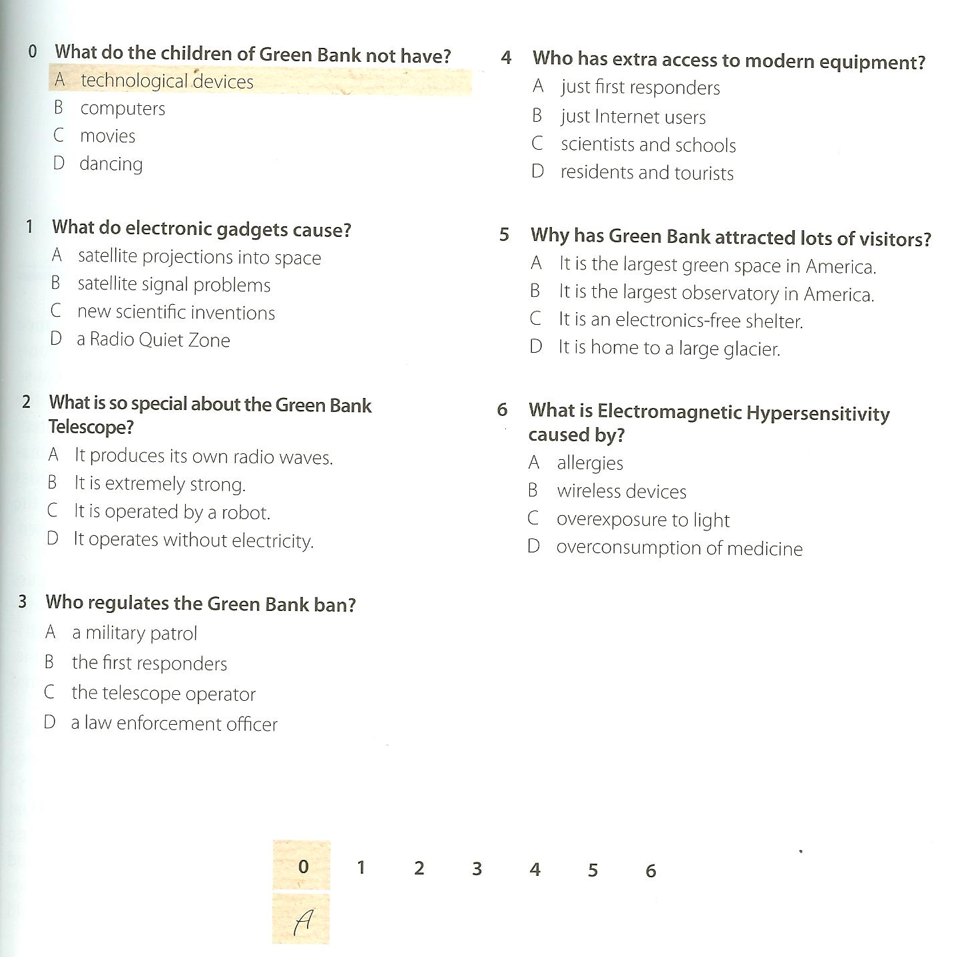

Writing: Personification: A day in the life of our blackboard
Describe a typical day in the life of a blackboard. What does the blackboard see? What are its thoughts, feelings and reactions to the events in the classroom? Write about 300 words on the back of this sheet.



