Test 2 5b December 2016

Listening
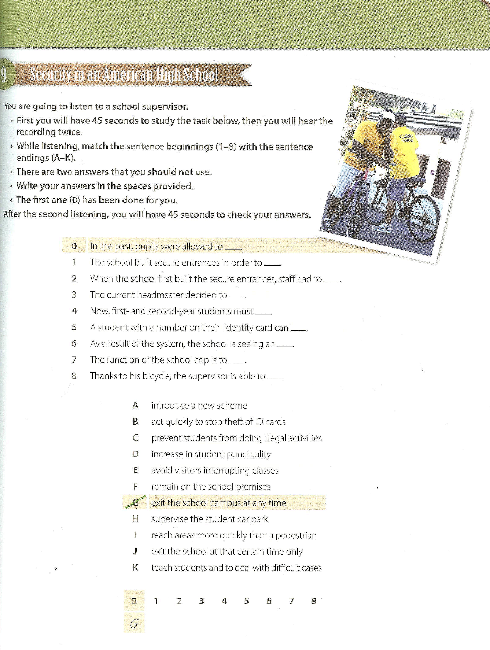

Writing: Christmas Blog Post
Write a post for our blog “gibsters.com“. In your post express your opinion on one of the following issues or give your readers practical tips for the holiday season.
Write about 300 words.

The Christmas Shopping Craze: Is this the true spirit of Christmas?


THE BEST CHRISTMAS MARKETS IN YOUR AREA

FESTIVE PARTY OUTFITS

NEW YEARS RESOLUTIONS

HOW TO DECORATE YOUR HOME ON A BUDGET

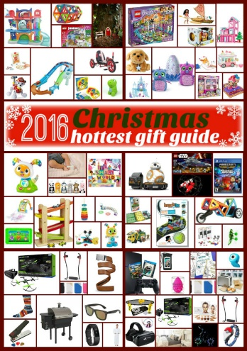
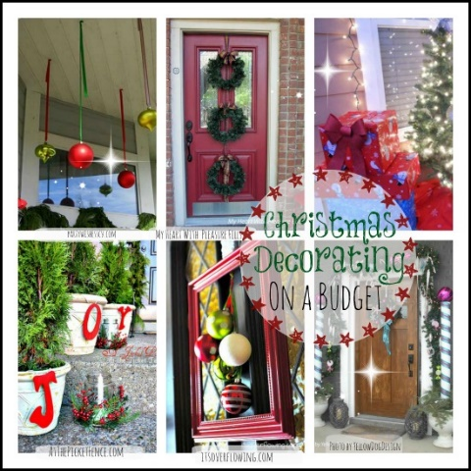
AN OPEN LETTER TO SANTA

THE BEST CHRISTMAS MOVIES

YOUR CHRISTMAS STORY

CHRISTMAS GIFT GUIDES

