Possession
Work with a parter. Look at the examples: Wie wird im Englischen Besitz ausgedrückt? Was fällt dir bei der Schreibweise auf?
Teile die Sätze in zwei Gruppen. Lege zuerst die Satz und Bildkarten auf, dann übertrage deine Lösung in das Arbeitsblatt und finde deine eigene Regel.
Peter’s camera is brand new.
Thomas‘ pencil is very long.
My parents‘ bedroom is very big.
John’s pumpkin is huge.
Sue’s desk is clean.
The rabbit’s ears are long.
My friend’s house is very small.
My cousins’ dog is a great friend.
My cousin’s dog is a great friend.
My parents’ car is very big.
My hamsters’ cage (Käfig) is very big.
My hamster’s cage is always clean.(sauber)
My grandmother’s cakes are the best.
Group 1:

Group 2:

My Rule:
Fill in:
my, your, his, her, Peter's, our, mine, yours, ours

........... name is Mary. What's ................ name?

........... name is Tom. He's from America.

........... name is Ann. She's from England.

Do you like ................. new school, Peter and Mary?

Yes, we like ................ new school very much.

Is this your homework book, Tom? No, it isn't .........., it's...............

Thomas, is this your pencil case? No, .............. is here, under........desk.

Complete the text

Look, this is ....... new schoolbag. It's just like .............
Sue's bag is also new, but ......... is not as nice as ............
Is that ruler on the floor .............? Yes, thank you, it's ...... ruler.
Where is ............... ruler?
Look, this is ............. new house. We like it very much.
Do you have a picture of .......... ? Here you are, that's ............. house.
Do you like it?
Fill in:
my, your, his, her, Peter's, our, mine, yours, ours

My name is Mary. What's your name?

His name is Tom. He's from America.

Her name is Ann. She's from England.

Do you like our new school, Peter and Mary?

Yes, we like our new school very much.

Is this your homework book, Tom? No, it isn't mine, it's Peter’s

Thomas, is this your pencil case? No, mine is here, under my desk.

Complete the text

Look, this is my new schoolbag. It's just like mine.
Sue's bag is also new, but hers is not as nice as mine.
Is that ruler on the floor yours ? Yes, thank you, it's my ruler.
Where is your ruler?
Look, this is our new house. We like it very much.
Do you have a picture of yours ? Here you are, that's our house.
Do you like it?
Peter’s camera is brand new.
Thomas‘ pencil is very long.
My parents‘ bedroom is very big.
John’s pumpkin is huge.
Sue’s desk is clean.
The rabbit’s ears are long.
My friend’s house is very small.
My cousins’ dog is a great friend.
My cousin’s dog is a great friend.
My parents’ car is very big.
My hamsters’ cage (Käfig) is very big.
My hamster’s cage is always clean.(sauber)
My grandmother’s cakes are the best.
Peter’s camera is brand new.
John’s pumpkin is huge.
Sue’s desk is clean.
The rabbit’s ears are long.
My friend’s house is very small.
My cousin’s dog is a great friend.
My hamster’s cage (Käfig) is always clean.
My grandmother’s cakes are the best.
Thomas‘ pencil is very long.
My cousins’ dog is a great friend.
My parents‘ bedroom is very big.
My parents’ car is very big.
My hamsters’ cage is very big.

Peter’s camera is brand new.
John’s pumpkin is huge.
Sue’s desk is clean.
The rabbit’s ears are long.
My friend’s house is very small.
My cousin’s dog is a great friend.
My hamster’s cage (Käfig) is always clean.
My grandmother’s cakes are the best.
Thomas‘ pencil is very long.
My cousins’ dog is a great friend.
My parents‘ bedroom is very big.
My parents’ car is very big.
My hamsters’ cage is very big.

Peter’s camera is brand new.
John’s pumpkin is huge.
Sue’s desk is clean.
The rabbit’s ears are long.
My friend’s house is very small.
My cousin’s dog is a great friend.
My hamster’s cage (Käfig) is always clean.
My grandmother’s cakes are the best.
Thomas‘ pencil is very long.
My cousins’ dog is a great friend.
My parents‘ bedroom is very big.
My parents’ car is very big.
My hamsters’ cage is very big.

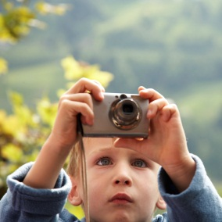 Peter’s camera is brand new.
My hamster’s cage (Käfig) is always clean. 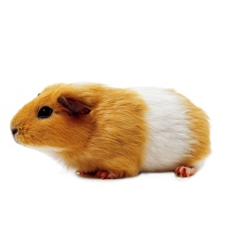

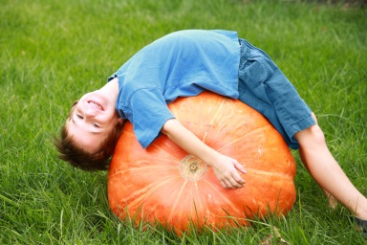John’s pumpkin is huge.

Sue’s desk is clean. 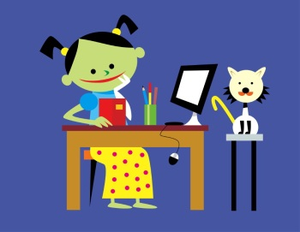
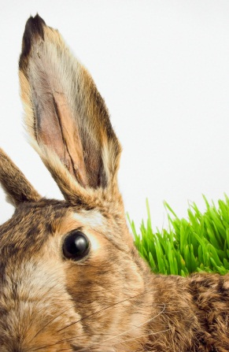The rabbit’s ears are long.
My friend’s house is very small. 

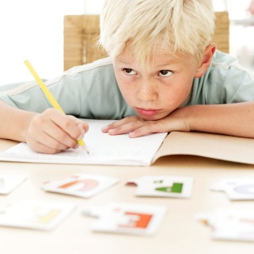
Thomas‘ pencil is very long.
My grandmother’s cakes are the best.

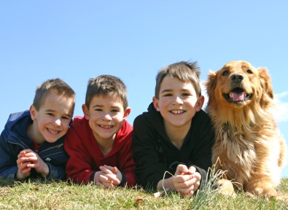
My cousins’ dog is a great friend.

My cousin’s dog is a great friend.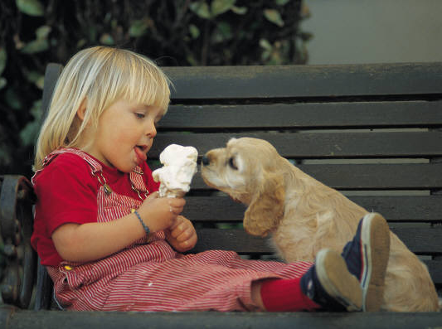
My parents’ car is very big.
My parents‘ bedroom is very big. 
My hamsters’ cage is very big.dfasd

