What’s in the news?

Headlines and Expectations:
Read the headlines and leads on pages 2 and 3 and guess what the articles are about. Write down 3-5 questions about each topic. Later you will be able to check whether the article really answers your questions.

Reading
Choose one of the topics that interests you and read the whole article. Work with a partner who has chosen the same article. Make sure you understand the text very well. Highlight important information and ask your teacher if you need help with unknown expressions.

Preparing an info card
Write the most important facts and information on the A6 card provided by your teacher. Write keywords or short phrases – do not write whole sentences.

Preparing your elevator speeches:
An elevator speech is a short speech (the time you need to ride from the first floor to the top floor of a skyscraper). In this speech you pass on some important information to your audience or you try to convince your listener of your opinion.
Plan your speech well – start with a general overview of the topic, then talk about the details. Practice your speech a few times (go into the hallway and talk to yourself).


Ready for the elevator speeches:

- Line up in two parallel lines facing each other.
- Speak to the person facing you for one minute without stopping.
- Then your partner may ask you a few questions. Try to answer them as fully as possible.
- Change roles: Your partner speaks for one minute while you listen carefully. Then ask some questions.
- Move to the next partner at the sign of the bell…

Vocab work
Choose three to five useful phrases (3-5 words long) from your article and write them on vocab cards.
Then get together in groups of four. Work with classmates who have read different texts. Teach your new phrases to your friends and write their phrases on cards as well.
Then put the new cards in the middle and play Voctivity.
Your Goal: You want to know all the new phrases before the bell rings and the lesson is over.





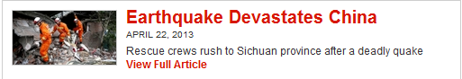





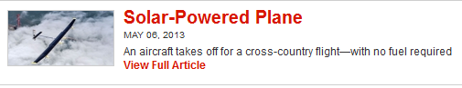

Science

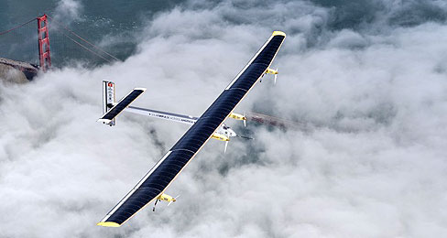
Solar-Powered Plane
An aircraft takes off for a cross-country flight—with no fuel required
May 06, 2013
By Cameron Keady with AP reporting
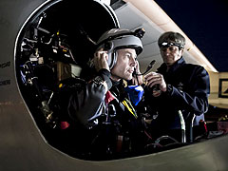
Powered only by solar panels on its wings, Solar Impulse will reach its final destination, New York City, in early July.It’s a bird! It’s a plane! It’s the Solar Impulse! On May 3, 2013, aviation history was made when a solar-powered airplane, named Solar Impulse, began a journey across the United States. The plane’s creators, André Borshberg and Bertrand Piccard of Switzerland, are taking turns piloting the aircraft as it crosses the nation.
“All the big pioneers of the 20th century have tried to fly coast to coast across America,” said Piccard, who was in the pilot’s seat at takeoff. “So now we’re trying to do this, but on solar power with no fuel.”
©SOLAR IMPULSE
Swiss psychiatrist and balloonist Bertrand Piccard is co-piloting the aircraft during its journey.
Across America
Solar Impulse departed from Moffett Federal Airfield, in Northern California, just after dawn on May 3. Traveling at around 40 miles per hour, the plane will make its voyage in five separate trips. Each flight leg will take 19 to 25 hours with 10-day stops in each city. The first leg of the journey, from California to Phoenix, Arizona, was completed in 20 hours. From Phoenix, Solar Impulse will make stops in Dallas, TX, St. Louis, MO, and Washington, DC, before ending its last leg in New York City in early July. Solar Impulse’s journey marks the first time an airplane powered exclusively by solar energy will fly across the country during both the day and the night.
Plane Power
The solar-powered plane is a single-seat aircraft. “Our plane is not designed to carry a passenger, but to carry a message,” Piccard has said numerous times. That message is to use innovative, clean technologies for energy efficiency. Solar Impulse is intended to make its cross-country voyage without using a single drop of fuel. By day, 12,000 solar cells are charged by the sun to power lithium batteries. That enables the plane to fly at night—but it cannot travel through clouds.
Solar Impulse weighs just 3,500 lbs, about as much as a car. Most of the weight is from the solar panels that cover its wings, which stretch 208 feet. The aircraft has reached an absolute altitude of 30,300 feet and has completed a trip that lasted more than 26 hours. This adventure is Solar Impulse’s final trip before its creators attempt an around-the-world flight in 2015. “We want to show that with clean technologies, a passionate team, and a far-reaching pioneering vision, one can achieve the impossible,” Piccard said in a statement.


A Walk in Space
Astronauts investigate a leak at the International Space Station
May 13, 2013
By Cameron Keady with AP reporting
Chris Cassidy inspects the International Space Station on May 11.
There was some trouble in space over the weekend. On Thursday, May 9, flakes of frozen ammonia were seen drifting from the International Space Station (ISS). The team onboard immediately prepared for a spacewalk to look into the issue. Two days later, on Saturday, two astronauts stepped outside the ISS to investigate the leak. The chief suspect was an old ammonia pump.
Thomas Marshburn and Christopher Cassidy conducted the search, but did not discover any visible damage. "All the pipes look shiny clean, no crud," Cassidy reported as he used a mirror to peer into tight, deep openings. Even so, the astronauts removed the old pump and replaced it with a new one.
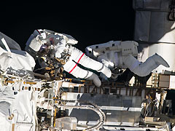
NASA astronauts Tom Marshburn and Chris Cassidy completed the May 11 spacewalk in 5 hours and 30 minutes.
Keeping It Cool
Ammonia is used on the ISS to cool the spacecraft’s electronic equipment. NASA said this leak did not pose a safety threat to the six space station residents. But problems with the cooling system could threaten experiments and equipment.
It is still not clear why exactly the leak erupted. NASA speculates that a microscopic piece of space matter struck the space station, leaving a tiny crack in the ammonia pump. Another possibility is that there was simply a leaky seal in the pipe. Either way, “there’s nothing to lose by putting in a fresh pump and pressing ahead with additional detective work,” said Mission Control.
Studies in Space
The ISS was launched into orbit in 1998. Since 2000, a rotating crew of astronauts and scientists has continuously occupied it. While in orbit, the international team of astronauts performs scientific research and collects data about conditions in the Milky Way and beyond. Many of their experiments focus on humans’ ability to live and work in space over long periods of time.
While these astronauts have performed some amazing tasks, NASA has never before staged a spacewalk so quickly. Marshburn has been on the space station since December, and Cassidy is a new arrival to the ISS. While the leaky pump mystery continues to puzzle the ISS team, they are hopeful further investigations will provide answers. “This type of event is what the years of training were for,” space station commander Chris Hadfield said in a tweet Friday. “A happy, busy crew, working hard, loving life in space.”
World

A Heroic Return
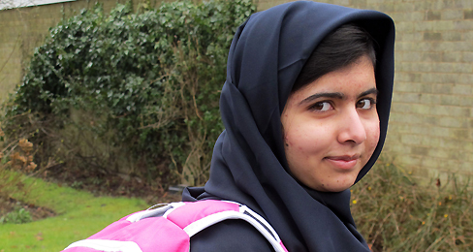
Women's-education activist Malala Yousafzai goes back to school
March 20, 2013
By TIME For Kids
Malala Yousafzai gets ready for her first day back at school on March 19, just weeks after being released from the hospital.
On March 19, Malala Yousafzai, a 15-year-old Pakistani student and women’s-education activist, returned to the classroom on for the first time since being violently attacked by a member of the Taliban on October 9, 2012. Malala was shot on her way home from school in Mingora, Pakistan. The Taliban group Tehrik-e-Taliban Pakistan (TTP) took responsibility for the attack. The group said the attack should serve as a warning to others. TTP’s members follow a strict version of Islam and believe girls should not go to school. Malala was targeted because she is vocal about girls’ rights to education in Swat Valley, Pakistan.
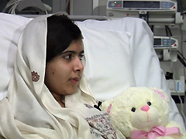
AFP/GETTY IMAGES/NEWSCOM
Malala recovers from the attack at Queen Elizabeth Hospital in Birmingham, England.
After a long period of recovery, Malala is starting as a ninth-year student at Edgbaston High School. It is the oldest independent girls school in Birmingham, England. Though she has no concrete plans to return to Pakistan, Malala still speaks out as a voice for change in her country, and everywhere. “I am excited that today I have achieved my dream of going back to school. I want all girls in the world to have this basic opportunity,” Malala said in a statement. “I miss my classmates from Pakistan very much but I am looking forward to meeting my teachers and making new friends here in Birmingham.”
Malala’s Journey
Malala has been an Internet blogger, or writer, since she was 11 years old. In 2011 she was awarded Pakistan’s National Peace Award for her bravery in writing about the difficulties of life and education in the shadow of the Taliban. She has spoken publicly about children’s rights and been nominated for an international children’s peace prize.
After the attack in 2012, support for Malala poured in from around the world. The United Nations declared November 10 Malala Day. Former British Prime Minister Gordon Brown said the day honors Malala and shows the world that people of all sexes, all backgrounds and all countries stand behind her.

A Summer of Adventure
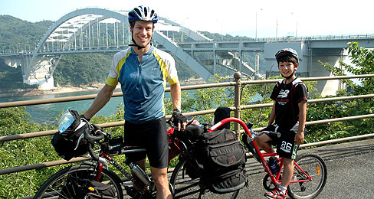
TFK catches up with author Charles Scott about the journey behind his book Rising Son
May 10, 2013,
By TFK Kid Reporter Faye Collins

Charles Scott and his son, Sho, spent the summer of 2009 bicycling the length of Japan.
Imagine your second grade summer: two months of vacations and popsicles, right? In 2009, Charles Scott and his son, Sho, wanted to have an adventure together, which eventually led to biking the length of Japan – more than 2,000 miles – in 67 days. Sho was 8 years old at the time. Charles transformed his journal into the book, Rising Son. TFK Kid Reporter Faye Collins talked to the father and son team about their experience.

TFK: What inspired you to bike across Japan?
CHARLES: I wanted to spend more time with my kids, so Sho and I sat down when he was 7 and came up with an idea for an adventure. I said, “It can be anything” and we decided to cycle the length of Japan. My wife is Japanese, so we’ve been to Japan before. We decided it would be cool to make it a bike adventure, and then we got carried away. First we imagined a week or two in Japan, then we thought: “Why don’t we do the whole country?” That was that.
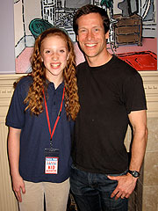
COURTESY COLLINS FAMILY
TFK Kid Reporter Faye Collins chats with author Charles Scott.

TFK: How did you feel after the first week of cycling?
SHO: At first it was hard, because after the first week my mom and my sister left, I didn’t really want that to happen. But once I got used to it I felt fine.
TFK: What were some of the most fun and exciting parts?
CHARLES: I really enjoyed getting out in the nature of Japan. Our image of Japan is kind of like New York City, a big megalopolis. But actually the country is has lots of mountains and beautiful places to go. We slept in a tent on the beach a lot of times, or in the mountains, and that was really a wonderful experience to share with my son. The second best thing was the fact that we met so many nice people.
TFK: What were some of the most challenging parts?
SHO: The mountains were really, really big. And when we were in Hokkaido, which was a part of town we were in, it was windy and cold.
CHARLES: We crossed the Japan Alps mountain chain, and it is no joke. They call it the Japan Alps because it is a whole really serious mountain chain. In the whole trip, we went over ten mountain passes. You ride up these switchbacks straight up a mountain, and it was very hard physically. But going down is scarier! And Sho is right, the weather was tough. There were times when we would just get caught in these big rainstorms. You would get soaked and you were pushing into the wind, and kept you from getting anywhere.
Kid Reporter
Faye Collins
My wife joined us for the first week in a car, just to make sure everything was okay. After a week, she and my daughter went home. So for the rest of the trip we didn’t have an easy option. It made us possible to just say: “Well, let’s just and deal with it.”
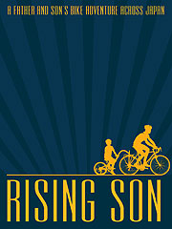
TFK: How many bike malfunctions did you have throughout the trip?
CHARLES: We had a total of ten flat tires over 67 days. I brought patches, spare tires, a toolkit and a little emergency roadside repair book with me.
TFK: How did the book come together?
CHARLES: I kept a journal during the trip, and also kept a blog so friends could stay updated. When I was a teenager, one of my life goals was to write a book. In the middle of this trip I realized, “This is the book!”
TFK: Was writing the book or getting it published harder than the actual journey?
CHARLES: In a way, it was. I joined a writing group. These wonderful people gave me suggestions to improve my book. It was really as much of a challenge as it was doing this trip. In both cases, I needed help.
TFK: How did it feel when you completed the quest?
SHO: It was a relief, but also disappointing because it was really fun.
CHARLES: I was happy for it to end, because I was so tired. I didn’t know if I could do this, I had self-doubts, so finishing felt like an accomplishment. I mentioned that one of the reasons I wanted to do this was to spend more time with my son. Now we share a great set of memories.

Earthquake Devastates China
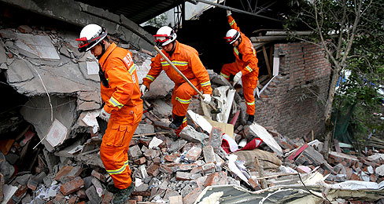
Rescue crews rush to Sichuan province after a deadly quake
April 22, 2013
By Stephanie Kraus with TIME and AP reporting

FENG LI—GETTY IMAGES

Rescue workers search for earthquake survivors in China's Sichuan province.
On Monday, rescue teams rushed to reach isolated parts of China’s Sichuan province after a deadly earthquake struck the area on April 20. The quake struck at 8:02 as Ren Keming, 19, was preparing for his school sports day. “I was in the middle of getting changed when the room started to rock, things began to shake all over the place,” he said. Ren did as many others did and raced to the ground floor to join his teachers in the gymnasium, where the floor was wide and flat.
Saturday’s quake killed more than 188 people and injured more than 11,000. Nearly two-dozen people are still missing. Authorities say Sichuan has experienced more than 2,200 aftershocks since the quake struck. China's Earthquake Administration measured the event at a magnitude 7.0 while the U.S. Geological Survey said it was a magnitude 6.6 quake. Many of the hardest hit areas were rural farming areas.
In Longmen village, authorities said nearly all the buildings had been destroyed during the frightening minute-long shake. Farmer Fu Qiuyue, 70, was working in a field when she heard explosions. “I turned around and saw my house simply flattening in front of me,” she said. “It was the scariest sound I have ever heard.”
An All-Too Familiar Heartbreak
Lushan is one of the hardest-hit areas. It is home to 1.5 million people. Saturday’s earthquake happened along the same fault line where a deadly quake struck in May 2008. That magnitude 7.9 quake killed more than 90,000 people.
Saturday morning, many people were at home, sleeping or having breakfast when disaster struck. Aftershocks continued to shack the region and tens of thousands of people moved into tents or cars, unable to return home or too afraid to go back.
Chinese Premier Le Keqiang arrived in Ya'an on Saturday afternoon. He visited those injured in hospitals and tents. “The current priority is to save lives,” he said.
Helping Hands

FENG LI—GETTY IMAGES
Earthquake survivors took shelter under homemade tents in Ya'an, China.
Rain on the first night after the quake slowed rescue work. Boulders from landslides blocked roads and made it difficult for relief teams to reach victims. The crews used dynamite to blast through the rubble-blocked roads. Many rescuers hiked through the rural hills to reach victims and led sniffer dogs to search for survivors.
Authorities in Ya’an said more than 2,000 rescuers were dispatched to the disaster area, bringing with them 200 tents and 1,400 quilts. The Chinese Red Cross deployed relief teams with food, water, medicine and rescue equipment to the disaster areas. People packed cars with supplies and headed to the disaster area. Anticipating traffic congestion that could hamper emergency teams, the government issued a notice on Monday asking volunteers, tourists and others not trained as rescuers to stay out of the disaster area.
In Lushan, quake survivors formed long lines in front of trucks and stalls to receive instant noodles, bottled water and other supplies. About 2,000 people gathered at a truck handing out bottled water on Monday. Ji Yanzi loaded a vehicle with cartons to take to her family of 10. “We're so grateful for these donations, ” she said.

World

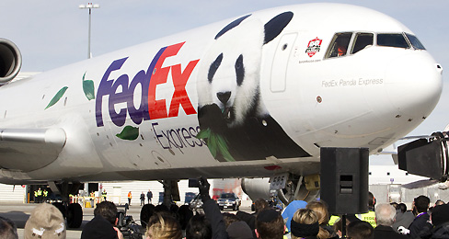
All Aboard the Panda Express
Two giant pandas are shipped to a new home in Canada
March 27, 2013
By Cameron Keady

FRED THORNHILL—REUTERS
The Panda Express airplane was designed especially for the pandas' long journey from China to Canada.
FedEx delivered some very precious cargo this week. On March 25, two giant pandas were shipped from China to Canada. The bears received a warm welcome to North America from Canada’s Prime Minister Stephen Harper and Chinese ambassador Zhang Junsai.
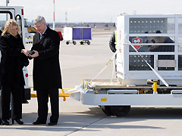
The pandas will spend 10 years in Canada—five at the Toronto Zoo, then five at the Calgary Zoo. This is the first time in 20 years that giant pandas have been loaned to a Canadian zoo, according to a FedEx press release. "I want to offer my sincere thanks to the government of China for sharing these two pandas, symbols of peace and friendship, with all Canadians," Prime Minister Harper told the Canadian Press.

FRANK GUNN—THE CANADIAN PRESS/AP
Canada's Prime Minister Stephen Harper signs for the pandas at Pearson Airport in Toronto, on March 25.
Safe Travels
The giant pandas are named Er Shun and Da Mao. Er Shun, a five-year-old female, came from Chongqing Zoo, in southwest China. Da Mao, a four-year-old male, traveled from Chengdu, which is home to China’s top panda research and breeding center.
The two bears traveled in style. FedEx designed a special airplane called the Panda Express, which features a large image of a panda on its exterior. Onboard, Er Shun and Da Mao traveled comfortably in white enclosures with holes for breathing. In the weeks leading up to their departure, the cages were placed in the pandas’ habitats in China so they could get used to them before the long journey.
The panda passengers were given plenty of snacks throughout the flight. Each panda received more than 200 pounds of bamboo and 100 pounds of apples. Yum!
A Precious Population
Specialists chose these pandas for breeding purposes, as part of an effort to help boost the bears’ population numbers. The World Wildlife Federation estimates that there are only 1,600 giant pandas left in the wild.
The panda’s decline is due in part to the loss of their primary food source, bamboo. The plant makes up 99% of the bears' diet, with some pandas eating about 40 pounds of it a day. According to a recent study published in the science journal Nature Climate Change, warming temperatures are causing a shortage of bamboo in at least one region of China where pandas live.
The climate in Er Shun and Da Mao ‘s new home in Canada is not ideal for growing bamboo. Twice a week, the Memphis Zoo, in Tennessee, will ship about 700 pounds of the green plant up north to the Toronto Zoo. While the pandas will be far from China, zookeepers plan to make Canada feel like home.

