What’s in the news?

Headlines and Expectations:
Read the headlines and leads on pages 2 and 3 and guess what the articles are about. Write down 3-5 questions about each topic. Later you will be able to check whether the article really answers your questions.

Reading
Choose one of the topics that interests you and read the whole article. Work with a partner who has chosen the same article. Make sure you understand the text very well. Highlight important information and ask your teacher if you need help with unknown expressions.

Preparing an info card
Write the most important facts and information on the A6 card provided by your teacher. Write keywords or short phrases – do not write whole sentences.

Preparing your elevator speeches:
An elevator speech is a short speech (the time you need to ride from the first floor to the top floor of a skyscraper). In this speech you pass on some important information to your audience or you try to convince your listener of your opinion.
Plan your speech well – start with a general overview of the topic, then talk about the details. Practice your speech a few times (go into the hallway and talk to yourself).


Ready for the elevator speeches:

- Line up in two parallel lines facing each other.
- Speak to the person facing you for one minute without stopping.
- Then your partner may ask you a few questions. Try to answer them as fully as possible.
- Change roles: Your partner speaks for one minute while you listen carefully. Then ask some questions.
- Move to the next partner at the sign of the bell…

Vocab work
Choose three to five useful phrases (3-5 words long) from your article and write them on vocab cards.
Then get together in groups of four. Work with classmates who have read different texts. Teach your new phrases to your friends and write their phrases on cards as well.
Then put the new cards in the middle and play Voctivity.
Your Goal: You want to know all the new phrases before the bell rings and the lesson is over.

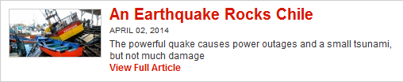











Fascinating Frogs
A biologist talks to TFK about the slimy stars of a new aquarium exhibit
April 03, 2014
By TFK Kid Reporter Phoebe Weintraub
Print
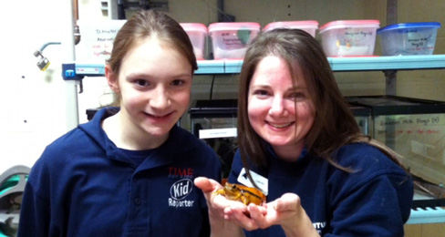
COURTESY WEINTRAUB FAMILY
TFK Kid Reporter and scientist Lauren Hauber pose with a frog at the Camden Aquarium, in New Jersey.
A new exhibit at the Adventure Aquarium in Camden, New Jersey, is putting frogs on center-stage. The show, titled “Nature’s Messenger,” features amphibians from around the world and educates visitors about threat facing frogs. Biologist Lauren Hauber, who helped plan the exhibit, talked to TFK about the important role of frogs and other amphibians in our environment.
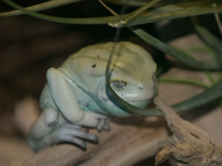
COURTESY ADVENTURE AQUARIUM
The waxy monkey frog, featured in the exhibit, is covered in a waxy substance that protects its skin.
TFK:
The exhibit has more than 20 species of frogs and other amphibians. Which one do you think is the most fascinating, and why?
LAUREN HAUBER:
The red-eye tree frog is the most popular because its eyes are so bright.
TFK:
Besides frogs, what other amphibians are part of the exhibit?
HAUBER:
Salamanders, such as the greater siren, are also featured.
TFK:
Why did you decide to host the amphibian exhibit here at the Camden Aquarium?
HAUBER:
We only have two exhibits a year, and frogs were chosen because they are an important part of our environment. Frogs are a signal to people when things become unhealthy in the environment.
TFK:
Kid Reporter

Phoebe Weintraub
Why do scientists study frogs and other amphibians?
HAUBER:
Frogs are an indicator of the health of the environment. Studies on frogs help with medical cures of certain diseases. Since frogs breathe through their skin, they are more susceptible to changes in the environment.
TFK:
In the wild, are these creatures in danger of becoming extinct?
HAUBER:
Yes, they are. There is a fungus called chytrid, which is devastating populations of amphibians around the world. Frequently, pet frogs are released into the wild and disrupt the native populations. When they come in contact with other frogs, they can cause the spread of disease.
TFK:
What can kids do to help frogs and other amphibians?
HAUBER:
Prevent pollution. Don’t throw anything into rivers. Put your trash in the proper receptacles.
TFK:
For kids who don't live near the Camden Aquarium but who want to learn more about frogs, is there a website you recommend?
HAUBER:
You can go to the Frog Watch section of the website for the Association of Zoos and Aquariums for more information. Another website is www.savethefrogs.com.

Save the Polar Bear
TIME looks at the plight of one of Earth's most charismatic creatures
February 27, 2014
By Bryan Walsh for TIME
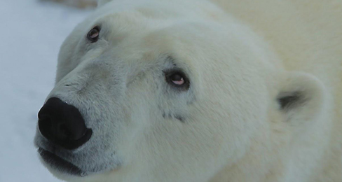
ERIC GILLESPIE—GOOGLE
A polar bear in the Churchill Wildlife Management Area in Canada looks up in this photo by a Google photographer.
It’s International Polar Bear Day today, so if you live near the Arctic Circle, hug the closest polar bear. Actually, do not do that—an adult male polar bear is nearly half a ton of hungry predator, and they are extremely dangerous. Still, the beasts deserve a little tenderness.
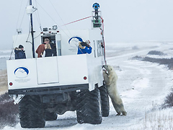
ERIC GILLESPIE—GOOGLE
A polar bear leans on a Tundra Buggy that is carrying the Google Street View Trekker.
The polar bear is now considered a vulnerable species, under threat from the loss of its sea ice habitat. To draw attention to their plight, Google is now offering glimpses of polar bears in their native environment, via its Street View program. Cameras in Cape Churchill and Wapusk National Park in northern Manitoba, Canada, captured images of polar bears doing their polar bear thing during an annual gathering in the region in October and November. You can see pictures of polar bears sparring, and a mother nursing her cub, all against the flat white and brown background of the Arctic. The footage was taken with Google’s Street View Trekker—15 cameras mounted on a backpack—from aboard the off-road vehicles known as tundra buggies.
Krista Wright is executive director of the conservation group Polar Bear International. She spoke to the CBC, a Canadian broadcaster, about Google’s program. “It provides an opportunity to document what it looks like now, the potential to document what it looks like next year, five years from now, 10 years from now,” she said.

Disappearing Sea Ice
Many scientists and conservationists fear that there may be far fewer polar bears in even the next 10 years, thanks mostly to the effects of climate change. Polar bears use sea ice as a platform to reach their prey—mainly seals—and summer sea ice is melting fast. Despite a rebound from a record low in 2012, the extent of Arctic sea ice is generally trending downwards, often dramatically. As the ice vanishes, polar bears are forced to swim longer and longer distances to reach those hunting platforms, which is taking a toll on the species.
Exactly how vulnerable polar bears are is not clear, partially due to the fact that they live in such a forbidding climate to humans and that polar bears are not exactly friendly. That makes getting a proper count challenging. But Google is helping with this as well: researchers are using Google Earth satellite images to count polar bears from space.
Still, most experts agree that there are about 20,000 to 25,000 polar bears alive, scattered around the Arctic—a perilously small number—though some subpopulations have rebounded, in part because of restrictions on hunting. There’s also evidence that polar bears are changing their dietary habits, possibly to adapt to the loss of sea ice. They are shifting from seals to snow geese, caribou, and berries. But polar bear subpopulations are still trending downward in many areas of the Arctic, and if climate change keeps vaporizing sea ice, the pressure on the bears will only increase.
Of course, that’s true of many, many species; in fact, a new study in the journal Nature Climate Change just found that global warming dramatically increases the risk of extinction for amphibians and reptiles. Yet how many other species are so popular that Coca-Cola will change the color of its cans just to draw attention to their plight, as the company did for polar bears in 2011? Last year a policy paper in Conservation Letters laid out an ambitious plan to save polar bears in the face of global warming, even going so far as to suggest feeding starving bears directly—an amazing thought, given the obvious risks. Why go to such great lengths to save the polar bear, and not, say Mexico’s critically endangered pygmy raccoon?
The truth is there’s no perfect reason. But as seen in Google Street View and those candid shots of polar bears in their element, there is something majestic about a polar bear against the backdrop of the Arctic, something wild and worth saving. And the polar bear dearly needs saving.

An Earthquake Rocks Chile
The powerful quake causes power outages and a small tsunami, but not much damage
April 02, 2014
By Kelli Plasket, with AP reporting
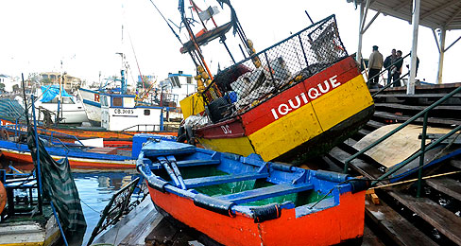
HECTOR MERIDA—REUTERS
Fishermen inspect boats that washed onto a dock after a tsunami hit the northern port city of Iquique, Chile.
A massive earthquake occurred off the coast of northern Chile on Tuesday night, setting off a small tsunami. The wave of sea water forced evacuations along the country’s entire Pacific coast. The quake was one of several to hit the region over the past two weeks.

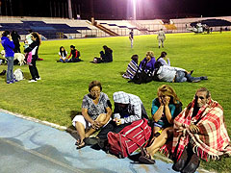
ALDO SOLIMANO—AFP/GETTY IMAGES
Residents of Iquique, Chile, take refuge at the city stadium following a tsunami alert triggered by an 8.5 magnitude earthquake on April 1.
Tuesday’s magnitude 8.2 quake struck 61 miles northwest of Iquique, Chile, a northern coastal city with a population of 200,000 people. Tremors were felt 290 miles away in La Paz, the capital of Bolivia. The shaking in La Paz was the equivalent of a 4.5 magnitude tremor, authorities there said. The earthquake also set off tsunami warnings in Hawaii, thousands of miles away.

Earthquake Effects
The quake began at 8:46 p.m. local time and set off landslides that blocked roads, knocked out power for thousands of people, damaged an airport, and started fires that destroyed several businesses. Authorities reported a total of six deaths. Chilean President Michelle Bachelet declared a state of emergency and was reviewing damage in Iquique. The country appeared to get through the incident mostly unharmed. Thousands of people moved inland as waves measuring more than six feet struck coastal cities. The mandatory evacuation order lasted nearly 10 hours. While the tsunami lifted some fishing boats onto city streets and sunk others, it otherwise caused no major damage.
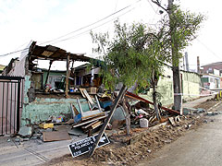
ALEX VALDES—EPA
A house in Iquique is left in ruins following the powerful quake.
Most of the mining industry in Chile—the world’s leading copper producer—is located in the northern regions. So far, none of the top mining companies in the area appears to have been affected.
In Iquique, about 300 inmates escaped from a women’s prison. Security officials were sent to the city to protect it from looting and several dozen prisoners were quickly captured. Hundreds of soldiers were also sent to the quake zone. “We have taken action to ensure public order in the case of Iquique,” Interior Minister Rodrigo Penailillo said, “so that the armed forces and police can coordinate and provide tranquility and security to the residents.”
“The country has done a good job of confronting the emergency,” Bachelet said in a message posted on Twitter. “I call on everyone to stay calm and follow the authorities’ instructions.”

Sea Treasure
Nearly 1,000 ounces of gold were recovered from a shipwreck off the coast of South Carolina
May 07, 2014
By Cameron Keady with AP reporting

ODYSSEY MARINE EXPLORATION, INC./AP
Five gold bars were recovered from the wreck of the S.S. Central America in April 2014.
Tales of sunken ships and buried treasure aren’t just written in storybooks. On Monday, May 5, Odyssey Marine Exploration, a company that explores deep-ocean shipwrecks, announced the recovery of almost 1,000 ounces of gold from a ship that sank more than 150 years ago. The S.S. Central America was caught in a hurricane in 1857 that claimed 425 lives and thousands of pounds of gold. Expeditions to retrieve the lost treasure in the late 1980s and early 1990s recovered about $50 million worth of gold. Now Odyssey is hoping to find even more gold buried in the wreckage.
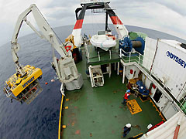
ODYSSEY MARINE EXPLORATION, INC./AP
This photo from 2003 shows the Odyssey Exploration launching a remote operated vehicle into the ocean to recover items from the sunken ship.

Lost at Sea
The S.S. Central America was a 280-foot wooden-hulled steamship launched in 1853, during the California Gold Rush era. While traveling from California to New York, with nearly 600 passengers and an estimated $400 million of gold bars and coins, the ship sailed into the path of a terrible hurricane. The Central America did not survive the storm, and sank 160 miles off the coast of South Carolina on September 12, 1857.
In addition to hundreds of crates of gold bars, the ship was carrying a large batch of newly-minted American $20 Double Eagle coins. Some of the travelers, fresh from their search for California’s natural treasure, were carrying golden nuggets and coins in their luggage. The impact of the wreckage was so severe, it contributed in part to the Panic of 1857, a time of great financial worry in United States caused by an economic decline.
Gold Marks the Spot
The Civil War followed shortly after the sinking of the Central America, and the lost treasure was soon forgotten by many. But, in 1980, an Ohio native named Tommy Thompson led a search for the ghost ship and its precious cargo. Thompson and his team, the Columbus-America Discovery Group, began conducting research to learn about the possible whereabouts of the lost steamship. They used sonar technologies that allowed them to scan the bottom of the ocean for debris and large objects. In 1988, the team struck gold. They found the long-lost Central America and began recovering its precious contents.
Legal disputes shut down Thompson’s operation, and it wasn’t until last month that Odyssey set out to retrieve the remainder of the ship’s treasure. The new team, aboard a craft called the Odyssey Explorer, will remain at the site of the wreckage until later this summer. “While we weren’t planning to recover gold so quickly, it did confirm that the site has not been disturbed since it was last visited 1991 and there is gold remaining,” said Mark Gordon, Odyssey’s president and chief operating officer.
The newly-recovered gold includes five gold bars and two of the $20 Double Eagle gold coins. The gold bars weigh between 106 and 344 ounces. Though it is unclear how much more of the sunken fortune will be retrieved, this week’s recovery marks a monumental moment in maritime history. Whatever else lies on the ocean floor amongst the wreckage of the Central America may soon be uncovered. Like any tale of lost treasure, there may be an unexpected ending.

Science

Talking Plants
A new study finds that plants communicate with one another to warn of danger
May 05, 2014
By Veronique Greenwood for TIME

GETTY IMAGES
Tomato plants talk to their neighbors to warn of diseases or infestations.
We tend to think of plants as the furniture of the natural world. They don’t move, they don’t make sounds, they don’t seem to respond to anything—at least not very quickly. Grass doesn’t cry when you cut it, flowers don’t scream when they’re picked. But as is often the case, our human view of the world misses quite a lot. Plants talk to each other all the time. And the language is chemical.
Over the years, scientists have reported that different types of plants, from trees to tomatoes, release compounds into the air to help neighboring plants. These chemical warnings all have the same purpose—to spread information about one plant’s disease or infestation so other plants can defend themselves. But exactly how plants receive and act on many of these signals is still mysterious.
In this week’s Proceedings of the National Academy of Sciences, researchers in Japan offer some explanations. They have identified one chemical message and traced it all the way from release to action.
The scientists looked at tomato plants infested by a common pest, the cutworm caterpillar. To start out, they grew plants in two plastic compartments connected by a tube. One plant was infested and placed upwind and the other was uninfested and placed downwind. The downwind plants were later exposed to the cutworm caterpillar. The results showed that plants that had previously been near sick neighbors were able to defend themselves better against the caterpillar.
Friendly Warnings
The researchers also studied leaves from exposed and unexposed plants. They found one compound showed up more often in the exposed plants. The substance is called HexVic. When the scientists fed HexVic to cutworms, it knocked down their survival rate by 17%. The scientists identified the source of HexVic, and sprayed it lightly over healthy plants. Those plants were then able to start producing the caterpillar-killing HexVic. Researchers confirmed that uninfested plants have to build their own weapon to fight off bugs and diseases. How do they know when to play defense? They are warned first by their friendly plant neighbors.
It is a complex tale, and it may be happening in more plant species than tomatoes. It may also be happening with more chemical signals that are still unknown to us. For now though, we know that plants not only communicate, they look out for one another.

Take A Hike, Litterbugs!
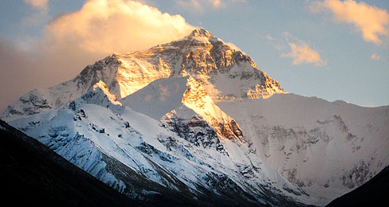
Climbers at Mount Everest are being asked to clean up after themselves
April 03, 2014
By Stephanie Kraus
Print

DAVID CIEMNY—GETTY IMAGES
Mount Everest has earned the nickname the World’s Highest Garbage Dump.
Climbing Mount Everest, the world’s highest mountain, just became more challenging. The government of Nepal is telling climbers they cannot leave trash on the trails. Each trekker will have to come down the mountain with at least 18 pounds of garbage. That’s the average amount of trash a climber leaves behind on Everest.
Officials say climbers are responsible for their own trash. “We are not asking climbers to pick up trash left by someone else,” said Maddhu Sudan Burlakoti, who works for the Nepal Tourism Ministry. “We just want them to bring back what they took up.”
More than 4,000 people have reached the 29,035-foot summit in the past 60 years. Leaving trash along the way helps trekkers keep their bags light so they have energy to reach the summit. “The trash problem in Mount Everest is not new,” Burlakoti says. “When the people started to climb the mountain, they started to leave their garbage there.” They have left behind cans, tents, food wrappers, and equipment. Last year, climbers carried down a total of four tons of trash.
World’s Highest Garbage Dump
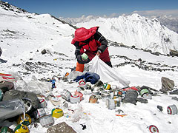
NAMGYAL SHERPA—AFP/GETTY IMAGES
A Nepalese volunteer collects trash left by climbers on Everest.
The new rule came into effect in April of 2014. To make sure it is followed, climbers will have to deposit money before the climb. Once they climb back down the mountain, officials will check trekkers at a return camp to make sure they have the required 18 pounds of trash. If they do, their money will be returned to them. If they do not, climbers will not receive their deposit and they will not be given a permit the next time they want to climb Everest.
The goal is to make sure no more litter will be left on Everest, which has earned the nickname the World’s Highest Garbage Dump. “As we offer Mount Everest to all the people of the world they should take responsibility to clean it,” Burlakoti says. “After seeing the results from this, we will extend this rule to other mountains also.”

