Chase Through Venice

by Emily & Jojo

Description:

Name: Chiara & Francesco DeGasperi

Age: 16 & 19

Setting: Venice

Hobbies, Interests: riding, swimming & biking, piano

Family: come from poor family, adopted, not loved

1
You give Francesco a sign. You let him know that you are about to grab the mask. You are in a famous museum and want to steal the old, phonetician mask. It was used for covering faces of dead people. “Now!” You think, and grab the mask. At the same time the alarm system starts blaring. Quickly you put the expensive mask under your jacket. You and Francesco use the secret stairs. You move the cushions to reveal the trap door and open the door. You run through and try to close the door quietly. Today is not your lucky day and the cover closes with a loud, high squeak. You realize that you now have to run. The secret tunnel ends at St. Mark´s square. You hear the police men´s steps coming closer and closer. Do you want to get through the sewage cover or do you want to go through a little crack in the wall?

If you want to hide in a crack, turn to page 4

If you want to climb up to St. Mark´s square, turn to page 6

2
You are a genius thief. After a while the two police men return. They started saying bad words. They were 100% sure that the thieves were in here, but after such a long time they can only have left. Angrily they climb out the tunnel. “Give me five, Chiara!” shouted Francesco. You are really happy, but how do you transport the treasure without getting caught? You finally decide to transport piece by piece secretly to the safe place under the bridge. On the black market you sell the mask and the treasure. Now you and your brother are rich. You return to your real family and tell them you are here to make a happy live possible.

HAPPY END!!!!!!!!!!!

3

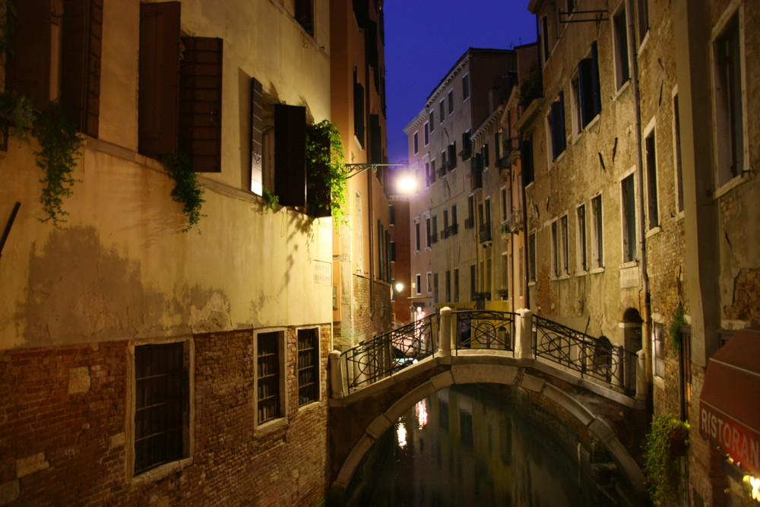
This is the bridge where you hide the treasure.

4

Puh! At the last moment you saw the crack in the wall. You both flee in the crack. You should not have eaten so much before you started you adventure! The crack is very small but with the help of Francesco you get through it. Carefully you spy through the crack, the police men are looking around. It seems like they know that someone was in there. The crack is hidden behind a little rock. Carefully you switch on your flash light. You can´t believe what your eyes see. You are in a little grotto, small like a garage. In the middle of it is a brown chest. It is decorated with leaf gold. Around it there are turquoise puddles, it seems like the water comes from a mountain. Tautly you try to lift the lid of the chest. And really, Francesco and you can open the chest. In it are golden coins, jewelery and many more things that twinkle proudly in the light of your flash light. Quietly you look again through the crack. You can´t see the police men. Are they really not here or do they want you to fall for their trap?

If you stay in the grotto and wait to be sure that there is no one waiting for you, turn to page 2

If you think you are alone and want to steal the treasure you found, turn to page 7

5

You decided to stay in the confession box. You hope that the monster doesn´t come to you. You are very scared and because of all the excitement you let your flashlight fall down. Suddenly the monster lets out a horrible scream. The steps sound angry. Then the monster pulls away the curtain. You close your eyes and scream as loud as you can. Then something weird happens. The voice of a boy says: “Do not be afraid. I´m only a poor guy. I get money for scaring tourist. I had to practice because tomorrow are coming many people to visit the church. But I couldn´t know that you are in there!” You open your eyes and see a boy. He is about 15 years old and has dark brown eyes. He wears big shoes to make loud steps. It was love at the first sight. When you get older you have to children. Francesco is the best man at your wedding with the “church monster” Paul.

HAPPY END!

6

As fast as you can you open the sewage cover. You help Francesco to get out and quietly you put the sewage cover back to its original place. You hardly see the shapes of the houses. If you are right, the church is in front of you. You don´t think long and start to run with your brother to the church. You hope that god will help you. Slowly you open the door. You look around and a creepy feeling overcomes you. With every step you get more and more scared. You decide to hide in the confession box (Beichtstuhl). You close the curtains so no one can see you. Suddenly you hear the church door open. Steps are coming closer and closer. Everytime thins unknown creature takes a step, a metal thing clacks on the marble floor. Now, do you want to go out of your hiding and fight with the creature, or not?

If you stay in the confession box, turn to page 5

If you go out and speak/fight with it, turn to page 8

7

You and your brother think that the police men are gone. Each of you fill the bags of your jackets with golden coins and rings... The mask you put in the box so the police can´t find it easily. Carefully you climb up the metal ladder. You tell Francesco to follow you. After two more steps you notice that the ladder can´t hold you both. First the anchor (Verankerung) comes out and then the whole ladder. You both fall down. When you try to stand up, your leg hurts so much that you have to sit down again. After a long talk with your brother you decide to go back to the museum. The police come and you tell them in your sweetest voice: “Look, we have brought back the stolen mask and shown you a new treasure.” The police agreed and so you don´t have to go to prison.
You have no treasure and mask, a broken leg, but you are not in prison.

The End

8

Nervously you put your hand in your pocket to get out your knife to fight against it. OH NO!!!! You forgot the knife at breakfast. Such a stupid thing. Scared you pull back the curtain and prepare to fight the creature with your bare hands. You switch on your flashlight and can´t believe what your eyes see. In front of you there stand a man with a false leg made out of metal. He looks like a pirate. Before he takes his sword, you try to control the situation with words. But after you spoke only a few words he takes the sword and in the next moment it is stucks in your chest. On the next morning the priest who wanted to open the church finds your dead body and two days later a big funeral happened.

The End

