Here are the answers to the British Food Quiz:
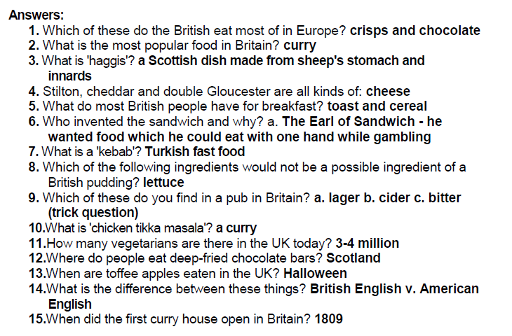

www.teachingenglish.org.uk
© BBC | British Council 2010

