This is a great activity.
Just a little technical tip. In order to produce several sets of these cards it is REALLY helpful to create a table on the page and make sure all your cards are the same size. The pictures do not necessarily have to be exactly the same size—but the cards should be. Otherwise it is a lot of time to cut them by hand and the game doesn’t look so professional. That’s a 5 min job .

Dog Meat
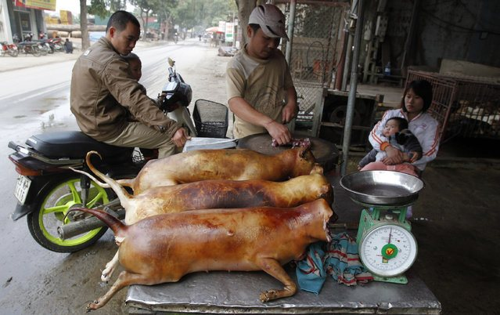

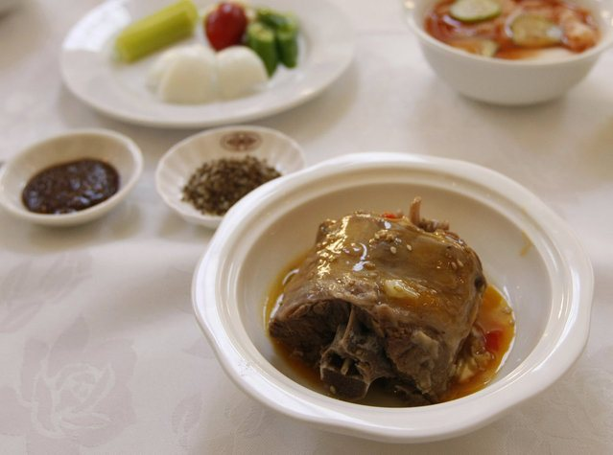
Dog meat is a popular traditional food in Vietnam. At first people started eating dog meat because it was cheap.

Roasted Rats
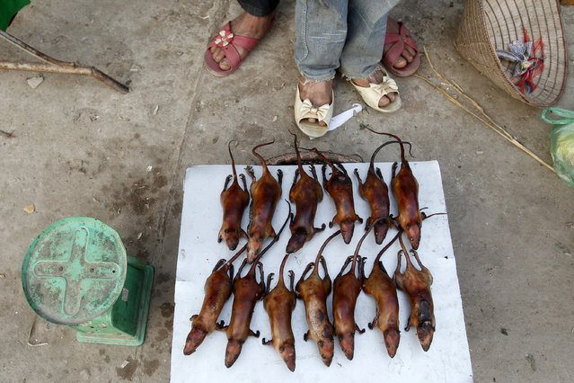
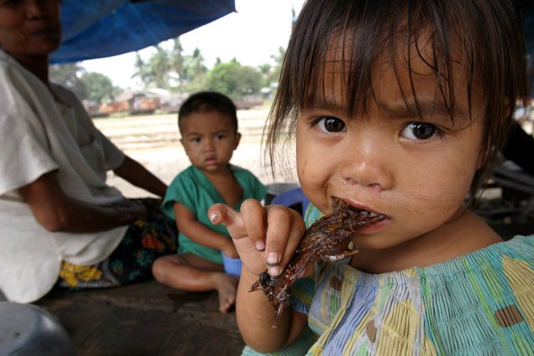
Meat-eaters in Vietnam had to eat rats instead of chicken because of the deadly bird flu virus that spread across Asia.

Snake Meat
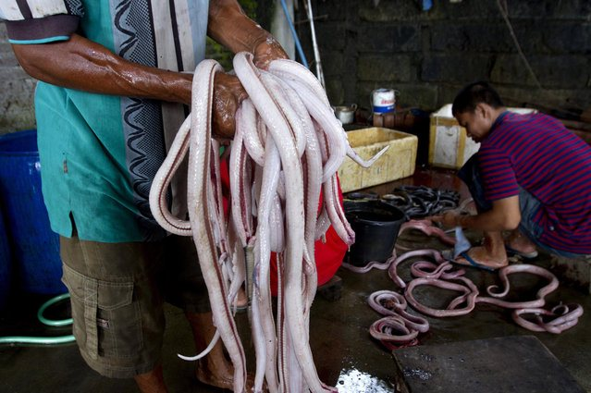
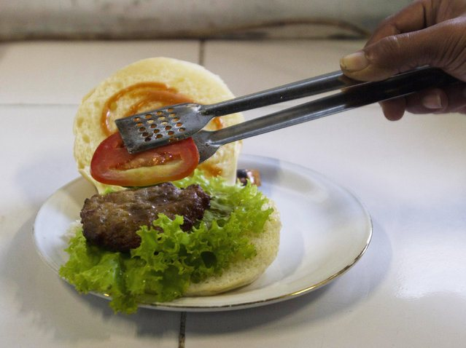
Cobra burgers are eaten in China. Some people believe cobra meat can cure (heilen) skin diseases and asthma.

Grasshoppers and Crickets
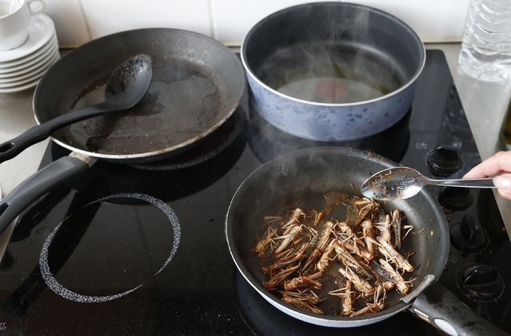
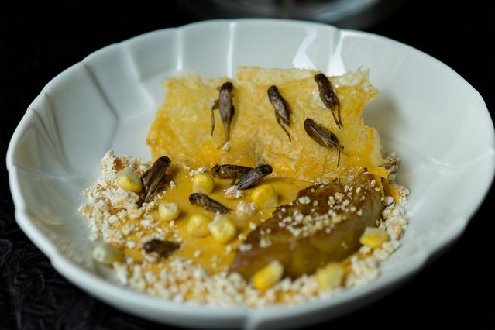
These exotic insects are served as a delicacy in exquisite French restaurants but in many African and Asian countries they are part of the people’s daily meals.

Lizard
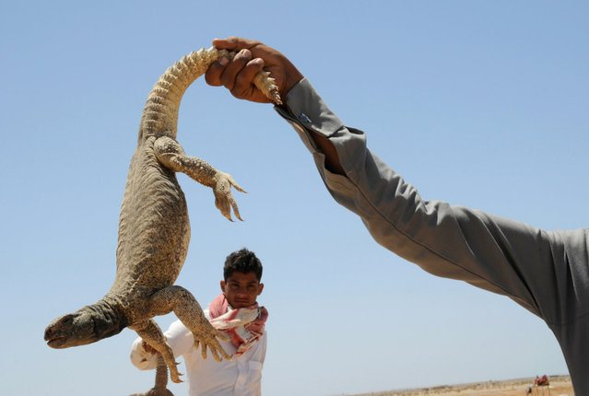
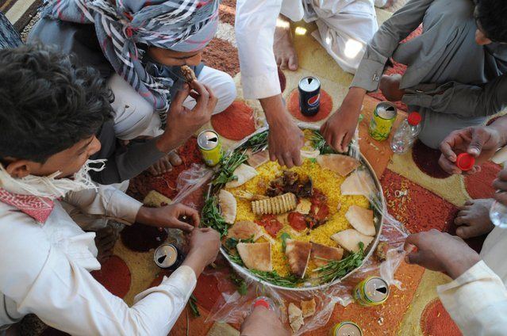
Lizards are a delicacy in the Middle East. According to popular belief, their blood is used to strengthen the body and treat diseases.

Worms
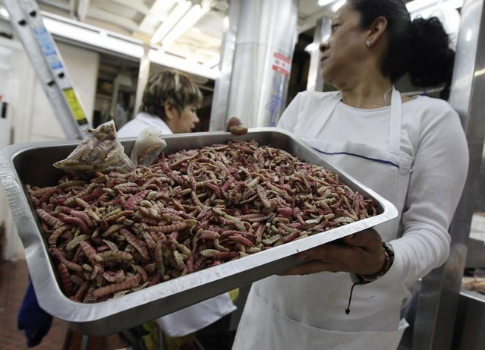
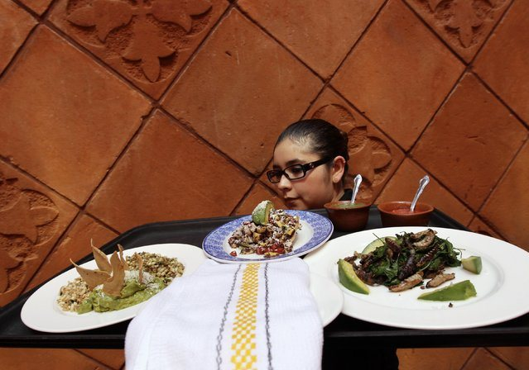
Worms are healthy and a great source of proteins. Eating worms could be a solution to the hunger crises in poor countries.

Soil (Erde)
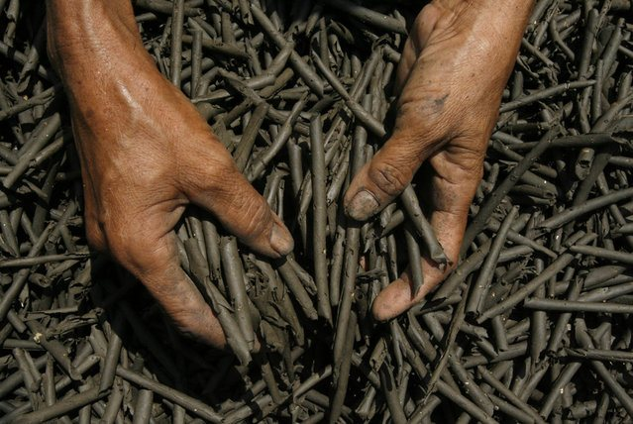
“Ampo“ is a traditional Indonesian snack made from clean dark earth. People believe it is an effective pain-killer and a healthy snack for pregnant women.
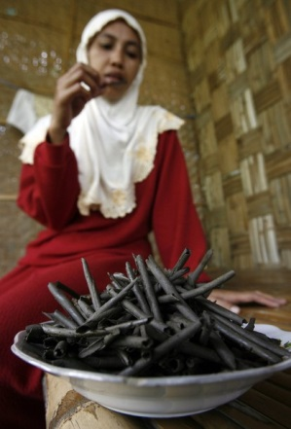

Fried Spiders
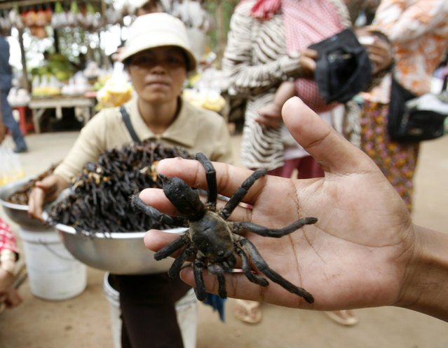
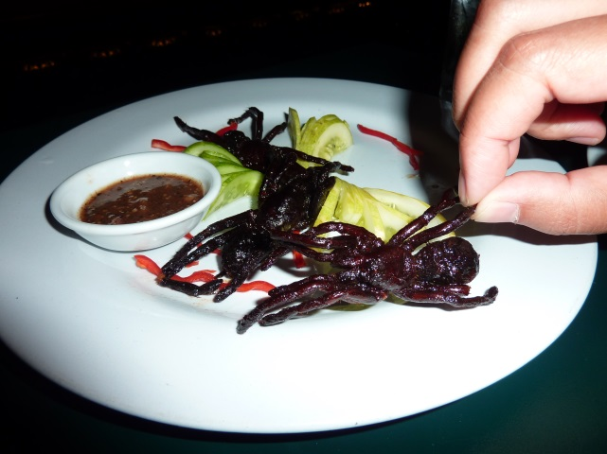
Deep-fried spiders are a traditional meal in Cambodia. They are crunchy on the outside and gooey (breiig) on the inside.

