7 Info sheets about Halloween
Copy 3-4 of each sheet (depending on class size)
Hand out randomly. Ss get together in groups (same text) and prepare a poster presentation about their topic (20 min)
Groups present their topics – class takes notes in the overview grid.

WHAT I WANT TO REMEMBER ABOUT HALLOWEEN
History
What are the origins?
When is it celebrated?

Costumes
Typical costumes?
Origins of costumes?
Trick or Treat
What is it?
Origins?
Typical pranks?
Jack O' Lantern
What is it?
What's the legend behind it?
Parties
Where can you celebrate?
Which kinds of parties are there?
Games
Which games and forms of divination are there?
Food
Give examples of disgusting and traditional food!

Halloween: History
Halloween is a holiday celebrated on the night of October 31st. The word Halloween is a shortening of All Hallows' Evening also known as Hallowe'en or All Hallows' Eve. All Hallows’ Eve is celebrated on the evening before All Hallows’ Day, which is also called All Saints Day. This is a Christian holiday honoring saints and has been celebrated on November 1st since the early Middle Ages!
Halloween has its origins in the ancient Celtic festival known as Samhain (pronounced "sah-win"). The festival of Samhain is a celebration of the end of the harvest season in Gaelic culture. Samhain was a time used to take stock of supplies and prepare for winter.
The ancient Gaels believed that on October 31, the boundaries between the worlds of the living and the dead overlapped and the deceased would come back to life and cause havoc such as sickness or damaged crops. They wore masks and costumes so that the ghosts and spirits did not recognize them as humans. Masks and costumes were also worn to appease the ghosts and spirits.

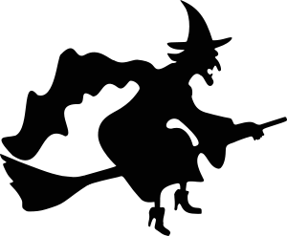
Halloween: Costumes
Part of the history of Halloween is Halloween costumes. When the Celts celebrated Samhain (this was their New Year’s Day) they believed that spirits could walk the earth. They also thought that demons, fairies and other creatures walked around during this night. The people were afraid of all these spirits, so they made huge bonfires, sacrificed animals and they often wore costumes to disguise themselves.
For their costumes they used animal skins and masks. They also blackened their faces to resemble their dead ancestors. There was even the chance for men and women to change roles for one night to break down social rules and divisions.
Typical Halloween costumes are skeletons, witches, ghosts, vampires, pirates, zombies, scarecrows and bats, because they are all associated with death and afterlife. However, people also like to disguise as famous people, like politicians, film stars, singers, sportsmen or movie characters like Batman or Spiderman. Children often dress up as princesses or knights, too.

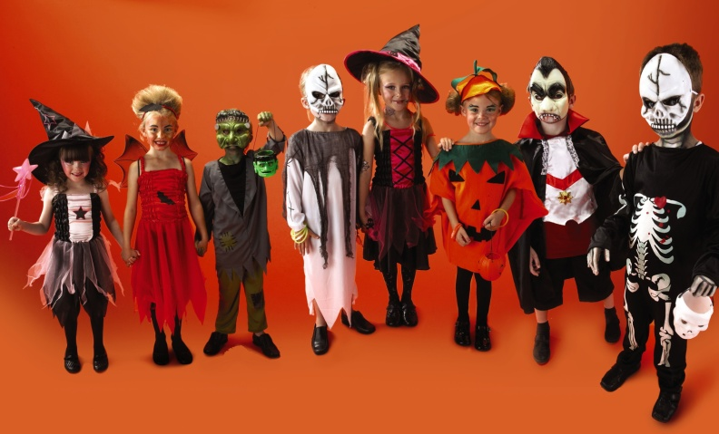
Halloween: Trick or Treat
Trick-or-treating, is an activity for children on or around Halloween in which they proceed from house to house in costumes, asking for treats such as confectionery or candies with the question, "Trick or treat?" The "trick" part of "trick or treat" is a threat to play a trick on the homeowner or his property if no treat is given. Trick-or-treating is one of the main traditions of Halloween.
Trick-or-treating might have come from the Celts, too: During Samhain young men in costumes went from door to door and asked for treats, so this could be the origin of trick-or-treating. Today, trick-or-treating is a Halloween-tradition and all people look forward to it.
However, people who refuse to give anything will sometimes find chalk drawings on their doors the next morning or find they are the victims of other pranks, like that their yard or house is covered in toilet paper or that eggs were thrown on their doors.

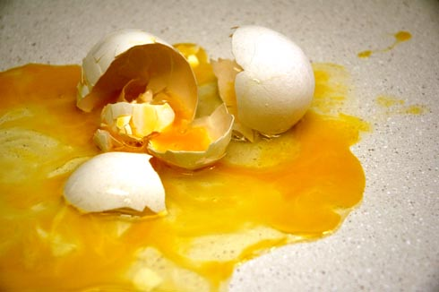

Halloween: Jack O’ Lantern
Every October, carved pumpkins peer out from porches and doorsteps in the United States and other parts of the world. These pumpkins with their carved faces which are illuminated by candles are a sure sign for Halloween. The Name Jack O’ Lantern comes from an Irish folktale about a man called Stingy Jack.
The legend of Stingy Jack is that Jack invited the Devil to have a drink with him, but didn't want to pay for his drink. So he convinced the Devil to turn himself into a coin that Jack could use to buy their drinks. Once the Devil did so, Jack kept the money and put it next to a silver cross, which prevented the Devil from changing back into his original form. Jack eventually freed the Devil, under the condition that he would not bother Jack and that, should Jack die, he would not claim his soul. Soon after, Jack died. As the legend goes, God would not allow such an unsavory figure into heaven. The Devil would not allow Jack into hell. He sent Jack off into the dark night with only a burning coal to light his way. Jack put the coal into a carved-out turnip and has been roaming the Earth with ever since.
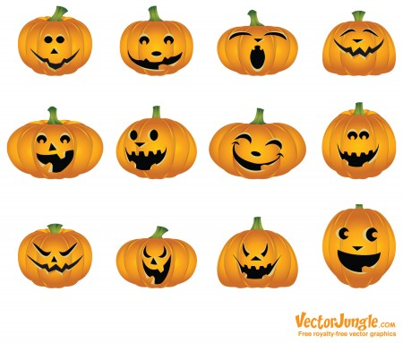
Halloween: Parties
Today school dances and neighbourhood parties called "block parties" are popular among young and old alike. More and more adults celebrate Halloween. They dress up as historical or political figures and go to masquerade parties. In larger cities, costumed children and their parents gather at shopping malls early in the evening. Stores and businesses give parties with games and treats for the children. Teenagers enjoy costume dances at their schools and the more outrageous the costume the better!
Also many families organize Halloween parties in their homes and invite their friends, relatives and neighbours. Usually they decorate their houses for these parties, so that they look spooky and mysterious. They use coffins, witches' caldrons, skeletons, skulls, ghosts and gravestones to decorate their houses for their parties and also offer various kinds of food and games to make it an unforgettable evening.
The telling of ghost stories and viewing of horror films are common fixtures of Halloween parties. Episodes of television series and Halloween-themed specials are commonly aired on or before Halloween, too.
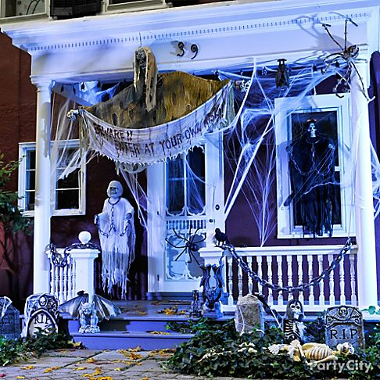
Halloween: Games
There are several games traditionally associated with Halloween parties. One common game is apple bobbing, in which apples float in a tub or a large basin of water and the participants must use their teeth to remove an apple from the basin. A variant of dunking involves kneeling on a chair, holding a fork between the teeth and trying to drop the fork into an apple.
Another common game involves hanging up treacle or syrup-coated scones by strings; these must be eaten without using hands while they remain attached to the string, an activity that inevitably leads to a very sticky face.
Some games traditionally played at Halloween are forms of divination. A traditional form of divining one's future spouse is to carve an apple in one long strip, then toss the peel over one's shoulder. The peel is believed to land in the shape of the first letter of the future spouse's name. Unmarried women were told that if they sat in a darkened room and gazed into a mirror on Halloween night, the face of their future husband would appear in the mirror.
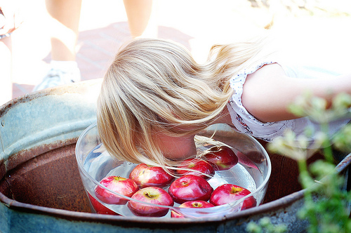

Halloween: Food
Naturally, food plays an important role at Halloween parties, because Halloween is all about candy! However, the food must be spooky and a little bit disgusting as well. So you might stumble across forked eyeballs (small round cakes with an icing that looks like an eyeball served on a fork), edible eyeballs, squashed guts (squash and tomato sauce), brain cupcakes (cupcakes with a coating that looks like a brain), cheese-fingers (cheese carved like a finger) or gingerbread skeletons (gingerbread figures with a sugar icing that looks like a skeleton).
One very traditional Halloween dish is the candy apple, which is a whole apple covered in sugar candy coating. This sweet apple is also used for some Halloween games, e.g. it is hung up and you must eat it without using your hands.
Another very traditional sweet is candy corn. It is triangle-shaped and yellow, orange and white. It is a type of candy made from corn syrup and sugar and it tastes like marshmallows.
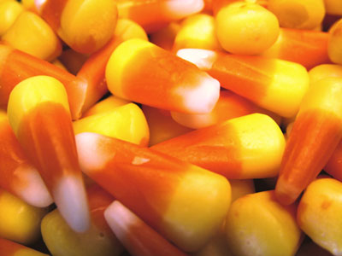 | 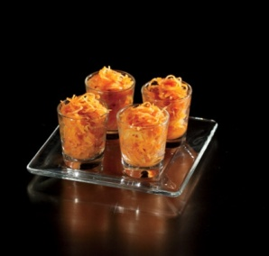 | 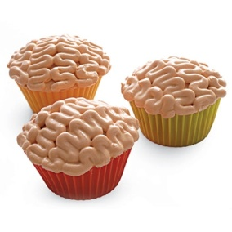 | 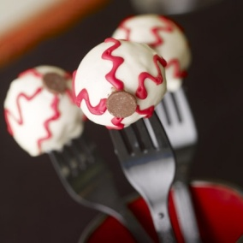
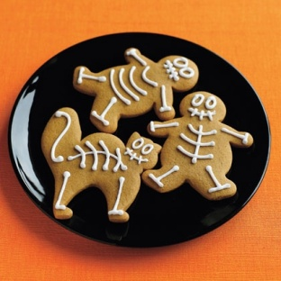 | 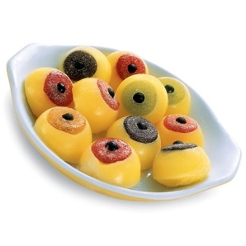 | 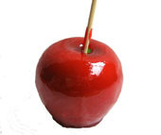 | 