Crazy and Awesome Inventions

The Pop-o-Matic: How does it work?
Describe what the machine does when Gromit hits the ball.

Language Tips

Describing a process:
First, get a tea cup.
Second, put a tea bag into the cup.
Then fill a kettle with water.
Next, place the kettle on the stove and turn on the burner.
After the water has boiled pour it into the tea cup.
Finally, enjoy your tea

How is it made?
It is measured…
It is added to…
It is weighed…
It is examined…
It is boiled…
It is packaged…
It is put in …
It is shipped to…

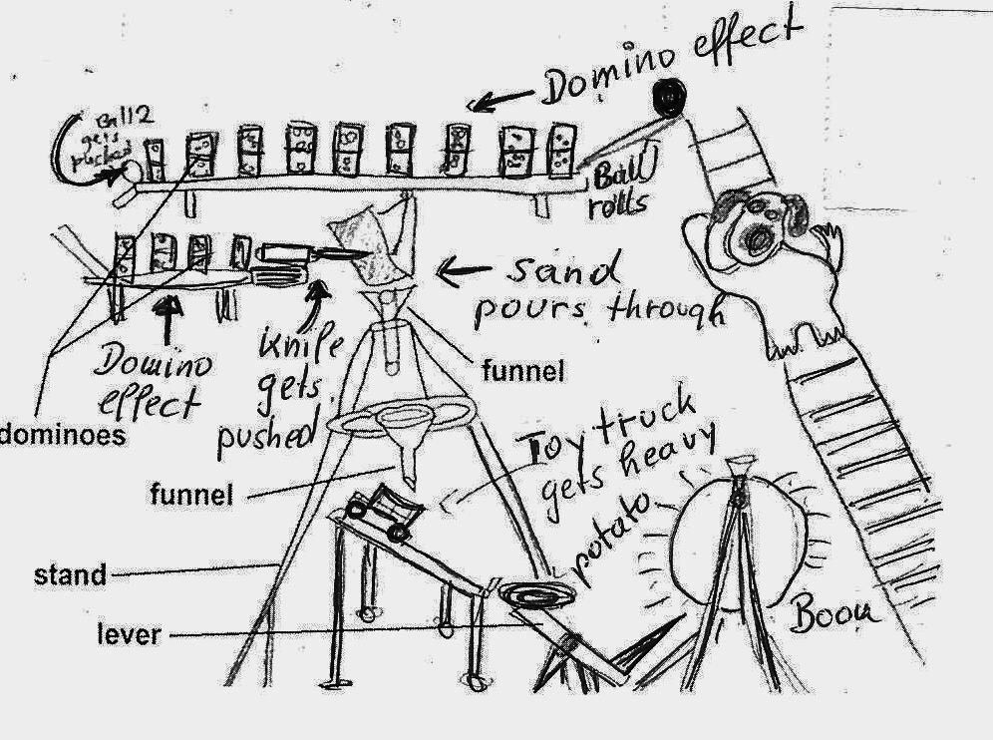

Watch the presentation of the Milk-Pouring-Machine and take notes. What do you need to build this machine?


How does it work? How many of the 34 steps can you remember?


Do you think it will work?
Let’s see….

Describing a process…

Example: How is Heinz ketchup made? Watch the video and take notes (keywords) on a separate sheet of paper.

What do you notice about the verb forms? Work with a partner and formulate a rule: What forms are used? When and why do we use them?

Now write down the main steps how ketchup is made. Write full sentences and use the passive voice.

Homework:
Watch another one of the “How is it made?” videos on you-tube and write down the main steps in the passive voice.

