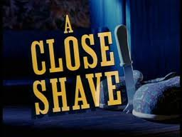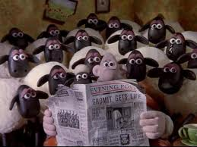
Vocabulary - Match the words to their definitions
to be peckish | to be shy or embarrassed
to be in debt | someone who rounds up sheep or cattle
a wrangler | a sheep which has been sheared
to get the kettle on | very good
to be sheepish | to be hungry
jolly good | to boil water for a cup of tea
rustling | to owe money
a shawn sheep | the act of rounding up sheep or cattle

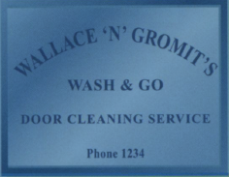
PART 1: Pay close attention to the first part, and see if you can spot the five mistakes on the sign.
- __________________________________
- __________________________________
- __________________________________
- __________________________________
- __________________________________
PART 2: Explain to your partner what is happening while the scene is playing. The person who is listening should not be watching the video.

PART 3: What has the mystery guest eaten? ____________________________________________
__________________________________________________________________________________
__________________________________________________________________________________

PART 4: Explain to your partner what is happening while the scene is playing. The person who is listening should not be watching the video.
PART 5: Who says what? Write WAL for Wallace or WEN for Wendolene.
- Thank you for coming so quickly.
- Allow me.
- I’ll soon have these cleared up.
- How embarrasing!
- All right pooch?
- What was it you wanted?
PART 6: Where do you think Preston is going? With your partner come up with a short dialogue between Preston and whomever you think he has gone to meet.
PART 7: Listen to the conversation between Wallace and Wendolene. Can you answer the questions below?
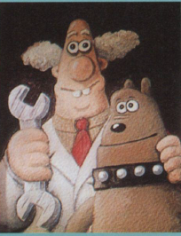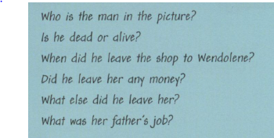

PART 8: Wallace says “we will have to get you cleaned up.” Who or what will he have to clean and how will he clean him or it?

PART 9: Wallace goes back to Wendolene’s shop.
Their conversation begins with: “Tell me about windows.”
It ends with: “The same time next week.”
What do they say in between?

