PART 10: Order the following pictures into the correct sequence.
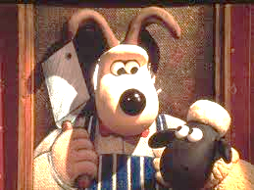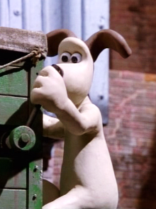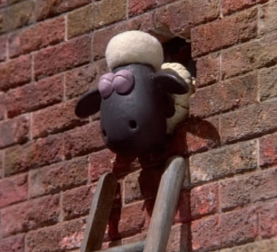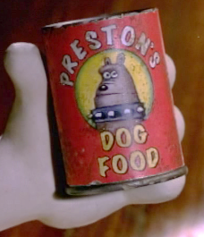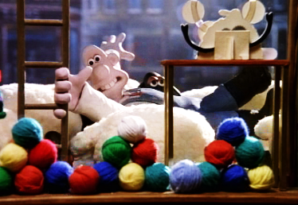

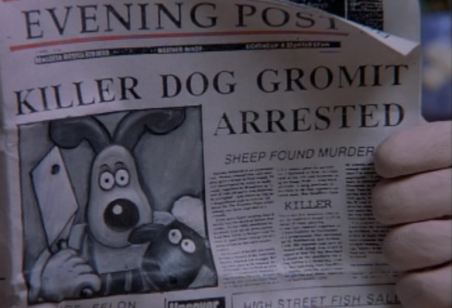
PART 11: Before watching the next part predict if the statements below are true (T) or false (F).
- The police have arrested Gromit.
- Gromit murdered a sheep.
- Wallace believes that Gromit is guilty.
- The sheep are living at Wallace’s house.
- Wendolene confesses to Wallace.
- Wendolene asks Wallace to clean her windows again.
- Wallace gets three newspapers a day.
- Gromit is found not guilty
- Gromit enjoys doing the puzzle.
- Friday the 17th is an important date for Gromit.

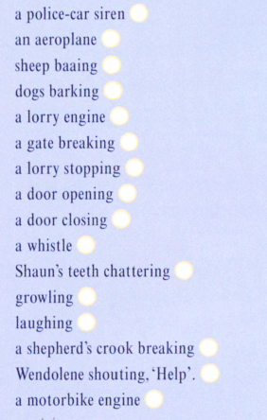
PART 12: While you watch tick off all PART 13: Order the sentences below from 1-9. of the noises you hear.
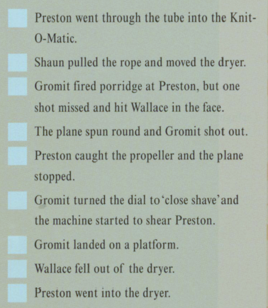
PART 14: What is going to happen… to Preston, Wallace, Gromit, Shaun, and Wendolene?
