Spooky Stories

10 things you’ve always wanted to know about ghosts

First write down your own opinion in the first column.
After reading your info-card, enter your new facts in the column on the right.
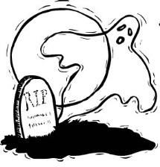
Then walk around in class and share your info with your classmates.

REMEMBER: ENGLISH ONLY or else…………………………………………………………

What is a ghost?
Your opinion: | What you have found out:
What is the first ever recorded sighting of a ghost?
Why doesn’t everyone have a ghost?
What is a medium?
What is a séance?
What is a ouija board?
What is Ectoplasm?
What is an ‘out of the body experience’?
How long do ghosts live?
Are ghosts dangerous?

STORY: The Turn of the Screw

The story is about a woman who goes to teach and look after two orphan children at a county estate in Essex. She hasn’t been there long when two ghostly presences arrive and give her all sorts of terrible frights and problems, especially as they seem to be after the children! She doesn’t know what to do and so she calls a late night radio ‘chat-in’ and talks to Al Mighty.

- Together with your partner, read out your part of the story! Each of you takes one of the roles. Write down what is happening to Mrs. T!
- Then try to find out the missing information from the others. Find out as much as you can and write it down under the right date!

18th May

12th June

16th June

10th August

15th October

16th November

Now you should know the whole horrible story but there are still some unsolved mysteries left! Get together in groups (3-4 people) and think about the following questions:

- Why did Peter Quint and Miss Jessel haunt Flora and Miles? What did they want from them?

- What happened to Flora after she was taken away?

- What would you have done to save Miles?

- Why didn’t their uncle help them?

- What did Mrs. T do after November 16th?
How to avoid ghosts

Unfortunately Mrs. T didn’t know how to get rid of ghosts! If she had known, things might have turned out differently. That’s why you should find out how to do it. Just in case!

Read your slip of paper carefully and take notes. Then walk around the room and collect as many anti-ghost tips as you can! Write them down so that you can look at them when you meet a ghost (important things to remember might be: What item do you need? How should you use it?)
Name of the tip | What do you need? How do you do it?

Language Practice:
Now choose 5 of these tips and write sentences using the following structures:
Write your sentences on a worksheet.
Example: Ghosts can be scared by wearing an amulet.

Ghosts can be scared by …(doing something)
Ghosts can be avoided by…
Ghosts can be tricked by…
Ghosts can be chased away by…
Story: The Screaming Skull
Read the following sentences taken from the story and discuss what the story might be about.

In spite of the blazing fire I felt a chill creep over my whole body.

I began to wish that I was as far away from those awful sounds as possible.

He says we should bury it once and for all and be done with it.

It was an ear-splitting scream.

When I first found the thing it had no lower jaw.

I feel very guilty about her death.

I’d been telling Luke about some Irish woman killing her husbands by drugging them then pouring boiling lead in their ears.

Mrs. Pratt had died in her sleep.

He took the lid off, the box was empty.

That poor little woman, and it was all my fault, you know.

“It’s out there! It’s out there!” Cried the Captain, gripping my arm so hard it hurt, his face the colour of ash.

“Grab it!” he bellowed, rushing towards me with the hatbox. “Grab it, man! Now!”

Dr. Luke Pratt was found dead on the beach by one of the local fishermen.

The air was filled with a series of blood-curdling screams.

His death certificate said that he had been bitten by some person or animal unknown.

Reading and collecting vocabulary:
While reading use three colors to highlight phrases that refer to the following topics.
WEATHER
FEAR AND FRIGHT (how the characters feel)
NOISES AND SOUNDS
At home, write your phrases into your language practice book. Start a new page for each topic. Remember: Always write full sentences.

The Ending…
There is one last page of the story which you have not yet seen. It is the newspaper article that the writer has mentioned in the last paragraph.
What did he read in the paper?
Collect ideas with your friends, then write the newspaper article at home.
Remember: Every good newspaper article must answer these questions:
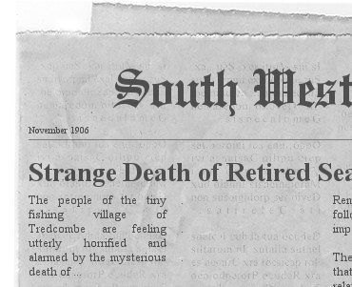
Who:
What:
Where:
When:
How:
On examination of his body it was discovered that…
It is not known how…
A surgeon who examined the wounds is of the opinion that…

Why:
Use these expressions in your article:

Upload your article on Moodle. After you have received my feedback and corrected your text, you can print it out like the example above. You will find the instructions on Moodle.
Show me your final printout of the article in exchange for the real ending of the story.

