The Middle Ages
Year 3, September - October
Classwork | Materials | Skills
Research: Life in the Middle Ages  Read the info-cards and find out about life in the Middle Ages. Collect interesting facts in your folder.  Make sure you collect information about the following topics:  - Interesting Characters: The Wife of Bath, Robin Hood…  - Food  - Health and hygiene  - Life in Medieval towns  - Life in the castle (boys and girls)  - Other interesting facts  You will see that some info-cards contain facts about more than one category. Keep separate fact-sheets in your binder to collect your information.  Then show your understanding of the info-texts in your book  “Life in the Middle Ages”.  You can do this in many ways: Here are some ideas to get you started:  Diary pages of medieval characters, Time-traveler’s diary, , letters, postcards, recipes, acrostics and other poems, alphabet, drawings, diagrams, lists, posters, announcements, songs, board games, home cures that really work, pages from a medieval book of home cures, and many more…  Choose a variety of different text-types and ideas to show your understanding of the information you have collected.  Your booklet has 12 pages + a table of contents. Put the 6 writing tasks of this workshop that have been marked with a book symbol 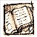into your booklet. You are free to choose topics and ideas for the other 6 pages.  Always write a first draft of your text on paper or on Moodle and ask your teacher/co-teacher for feedback. Then revise the text carefully and copy/paste it into your book. Decorate the pages nicely and write a table of contents on the fist page (yellow inside cover).  Make sure your pages are really interesting and show your good understanding of the facts.  You want to be proud of your work! | Info cards  Blank booklets  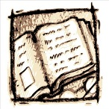  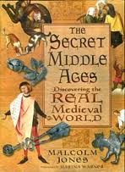  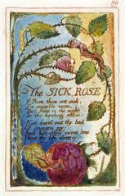
The Wife of Bath: by Geoffrey Chaucer  Can you read this old text in strange English? What does it tell us about the Wife of Bath?  Design a first page for your booklet. Show what you have found out about her. |  | 
Medieval Home Cures: Work with a partner and find out about medieval remedies for common health problems. | Pairwork  A and B
Home Remedy  Write a recipe for a home remedy, either a real one or one you have created yourself.  Say what the remedy is for and give instructions for its use. Design a nice A4 sheet for a home remedy book. Put your page into your Middle Ages booklet. | 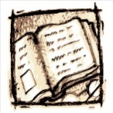
What’s in the Cauldron: Food in the Middle Ages  Describing a process (passive voice) | Dictogloss
Speed Matching: Activities in the Middle Ages | Cardame, Groups
Personal Coat of Arms: Design your personal coat of arms and write about a page about your ideas. Put this page into your Middle Age booklet. | 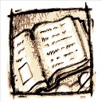
Catherine, called Birdy  It wasn’t easy being a girl in the Middle Ages, especially for a rebellious girl like Birdy. Work on excerpts from the novel. | Whole class  Birdy package | 4 skills
Catherine called Birdy: Be a writer  Write Birdy’s diary for a day (see instructions on page ..)  Put your revised diary page into your Middle Age booklet. | 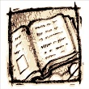
Robin Hood  Robin Hood and the Shooting Contest: reading comprehension | RH-package
Robin Hood film clips | Video and RH package
Robin Hood and the Shooting Contest: Text reconstruction exercises | RH package
Robin Hood vocabulary and dictionary work | RH package
Robin Hood – fact or fiction?  Use the internet to find out about the legend of Robin Hood. Print out a few pages of information and highlight what you consider to be the most important points.  Then design an interesting page for your booklet. | Internet
Personal Reading: Choose a short book to read at home and write a page about it in your reading diary.  We are going to start a bigger book project around October 15th. So don’t start a big book now that you won’t be able to finish by then. | Library  Reading Diary
New Grammar: Books were written by hand in the Middle Ages: Passive voice
Middle Ages Narrative: Choose A, B or C  (Put this text into your booklet after you have revised it.)  A: Time Traveller Narrative  Imagine you had a time machine and traveled back in time to the Middle Ages. You landed in Sherwood Forest, met Robin Hood and his Merry Men and had an adventure with them. Write a story describing what happened. Use your dictionaries to look up new, interesting words or expressions. Include at least 3 new words/expressions in your text and highlight them. (300 words approximately)  B: Write a diary entry of a girl who has been accused of witchcraft  C: Write a diary entry of a boy who is the son of a peasant farmer. | Writing folder  Dictionary  Info on your worksheets

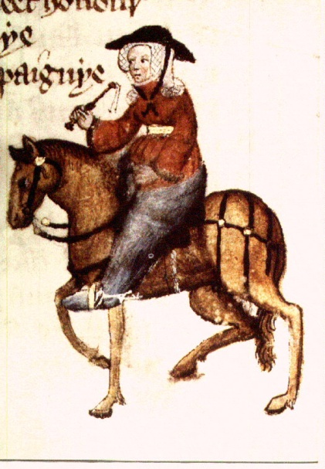

A good WIF was ther of biside BATHE,
But she was somdel deef, and that was scathe.
Of clooth-makyng she hadde swich an haunt
She passed hem of Ypres and of Gaunt.
In al the parisshe wif ne was ther noon
That to the offrynge bifore hire sholde goon;
And if ther dide, certeyn so wrooth was she
That she was out of alle charitee.
Hir coverchiefs ful fyne weren of ground;
I dorste swere they weyeden ten pound
What does this Middle English text tell us about the Wife of Bath?
Be a linguist and try to answer the following questions:

What was the lady wearing?

What did she look like?

How many husbands has she had?

To which places has she traveled?

What else can you say about her?

That on a Sonday weren upon hir heed.
those she had on her head on Sundays.
Hir hosen weren of fyn scarlet reed,
Ful streite yteyd, and shoes ful moyste and newe.
Boold was hir face, and fair, and reed of hewe.
She was a worthy womman al hir lyve:
Housbondes at chiche dore she hadde fyve,
Withouten oother compaignye in youthe-
But thereof nedeth nat to speke as nowthe.
And thries hadde she been at Jerusalem;
She hadde passed many a straunge strem;
At Rome she hadde been, and at Boloigne,
In Galice at Seint-Jame, and at Coloigne.
She koude muchel of wandrynge by the weye.
Gat-tothed was she, soothly for to seye.
Upon an amblere esily she sat,
Ywympled wel, and on hir heed an hat
As brood as is a bokeler or a targe;
A foot-mantel aboute hir hipes large,
And on hir feet a paire of spores sharpe.
In felaweshipe wel koude she laughe and carpe.
Of remedies of love she knew per chaunce,
For she koude of that art the olde daunce.

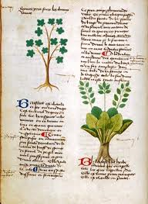
Medieval Home Cures
Student A

Being ill in the Middle Ages was no fun. People couldn’t just go and see a doctor when they were ill but had to rely on rather basic treatment and home cures based on herbal medicine.

Read the following text carefully. Underline and look up unknown words in the dictionary. Be prepared to answer your partner’s questions about these health problems and suggest a cure.

Birdy writes in her diary:  I put a toad in George’s bed. I don’t know why. I cried at dinner and left the table before the almond cream. I don’t know why. I cannot be a monk nor a crusader nor a tumbler. I must stay here and die. My humours are greatly out of order.  I prescribed myself wormwood in spiced wine and some of the custard left from supper. | Father Hew suffers from boils and blotches. His skin looks terrible. To test my skills my mother asked what I would advise. I thought the best remedy was to throw himself in the river, but aloud I said an ointment made of oil of bay and a bath might help.
My father woke up roaring like a real beast this morning. Toothache! He rubbed garlic on his thumb and left the smelly paste there all day but the reliable remedy did not work.  Later the doctor told my father that the toothache is due to an imbalance of humours in his body. He recommended letting out some blood by cutting a vein under his tongue.  This didn’t help either. So my father had to go to the barber to have his tooth pulled out. | We gathered nuts today – walnuts, chestnuts, hazelnuts, looking especially for the double nuts that protect against rheumatism and the spells of witches.

Pair work: Ask your partner what to do in case of the health problems below. What cure can she/he advise? Answer your partner’s questions.
- a headache
- swelling of one’s legs
- bad injuries
- a rash

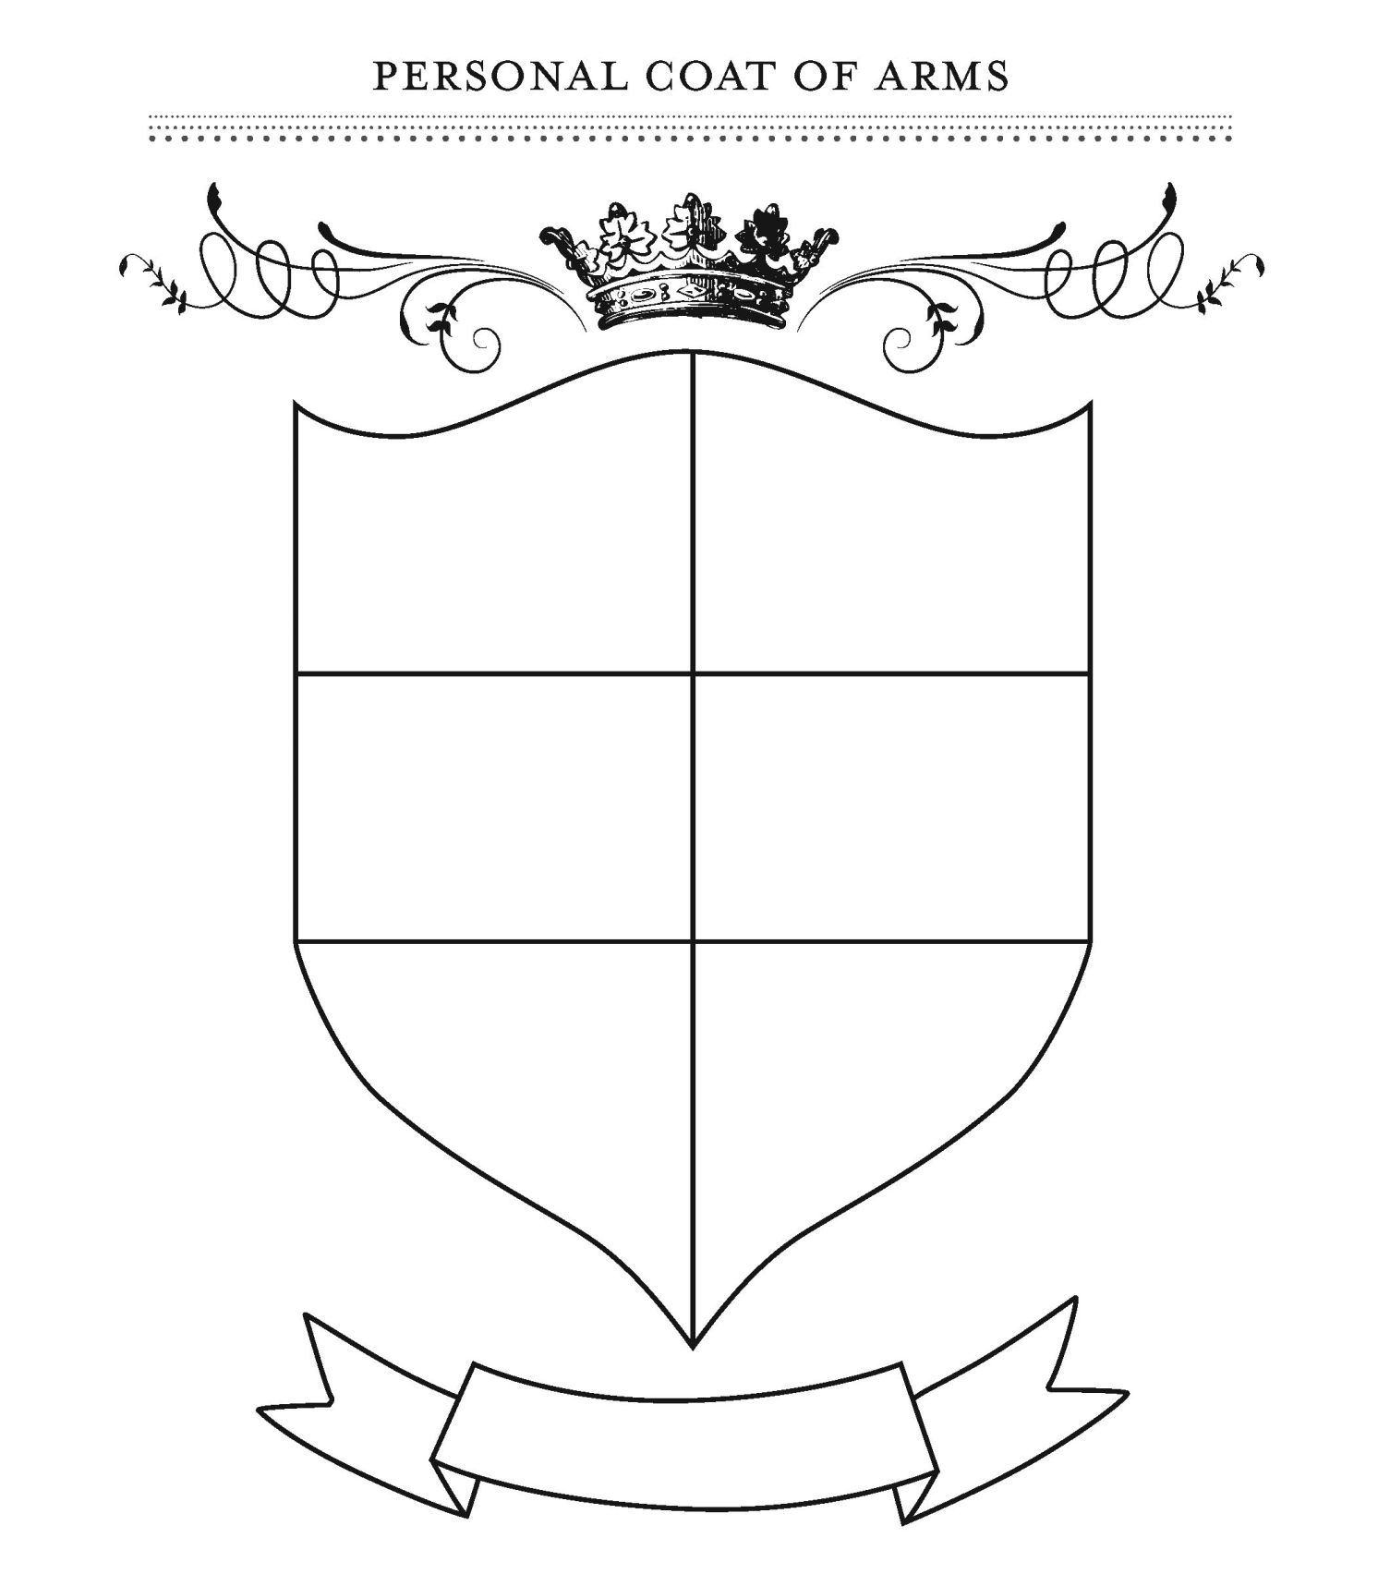
Create an individual coat of arms by making a drawing in each section. Make drawings that answer the following questions:
- Express in a drawing the most significant event in your life from birth up till now.
- Express in a drawing your greatest success or achievement in the past year.
- Express in a drawing your happiest moment in the past year.
- Express in a drawing something you are good at.
- What would you want to accomplish by the time you are twenty-five?
- Anything else that we should know about you.

Medieval Home Cures
Student B

Being ill in the Middle Ages was no fun. People couldn’t just go and see a doctor when they were ill but had to rely on rather basic treatment and home cures based on herbal medicine.

Read the following text carefully. Underline and look up unknown words in the dictionary. Be prepared to answer your partner’s questions about these health problems and suggest a cure.

Just before dinner we found Roger Moreton lying unconscious (bewusstlos) in the black, soggy street near the house. He survived a bad fight last night. Now he lies in my parents’ bed with broken bones, still asleep and with cobwebs packed about his wound, his fever raging. | In this heat my mother suffers much from swelling of her legs, which means the baby likely will be a girl. I applied a paste of bean meal, flour, vinegar and oil, but the dogs kept trying to eat it. So I washed her off and have been rubbing her legs with sweet smelling oils and singing her sweet songs and it seems to help.
I have developed a rash on my body where the rough cloth rubs on my skin. I wanted to take a bath, thinking that the dirt on my skin made the rash worse, but the tub has been turned upside down and is being used as an extra table in the kitchen and I cannot have it until spring, so I just spread goose grease on my rash. The dogs are following me everywhere. | Being tortured with headaches my mother stayed in bed with a tonic I made her of chamomile and honey.  I begged my mother to allow me to go ice skating, but she had a head ache and wouldn’t speak of it. So I made her a potion of peony and oil of roses to soothe her head.

Pair work: Ask your partner what to do in case of the health problems below. What cure can she/he advise? Answer your partner’s questions.

- sadness and depression
- a toothache
- rheumatism
- skin problems

