A Day in Medieval Graz
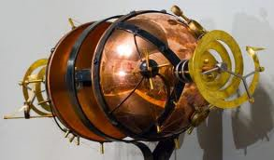 by Benjamin Wunderling, 3b
I couldn’t believe I was doing this. My good friend (and experimental genius) Mr. John Lockweed hat invited me to his house so he could show me his new invention. I, of course, had agreed. As soon as I was at his house, he had pulled me into his laboratory and had pointed at a huge construction that looked a bit like a gigantic steel egg. “That, my friend,” he had said, “is the first ever built time machine!” “Does it work?” I had asked. “Of course it does!” he had replied. “Would you like to try it?” And I had agreed.

A moment later I was in his machine, watching John pull all sorts of levers and pushing many different buttons. “You’ll be gone for a day. Then, no matter where you are, you will be transported back here,” he had said. I hoped it was true. Suddenly a metallic voice boomed: “5,4,3,2,1, blast off!” The egg started rattling and shaking. John yelled: “Don’t forget, you’ll be teleported back at 9 p.m. the next day!” Then the world went black, as I disappeared from the twenty first century and was thrown back in time…
I landed in medieval Graz, just as John had said. People were walking up and down the street, which was really dirty. Nobody paid attention to me, probably because I was sitting almost up to my waist in the stinking mud of the street. When I had landed here, so much mud had splashed over me, that you could not see the color of my clothes, which was probably a good thing, since they came from my time. A quick look at my watch told me, I still had a day to explore, so I stood up and walked down the street. While walking, I noticed that the shops lacked names, but each shop had a painted sign above the door. For instance the smith’s house had a picture of a hammer above the door. After a while I reached a big square. Everywhere traders had set up their tents. You could see swords, spices, golden jewelry, furs, shields, horses and much more. The square was as full as an anthill. As I was walking farther into the square, a shiny object under a table caught my eye. I reached down and picked it up. It was a silver coin! 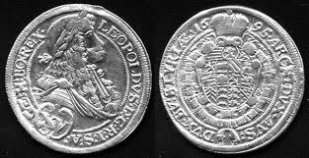
I kept walking until I found a nice stand where they were selling different kinds of tarts. I bought two apple tarts and gave the trader the silver coin. He stared at it incredulously and then screamed: “I’m rich” and ran away. I kept walking, eating my tarts, which were greasy but good. I kept looking at all the different goods, when suddenly I heard a frightened scream: “The Turks are in the city!”
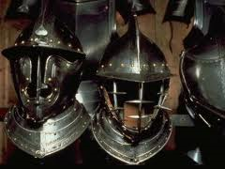
That one sentence turned the peaceful traders and citizens into a scared and screaming mob which swept me towards the smaller alleyways, where they had their houses. As I looked back, I saw at least fifty mounted knights riding down the street holding spears and burning torches. They stabbed down people and set the houses on fire. My legs felt like they were on fire from all the running. The first riders were almost upon me. With the last of my power I jumped into a small and dark alley on the side of the road. Just in time. The riders thundered past my hiding spot. This was not what I had expected when John had said “the glorious Middle Ages”. I looked at my watch: still four hours to go.
I stayed in that alley for what seemed like a lifetime, while the Turks battled the knights from Graz. It was a cold, stinky, narrow and dark hiding place, but it worked. Nobody found me for hours until the fight was almost over. Suddenly a Turkish foot-soldier ran into the alley where I was hiding, probably to find a hiding-place himself. He saw me and drew his sword. Without wasting time he walked up to me, raised his sword and everything went black.
When I awoke, I was lying in John’s bed. Then I fainted again from shock. Later, John told me that the time machine had probably pulled me back an instant before the soldier had attacked me. I had been extremely lucky and I never ever tried John’s time machine again. Even though I had nearly been killed, the rest of my time in medieval Graz had been amazing.

The End

