

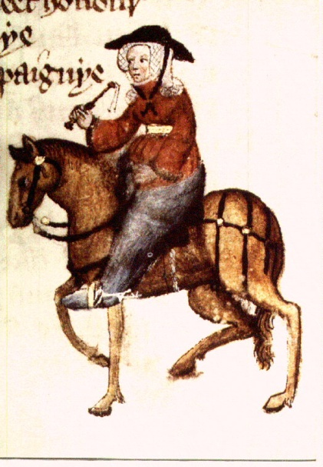
A good WIF was ther of biside BATHE,
But she was somdel deef, and that was scathe.
Of clooth-makyng she hadde swich an haunt
She passed hem of Ypres and of Gaunt.
In al the parisshe wif ne was ther noon
That to the offrynge bifore hire sholde goon;
And if ther dide, certeyn so wrooth was she
That she was out of alle charitee.
Hir coverchiefs ful fyne weren of ground;
I dorste swere they weyeden ten pound
That on a Sonday weren upon hir heed.
those she had on her head on Sundays.
Hir hosen weren of fyn scarlet reed,
Ful streite yteyd, and shoes ful moyste and newe.
Boold was hir face, and fair, and reed of hewe.
She was a worthy womman al hir lyve:
Housbondes at chiche dore she hadde fyve,
Withouten oother compaignye in youthe-
But thereof nedeth nat to speke as nowthe.
And thries hadde she been at Jerusalem;
She hadde passed many a straunge strem;
At Rome she hadde been, and at Boloigne,
In Galice at Seint-Jame, and at Coloigne.
She koude muchel of wandrynge by the weye.
Gat-tothed was she, soothly for to seye.
Upon an amblere esily she sat,
Ywympled wel, and on hir heed an hat
As brood as is a bokeler or a targe;
A foot-mantel aboute hir hipes large,
And on hir feet a paire of spores sharpe.
In felaweshipe wel koude she laughe and carpe.
Of remedies of love she knew per chaunce,
For she koude of that art the olde daunce.

What does this Middle English text tell us about the Wife of Bath?
Be a linguist and try to answer the following questions:
What was the lady wearing?
What did she look like?
How many husbands has she had?
To which places has she traveled?
What else can you say about her?

