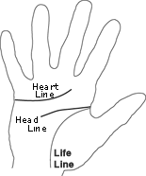
Palm Reading: The future in your hands

Your palm, like your fingerprint, is unique. To the fortune-teller, your hands are mirrors reflecting your personality and your destiny.
Give yourself a hand!
When you decide to read your palm, use your major (or writing) hand. This is the right for a right-handed and the left for a left-handed person.
The Life Line: Let’s get physical!
The most important line, your life line, appears between your thumb and index finger and travels down toward the middle of your palm (refer to diagram). It shows the “physic al” you.
- The longer your life line, the more energy and good health you’ll have.
- A short life line or one with smaller lines crisscrossing it could mean weakness, illness or worry. A short line doesn’t mean a short life!
The Head Line: Think about it!
The head line – starting between your thumb and index finger, and running across your palm above the life line (refer to diagram) – shows the “thinking” you.
- When your head line starts near your life line, you’re careful and like to mull things over. You follow your head, not your heart.
- When your head line starts at a different place than your life line, you are independent. You like fun, surprises, and adventure.
- If your head line is straight, dark, and deep, you are a realist.
The Heart Line: How deep is your love?
The heart line, the line near your fingers, begins between your index and middle finger, and curves down to the area under your pinky finger. This line shows the “feeling” you.
- If the heart line is longer than the head line, you’re ruled more by your heart than by your head. A deep or dark line means you’re warm, affectionate, and very emotional.
- A wide space between the heart and the head lines means you’re outgoing and not afraid to be different. A narrow space means you lack self-confidence. It’s hard for you to tell people how you feel.
- A heart line full of breaks and crosses might mean difficulty in relationships.
Mirror Images – NOT!
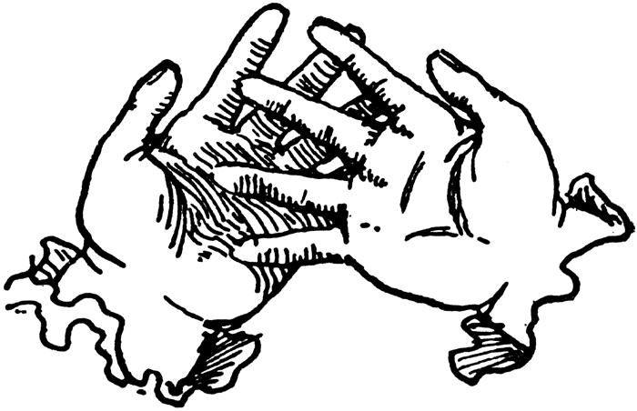
Compare your left palm to your right palm. Can you spot some differences? Fortune-tellers believe that the lines and markings of the minor hand (the one you don’t write with) show the “life plan” you were born with. The major hand shows what you do with that life plan.
Let’s say, for example, that you’re born with a long, pronounced life line, but become a heavy smoker in your twenties. A reading of your left palm (right, if you’re left-handed) shows your destiny: a long, healthy life. In contrast, your right palm (lift, if you’re left-handed) might show a faint, short or crossed life line, indicating broken or poor health.
The major hand reflects or destiny as influenced by our choices.

