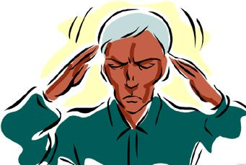
Superstitions

Personality Quiz

Tick off the appropriate letters.

- A black cat has just crossed the street in front of you. What’s your reaction?
- I don’t care
- I am still thinking about the black cat an hour later.
- I am really worried.
- Some people believe that there is life in space. What’s your opinion?
- I think life in space is possible, but I am not sure.
- I think this is absolute nonsense.
- I am sure that there is life on other planets.
- What do you think about the Yeti?
- I don’t think the Yeti exists.
- I don’t know if the Yeti exists, but I am very interested in reading about it.
- I believe the Yeti exists.
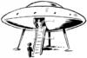
- Many newspapers print horoscopes.
- I read my horoscope every day and I believe that what it says is true.
- I sometimes read horoscopes.
- I think horoscopes are nonsense.
- Some people say they know what others are thinking, because they can ‘read’ their minds.
- I am sometimes able to ‘read’ other people’s minds myself.
- I think this is nonsense.
- I don’t know whether this is true.
- Lots of people tell ‘strange’ stories. In these stories things happen that nobody can explain.
- I believe most strange stories are true.
- I don’t really believe such stories, but I am interested in listening to them.
- I believe that everything can be explained logically.
Scores
 | 1 | 2 | 3 | 4 | 5 | 6
a | 6 | 4 | 6 | 2 | 4 | 2
b | 4 | 6 | 4 | 4 | 6 | 4
c | 2 | 2 | 2 | 6 | 2 | 6


RESULTS 29-36 points
You think most things can be explained. The rest is nonsense. One day you will wake up in a UFO and have breakfast with little green people. And you will think you are dreaming.

RESULTS 18-28 points
You are interested in fantastic things, but you are not sure whether they are true. So your only chance is to try things out. So your only chance is to try things out. Go to the Himalaya, and visit the Yeti.

Discuss your results with your partner.

Are they true?
Then do the numerology experiments on the next page. Ask your teacher if you need help with the vocabulary and make sure you really know all the words.
Take notes of your partner’s results in all these activities. You will need this information for your homework:

Homework: Astrological Report
Imagine you are a master astrologer and you have just had a long session with your client (your partner in this exercise). Write him/her a detailed astrological report summing up the results of the personality quiz and the numerology activities. Use lots of the new words from the worksheets and make sure you report looks really professional.

Astrological Report for …… (name of student).
The results of your personality quiz and numerology analysis have shown the following results.
Tip:. Use the present tense to describe your client’s character and personality traits.
Use the “will” future to predict your client’s destiny. (You will have a long and happy life…)

