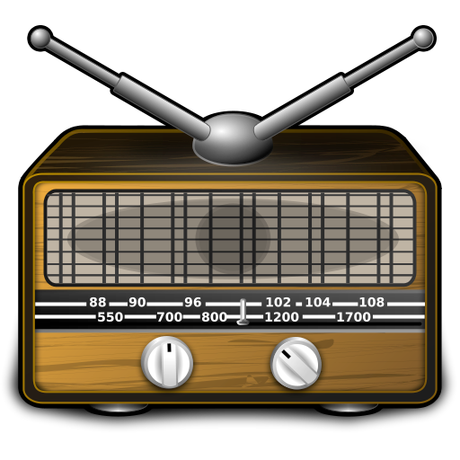
Radio Shows
After reading about all the mysterious events in the workshop choose an area that interests you (angels, channeling, UFOs, ghosts, vanishing people, corn circles...)
Search the internet for more information about your topic.
TIP: enter ENGLISH search-words (for example: UFO sightings, UFOs in America..., recent UFOs...)
You can also enter: UFOs English
This will give you English results and it will be A LOT EASIER for you to summarize the information.
Print out a few interesting pages and highlight the main points.
Then meet with your group and prepare a 5 minute radio show about the event or topic.
Tip: One of you can be a scientist or expert, one can we a witness (Zeuge), one can be the host of the radio show)
You can use some special sound effects (simple things that make noises).
Make sure you plan a good, clear opening statement for your radio show where you tell your audience
- what the program will be about
- what has happened
- where it happened
- who is involved (introduce your visitors)
Record your radio-show on your mobile phone. Then transfer the file to your computer and upload it to Moodle.
When all the files have been uploaded I will make them available to you so you can listen to your friends' programs.
NOW LISTEN to your classmates' radio-shows. Take notes while you are listening. Then write a short newspaper article about these strange events.
Make sure your article has a catchy title and an interesting lead-sentence.
Your article must answer the questions: who? what? where? when? why?

