Deer visits every morning
A cat in Harrisburg , Pennsylvania has a special friend that visits every morning.
The owner finally took pics.
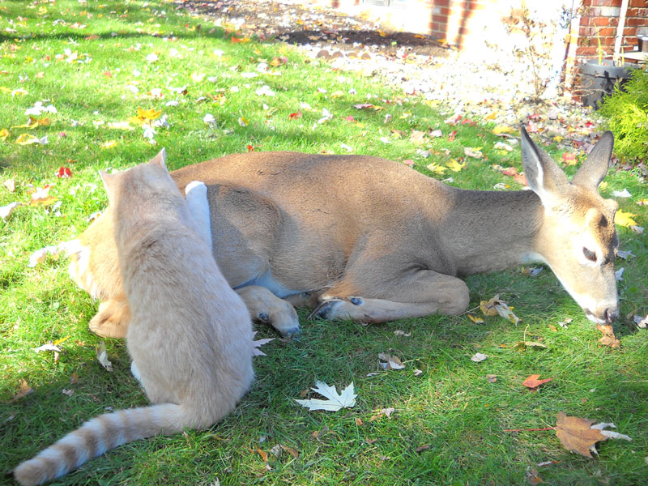

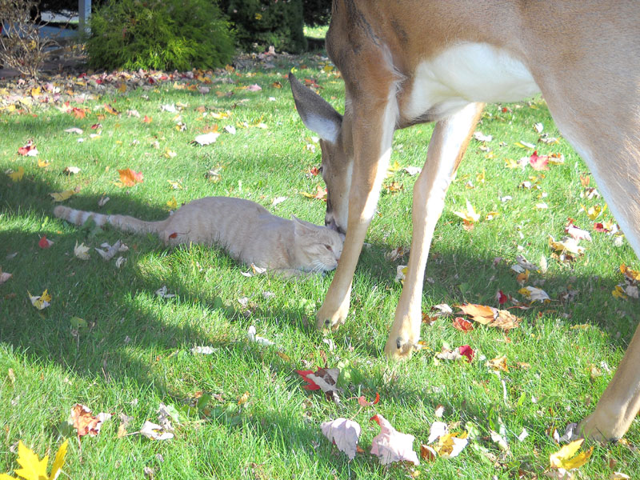

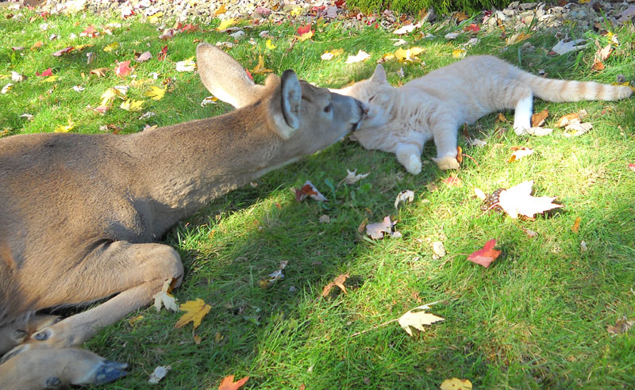

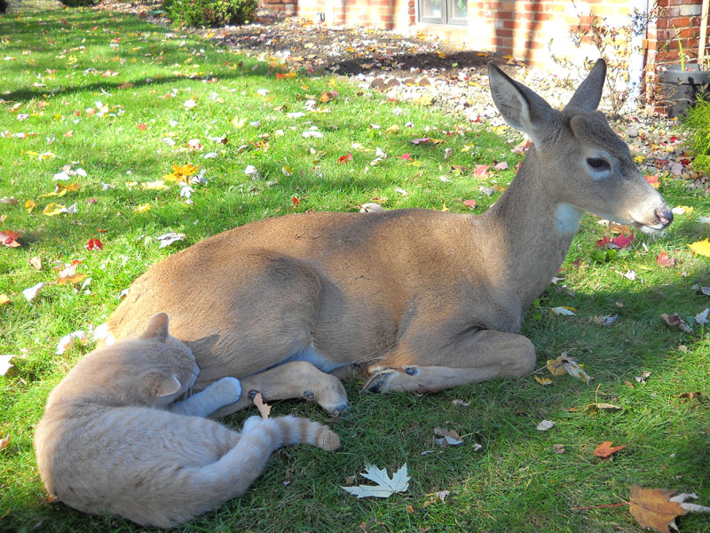

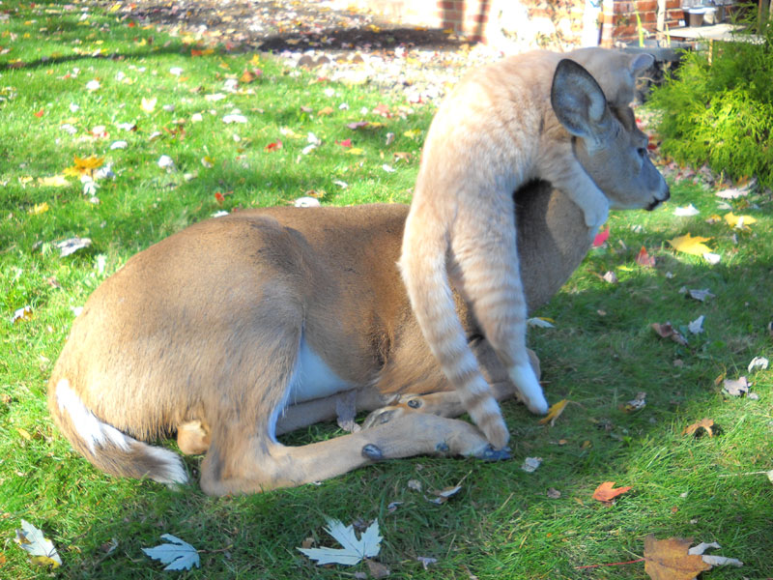
Those we love don't have to be exactly like us. But it's nice if they scuba dive.

