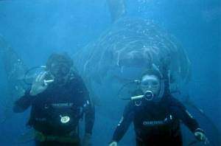 | Shark Behind Divers  Fake
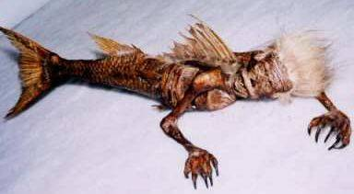 | Dead Mermaid Caracas  Fake
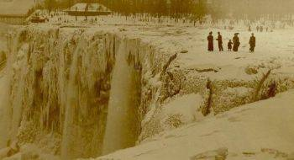 | Niagara Falls Frozen Over  Real
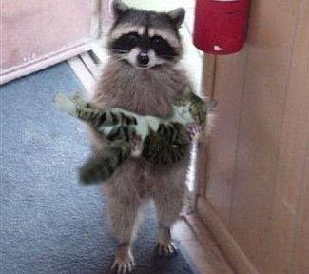 | Racoon Holding A Cat  Fake
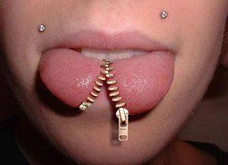 | Zipper Tongue  Fake
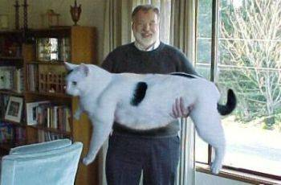 | Giant Cat  Fake
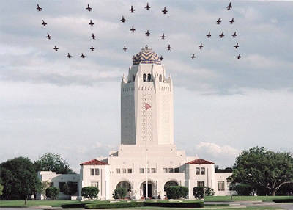 | USA Plane Formation  Fake
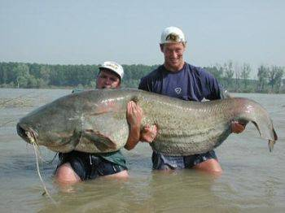 | Giant Catfish  Real
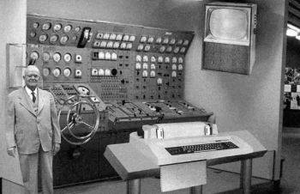 | Home Computer Advertisement of 1954  Fake
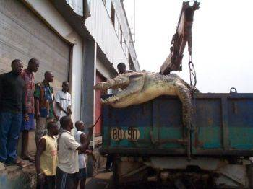 | Giant Croco  Real
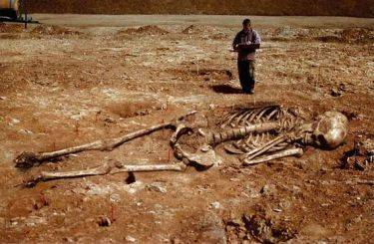 | Giant Skeleton  Fake
 | North Pole Sunset  Fake
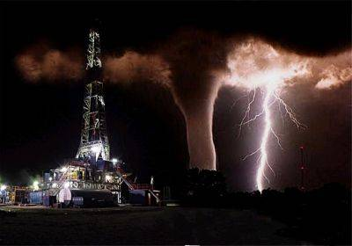 | Texan Tornado  Fake
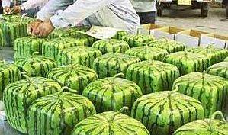 | Square Watermelons  Real
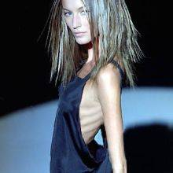 | Skinny Model  Fake
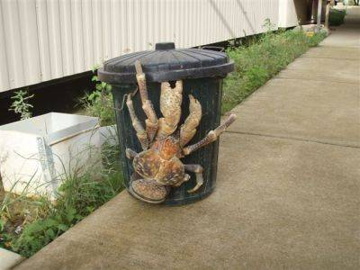 | Giant Coconut Crab  Real
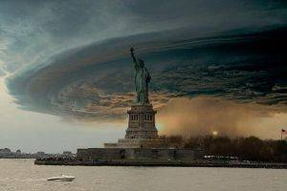 | New York City Tornado  Fake
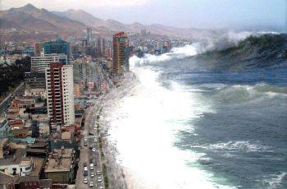 | Wave  Fake
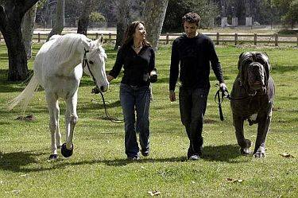 | The World’s Biggest Dog  Fake
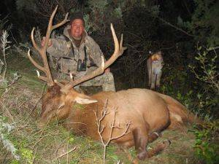 | Sneaky Mountain Lion  Fake
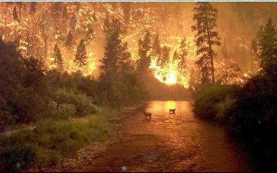 | Montana Forrest Fire  Real
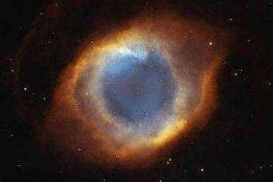 | Space Nebula Resembles Human Eye  Real
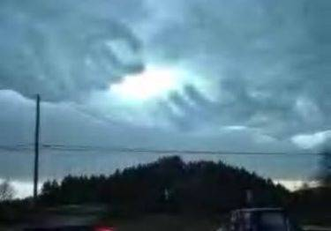 | God’s Hands in the Clouds  Fake
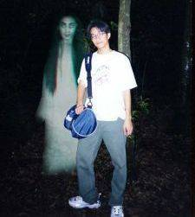 | Ghost  Fake
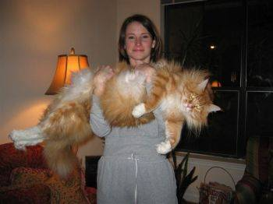 | Giant Housecat  Real
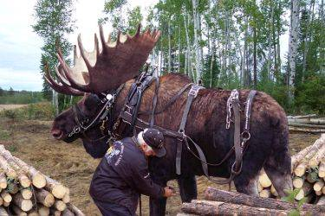 | Work Moose  Fake
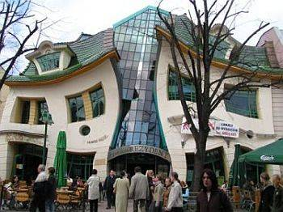 | ‘Drunk Building’  Real
 | Black And White Twins  Real
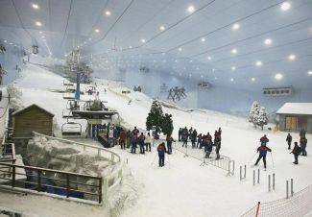 | Indoor Ski Resort in Dubai  Real
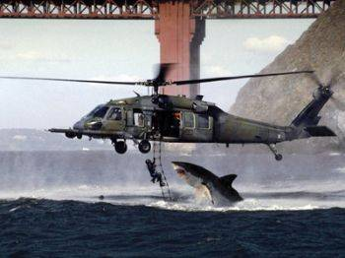 | Shark Attacks Helicopter  Fake
 | Former Governor of Alaska  Fake
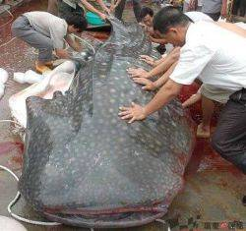 | Really Big Catfish  Real
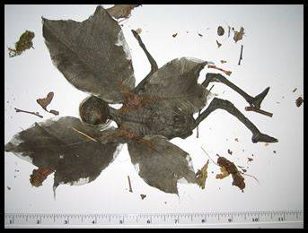 | Fairy Mummy  Fake
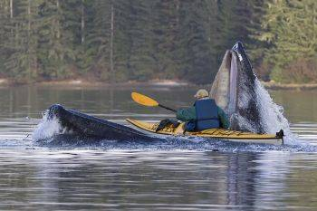 | Wale Attack  Fake
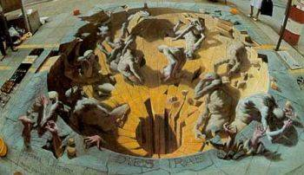 | Realistic Street Painting  Real
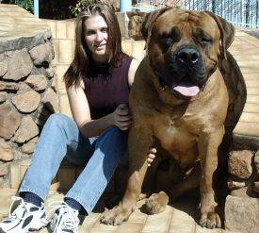 | Big Dog  Real
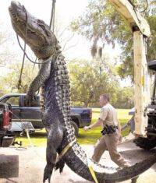 | Giant Texas Alligator  Real
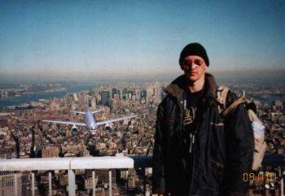 | Tourist On World Trade Center  Fake
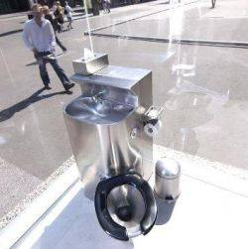 | Toilet With Glass Walls  Real  (Mirror Glass)
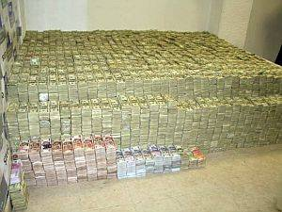 | Drug Money  Real
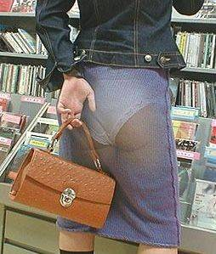 | Japanese Fashion  Fake

