4th Test: 3b May 2011

I: ‘I need a job.’
You want to earn some money and decide to find a little job. Think of things you do well, such as babysitting, gardening, mowing the lawn for old ladies, shopping, tutoring younger children in Math, English or German. You might want to be a librarian at your local or church library or you might be a computer freak who can install and debug programs for your neighbors and friends. You might be an animal lover and walk dogs or feed cats and hamsters while their owners are on holiday. You might also have other ideas and skills.

You have just found some interesting job offers posted on your school notice-board. Choose a job you would like to do and write a short letter of application.
Describe yourself as a very skilled and experienced person in the area of your choice. Use the present perfect tense to describe your general experiences and the past tense for specific events. Write about 100-150 words. Start like this:

Dear Mr./Mrs. …………,

I have just read your advertisement on our school notice-board and I feel that I am the ideal person to help you. …

II. Have you heard?
Choose one of the pictures below and write an urban legend about it. Make sure your story sounds really plausible. Warn your friends of the possible dangers involved.

Chinese Restaurant Closed for Serving
Rats, Mice and Kittens
Giant Bunny caught in Graz

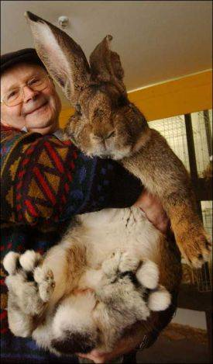
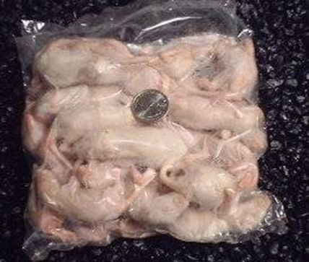

Baumax: Poisonous Snake sold with Potted Plant

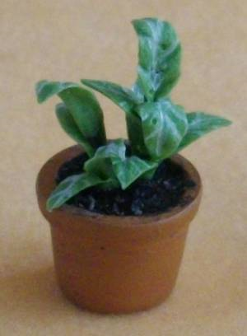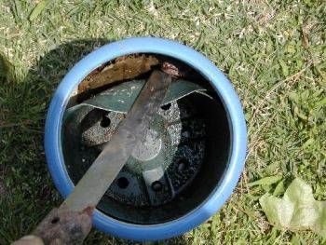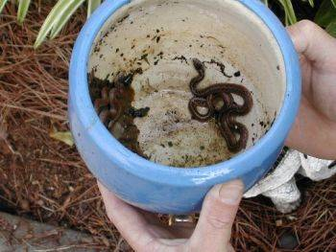

Atlanta Restaurant Closed for Serving Rats, Mice, Kittens

Email hoax claims an 'Asian/Chinese restaurant' in Atlanta, Georgia was closed by authorities for offering dishes made of rats, mice, kittens, and puppies.
Description: Email hoax / Urban legend
Circulating since: Jan. 2005
Status: False
Analysis: See comments
Email example contributed by V. Heimer, Jan. 11, 2005:
Subject: POPULAR RESTAURANT SHUT DOWN ! ! ! ! !
Wow I don't quite know what to say to this other than what is the restaurant's name.
THIS IS NOT CHICKEN.. LOOK HARDER...
A popular Asian/Chinese restaurant bistro here in Atlanta was closed down this morning after authorities received a tip that the owner was accepting shipments of rats and mice from a vendor to prepare in his dishes. The owner and his wife were arrested early this morning and charges are not known at this time. After a full search of the kitchen, authorities found, packaged rats, mice, kittens, puppies and a large frozen hawk. The restaurant is a popular gathering spot for local celebrities such as Whitney Houston and husband Bobby Brown, Jermaine Dupree, Janet Jackson, Usher, Monica, Puffy, TI, Ludacris, Lil Jon, Toni Braxton, TLC and others. The restaurant has locations off Peachtree Road and Alpharetta near North Pointe Mall.

