4th Test: 3b June 2015

- Speculating and Making Assumptions:
Read the following message posted on an internet blog. What do you think about it? Might this be true? Write a reply to the blog– imagine you were posting this online. Write at least 50 words, that is 5-6 sentences.
In your answer you must NOT use the word MAYBE. This word is TABOO today. Express your assumptions using better expressions.
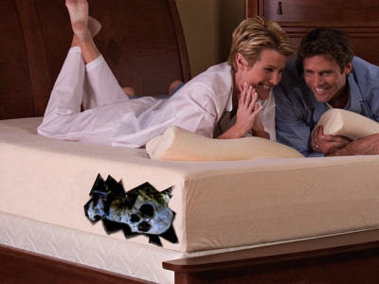
A couple checked into a hotel in Las Vegas. They noticed a terrible, foul smell in their room all night. They called the staff to complain. At first they did not find anything and went back to sleep. In the morning they complained again and the cleaning lady finally found out that the stench must be coming from the bed.
She called the janitor to help her take off the mattress and they made a terrible discovery. The couple had been sleeping over the rotting body of a dead girl who had been stuffed in the bed frame.
- Best Book For Teens

The website TOP 100 – Best Books for Teens posts reviews of great books for teens.
You have 50 words to present a book that you love and want to be included in the Top 100.
Make sure you say the most important things about your book. Include information about
- the characters and their main problem,
- the plot and
- who you recommend the book for.

- Have you heard?
Choose one of the pictures below and write an urban legend about it. Make sure your story sounds really plausible. Warn your friends of the possible dangers involved. Write about 150 words.
Chinese Restaurant Closed for Serving
Rats, Mice and Kittens
Giant Bunny caught in Graz


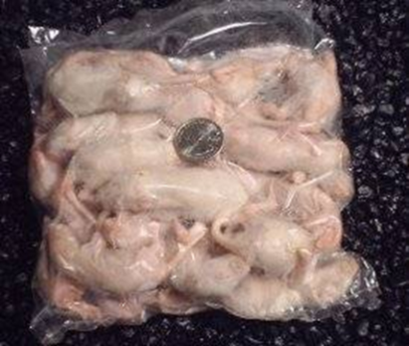

Baumax: Poisonous Snake sold with Potted Plant

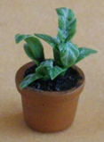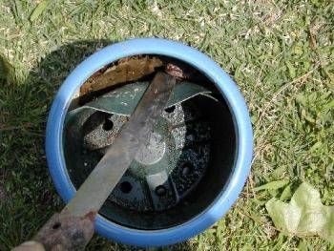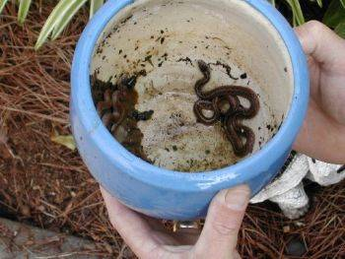

Atlanta Restaurant Closed for Serving Rats, Mice, Kittens

Email hoax claims an 'Asian/Chinese restaurant' in Atlanta, Georgia was closed by authorities for offering dishes made of rats, mice, kittens, and puppies.
Description: Email hoax / Urban legend
Circulating since: Jan. 2005
Status: False
Analysis: See comments
Email example contributed by V. Heimer, Jan. 11, 2005:
Subject: POPULAR RESTAURANT SHUT DOWN ! ! ! ! !
Wow I don't quite know what to say to this other than what is the restaurant's name.
THIS IS NOT CHICKEN.. LOOK HARDER...
A popular Asian/Chinese restaurant bistro here in Atlanta was closed down this morning after authorities received a tip that the owner was accepting shipments of rats and mice from a vendor to prepare in his dishes. The owner and his wife were arrested early this morning and charges are not known at this time. After a full search of the kitchen, authorities found, packaged rats, mice, kittens, puppies and a large frozen hawk. The restaurant is a popular gathering spot for local celebrities such as Whitney Houston and husband Bobby Brown, Jermaine Dupree, Janet Jackson, Usher, Monica, Puffy, TI, Ludacris, Lil Jon, Toni Braxton, TLC and others. The restaurant has locations off Peachtree Road and Alpharetta near North Pointe Mall.

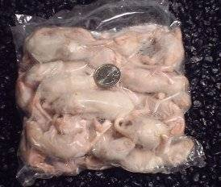

Assessment: Test 4, 3c

Speculating and making assumptions: 50 words

Range: 10 (might, could, may…)
Accuracy: 10

Best Book for Teens 50words

T/O: 10 (characters, problem, plot)
Language: 10 (range 5 and accuracy 5)

Have you heard? 30 x 2

T/O 10 (x2)
R 10 (x2)
A 10 (x2)

100 pts

