Moll DeGrow

A New Jersey Spooky Story
retold by
S. E. Schlosser
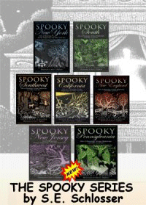
Moll DeGrow was a wicked witch who once lived on Gully Road in what is now Newark, New Jersey. She took delight in the misery of others, and made things miserable for the folks living near her. If a neighbor slighted her, she would sour their milk. If anyone called her a witch, she made their dogs turn vicious. People were very cautious around Moll De Grow.
When a new family moved in, their grown-up son took offense with the witch's rude behavior toward his mother and told her off. That night, an evil black dog with glowing red eyes emerged from the woods in front of his horse. The horse bolted and the dog raced after it,leaping up to bite at his tail and sides. The young man was struck by a low-hanging branch and fell lifeless to the ground. The hound howled once in triumph and then disappeared in a puff of acrid smoke, leaving the terrified horse to walk trembling back to its dead master and stand guard until his body was found.
Folks put up with Moll DeGrow for many years. But then there came a rash of unexplained infant deaths. People soon realized that Moll DeGrow had a grudge against each of the families that had lost a child. When she was accused by a hysterical mother of causing the death of her baby girl, Moll DeGrow just laughed and didn't deny it. This was the last straw for the local residents. They formed a mob and went to Gully Road to burn the witch to death. But when they reached her house, Moll DeGrow was already dead, sitting bolt upright in her chair with a cruel smile on her lifeless face.
Moll DeGrow was buried in the Mount Prospect Cemetery on Gully Road, and her malicious ghost continued to haunt the place long after her body turned to dust.

