My Book Of Tall Tales
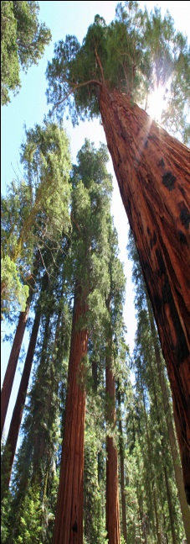
Name:……………………………………….

T
A
L
L

T
A
L
E
S

My Book of Tall Tales
In your book of tall tales collect information and details about the tales that you have read and listened to in this project.
Your pages should
- show that you have understood the stories
- help you remember the important facts and details
- help you remember the new words, so you can retell the stories yourself.
Use any formats you think are useful for these purposes. Be creative and design your pages nicely.


The second part of your book is reserved for your own tall tales. You will be asked to write two tales for homework and one tale in the test. After revising and correcting them carefully, glue in your finished tales and illustrate them nicely.
Make sure your book of tall tales shows your full potential!
Your TTB will be part of your portfolio at the end of the year.

Oral Work:
In this project we are going to practice storytelling. Use the notes/drawings/facts… in your “Book of Tall Tales” and tell your stories to your classmates, your teacher and co-teacher. Go over your notes and plan what you are going to say and how you are going to say it. Then find an audience and tell your story.
For each story that you have shared, ask your audience to sign your “Story Teller’s Record” below.
Collect at least three signatures, one must be from a teacher or co-teacher.
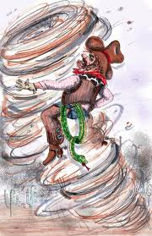
Date | Title of story: | I told this story to:
Don’t forget that we speak ENGLISH ONLY in this class!!!

