Tall Tales from the American West
In this workshop we will practice story writing and storytelling and you will learn about life in the Wild West. Do all the tasks carefully and collect useful phrases as you go along. Don’t forget that you are doing this workshop in order to improve your English and to expand your vocabulary.

Who was Pecos Bill?  Walk around in class and share the information on your little info and picture cards. What do all these things tell you about Pecos Bill?  - What kind of a person was he?  - What kind of problems did he solve?  - How did he solve them? | info cards
Song: Pecos Bill  Work with a partner and complete the gaps  Then listen to the song and check your solutions. | WS 1
Reading: Read one of the tales about Pecos Bill. Make sure you understand it really well.  Choose a few useful phrases that will help you retell the story later and transfer them into your vocab book.  Design a page about this tale in your “Tall Tales Book”(TTB) (see instructions there).  Practice retelling your tale orally. You can use your TTB but you must not use the original story sheet. | Colored story sheets 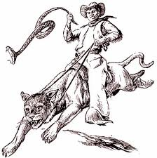
Oral Story telling: Now find two friends who have read a different tale. Share your stories and design a page in your TTB for each story that you have heard. Ask your friends to sign your “story-teller page” in your TTB. (detailed instructions in your TTB) | TTB
Pecos Bill: the movie  Now let’s watch the Disney movie about Pecos Bill. Which of the tales do you recognize?  Answer the questions on worksheet … while watching the film. | Moodle/in class
Who was Paul Bunyan?  Paul Bunyan’s Birth: Text Market | info strips, TTB  whole class
Read one of the Paul Bunyan tales that you find on moodle.  Design a page in your TTB and collect a few useful phrases in your vocab book. Be prepared to retell your tale to your friends. | TTB ,Moodle 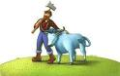
Find 2 friends who have read a different Paul Bunyan story and share them. Keep working on your TTB as above. | TTB
Writing Tall Tales
Do the language tasks and activities in your workshop package very carefully.
Mississippi Mosquitoes: unscramble the text and copy it into your tall tales book. | WS 3, TTB
Frozen Dawn | WS 3
Comparing | WS 5
Simile Characters and Simile Search | WS 6
Write a tall tale according to the instructions on WS 4 and the yellow tall tale recipe | WS 4, Moodle
Continue the tall tale on WS 4 | WS 4. Moodle
Peer Conference: Meet with 2 friends and ask them to give you critical feedback on your tales. Get some feedback from a teacher or Uni-student and revise your tales VERY carefully. Print a final version and stick it into your TTB. Polish and complete your TTB and hand it in for assessment.
Vocab-Book: Complete your vocabulary collection and study the new phrases with a partner. Use some of the vocab-activities discussed in class.
Then ask your teacher or co-teacher to test you.

Collect all your texts in your TTB (Tall-tales book). Look at the detailed instructions there and make sure you do your best.
You want to be proud of your finished TTB!
Proud like a peacock!!!

Tall Tales: Pecos Bill and Paul Bunyan

Who was Pecos Bill?

Artist: Creek Nickel Song: Pecos Bill Album: Little Cowpoke
Now Pecos Bill was _____________ cowboy down in Texas
Why, he's the Western Superman to say the _____________
He was the roughest, ______________ critter, never known to be a quitter
'Cause he never had no fear of man nor beast
So yippee-i-ay-i-ya, yippee-i-o
He's the toughest critter west of the Alamo
Once he roped a ____________ cyclone out of nowhere
Then he straddled it and settled down with ease
And while that cyclone bucked and flitted, Pecos rolled a smoke and ________ it
And he _______________ that ornery wind down to a breeze
So yippee-i-ay-i-ya, yippee-i-o
He's the toughest critter west of the Alamo
Now once there was a drought that spread all over Texas
So to ____________ Californy he did go
And though the gag is kind of corny, he _______________ rain from Californy
And that's the way we _______ the Gulf of Mexico
So yippee-i-ay-i-ya, yippee-i-o
He's the toughest critter west of the Alamo
Now once a band of rustlers ____________ a herd of cattle
But they didn't know the herd they stole was Bill's
And when he _______________ them crooked villains
Pecos knocked out all their fillings
That's the reason _________ there's gold them thar hills
So yippee-i-ay-i-ya, yippee-i-o
He's the toughest critter west of the Alamo
Pecos lost his way while traveling in the desert (Water, water, water...)
It was ninety miles across the ________________ sand (Water, water, water...)
He ________ he'd never reach the border (Water...)
If he didn't get some water (Water...)
So he got a stick and ________ the Rio Grande
While a tribe of painted Indians did a war-dance
Pecos started shooting up their little game
He ____________ those redskins such a shakeup
That they jumped out of their makeup
That's how the Painted Desert got _______ name
So yippee-i-ay-i-ya, yippee-i-o
He's the toughest critter west of the Alamo
While reclining on a __________ high over Texas
With his _________ he made the stars evaporate
Then Pecos ______ them stars declining
So he left one brightly __________
As the ____________ of the Lone Star Texas State
So yippee-i-ay-i-ya, yippee-i-o
He's the toughest critter west of the Alamo
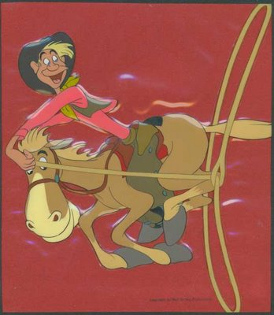 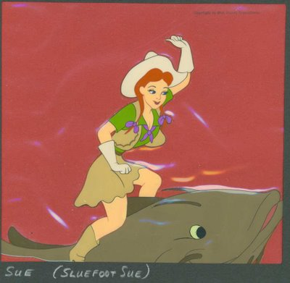

Part 1
- How hungry was Bill when he finally found the coyote family?
Old Bill was _________________________ than a woodpecker with a headache.
- Bill could out-jump the ________________ and he could out-hiss the _____________________?
- When Bill first saw Widow Maker he was trying to fight off the buzzards, and the narrator described the fight as an unfair fight of 50 to 1, but one plus Bill made it _____________________________________!
- Bill and Widow Maker stuck together like _________________________________________ or _______________________________________________.
- Bill was the __________________ _______________________ critter west of the Alamo.
- What are some of the great deeds Bill did for the state of Texas?

Part 2
When Bill had met Sue he was as happy as a ___________________________________________.
Sue made Bill feel unusual, like a slug of rye _____________________________________________.
Bill could not believe his eyes or the pounding sound inside his ears, which was like
_________________________________________________________________________________.
On Bill and Sue’s wedding day Sue wanted to ride Widow Maker. Unfortunately, the bustle in Sue’s dress made her take off like a _____________________________________________.
It kept bouncing Sue ______________________________and ______________________________.
And that’s how come to this very day coyotes ___________________________________________
_________________________________________________________________________________

For homework find out about another famous hero of the American West.
Find out about Paul Bunyan and bring one of his tales to class.
You will find them on Moodle.

Listen to the following tall tale. Then complete the text.

Frozen Dawn
retold by
S. E. Schlosser

One ______________, it was so ____________ that the dawn ___________ solid. The sun got _____________ between two ____________________, and the earth _____________ up so much that it couldn't ______________. The first _____________ of sunlight froze halfway over the mountain_______________. They looked like yellow ________________ dripping _____________ the ground.
Now Davy Crockett was ______________ home after a ___________________ night hunting when the dawn ____________ up so solid. Being a _____________ man, he knew he had to do something ___________ or the ____________ was a goner. He had a _____________ killed bear on his ____________, so he whipped it off, _____________ right up on those ___________ of sunlight and ____________ beating the hot bear carcass against the ______ blocks __________ were squashing the sun. Soon a gush of hot oil ____________ out of the bear and it _____________ the ice. Davy ____________ the sun a good hard kick to get it ___________, and the sun's heat ____________ the earth and started it _______________ again. So Davy ____________ his pipe on the sun, _______________ the bear, _____________ himself down the sun __________ before they ____________ and took a bit of ______________ home in his pocket.

Mississippi Mosquitoes
retold by
S. E. Schlosser
The sentences of the following tale have been scrambled. Cut out the sentences and glue them into your TTB in the correct order.

"Shall we eat him on the bank or in the swamp?" he heard one ask the other.
"We'd better eat him on the bank," said the other. "Or else the big mosquitoes in the swamp will take him away from us."
A visitor to Mississippi decided to take a walk along the river in the cool of the evening.
As he promenaded beside the flowing Mississippi, he heard the whirling sound of a tornado.
But the visitor just laughed and told his host he wasn't to be put off from his evening walk by a few mosquitoes.
Frightened near to death, the man lashed out at the mosquitoes until they lost their grip and dropped him into the river.
He was carried two miles downstream before he was fished out by a riverboat pilot.
His host warned him that the mosquitoes in the area had been acting up lately, tormenting the alligators until they moved down the river.
Looking up, he saw two mosquitoes as big as elephants descend upon him.
The man left Mississippi the next day, and has never gone for another walk from that day to this.
They lifted him straight up in the air and carried him out over the river.

Writing A Tall Tale
  - Use this RECIPE to plan your first tall tale. Then type your tall-tale and upload it to Moodle.

First choose a tall tale hero. Remember, the key is to EXAGGERATE your hero’s characteristics. Make him or her bigger or stronger or faster or smarter than anyone else!

Now you need an adventure for your hero. Once again, the key is to EXAGGERATE. The main event of a tall tale is not something that can happen in real life.

Use the following story pattern to write your story.

………………… …………….was the ………………………………………..
(Name of tall tale hero) (describe words like: toughtest, smartest…)

man/woman in the state of …………………………………..and loved to tell and
(state name)
retell of his/her amazing feats. Now one day …………………………………….
(hero’s name)
went to visit …..………………………… ........................................... had been
(2nd character’s name) (2nd character’s name)
having big problems with…………………………………………………………. …………..…………………………………………………………………………………………………………………………………………………………………………………………………………………………………………………………………………………………………………………………………………………………………………………………………………………………………………………………………………………………………………………….………………………… explained his/her problem. That was all it took.
(2nd character’s name)
Right away, ………………………………………………………………………
(how the hero solved the problem)
……………………………………………………………………………………………………………………………………………………………………………………………………………………………………………………………………………………………………………………………………………………
………………………………………………………………………………………………………………………………………………………………………………………………………………………………………………………………
……………………………………………………………………………………………………………………………………………………………………………………………………………………………………………………………………………………………………………………………………………………
……………………….. problem was solved, and the folks in …………………..
(2nd character’s name) (state name)
now had a new tale to tell about ………………………………(hero’s name.

Continue the tale…

Mull de Grau

Mull de Grau was a wicked witch who once lived on Gully Road in what is now Newark, New Jersey. She took delight in the misery of others, and made things miserable for the folks living near her. If a neighbor slighted (angered) her, she would sour their milk. If anyone called her a witch, she made their dogs turn vicious (bad and aggressive). People were very cautious around Mull de Grau. When a new family moved in, their grown-up son got fed up with the witch's rude behavior toward his mother and told her off. That night, an evil black dog...
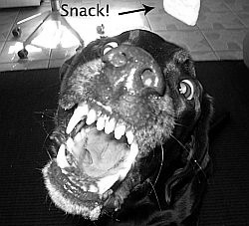

Complete the tale. Use your Tall Tale Recipe and your Writing Tall Tales model sheet to plan the tale. Include several comparisons to show the great dangers, the witch's meanness and your hero's courage.
Proofread your tale carefully before uploading it.
Bring a printout to class for peer-conferencing.

