Who was Pecos Bill?

For the Teacher

Step 1: Cut up lyrics and pictures, hand out in class. Each student gets one text-card and one picture. Students mill around telling each other what they know about Pecos Bill.
Step 2: Plenary: What kind of person was he? What kind of problems did he solve? How did he solve them?
(Elicit the typical features of tall tales and their heroes.)
Step 3: Hand out gapped text. Students work in pairs and try to fill the gaps.
Step 4: Ss listen to the song, then show solutions on the screen.
Step 6: Each student reads one of the tales in detail and designs an A5 page in their “Book of Tall Tales” to show that they have understood the story and to help them remember the facts
Step 7: Students meet in groups of three and share the three stories. Design a page about each tale in your “Book of Tall Tales”.
Step 8: Watch the movie on Youtube and do the tasks on the worksheet.
Step 9: Choose 10 new phrases that you would like to remember and write them into your vocab book.

Song:
http://www.youtube.com/watch?v=jHC8o9GNI8k&NR=1

The Disney Film
Part 1:
http://www.youtube.com/watch?v=OO00DpbJDuA&feature=related
Part 2:
http://www.youtube.com/watch?v=aE4YVFj-1DA&feature=related
Part 3:
http://www.youtube.com/watch?v=1BZuWS-KeGs&feature=related
Now Pecos Bill was quite a cowboy down in Texas  Why, he's the Western Superman to say the least  He was the roughest, toughest critter, never known to be a quitter  'Cause he never had no fear of man nor beast | Once he roped a raging cyclone out of nowhere  Then he straddled it and settled down with ease  And while that cyclone bucked and flitted, Pecos rolled a smoke and lit it  And he tamed that ornery wind down to a breeze
Now once there was a drought that spread all over Texas  So to sunny Californy he did go  And though the gag is kind of corny, he brought rain from Californy  And that's the way we got the Gulf of Mexico | Now once a band of rustlers stole a herd of cattle  But they didn't know the herd they stole was Bill's  And when he caught them crooked villains  Pecos knocked out all their fillings  That's the reason why there's gold in them thar hills
While a tribe of painted Indians did a wardance  Pecos started shooting up their little game  He gave those redskins such a shakeup  That they jumped out of their makeup  That is how the Painted Desert got its name | Pecos lost his way while traveling in the desert  It was ninety miles across the burning sand  He knew he'd never reach the border  If he didn't get some water  So he got a stick and dug the Rio Grande
While reclining on a cloud high over Texas  With his guns he made the stars evaporate  Then Pecos saw the stars declining  So he left one brightly shining  As the emblem of the Lone Star Texas State | 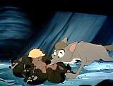 Pecos Bill raised by a pack of coyotes
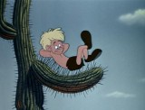  Pecos Bill, as a young boy, lying on a cactus | 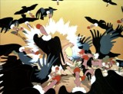  Pecos Bill attacking vultures by saving Widowmaker's life
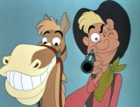  Pecos Bill aiming his pistol | 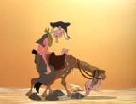  Pecos Bill and Widowmaker thirsty
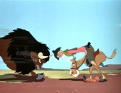  Pecos Bill butting a buffalo's head | 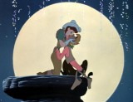  Pecos Bill and Slue-Foot Sue kissing
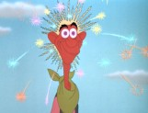  Pecos Bill lovesick | 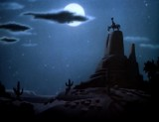  Pecos Bill and Widowmaker howling at the moon where Slue-Foot Sue stays

The Birth of Pecos Bill
A Texas Tall Tale
retold by
S. E. Schlosser
Well now Pecos Bill was born in the usual way to a real nice cowpoke and his wife who were journeying west with their eighteen children. Bill's Ma knew right from the start that he was something else. He started talkin' before he was a month old, did his teething on his Pa's bowie knife and rode his first horse jest as soon as he learned to sit up on his own. When he started to crawl, Pecos Bill would slither out of the wagon while his Mama was cookin' supper and wrestle with the bear cubs and other wild animals that roamed the prairies.
Yep, the whole family was expecting great things of little Bill; until they lost him in the drink. Seems they took the wagons over the Pecos River while Pecos Bill was taking a nap and he got bounced out of the back and swept downstream afore anyone missed him. If he hadn't taught himself to swim right-quick, he would have been a goner!
Right about the time Pecos Bill was drying out and trying to get a fix on where he was, a Mama Coyote came along and decided to adopt the poor waif and raise him with the rest of her pups. So Pecos Bill spent the first fifteen years of his life running around with the coyote pack, howling to the moon, chasing prey across the prairies, and having the time of his life.
Pecos Bill plumb forgot all about his real family, until the day he turned sixteen and his older brother came along. He was punchin' a herd of long-horn cattle and had brought them down to drink from the Pecos River. The ol' cowpoke took one look at Pecos Bill and knew he'd found his long-lost brother, on account of he looked jest like their Ma, who'd died of a broken heart after they lost little Bill in the river.
"See here, ain't you Pecos Bill, my little brother?" demanded the cowpoke of Pecos Bill when he came jumping over a giant log to run about in the field and howl at the full moon.
"Don't think so," said Pecos Bill. "I'm a coyote! Listen to me howl!" Pecos Bill let out a horrendous shout and scampered about the field on all fours. He scared the herd so bad that the long horns almost stampeded.
"You stop that!" Bill's brother shouted after he got the cattle calmed down. "And tell me this; how come you ain't got a long bushy tail if you're a coyote."
That was a tricky question. Pecos Bill thought about it for a long time.
"I got fleas," he volunteered. "And I howl at the moon!"
"Everybody in Texas has fleas and howls at the moon. That ain't no excuse," said his big brother. "Any how, you can walk upright like a normal person and you can talk too. That ain't what a coyote does."
"I guess you're right," said Pecos Bill.
"'Course I'm right. I'm your big brother and I outta know," snapped the cowpoke. "It's about time you stopped foolin' around on the prairie and became a cowboy like all the rest of us."
That made good sense to Pecos Bill. So he bid farewell to the coyote pack and went out west with his brother to learn to be a cowboy. Soon as he learned the ropes some, Pecos Bill began to realize that the cowboys needed some new tricks to help them cope with them stubborn longhorns. The cowboys kept getting the cows mixed up, which made the owners mad, so Pecos Bill invented the branding iron so they could put a mark on each cow telling everybody who owned it. Then he noticed that the other cowboys were having trouble making the wilder cows behave. Now whenever Pecos Bill saw a cow misbehavin', he'd jump on its back and ride it until it had bucked and kicked itself into behaving better. But the other cowboys weren't so skilled as Bill, so he invented the lasso to help them tame the wild cows.
Pecos Bill's brother was right proud of him. "Not bad for a kid raised by coyotes," he told his baby brother. "In another couple of years, you'll be the toughest cowboy in the world."
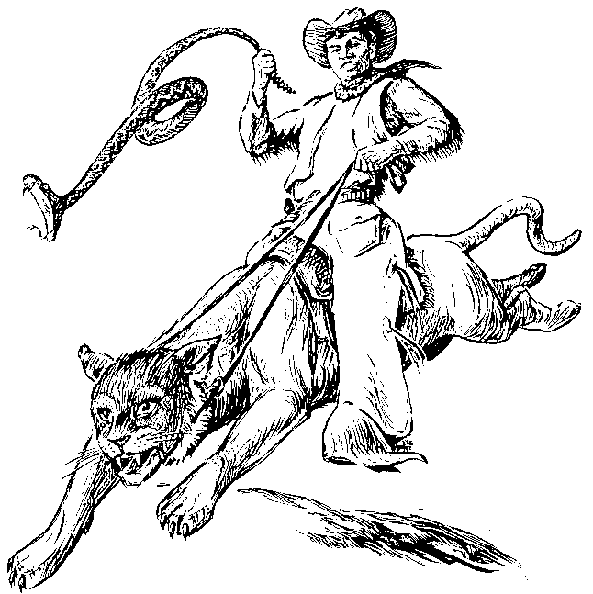

Pecos Bill and Slue-foot Sue
A Texas Tall Tale
retold by S. E. Schlosser 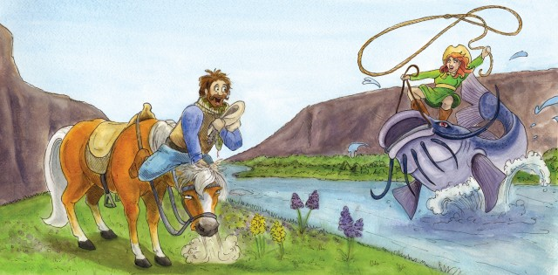
Now, Pecos Bill had a way with wimmen. No doubt. He had dozens of wives during his time. But his one true love was Slue-foot Sue. She was his first wife - and she could ride almost as good as Bill himself.
Bill first saw Slue-foot Sue ridin' a catfish down the Rio Grande. She was riding standing up and holdin' on with only one hand so she could take pot-shots at the clouds with her six-shooter. Was making a right pretty pattern too. Bill jest went head over heels for her. Proposed on the spot. They was married the next day too.
Sue was dressed in one of them white jobs with the large hoops. Looked plumb beautiful. Right after they was married, Sue insisted Bill prove how much he loved her by letting her ride his horse, Widow-maker. Bill couldn't talk her out of it, so Sue climbed on that great devil of a horse.
Well, Widow-Maker bucked like a maniac, jest as you'd expect. Sue was thrown off - clear up to the clouds. Luckily, Sue was still wearing her springy hoop. When she hit the ground, she bounced up again. But we all soon realized Sue couldn't stop bouncing. She bounced so high she kept hitting her head on the moon. She was crying and crying buckets of tears, and throwin' kisses to her new husband. But even he couldn't stop her bouncing.
We waited three days and four nights. Finally, even Bill realized that she was gonna starve to death before she stopped bouncing, so he had to shoot her. It was a cryin' shame. Well, time heals wounds, and Bill finally got married again. And again. And again. But I'm tellin' you, he never felt the same about another woman as he felt for his first wife, Slue-foot Sue.

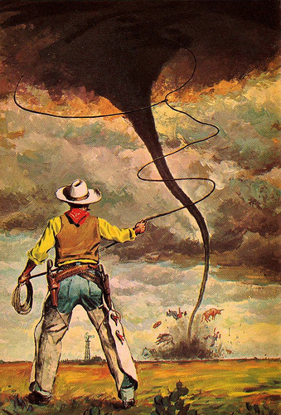
Pecos Bill Rides a Tornado
A Kansas Tall Tale
retold by S.E. Schlosser
Now everyone in the West knows that Pecos Bill could ride anything. No bronco could throw him, no sir! Fact is, I only heard of Bill getting' thrown once in his whole career as a cowboy. Yep, it was that time he was up Kansas way and decided to ride him a tornado.
Now Bill wasn't gonna ride jest any tornado, no ma'am. He waited for the biggest gol-durned tornado you ever saw. It was turning the sky black and green, and roaring so loud it woke up the farmers away over in China. Well, Bill jest grabbed that there tornado, pushed it to the ground and jumped on its back. The tornado whipped and whirled and side-winded and generally cussed its bad luck all the way down to Texas. Tied the rivers into knots, flattened all the forests so bad they had to rename one place the Staked Plains. But Bill jest rode along all calm-like, give it an occasional jab with his spurs.
Finally, that tornado decided it wasn't getting this cowboy off its back no-how. So it headed west to California and jest rained itself out. Made so much water it washed out the Grand Canyon. That tornado was down to practically nothing when Bill finally fell off. He hit the ground so hard it sank below sea level. Folks call the spot Death Valley.
Anyway, that's how rodeo got started. Though most cowboys stick to broncos these days.

The Death of Pecos Bill
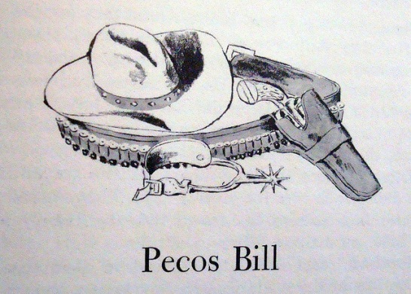
Retold by S. E. Schlosser
Now, Pecos Bill didn't live forever. Nope, not even Bill could figure out how to do that. Here's how he died.
When Bill was gettin' on in years, a Boston man came down to New Mexico for a visit. He fancied himself a bit of a cowboy. Got himself one of them mail-order suits, don't ya know. The ones with the lizard skin boots, a shiny brass belt buckle, a new pair of blue jeans and a huge ten gallon hat with not a speck of dust on it. Well, when Pecos Bill saw him trying to swagger into a bar, he jest lay down on the sidewalk and laughed himself to death!

Solutions: Pecos Bill Song
Now Pecos Bill was quite a cowboy down in Texas
Why, he's the Western Superman to say the least
He was the roughest, toughest critter, never known to be a quitter
'Cause he never had no fear of man nor beast
So yippee-i-ay-i-ya, yippee-i-o
He's the toughest critter west of the Alamo
Once he roped a raging cyclone out of nowhere
Then he straddled it and settled down with ease
And while that cyclone bucked and flitted, Pecos rolled a smoke and lit it
And he tamed that ornery wind down to a breeze
So yippee-i-ay-i-ya, yippee-i-o
He's the toughest critter west of the Alamo
Now once there was a drought that spread all over Texas
So to sunny Californy he did go
And though the gag is kind of corny, he brought rain from Californy
And that's the way we got the Gulf of Mexico
So yippee-i-ay-i-ya, yippee-i-o
He's the toughest critter west of the Alamo
Now once a band of rustlers stole a herd of cattle
But they didn't know the herd they stole was Bill's
And when he caught them crooked villains
Pecos knocked out all their fillings
That's the reason why there's gold them thar hills
So yippee-i-ay-i-ya, yippee-i-o
He's the toughest critter west of the Alamo
Pecos lost his way while traveling in the desert (Water, water, water...)
It was ninety miles across the burning sand (Water, water, water...)
He knew he'd never reach the border (Water...)
If he didn't get some water (Water...)
So he got a stick and dug the Rio Grande
While a tribe of painted Indians did a war-dance
Pecos started shooting up their little game
He gave those redskins such a shakeup
That they jumped out of their makeup
That's how the Painted Desert got its name
So yippee-i-ay-i-ya, yippee-i-o
He's the toughest critter west of the Alamo
While reclining on a cloud high over Texas
With his guns he made the stars evaporate
Then Pecos saw them stars declining
So he left one brightly shining
As the emblem of the Lone Star Texas State
TEACHER COPY
Listen to the following tall tale. Then complete the text.

Frozen Dawn
retold by
S. E. Schlosser

One winter, it was so cold that the dawn froze solid. The sun got caught between two ice blocks, and the earth iced up so much that it couldn't turn. The first rays of sunlight froze halfway over the mountain tops. They looked like yellow icicles dripping towards the ground.
Now Davy Crockett was headed home after a successful night hunting when the dawn froze up so solid. Being a smart man, he knew he had to do something quick or the earth was a goner. He had a freshly killed bear on his back, so he whipped it off, climbed right up on those rays of sunlight and began beating the hot bear carcass against the ice blocks which were squashing the sun. Soon a gush of hot oil burst out of the bear and it melted the ice. Davy gave the sun a good hard kick to get it started, and the sun's heat unfroze the earth and started it spinning again. So Davy lit his pipe on the sun, shouldered the bear, slid himself down the sun rays before they melted and took a bit of sunrise home in his pocket.

One ______________, it was so ____________ that the dawn ___________ solid. The sun got _____________ between two ____________________, and the earth _____________ up so much that it couldn't ______________. The first _____________ of sunlight froze halfway over the mountain_______________. They looked like yellow ________________ dripping _____________ the ground.
Now Davy Crockett was ______________ home after a ___________________ night hunting when the dawn ____________ up so solid. Being a _____________ man, he knew he had to do something ___________ or the ____________ was a goner. He had a _____________ killed bear on his ____________, so he whipped it off, _____________ right up on those ___________ of sunlight and ____________ beating the hot bear carcass against the ______ blocks __________ were squashing the sun. Soon a gush of hot oil ____________ out of the bear and it _____________ the ice. Davy ____________ the sun a good hard kick to get it ___________, and the sun's heat ____________ the earth and started it _______________ again. So Davy ____________ his pipe on the sun, _______________ the bear, _____________ himself down the sun __________ before they ____________ and took a bit of ______________ home in his pocket.

TEACHER: SOLUTIONS
Mississippi Mosquitoes
retold by
S. E. Schlosser
The sentences of the following tale have been scrambled. Cut out the sentences and glue them on a new sheet in the correct order.

A visitor to Mississippi decided to take a walk along the river in the cool of the evening.
His host warned him that the mosquitoes in the area had been acting up lately, tormenting the alligators until they moved down the river.
But the visitor just laughed and told his host he wasn't to be put off from his evening walk by a few mosquitoes.
As he promenaded beside the flowing Mississippi, he heard the whirling sound of a tornado.
Looking up, he saw two mosquitoes as big as elephants descend upon him.
They lifted him straight up in the air and carried him out over the river.
"Shall we eat him on the bank or in the swamp?" he heard one ask the other.
"We'd better eat him on the bank," said the other. "Or else the big mosquitoes in the swamp will take him away from us."
Frightened near to death, the man lashed out at the mosquitoes until they lost their grip and dropped him into the river.
He was carried two miles downstream before he was fished out by a riverboat pilot.
The man left Mississippi the next day, and has never gone for another walk from that day to this.

Solutions:

Mull de Grau
Mull de Grau was a wicked witch who once lived on Gully Road in what is now Newark, New Jersey. She took delight in the misery of others, and made things miserable for the folks living near her. If a neighbor slighted (angered) her, she would sour their milk. If anyone called her a witch, she made their dogs turn vicious (bad and aggressive). People were very cautious around Mull de Grau. When a new family moved in, their grown-up son got fed up with the witch's rude behavior toward his mother and told her off. That night, an evil black dog...
Complete the tale. Use your Tall Tale Recipe and your Writing Tall Tales model sheet to plan the tale. Include several comparisons to show the great dangers, the witche's meanness and your hero's courage.
Proofread your tale carefully before uploading it.
Bring a printout to class for peer-conferencing.

Moll DeGrow
A New Jersey Spooky Story
retold by
S. E. Schlosser

Moll DeGrow was a wicked witch who once lived on Gully Road in what is now Newark, New Jersey. She took delight in the misery of others, and made things miserable for the folks living near her. If a neighbor slighted her, she would sour their milk. If anyone called her a witch, she made their dogs turn vicious. People were very cautious around Moll De Grow.
When a new family moved in, their grown-up son took offense with the witch's rude behavior toward his mother and told her off. That night, an evil black dog with glowing red eyes emerged from the woods in front of his horse. The horse bolted and the dog raced after it,leaping up to bite at his tail and sides. The young man was struck by a low-hanging branch and fell lifeless to the ground. The hound howled once in triumph and then disappeared in a puff of acrid smoke, leaving the terrified horse to walk trembling back to its dead master and stand guard until his body was found.
Folks put up with Moll DeGrow for many years. But then there came a rash of unexplained infant deaths. People soon realized that Moll DeGrow had a grudge against each of the families that had lost a child. When she was accused by a hysterical mother of causing the death of her baby girl, Moll DeGrow just laughed and didn't deny it. This was the last straw for the local residents. They formed a mob and went to Gully Road to burn the witch to death. But when they reached her house, Moll DeGrow was already dead, sitting bolt upright in her chair with a cruel smile on her lifeless face.
Moll DeGrow was buried in the Mount Prospect Cemetery on Gully Road, and her malicious ghost continued to haunt the place long after her body turned to dust.
Use for text market activity


The Birth of Paul Bunyan
retold by
S. E. Schlosser
Now I hear tell that Paul Bunyan was born in Bangor, Maine. It took five giant storks to deliver Paul to his parents. His first bed was a lumber wagon pulled by a team of horses. His father had to drive the wagon up to the top of Maine and back whenever he wanted to rock the baby to sleep.

As a newborn, Paul Bunyan could hollar so loud he scared all the fish out of the rivers and streams. All the local frogs started wearing earmuffs so they wouldn't go deaf when Paul screamed for his breakfast. His parents had to milk two dozen cows morning and night to keep his milk bottle full and his mother had to feed him ten barrels of porrige every two hours to keep his stomach from rumbling and knocking the house down.

Within a week of his birth, Paul Bunyan could fit into his father's clothes. After three weeks, Paul rolled around so much during his nap that he destroyed four square miles of prime timberland. His parents were at their wits' end!

They decided to build him a raft and floated it off the coast of Maine. When Paul turned over, it caused a 75 foot tidal wave in the Bay of Fundy. They had to send the British Navy over to Maine to wake him up. The sailors fired every canon they had in the fleet for seven hours straight before Paul Bunyan woke from his nap! When he stepped off the raft, Paul accidentally sank four war ships and he had to scramble around sccooping sailors out of the water before they drowned.
After this incident, Paul's parents decided the East was just too plumb small for him, and so the family moved to Minnesota.

