Understanding Shakespeare
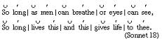
Iambic Pentameter
Iambic Pentameter School Project, Dance, Sing, Clap, Enjoy
http://www.youtube.com/watch?v=akcHE2do8_M
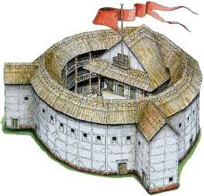
The Globe Theatre – original language
http://www.youtube.com/watch?v=gPlpphT7n9s

Hamlet, soliloquy
Rowan Atkinson gives advice to Shakespeare:
http://www.youtube.com/watch?v=HvQ_p4oh-Zw

- Richard Burton, 1964
http://www.youtube.com/watch?v=lsrOXAY1arg&list=RDqjMKBCyf2pQ
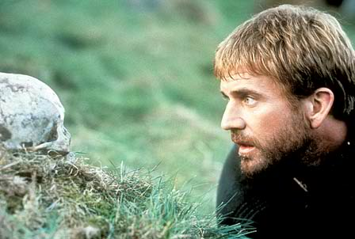
- Mel Gibson, 1990 (Alas, poor Yorik)
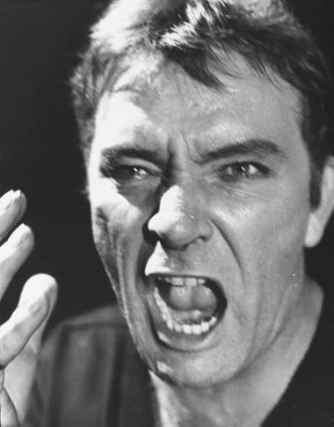
http://www.youtube.com/watch?v=UbxMhvcxJJc

- Kenneth Branagh, 1996 (Soliloquy)
http://www.youtube.com/watch?v=7Fd3_IVNJE0&list=RD5JgKa9hBWvU
- Ethon Hawke,2000 (Soliloquy)
http://www.youtube.com/watch?v=-YHMYkUrV7A&list=RDqjMKBCyf2pQ
- Hamlet Rap, 2009
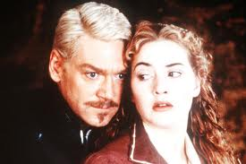
http://www.youtube.com/watch?v=qjMKBCyf2pQ&list=RD5JgKa9hBWvU

Understanding Shakespeare
- Thee, Thou, Thy and Thine (You and Your)
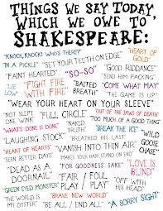
It’s a common myth that Shakespeare never uses the words “you” and “your” – actually, these words are commonplace in his plays. However, he also uses the words “thee / thou” instead of “you” and the word “thy / thine” instead of “your”. Sometimes he uses both “you” and “thy” in the same speech. This is simply because in Tudor England the older generation said “thee” and “thy” to denote a status or reverence for authority. Therefore when addressing a king the older “thou” and “thy” would be used, leaving the newer “you” and “your” for more informal occasions.
- Art (Are)
The same is true of “art”, meaning “are”. So a sentence beginning “thou art” simply means “You are”.
- Ay (Yes)
“Ay” simply means “yes”. So, “Ay, My Lady” simply means “Yes, My Lady.”
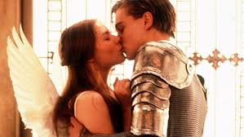
- Would (Wish)
Although the word “wish” does appear in Shakespeare, like when Romeo says “I wish I were a cheek upon that hand,” we often find “would” used instead. For example, “I would I were …” means “I wish I were…”
- Give Me Leave To (Allow Me To)
“To give me leave to”, simply means “To allow me to”.
- Alas (Unfortunately)
“Alas” is a very common word that isn’t used today. It simply means “unfortunately”, but in modern English there isn’t an exact equivalent.
- Sirrah (Sir)
“Sirrah” means “Sir” or “Mister”.
- -eth
Sometimes the endings of Shakespearian words sound alien even though the root of the word is familiar. For example “speaketh” simply means “speak” and “sayeth” means “say”.
- Don’t, Do and Did
A key absence from Shakespearian English is “don’t”. This word simply wasn’t around then. So, if you said “don’t be afraid” to a friend in Tudor England, you would have said “be not afeard.” Where today we would say “don’t hurt me,” Shakespeare would have said “hurt me not.” The words “do” and “did” were also uncommon, so rather than saying “what did he look like?” Shakespeare would have said “what looked he like?”
It is important to note that when Shakespeare was alive, language was in a state of flux and many modern words were being integrated into the language for the first time. Shakespeare himself coined many new words and phrases. Shakespeare’s language is therefore a mixture of the old and the new.

Understanding Hamlet – soliloquy –
the whips and scorns of time to feel old and tired
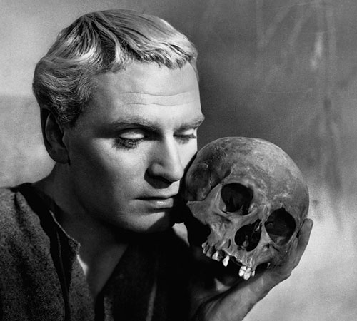
the proud man’s contumely an arrogant person who shows no respect
the pangs of despised love your love is not returned
the law’s delay justice has not been done
the insolence of office inefficient offices, workplace
the spurns that patient merit of the unworthy takes you are nice to someone who treats you badly
their currents turn awry A reference to the sea and its tides: "Because of their thoughts, their currents become unstable."
To be, or not to be--that is the question:
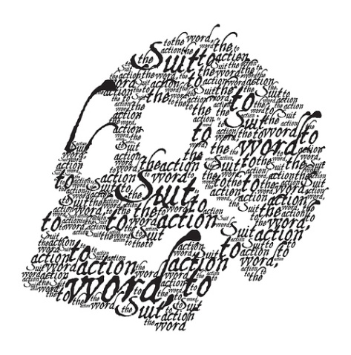
Whether 'tis nobler in the mind to suffer
The slings and arrows of outrageous fortune
Or to take arms against a sea of troubles
And by opposing end them. To die, to sleep--
No more--and by a sleep to say we end
The heartache, and the thousand natural shocks
That flesh is heir to. 'Tis a consummation aim
Devoutly to be wished. To die, to sleep--
To sleep--perchance to dream: ay, there's the rub,
maybe the rub= the problem (turning point!)
For in that sleep of death what dreams may come
When we have shuffled off this mortal coil, troubles of daily life
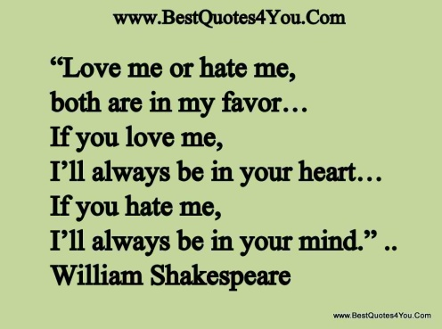
Must give us pause. There's the respect
That makes calamity of so long life.
For who would bear the whips and scorns of time,
Th' oppressor's wrong, the proud man's contumely
The pangs of despised love, the law's delay,
The insolence of office, and the spurns
That patient merit of th' unworthy takes,
When he himself might his quietus make rest/retirement
With a bare bodkin? Who would fardels bear, naked blade burden
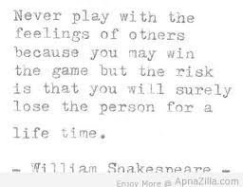
To grunt and sweat under a weary life,
But that the dread of something after death,
The undiscovered country, from whose bourn
No traveller returns, puzzles the will,
And makes us rather bear those ills we have
Than fly to others that we know not of?
Thus conscience does make cowards of us all, knowing/WISSEN
And thus the native hue of resolution hue - (Farbton) red for courage
Is sicklied o'er with the pale cast of thought, pale – colourless for cowardice
And enterprise of great pitch and moment
With this regard their currents turn awry unstable thoughts
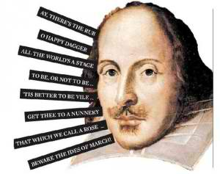
And lose the name of action. -- Soft you now,
The fair Ophelia! -- Nymph, in thy orisons
Be all my sins remembered.
To Be Or Not To Be” Soliloquy Translation/Interpretation
The question for him was whether to continue to exist or not –To die. To sleep. To sleep. Perhaps to dream. Yes, that was the problem, because in that sleep of death the dreams we might have when we have shed this mortal body must make us pause. Who would carry this load, sweating and grunting life if it weren’t for the dread of the after life – that unexplored country from whose border no traveler returns? That’s the thing that confounds us and makes us put up with those evils that we know rather than hurry to others that we don’t know about. So thinking about it makes cowards of us all, and it follows that the first impulse to end our life is obscured by reflecting on it. And great and important plans are diluted to the point where we don’t do anything.

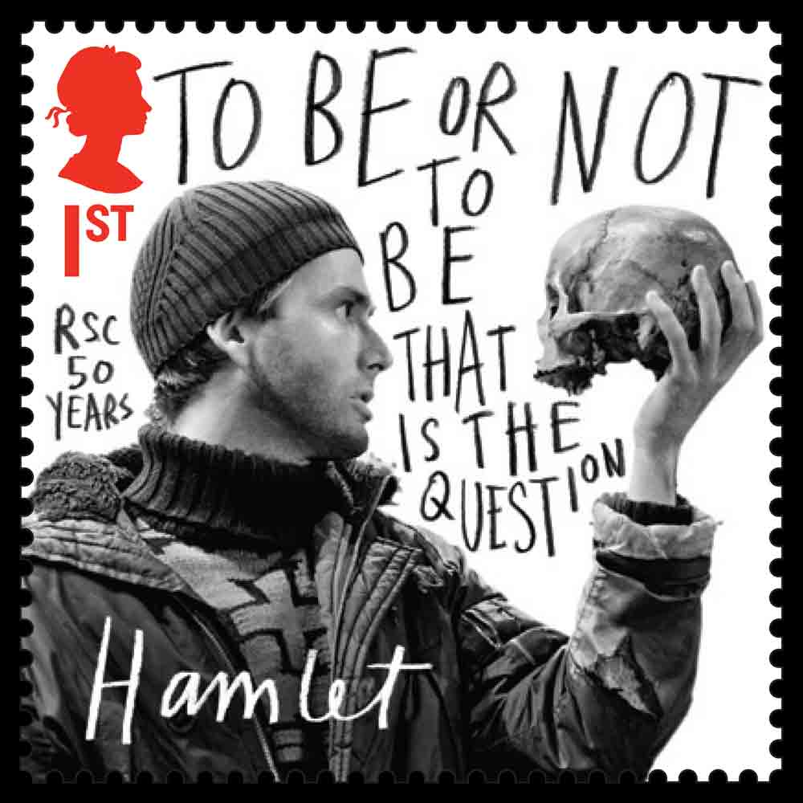
This soliloquy, probably the most famous speech in the English language, is spoken by Hamlet in Act III, scene i (58–90). His most logical and powerful examination of the theme of the moral legitimacy of suicide in an unbearably painful world, it touches on several of the other important themes of the play. Hamlet poses the problem of whether to commit suicide as a logical question:
“To be, or not to be,” that is, to live or not to live.
He then weighs the moral ramifications of living and dying. Is it nobler to suffer life, “[t]he slings and arrows of outrageous fortune,” passively or to actively seek to end one’s suffering? He compares death to sleep and thinks of the end to suffering, pain, and uncertainty it might bring, “[t]he heartache, and the thousand natural shocks / That flesh is heir to.” Based on this metaphor, he decides that suicide is a desirable course of action, “a consummation / Devoutly to be wished.” But, as the religious word “devoutly” signifies, there is more to the question, namely, what will happen in the afterlife. Hamlet immediately realizes as much, and he reconfigures his metaphor of sleep to include the possibility of dreaming; he says that the dreams that may come in the sleep of death are daunting, that they “must give us pause.”
He then decides that the uncertainty of the afterlife, which is intimately related to the theme of the difficulty of attaining truth in a spiritually ambiguous world, is essentially what prevents all of humanity from committing suicide to end the pain of life. He outlines a long list of the miseries of experience, ranging from lovesickness to hard work to political oppression, and asks who would choose to bear those miseries if he could bring himself peace with a knife, “[w]hen he himself might his quietus make / With a bare bodkin?” He answers himself again, saying no one would choose to live, except that “the dread of something after death” makes people submit to the suffering of their lives rather than go to another state of existence which might be even more miserable. The dread of the afterlife, Hamlet concludes, leads to excessive moral sensitivity that makes action impossible: “conscience does make cowards of us all. . thus the native hue of resolution / Is sicklied o’er with the pale cast of thought.”
In this way, this speech connects many of the play’s main themes, including
- the idea of suicide and death
- the difficulty of knowing the truth in a spiritually ambiguous universe
- the connection between thought and action.
In addition to its crucial thematic content, this speech is important for what it reveals about the quality of Hamlet’s mind. His deeply passionate nature is complemented by a relentlessly logical intellect, which works furiously to find a solution to his misery. He has turned to religion and found it inadequate to help him either kill himself or resolve to kill Claudius. Here, he turns to a logical philosophical inquiry and finds it equally frustrating.
