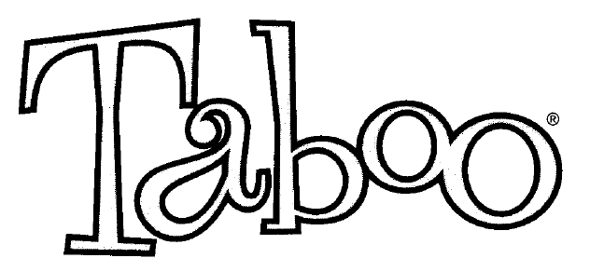
Taboo is a word guessing game. The objective of the game is for a player to have their partners guess the word on the top of the player's card without using the word itself or the additional words listed on the card.
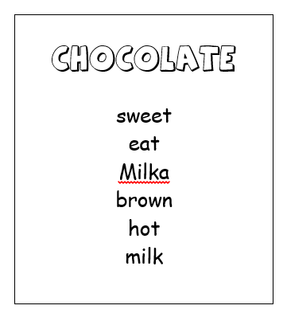
guess word

TABOO words
- Students go together in groups (of 4 to 5 students). Teams take turns guessing words.
Team A chooses one of their players to be their first “Clue-giver” and that player picks a card. The clue-giver’s teammates are not allowed to see the cards and they should sit opposite the clue-giver, waiting to shout out their answers.
- As soon as a card is drawn, turn over the timer (e.g. 30 seconds or 60 seconds) and the clue-giver starts giving clues that will make teammates say the guess word.
RULES FOR CLUES:
- No form or part of ANY printed word on the card may be given as a clue. For example: If the guess word is “spaceship”, “space” or “ship” cannot be given as a clue. If “drink” is a taboo word, “drunk” cannot be given as a clue etc.
- You cannot say the guess word “sounds like” or “rhymes with” another word.
- No initials or abbreviations if the words they represent are included on the card. For example: “TV” cannot be used if “television” is on the card.
- As the clue-giver gives clues, his or her teammates shout out possible words trying to say the guess word. There is no penalty for wrong guesses.
- Each time a teammate shouts out the correct guess word, the team scores a point. The clue-giver then picks another card. When the time is over, the number of correctly guessed words is the number of points scored.
During the clue-giver’s turn either the teacher or another student should watch the clue-giver and the cards. If a taboo word is used or if any rules are broken, no point for this card will be awarded and the clue-giver has to pick a new card. Another student should watch the time and stop if the time is over.
When all players have had one turn as clue-giver, the team with the most points wins the game.
HAVE FUN !
SPAGHETTI  pasta  noodles  sauce  Italian  tomato |  | CACTUs  plant  green  needle  desert  water |  | pirate  ship  eye patch  sword  parrot  evil
Coffee  brown  hot  flavored  iced  brewed |  | Harry potter  wizard  Hogwarts  book  spells  glasses |  | goat  cheese  milk  farm  beard  animal
test  study  learn  school  teacher  answer |  | raincoat  rain  yellow  wet  umbrella  outside |  | God  creator  universe  religion  prayer  Bible
father  parent  husband  dad  family  mother/mum |  | eyes  two  open and close  see  face  color |  | Fridge  cold  kitchen  food  inside  stock
DANCING  disco  move  body  feet  floor |  | Rose  red  flower  love  Valentine’s Day  thorn |  | WORD  read  say  letters  sentence  book
MOUNT EVEREST  tall  highest  Nepal  climb |  | SKY  heaven  up  clouds  sun  night |  | MARATHON  run  long  New York  miles  kilometers
spring  season  warm  flowers  rain  summer / fall / winter |  | JUSTIN BIEBER  singer  popular  like  male  girls |  | BART SImpson  cartoon  character  boy  skateboard  Homer
HAIR  color  head  style  cut |  | Math  numbers  school  plus  minus  subject |  | NEWSPAPER  read  information  daily  coffee  morning
Barack OBAMA  president  USA  black  White House  powerful |  | MUSHROOM  forest  fungus  soup  grow  ground |  | face  eyes  mouth  nose  head  pretty
MERCURY  planet  element  solar system  supermarket |  | chocolate  sweet  eat  Milka  brown  hot  milk |  | TREE  green  grow  plant  big  leaves  trunk
I Pod  music player  MP3  Apple  I phone / I Pad  songs |  | TEA  time  England  hot  cup  iced |  | Big Ben  London  clock  tower  bells  palace
HOUSE  live  family  white  garden |  | Bible  testament  book  holy  write  religion |  | Birthday Cake  candles  celebrate  born  baking  sweet
SPANISH  language  country  football/soccer  Portugal  Class |  | HAMMER  nail  tool  auction  shark |  | Book  read  paper  page  novel
HAPPINESS  feeling  good  nice  bad  positive |  | dictionary  look up  book  words  definition  meaning |  | PARIS  France  Eiffel Tower  love  Champs Elysées
DISHWASHER  machine  product  kitchen  dirty  plate |  | T-Shirt  wear  white  on  sleeve |  | ICE Cream  cone  desert  freezer  cold  flavor
VOLDEMORT  Harry Potter  name  villain  bad  wizard |  | FEAR  scared  terror  spiders  claustrophobic |  | PENCIL  write  pen  hold  hand  use
run  race  legs  feet  fast  walk |  | TOYOTA  car  drive  brand  Japanese  road |  | LIPSTICK  red  lips  beautiful  women  purse
SUPERMAN  fly  strong  Kryptonite  blue  red |  | GLASS  drink  water  thirsty  wine  beer |  | WATER  drink  faucet  wet  H₂O  glass
Heart  attack  death  pain  hospital  faint  life |  | CUP  drink  coffee  hot  sip |  | CHALK  school  blackboard  white  write
SMARTPHONE  cellular  call  internet  dial  handy |  | ROOF  house  part  top |  | Vampire  blood  teeth  monster  dead  twilight
MICROWAVE  hot  food  appliance  electric  kitchen |  | GLASSES  see  wear  sun  eyes  face |  | tennis  sport  ball  racket  yellow  Grand Slam
weather  hot  cold  sun  rain  forecast |  | Hotel  stay  vacation/holiday  motel  concierge |  | APPLE  fruit  red  banana  orange
camping  mountain  tent  outdoor activity  fire |  | hospital  clinic  doctor  dentist  sick |  | History  before  old  subject  ancient
Envelope  letter  post office  mail  postman |  | pillow  head  sleep  bed  comfortable |  | battery  phone  power  electric  charge

