Big Names in Literature
  - Overview of project tasks
In this project each group will present a famous contemporary writer and give examples of his/her works. The main steps in this project are:
- Present the novels that you have read to your group-members.
- Compare and contrast the novels. What do they have in common? Can you find any features that seem to be typical of this writer?
- Find some information about the writer and his/her biography. Make sure you only focus on interesting, relevant details.
- Present your writer and his/her works to the class. Include references to the short story that the class has read and help your classmates see the typical features in the story (if possible).
Follow the detailed instructions below:
I wish I could…
I wi
I

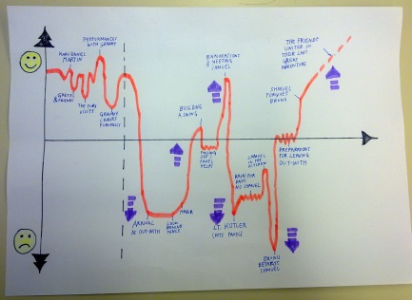
Plot and problem
Draw a plot diagram of your story. Show the ups and downs in one of the main characters’ lives. If you feel that two main characters are really important, produce two plot diagrams to show their different points of view.
Add a few speech or thought bubbles to show the main characters’ problems, wishes, hopes…

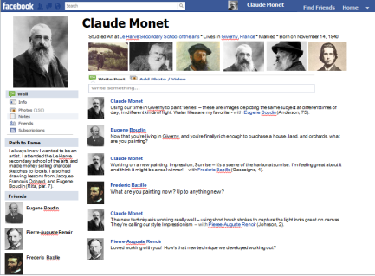
Characters
Create a fake facebook page for each of the main characters. Share the work in your group. Your facebook pages should show the characters personality traits, lifestyle, problems and goals in life.
Use the templates that you find on moodle (ppt or word). Your facebook page must include
- basic profile data (age, family info, education, a few fitting pictures….)
- friends (other characters from the book)
- several “What’s on your mind” postings referring to events in the book. Use these postings to show the main events in the novel and to show the character’s development. Add pictures to make this more realistic and to help your classmates understand the characters and their problems, goals and wishes.
- several posts from friends
- anything else you find fitting (likes, ….)

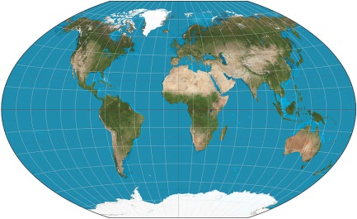
Setting
Where does the story play? You might include the info about the setting in your facebook pages or show the setting in other creative ways: maps, postcards, “selfies”.
What role does the setting play? Could the story play anywhere else?

Author
Present important, relevant background information about the author of your novels. Leave out unimportant biographical details. Only include facts that YOU find interesting YOURSELF and that help us understand the novels better. Use visuals to help your audience understand the main points.

Talk-show


Act out part of a talk-show in which the main characters from the different novels meet in the studio. The purpose of the talk show is to show the characters, their thoughts and secrets to your classmates.
- You will need a talk show host. The host will have to introduce the show and the guests and will lead through the program.
- In your group prepare good questions that the host will ask
- Find a common theme that you want to talk about.
- Create a fitting backdrop (a ppt slide) to create atmosphere.
- Practice your talk show so your performance will run smoothly and professionally.
- Your program should be between 10 and 15 minutes long.

In your presentation:
- Start with the talk-show and introduce the characters. Make sure your classmates get a good insight into these people’s minds and problems.
- Then present the individual novels briefly. Focus on the main events and main characters only.
- In part 3 present the author and focus on aspects that all the novels and stories have in common.
Allow 5 additional minutes for the discussion.

Assessment
Preparation and written tasks: |  |  | 
Character profiles (facebook pages) reveal a very good understanding of the characters in the book.
Plot diagrams clearly show the main events and their effects on the main character(s).

Presentation
Talk show
Intro: The host introduces the program and the topic clearly. The format is appropriate for and typical of a quality talk show. The host puts the characters into context and explains why the characters have been invited.
Questions: The questions that are asked reveal the characters’ personal situations (setting), personality traits, problems and wishes clearly.
Characters: During the discussions the characters act believably and represent the book characters and their personal situations clearly and understandably.
Presentation of individual novels:
Plot: The main events are presented clearly and logically.
Setting: The setting of each story is clearly presented. The effect of the setting on the characters or on the events is explained clearly. (if relevant).
Author: the main biographical information is presented clearly. No irrelevant details confuse the audience.
The typical features of the author’s work are presented clearly, using specific examples from the novels and stories. (style and tone, themes, characters, setting…)
Visuals: Visuals have been designed carefully and support the content.

Speaking:
- Fluency and interaction: communicates and interacts with a high degree of fluency and spontaneity.
- Range of spoken language: expresses her/himself very clearly, no restriction, very wide range of vocabulary for the task. Wide range of complex structures.
- Accuracy of spoken language: hardly any incorrect word choice, very good grammatical control, clear, natural pronunciation and intonation.

30 P

