Name_______________________________________________________ GROUP A

7ab Pölzleitner ENGLISH TEST 3 June 2010

I Reading Comprehension (5pts)
Read the text then choose the correct heading for each paragraph (A-E) from the list of headings in the box (i-viii).

An eruption in Greece
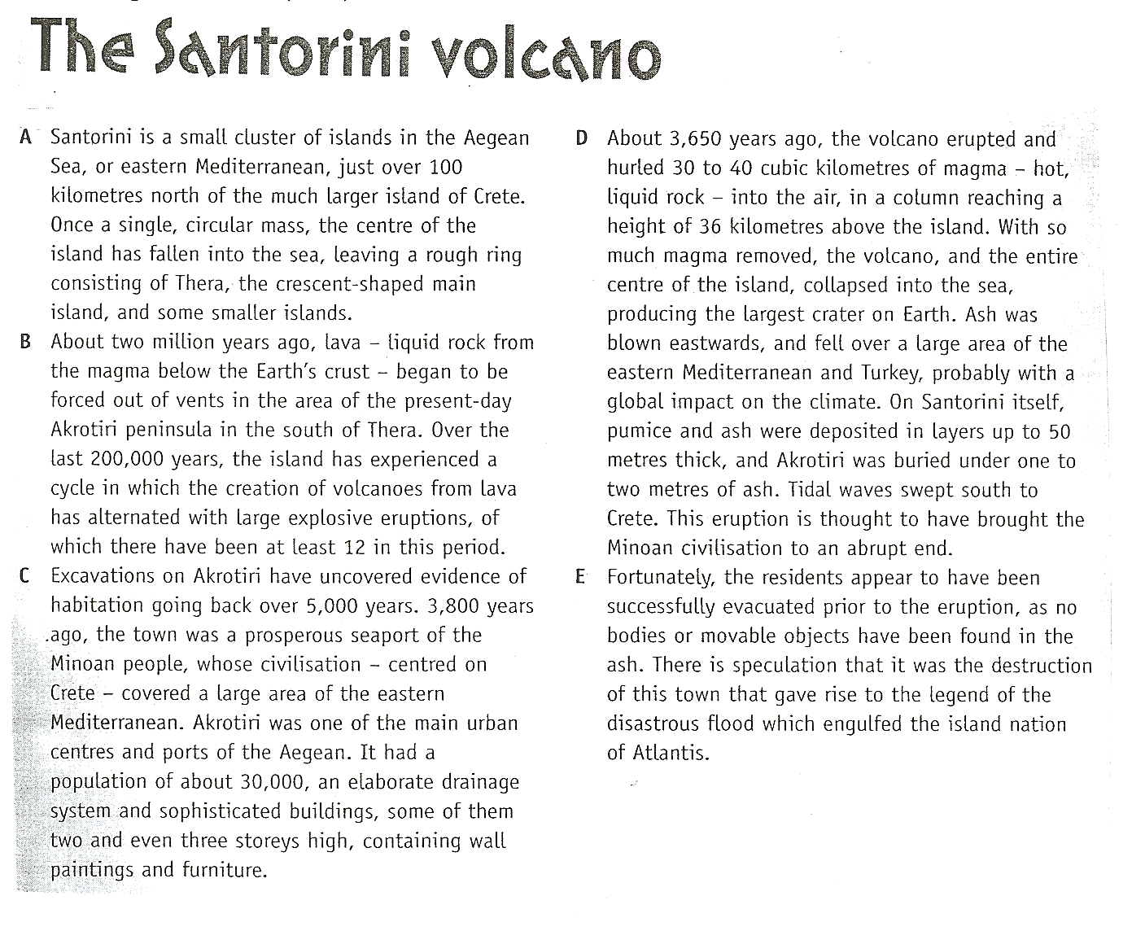

Headings

i A history of volcanic activity
ii How Santorini was destroyed
iii Santorini today
iv Lives saved – and a mythological link
v Links with volcanic eruptions elsewhere
vi How homes were constructed
vii A legend proved true
viii A wealthy settlement

Paragraph A:___________ Paragraph B: ___________ Paragraph C: __________

Paragraph D: ___________ Paragraph E: ___________
II TENSES: Postcard: 15 pts
Write a short postcard from the Nova Rock festival. Use the following words and watch your tenses. Use the words in the order they are given and add relevant details to make your postcard sound authentic.
I here since Friday // music great so far // already listen to ....// last night highlight... //
my first time here// with Toni, he already here 3 times// he says never as good as this year// lose my mobile // no problem -- old anyway -- have it 5 years// today meet Joe- friend from elementary school// not see him for ages//dye hair green//with his girlfriend// I not believe it -- together 4 years!!

III Vocabulary/Word Formation (15pts)
Read the text. Use the word in brackets to form a related word that fits in the gap.

Danvers County held an inter-schools sports day for the first time last month. The aim was to promote _________________________________(compete) with regard to sport and to encourage ___________________________________ (recognize) of the strengths and _____________________________(weak) of students from different backgrounds. The event was enjoyed by all and has been declared an _______________________________ (stand) success. More events of the same kind are planned for the future.

Interest in the event exceeded the organizers’ expectations, with over twenty schools taking part. The __________________________________ (compete) were eager to represent their schools and gave impressive ___________________________________ (perform) in all disciplines. The students spectating were appreciative: there were no signs of _________________________(behave) or ________________________________(respect) towards officials.

In view of the recent increase in drug-related incidents in Danvers County schools, many principals were initially opposed to the sports day. Their _____________________________ (perceive) of the event was that it would be creating an opportunity for trouble. They feared _______________________________ (legal) occurrences, such as drug-dealing, or even the ____________________________________ (consume) of drugs at the event. Their
_____________________________________ (advise) was to have police supervision. However, it was decided to put trust in the students’ sense of _________________________
(responsible) and on this occasion the students proved themselves to be entirely
____________________________________ (rely). There was no trouble of any kind.

III. Report Writing (65pts)
Teenagers turning 16 are pestering their parents about going out on the weekends but often parents are worried and badly informed about nightlife in Graz.
- Write a report intended for parents in Graz suggesting
- suitable places for 16 year olds
- places they should avoid and dangers they might run into
- give tips for “safe fun” for this age group.
Write about 300 words
Name_______________________________________________________ GROUP B

7ab Pölzleitner ENGLISH TEST 3 June 2010

I Reading Comprehension (5pts)
Read the text then choose the correct heading for each paragraph (A-E) from the list of headings in the box (i-viii).

An eruption in Greece

Headings

i A history of volcanic activity
ii Links with volcanic eruptions elsewhere
iii A legend proved true
iv Lives saved – and a mythological link
v How Santorini was destroyed
vi How homes were constructed
vii Santorini today
viii A wealthy settlement

Paragraph A:___________ Paragraph B: ___________ Paragraph C: __________

Paragraph D: ___________ Paragraph E: ___________
II TENSES: Postcard: 15 pts
Write a short postcard from the Nova Rock festival. Use the following words and watch your tenses. Use the words in the order they are given and add relevant details to make your postcard sound authentic.
I here since Friday // music great so far // already listen to ....// last night highlight... //
my first time here// with Toni, he already here 3 times// he says never as good as this year// lose my mobile // no problem -- old anyway -- have it 5 years// today meet Joe- friend from elementary school// not see him for ages//dye hair green//with his girlfriend// I not believe it -- together 4 years!!

III Vocabulary/Word Formation (15pts)
Read the text. Use the word in brackets to form a related word that fits in the gap.

Danvers County held an inter-schools sports day for the first time last month. The aim was to promote _________________________________(compete) with regard to sport and to encourage ___________________________________ (recognize) of the strengths and _____________________________(weak) of students from different backgrounds. The event was enjoyed by all and has been declared an _______________________________ (stand) success. More events of the same kind are planned for the future.

Interest in the event exceeded the organizers’ expectations, with over twenty schools taking part. The __________________________________ (compete) were eager to represent their schools and gave impressive ___________________________________ (perform) in all disciplines. The students spectating were appreciative: there were no signs of _________________________(behave) or ________________________________(respect) towards officials.

In view of the recent increase in drug-related incidents in Danvers County schools, many principals were initially opposed to the sports day. Their _____________________________ (perceive) of the event was that it would be creating an opportunity for trouble. They feared _______________________________ (legal) occurrences, such as drug-dealing, or even the ____________________________________ (consume) of drugs at the event. Their
_____________________________________ (advise) was to have police supervision. However, it was decided to put trust in the students’ sense of _________________________
(responsible) and on this occasion the students proved themselves to be entirely
____________________________________ (rely). There was no trouble of any kind.

III. Report Writing (65pts)
Teenagers turning 16 are pestering their parents about going out on the weekends but often parents are worried and badly informed about nightlife in Graz.
- Write a report intended for parents in Graz suggesting
- suitable places for 16 year olds
- places they should avoid and dangers they might run into
- give tips for “safe fun” for this age group.
Write about 300 words

