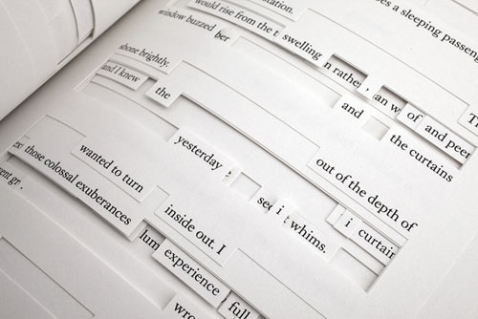
Found Poetry
Found poetry is the rearrangement of words or phrases taken randomly from other sources (such as clipped newspaper headlines, bits of advertising, handwritten cards …) in a manner that gives the rearranged words a completely new meaning.

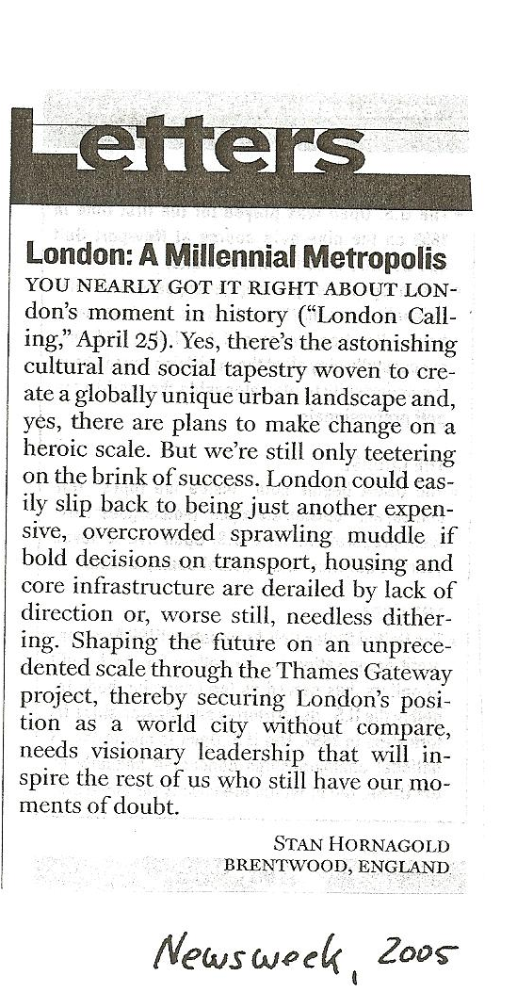
A famous example of found poetry – or “found writing” is Jonathan Safran Foer’s book Tree of Codes, which is based on The Street of Crocodiles by Bruno Schulz. Foer has used it as a canvas, cutting into and out of the pages, to arrive at an original new story.
The following examples written by GIBS students of year 7 are based on two letters to the editor of Newsweek.

London  Inspiring world city without compare  Globally unique urban landscape  Cultural tapestry woven to create  Change on a heroic scale  But we are still only teetering on the brink  derailed by lack of direction  another expensive,  overcrowded muddle,  full of doubt. | Bombay Dreams of Urbanization  on the backs of  men  women  and  children  displace  and  homeless.  Who is to blame?

