This Is Just To Say
By William Carlos Williams

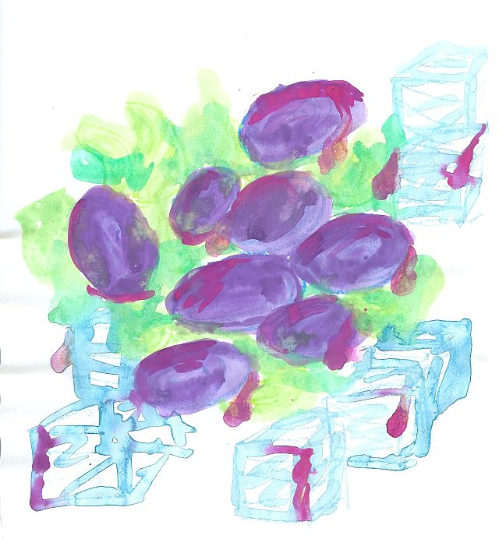
I have eaten
the plums
that were in
the icebox

and which
you were probably
saving
for breakfast

Forgive me
they were delicious
so sweet
and so cold

William Carlos Williams,''This Is Just to Say'' from The Collected Poems: Volume I, 1909-1939, copyright ©1938 by New Directions Publishing Corp. Reprinted by permission of New Directions Publishing Corp.

