What's the Story?

John Hardy was a brave little man,
He carried two guns ev'ry day.
Killed him a man in the West Virginia land,
Oughta seen poor Johnny gettin' away, Lord, Lord,
Oughta seen poor Johnny gettin' away.
John Hardy was standin' at the barroom door,
He didn't have a hand in the game,
Up stepped his woman and threw down fifty cents,
Says, "Deal my man in the game, Lord, Lord...."
John Hardy lost that fifty cents,
It was all he had in the game,
He drew the forty-four that he carried by his side
Blowed out that poor Negro's brains, Lord, Lord....
John Hardy had ten miles to go,
And half of that he run,
He run till he come to the broad river bank,
He fell to his breast and he swum, Lord, Lord....
He swum till he came to his mother's house,
"My boy, what have you done?"
"I've killed a man in the West Virginia Land,
And I know that I have to be hung, Lord, Lord...."

He asked his mother for a fifty-cent piece,
"My son, I have no change."
"Then hand me down my old forty-four
And I'll blow out my agurvatin' [sic] brains, Lord, Lord...."
John Hardy was lyin' on the broad river bank,
As drunk as a man could be;
Up stepped the police and took him by the hand,
Sayin' "Johnny, come and go with me, Lord, Lord...."
John Hardy had a pretty little girl,
The dress she wore was blue.
She come a-skippin' through the old jail hall
Sayin', "Poppy, I'll be true to you, Lord, Lord...."
John Hardy had another little girl,
The dress that she wore was red,
She came a-skippin' through the old jail hall
Sayin' "Poppy, I'd rather be dead, Lord, Lord...."
They took John Hardy to the hangin' ground,
They hung him there to die.
The very last words that poor boy said,
"My forty gun never told a lie, Lord, Lord...."
LYRICS AS REPRINTED IN ALAN LOMAX, FOLK SONGS OF NORTH AMERICA, GARDEN CITY, 1960
Read the Ballad of John Hardy. What is the story?
Highlight the main facts and write them in the box in note form.

Now read the following newspaper article about the same incident and list any differences between the poem and the newspaper article.

Check for the following aspects:
What seems to have interested the writers?
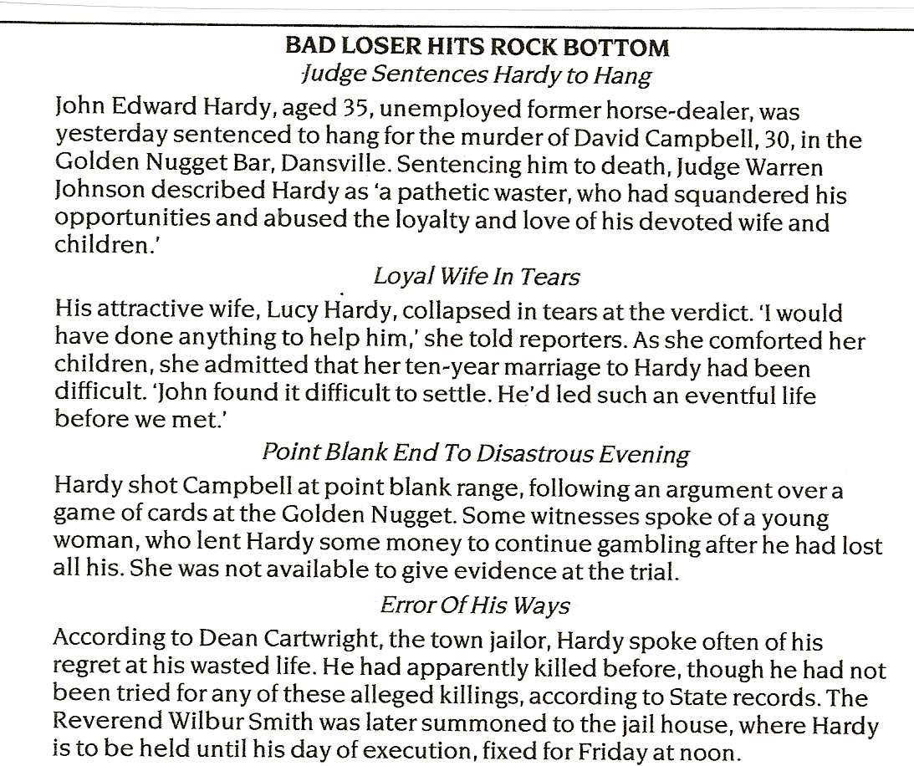
How is the story devided up?
What types of language are used?
How do you feel about the characters?

The next piece is the opening paragraph of a short story about John Hardy.
Chapter 1:
He had to get back. His thoughts were racing but, wherever they ran, they ended up at the same point: he had to get back.
The night air was cool on his face as he ran. John was shivering. From fear or cold,it made little difference. After what he'd done, there was only one place to go. Home. If only he could turn back time and make it undone. He shuddered, pictures of the last few minutes in that bar kept flashing in front of his eyes, David Campbell's face, his piercing scream and the dull thud as his body hit the floor...

What difference do you notice between the shortstory and the newspaper article?

Homework: Read the two ballads on the following page and choose one. Then do one of the following tasks:
- Write a newspaper article based on the poem.
or
- Write a short story based on the poem.
Decide which facts seem important for your text. Invent suitable details to make your text more colorful and plausible. Use the text writing recipies to help you plan and structure your article or your shortstory. Write about 300 words.
Choose one of the two ballads and write a newspaper article or a short story about the events, as if they had just happened yesterday.
Landlord, landlord,
My roof has sprung a leak.
Don't you 'member I told you about it
Way last week?
Landlord, landlord,
These steps is broken down.
When you come up yourself
It's a wonder you don't fall down.
Ten Bucks you say I owe you?
Ten Bucks you say is due?
Well, that's Ten Bucks more'n I'l pay you
Till you fix this house up new.
What? You gonna get eviction orders?
You gonna cut off my heat?
You gonna take my furniture and
Throw it in the street?
Um-huh! You talking high and mighty.
Talk on-till you get through.
You ain't gonna be able to say a word
If I land my fist on you.
Police! Police!
Come and get this man!
He's trying to ruin the government
And overturn the land!
Copper's whistle!
Patrol bell!
Arrest.
Precinct Station.
Iron cell.
Headlines in press:
MAN THREATENS LANDLORD
TENANT HELD NO BAIL
JUDGE GIVES NEGRO 90 DAYS IN COUNTY JAIL!
Langston Hughes

Ballad of the Triangle Fire

By Ruth Rubin
In the heart of New York City, near Washington Square
In nineteen eleven, March winds were cold and bare.
A fire broke out in a building ten stories high,
And a hundred and forty-six young girls in those flames did die.
On the top floor of that building, ten stories in the air
These young girls were working in an old sweatshop there;
They were sewing shirtwaists for a very low wage.
So tired and pale and worn-out! They were at a tender age.
The sweatshop was a stuffy room with but a single door;
The windows they were gray with dust from off that dirty floor;
There were no comforts, no fresh air, no light to sew thereby,
And the girls, they toiled from early morn till darkness filled the sky.
Then on that fateful day — dear God, most terrible of days!
When that fire broke out, it grew into a mighty blaze.
In that firetrap way up there with but a single door,
So many innocent working girls burned, to live no more!
A hundred thousand mourners, they followed those sad biers.
The streets were filled with people weeping bitter tears.
Poets, writers everywhere described that awful pyre,
When those young girls were trapped to die in the Triangle Fire.
© 1968 Ruth Rubin from the Sing Along Songbook, 1993 UCLEA NE Summer Institute for Union Women, New York State School of Industrial and Labor Relations, Cornell University, Ithaca, New York, 1993.

