Test 1 Poetry Quarter 7ab

TEXT I: Newspaper Article

Write a short newspaper article based upon the story told in the poem “Incendiary”.
Your article should
- Give all the important facts and ideas of the poem
- Be written for a quality paper and use formal language and clear paragraphing
- Be about 200 words long
- Have a catchy title and a lead.

Incendiary
That one small boy with a face like pallid cheese
And burnt-out little eyes could make a blaze
As brazen, fierce and huge, and red and gold
And zany yellow as the one that spoiled
Three thousand guineas worth of property
And crops at Godwin's Farm on Sunday
Is frightening – as fact and metaphor:
An ordinary match intended for
The lighting of a pipe or kitchen fire
Misused may set a whole menagerie
Of flame-fanged tigers roaring hungrily.
And frightening, too, that one small boy should set
The sky on fire and choke the stars to heat
Such skinny limbs and such a little heart
Which would have been content with one warm kiss
Had there been anyone to offer this.
Vernon Scannell
TEXT II: Diary

Write a diary entry for the main character of the novel that you have just read. Your diary entry should be based upon one of the following scenes taken from your novel. Before you start writing make a plan and decide
- What atmosphere you want to create
- What mood your character is in and
- What small insight your character ist going to gain in this scene.
- Write about 250 – 300 words.

The Passion of Artemisia
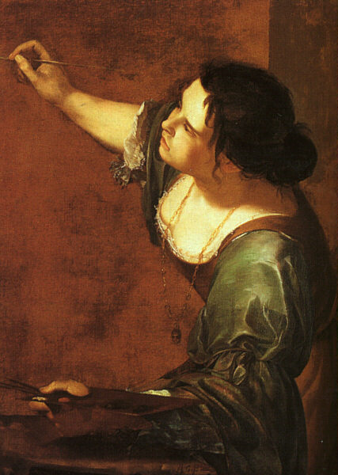
A: Although Artemisia suffers some remorse for some of the choices she makes, Susan Vreeland makes it clear that this is a woman for whom art comes first. On her husband's artistic frustrations, Artemisia ruminates, "If a person loves something above all else, if he values the work of his heart and hands, then he should naturally, without hesitation, pour into it his whole soul, undivided and pure. Great art demands nothing less."
Create a scene that shows Artemisia in this conflict between being an artist, a wife and a mother.

B:Artemisia and Pietro have just climbed up the stairs to the top of the Duomo in Florence.
Describe the scene from the point of view of Artemisia.
- Why did she want to climb to the top?
- What does she see there?
- What does she realize up there?

TEXT II: Diary

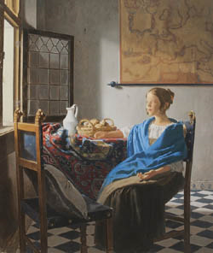
Girl in Hyacinth Blue

In the last story of the book we meet Magdalena, the girl in the painting, and learn how the painting has been created.
Write a short short-story describing

A: Magdalena's secret thoughts while being painted by her father. What does she realize in this process?

or

B: Vermeer's secret thoughts while painting his daughter.

TEXT II: Diary

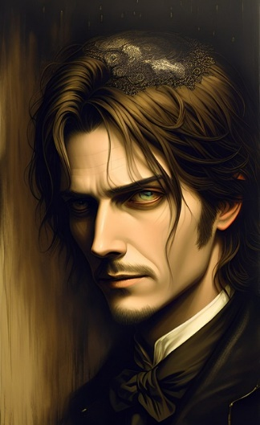
The Picture of Dorian Gray
A: Towards the end of the novel Dorian decides to change his immoral ways and be good again. He is in love with Hetty Merton, the vicar's innocent daughter, and has behaved well for a little while. Dorian wonders if the portrait has begun to change back as well, losing its sinful, awful appearance and reflecting his own improved character. He unveils the portrait to find it has become worse.

Describe this scene and show Dorian's reasoning and secret thoughts in that moment. What does Dorian realize when he sees the painting again? What were his true motifs for wanting to change his behavior?

B: After Sybil's unfortunate and bad performance in Romeo and Juliet Dorian rejects her, saying her beauty was in her art, and he is no longer interested in her if she can no longer act. When he returns home he notices that his portrait has changed.
Describe this scene,showing Dorian's thoughts and insights at that moment.

TEXT II: Diary

Girl With A Pearl Earring

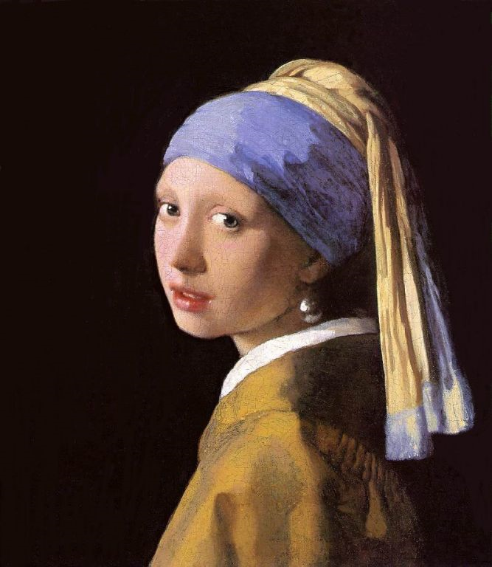
A: Towards the end of the novel Catharina finds out that her husband has painted Griet wearing her earrings. In a fit of jealousy Catharina threatens Griet with a knife and Griet knows that she has to leave the Vermeer household for good. She reaches the eight-pointed star in the middle of the square and considers her options: going back to her parents; marrying Pieter the butcher; going to van Ruijven's house; going to Rotterdam and searching for Frans; going off on her own somewhere; going back to the Vermeers; going to church and praying for guidance.
Finally Griet makes her choice. What does she decide? What were her reasons?
Write a short story focusing on this moment and show how Griet makes her decision.

B: Griet's secret thoughts: Look at the painting “Girl with a pearl earring” and write a short story showing Griet's secret thoughts and insights at this very moment.

