Year 7
Elisabeth Pölzleitner
GIBS
Year 7
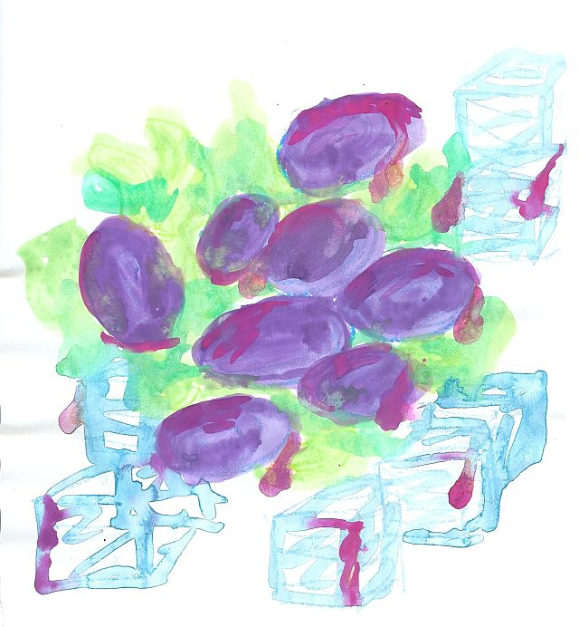
This Is Just to Say
I have eaten
the plums
that were in
the icebox
and which
you were probably
saving
for breakfast
Forgive me
they were delicious
so sweet
and so cold

William Carlos Williams
Materials for the Poetry Quarter
Dear colleagues,
Feel free to use my poetry materials in your classes. Pick whatever you find suitable for your groups. Please let me know if you find any errors or have any ideas for improvement.
This is work in progress…
Lis

For further ideas and instructions go to
epep.at – reading – poetry.

What is POETRY? 2
Reading Poetry 3
Creating Mood 4
Playing with Symbolism 5
Patterns and Shapes 6
Acrostic Poems 6
Limericks 7
Concrete Poems 8
Writing Haikus: Snapshots of America 9
Found Poetry 11
Let’s LOOK at Imagist Poetry 12
Describing a picture: Art beyond sight 13
Sonnets 14
Reconstructing a sonnet (cut up this page) 15
Parodies 16
Ballads 17
Ballad of the Triangle Fire 20
Poetry and Painting 21
Vincent van Gogh 21
Secret Thoughts of Modern Art: Nighthawks A 24
Secret Thoughts of Modern Art: Nighthawks B 25
La Repasseuse (Woman Ironing) by Degas. 27
Tom’s Diner 29


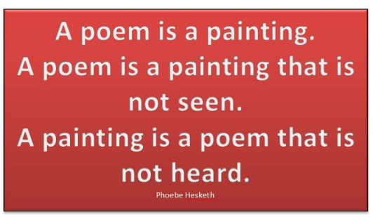

What is POETRY?

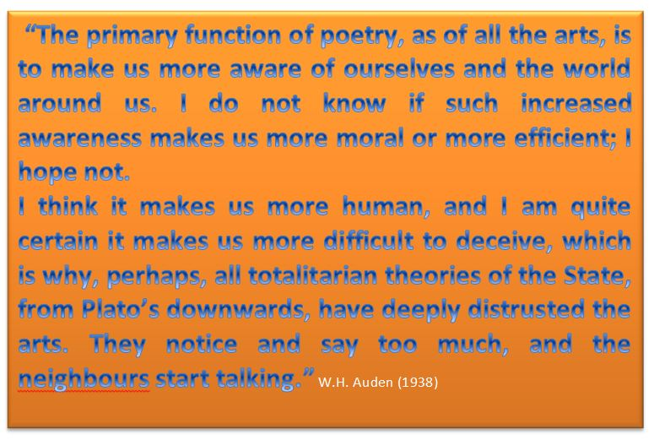

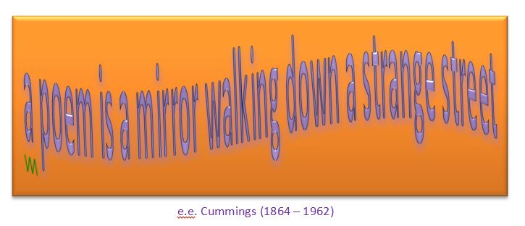

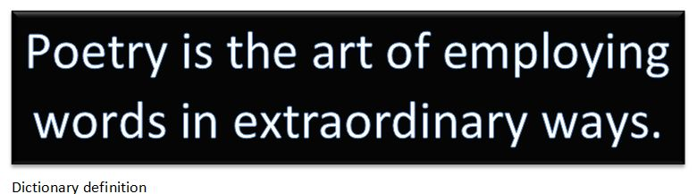

Reading Poetry

Introduction to Poetry

by Billy Collins
I ask them to take a poem
and hold it up to the light
like a color slide
or press an ear against its hive.
I say drop a mouse into a poem
and watch him probe his way out,
or walk inside the poem's room
and feel the walls for a light switch.
I want them to waterski
across the surface of a poem
waving at the author's name on the shore.
But all they want to do
is tie the poem to a chair with rope
and torture a confession out of it.
They begin beating it with a hose
to find out what it really means.

Introduction to Poetry

by Billy Collins
I ask them to take a poem
and hold it up to the light
like a color slide
or press an ear against its hive.
I say drop a mouse into a poem
and watch him probe his way out,
or walk inside the poem's room
and feel the walls for a light switch.
I want them to waterski
across the surface of a poem
waving at the author's name on the shore.
But all they want to do
is tie the poem to a chair with rope
and torture a confession out of it.
They begin beating it with a hose
to find out what it really means.

Introduction to Poetry

by Billy Collins
I ask them to take a poem
and hold it up to the light
like a color slide
or press an ear against its hive.
I say drop a mouse into a poem
and watch him probe his way out,
or walk inside the poem's room
and feel the walls for a light switch.
I want them to waterski
across the surface of a poem
waving at the author's name on the shore.
But all they want to do
is tie the poem to a chair with rope
and torture a confession out of it.
They begin beating it with a hose
to find out what it really means.

Introduction to Poetry

by Billy Collins
I ask them to take a poem
and hold it up to the light
like a color slide
or press an ear against its hive.
I say drop a mouse into a poem
and watch him probe his way out,
or walk inside the poem's room
and feel the walls for a light switch.
I want them to waterski
across the surface of a poem
waving at the author's name on the shore.
But all they want to do
is tie the poem to a chair with rope
and torture a confession out of it.
They begin beating it with a hose
to find out what it really means.

Creating Mood

Conquerors
By sundown we came to a hidden village
Where all the air was still
And no sound met our tired ears, save
For the sorry drip of rain from blackened trees
And the melancholy song of swinging gates.
Then through a broken pane some of us saw
A dead bird in a rusting cage, still
Pressing his thin tattered breast against the bars,
His beak wide open. And
As we hurried through the weed-grown street,
A gaunt dog started up from some dark place
And shambled off on legs as thin as sticks
Into the wood, to die at least in peace.
No one had told us victory was like this;
Not one amongst us would have eaten bread
Before he'd filled the mouth of the gray child
That sprawled, stiff as stone, before the shattered door.
There was not one who did not think of home.
by Henry Treece
Vocab Work:
Choose 5 new words and collect collocations and example sentences for them.

Reading the poem
Read the poem and listen to all the sounds. See all the images.
What is the atmosphere of this poem?
How does the poet create this atmosphere. Highlight all the words that contribute to this image.

Writing a poem and creating atmosphere
Write your own poem based on Henry Treece’s model but change the atmosphere to sunny and positive. Start like this:

Peace
In the morning we came to a bustling village
….

Playing with Symbolism

Thunderstorm

Carl Sandburg
Fog
The fog comes
on little cat feet.

It sits looking
over harbor and city
on silent haunches
and then moves on.

In this poem Carl Sandburg is playing with an extended metaphor – that is a series of comparisons between two unlike things that have several elements in common.
What are the similarities between FOG and a CAT? Write them in the overlapping part of the VENN diagram.



Now write your own poem based on Sandburg’s model. The title of your poem is “Thunderstorm”

Patterns and Shapes

Acrostic Poems

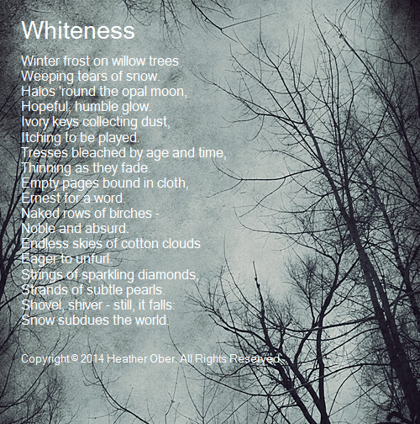
BORIS
Bright
Observer and
Rational thinker,
Imperturbable and Independent, even concerning the choice of his
Songs
http://www.poetrysoup.com

Typical ingredients and rules of acrostic poems:

Now try your hand at writing your own acrostic poem. You might want to write about yourself, using your name as a title. Other good topics are special holidays or seasons, places etc.

Limericks
The limerick is a humorous poem with a very special form and rhythm. The form was popularized by Edward Lear in the 19th century. The name of the verse form is derived from county in SW Ireland, in the province of Munster. Its capital city is Limerick situated on the River Shannon.
Read the following limericks and choose your favorite one. Learn it by heart.
There once was a from Hyde,
Who ate a sour apple and died,
While her lover lamented,
The apple fermented,
and made cider inside her inside.
There was a young lady of Riga
Who smiled as she rode on a tiger;
They returned from the ride
With the lady inside,
And the smile on the face of the tiger.

Anonymous

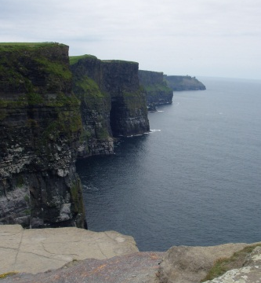
There once was a child named Lou
who never liked eating his stew
his mother got mad
she said he was bad
'cause he said that it tasted like poo

ARIANE
There once was a girl with curls,
whose eyes shone like brilliant dark pearls.
Her songs and guitar
were always above par
and her smiles sent our thoughts into whirls.
There was once a boy whose name was Noah
He went to the high cliffs of Moher
He wanted to see more
But he fell off the shore
And that’s the sad story of Noah

Viki Muster, 14

KATI
There once was a girl called Kati
Who loved it to go out and party.
Her school-time she’d spend
With Vanessa, her friend,
Quietly observing or chatting.

Then figure out the typical form of a limerick:
1st words:

Number of lines and rhyme (use letters to illustrate that)

Rhythm (illustrate the rhythm by stress marks: - /-/)

Write your own limerick about one of your classmates.

Concrete Poems

Examples:

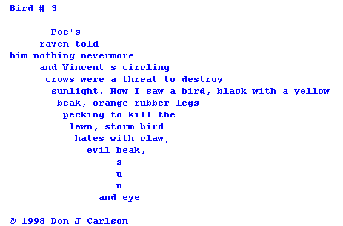
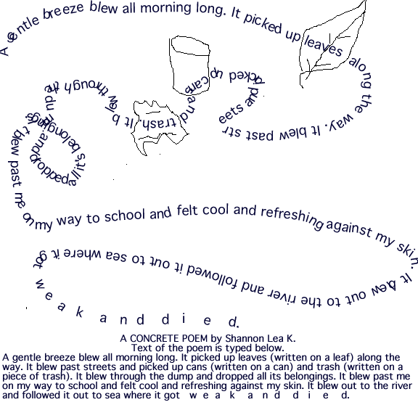

http://www.schools.pinellas.k12.fl.us/educators/tec/pravda3/concrete.html



Typical ingredients and rule for concrete poems:

Now try writing your own concrete poem.

Writing Haikus: Verbal Snapshots

A haiku is a minimalist form of poetry. The writer has 17 syllables through which to convey an experience.
A haiku is like a written snapshot. It recreates the atmosphere of a moment in 3 lines (5 syllables, 7 syllables, 5 syllables). Modern English haikus do not always follow this rule very strictly.
The content of a haiku is typically, but not always, focused on a small but important moment in a person’s everyday life. Part of writing a haiku is finding the ‘awe’ that is usually passed by without notice – the act of creating a haiku is the act of focusing our attention more closely than we might otherwise do. It is like a picture in close-up.
Sometimes haikus deal with important realizations (epiphanies) in a person’s life. Read the following examples and try to visualize the scenes and take in the atmosphere or understand the important realization.
Midday hush  the rasp of a mallard  calling his mate  Ray Rasmussen | on every icicle’s tip  a drop  of sunlight  Alexey Andreyev
street musicians resting –  red maple leaf  lands on the keyboard | second husband  painting the fence  the same green  Carol Montgomery p.
Tompkins Square –  an old man teaches Tai-Chi  to a crowd of pigeons  Paul Mena | a supermarket  in someone’s cart – beef, beer,  flowers and a child  Alexey Andreyev
what is that building?  cobble-stoned streets, glass canyons.  I’m tired. My feet hurt.  Margaret Hinchcliffe | with a flourish  the waitress leaves behind  rearranged smears  Dee Evetts
sunrise  I forget my side  of the argument  George Swede | thundering surf  seagull cries on the  bitter winds  Stonecrow
Snapshots of America:
Go through your pictures and memories or our class trip and choose one specific moment. Capture your impression in a haiku. Layout your haiku nicely and add your picture.
Or
Snapshots of …………………. (any other interesting place that you have recently visited.)
Choose an interesting and intensive moment – some kind of epiphany and capture it in a haiku. Add a fitting picture and create an attractive page.

More examples of haikus

What it’s about
The Sunflower Project NYC started in the Spring of 2002 as a living memorial planting project to remember the people lost on September 11th, to honor their families, to thank the people everywhere who contributed to the recovery, and to make our world better, one patch at a time.
The idea is for individuals, groups and communities to create their own sunflower memorials everywhere—to remember and honor life with living, growing symbols of renewal and hope.

A fork in my bag.  Next to my comb some wet seeds.  Armed and dangerous. | Armed with black seeds  I glance around furtively  then complete my task
Dig hole with chopstick  Make sure seed goes into hole  Mission accomplished | Look at me strangely  Wonder why I'’ poking dirt  Doesn'’ everyone?
Watering something?  Not me, I just spilled water...  for the seventh time | Planting sunflowers.  Large Federal Agent says  "“et'’ see some ID"”
In New York, Cher can  strut nude-—o notice. Plant seeds?  People stop. What'’ that? | Small dog and small mind  in tow, local Tree Lady  watches me closely.
online: site no longer available

Found Poetry

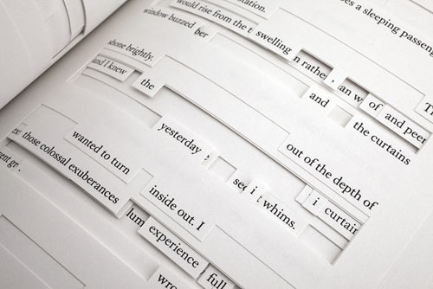
Found poetry is the rearrangement of words or phrases taken randomly from other sources (such as clipped newspaper headlines, bits of advertising, handwritten cards …) in a manner that gives the rearranged words a completely new meaning.
A famous example of found poetry – or “found writing” is Jonathan Safran Foer’s book Tree of Codes, which is based on The Street of Crocodiles by Bruno Schulz. Foer has used it as a canvas, cutting into and out of the pages, to arrive at an original new story.

Choose one of the following letters to the editor and write a found poem based on it.

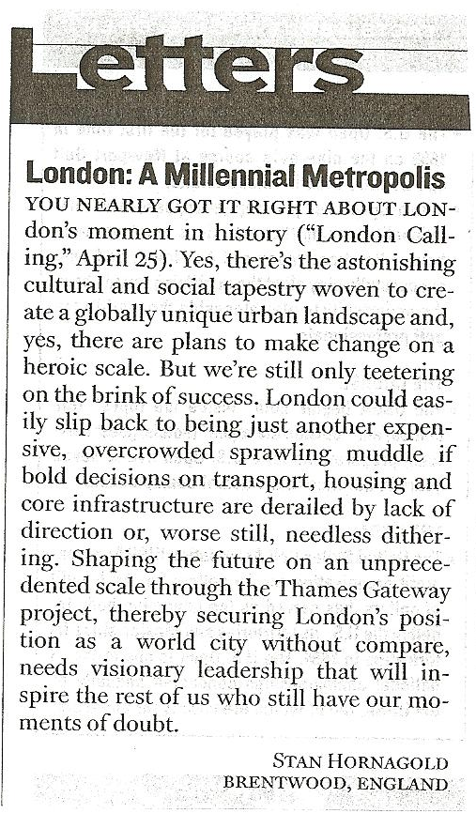

Let’s LOOK at Imagist Poetry

Imagism was a brief, complex yet influential poetic movement of the early 1900s, a time of reaction against late nineteenth-century styles in poetry as well as painting and architecture which was flowery and ornate.
In contrast, imagist poems are very short and describe one pure image or emotion. Imagist poets avoid any superfluous word. The image itself is the meaning.
- Read the following Imagist poems and try to imagine the scenes in detail. Share your mental images with a partner or small group.
- Choose your favorite poem and do the task “art beyond sight” on the next page.

In a Station of the Metro

The apparition of these faces in the crowd;
Petals on a wet, black bough.

Ezra Pound
The Red Wheelbarrow

so much depends
upon

a red wheel
barrow

glazed with rain
water

beside the white
chickens.

William Carlos Williams

The City

In the morning the city
Spreads its wings
Making a song
In stone that sings.

In the evening the city
Goes to bed
Hanging lights
Above its head.

Langston Hughes

The Toaster

A silver-scaled dragon with jaws flaming red
Sits at my elbow and toasts my bread.
I hand him fat slices, and then, one by one,
He hands them back when he sees they are done.

William Jay Smith

Apartment House

A filing cabinet of human lives
Where people swarm like bees in tunnelled hives,
Each to his own cell in the covered comb,
Identical and cramped -- we call it home.

Gerald Raftery

Describing a picture: Art beyond sight

Go to the website “Art Beyond Sight”

http://www.artbeyondsight.org/handbook/acs-verbalsamples.shtml
and choose three paintings that you find interesting. Read and listen to the descriptions and collect some useful phrases.

Useful phrases:

Then choose one of the imagist poems on the previous page and paint, find or imagine a painting or photo that might have inspired the poet. What do you see? Describe your painting / photo in detail.

Sonnets
My mistress' eyes are nothing like the sun
(Sonnet 130) by William Shakespeare


My mistress' eyes are nothing like the sun;
Coral is far more red than her lips' red;
If snow be white, why then her breasts are dun;
If hairs be wires, black wires grow on her head.

I have seen roses damasked, red and white,
But no such roses see I in her cheeks;
And in some perfumes is there more delight
Than in the breath that from my mistress reeks.

I love to hear her speak, yet well I know
That music hath a far more pleasing sound;
I grant I never saw a goddess go;
My mistress when she walks treads on the ground.

And yet, by heaven, I think my love as rare
As any she belied with false compare.

Work with a partner. Explore the poem.
- Try to SEE the woman. What does she look like? Use the box on the right to describe the woman in modern words.
- Read the sonnet out aloud and notice the rhythm. Mark the stresses. Can you find a pattern?
- Mark the rhyme (a, b, c…)

- What is the poet saying about his love? Mark the positive comments with a + and the negative ones with a -. Does he love her?
Shall I compare thee to a summer’s day?
Use the text pieces provided by your teacher and reconstruct sonnet 18.
Both content and rhyme will help you.
Figure 1: https://thedaily400.files.wordpress.com/2013/10/broken-vase1.jpg

Reconstructing a sonnet (cut up this page)
Shall I compare thee to a Summer's day?
Thou are more lovely and more temperate:

Rough winds do shake the darling buds of May,
And Summer's lease hath all too short a date:

Sometime too hot the eye of heaven shines,
And often is his gold complexion dimm'd;

And every fair from fair sometime declines,
By chance or nature's changing course untrimm'd:
But thy eternal Summer shall not fade
Nor lose possession of that fair thou ow'st;

Nor shall Death brag thou wander'st in his shade,
When in eternal lines to time thou grow'st:

So long as men can breathe, or eyes can see,
So long lives this, and this gives life to thee.

Parodies
Read the following famous sonnets and their parodies. Then choose a sonnet (online) and write your own parody.
Sonnet at Journey’s End
Shall I compare thee to a ticket collector?
Thou art more lovely and more even tempered
(‘T would not be hard!)
Rough hands do take the darling tickets of May
And one’s yearly Season hath all to short a date.
Sometimes my photocard is checked
Other times I am waved through at the gate:
This inconsistency doth leave me perplex’d
But ‘tis not the traveller’s place to question why,
For I know that at my journey’s end –
(Despite snow that doth have some error and
Leaves that lieth where they shouldst not) –
I shall find thee waiting by our fire’s grate,
And thy eternal summer shall never fade
Even though Knapp’s boys often make me late.
(Tagholm 2001, 49)
William Shakespeare, SONNET 18
Shall I compare thee to a summer's day?
Thou art more lovely and more temperate:
Rough winds do shake the darling buds of May,
And summer's lease hath all too short a date:
Sometime too hot the eye of heaven shines,
And often is his gold complexion dimm'd;
And every fair from fair sometime declines,
By chance or nature's changing course untrimm'd;
But thy eternal summer shall not fade
Nor lose possession of that fair thou owest;
Nor shall Death brag thou wander'st in his shade,
When in eternal lines to time thou growest:
So long as men can breathe or eyes can see,
So long lives this and this gives life to thee.
Composed upon Oxford Street
Earth has plenty to show more fair:
Dull would he be of soul who could enjoy
Sights so grating in their commerciality:
This Street now doth, like an old rag, defile
The beauty of the morning; noisy, full,
Shops, department stores, burger bars and boutiques lie
Open unto the pavement, and to the sky;
All tacky and glittering in the fume-filled air.
Often did sun more beautifully bless
In his first splendour valley, rock or hill;
Ne’er saw I, and felt, a cacophony so deep!
The buses do charge at their own sweet will:
Dear God! The very pigeons seem tawdry and cheap;
And beneath the Street Londoners on the Central feel ill!
(Tagholm 2001, 17)
Composed Upon Westminster Bridge,
September 3, 1802
William Wordsworth
Earth has not anything to show more fair:
Dull would he be of soul who could pass by
A sight so touching in its majesty:
This City now doth, like a garment, wear
The beauty of the morning; silent, bare,
Ships, towers, domes, theatres, and temples lie
Open unto the fields, and to the sky;
All bright and glittering in the smokeless air.
Never did sun more beautifully steep
In his first splendour, valley, rock, or hill;
Ne'er saw I, never felt, a calm so deep!
The river glideth at his own sweet will:
Dear God! the very houses seem asleep;
And all that mighty heart is lying still!
-- William Wordsworth

To come or not to come: that is the question:
Whether ‘tis nobler in the mind to suffer
The looks and questions of well-meaning teachers
Or to take refuge in your bed
And by ignoring end them? To sleep; to nodd off,
No more; and by dreaming to say we end the workshops,
The exams, the thousand questionings
That school is heir to, ‘tis an escape devoutly to be wish’d.
To dream, to have a kip,
To sleep; perchance to miss another day: ay, there’s the rub...
(Pö, for one of her students. With apologies to you know who.)

Ballads
What's the Story?
Read the Ballad of John Hardy.
What is the story?
Highlight the main facts and write them in the box in note form.

John Hardy was a brave little man,
He carried two guns ev'ry day.
Killed him a man in the West Virginia land,
Oughta seen poor Johnny gettin' away, Lord, Lord,
Oughta seen poor Johnny gettin' away.
John Hardy was standin' at the barroom door,
He didn't have a hand in the game,
Up stepped his woman and threw down fifty cents,
Says, "Deal my man in the game, Lord, Lord...."
John Hardy lost that fifty cents,
It was all he had in the game,
He drew the forty-four that he carried by his side
Blowed out that poor Negro's brains, Lord, Lord....
John Hardy had ten miles to go,
And half of that he run,
He run till he come to the broad river bank,
He fell to his breast and he swum, Lord, Lord....
He swum till he came to his mother's house,
"My boy, what have you done?"
"I've killed a man in the West Virginia Land,
And I know that I have to be hung, Lord, Lord...."
He asked his mother for a fifty-cent piece,
"My son, I have no change."
"Then hand me down my old forty-four
And I'll blow out my agurvatin' [sic] brains, Lord, Lord...."
John Hardy was lyin' on the broad river bank,
As drunk as a man could be;
Up stepped the police and took him by the hand,
Sayin' "Johnny, come and go with me, Lord, Lord...."
John Hardy had a pretty little girl,
The dress she wore was blue.
She come a-skippin' through the old jail hall
Sayin', "Poppy, I'll be true to you, Lord, Lord...."
John Hardy had another little girl,
The dress that she wore was red,
She came a-skippin' through the old jail hall
Sayin' "Poppy, I'd rather be dead, Lord, Lord...."
They took John Hardy to the hangin' ground,
They hung him there to die.
The very last words that poor boy said,
"My forty gun never told a lie, Lord, Lord...."
LYRICS AS REPRINTED IN ALAN LOMAX, FOLK SONGS OF NORTH AMERICA, GARDEN CITY, 1960
Now read the following newspaper article about the same incident and list any differences between the poem and the newspaper article.
Check for the following aspects:
- What seems to have interested the writers?
- How is the story devided up?
- What types of language are used?
- How do you feel about the characters?

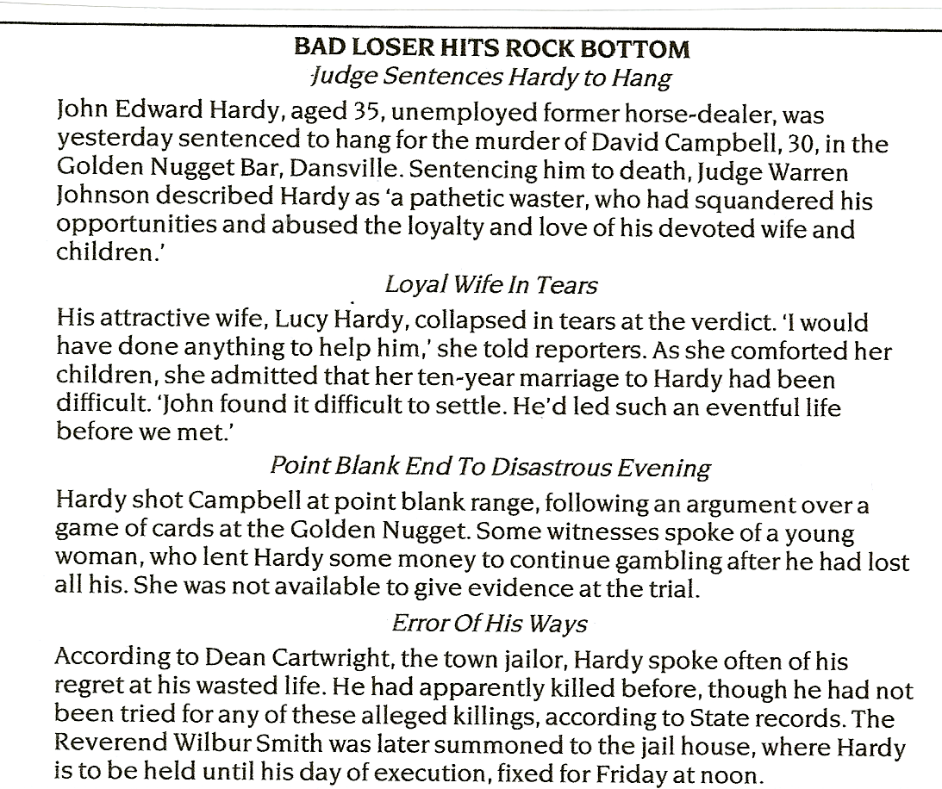

The next piece is the opening paragraph of a short story about John Hardy.
What difference do you notice between the shortstory and the newspaper article?
Chapter 1:
He had to get back. His thoughts were racing but, wherever they ran, they ended up at the same point: he had to get back.
The night air was cool on his face as he ran. John was shivering. From fear or cold,it made little difference. After what he'd done, there was only one place to go. Home. If only he could turn back time and make it undone. He shuddered, pictures of the last few minutes in that bar kept flashing in front of his eyes, David Campbell's face, his piercing scream and the dull thud as his body hit the floor...

Homework: Read the two ballads on the following page and choose one. Then do one of the following tasks:
- Write a newspaper article based on the poem.
or
- Write a short story based on the poem.
Decide which facts seem important for your text. Invent suitable details to make your text more colorful and plausible. Use the text writing recipies to help you plan and structure your article or your shortstory. Write about 300 words.

Ballad of the Triangle Fire

By Ruth Rubin
In the heart of New York City, near Washington Square
In nineteen eleven, March winds were cold and bare.
A fire broke out in a building ten stories high,
And a hundred and forty-six young girls in those flames did die.
On the top floor of that building, ten stories in the air
These young girls were working in an old sweatshop there;
They were sewing shirtwaists for a very low wage.
So tired and pale and worn-out! They were at a tender age.
The sweatshop was a stuffy room with but a single door;
The windows they were gray with dust from off that dirty floor;
There were no comforts, no fresh air, no light to sew thereby,
And the girls, they toiled from early morn till darkness filled the sky.
Then on that fateful day — dear God, most terrible of days!
When that fire broke out, it grew into a mighty blaze.
In that firetrap way up there with but a single door,
So many innocent working girls burned, to live no more!
A hundred thousand mourners, they followed those sad biers.
The streets were filled with people weeping bitter tears.
Poets, writers everywhere described that awful pyre,
When those young girls were trapped to die in the Triangle Fire.
© 1968 Ruth Rubin from the Sing Along Songbook, 1993 UCLEA NE Summer Institute for Union Women, New York State School of Industrial and Labor Relations, Cornell University, Ithaca, New York, 1993.

Landlord, landlord,
My roof has sprung a leak.
Don't you 'member I told you about it
Way last week?
Landlord, landlord,
These steps is broken down.
When you come up yourself
It's a wonder you don't fall down.
Ten Bucks you say I owe you?
Ten Bucks you say is due?
Well, that's Ten Bucks more'n I'l pay you
Till you fix this house up new.
What? You gonna get eviction orders?
You gonna cut off my heat?
You gonna take my furniture and
Throw it in the street?
Um-huh! You talking high and mighty.
Talk on-till you get through.
You ain't gonna be able to say a word
If I land my fist on you.
Police! Police!
Come and get this man!
He's trying to ruin the government
And overturn the land!
Copper's whistle!
Patrol bell!
Arrest.
Precinct Station.
Iron cell.
Headlines in press:
MAN THREATENS LANDLORD
TENANT HELD NO BAIL
JUDGE GIVES NEGRO 90 DAYS IN COUNTY JAIL!
Langston Hughes

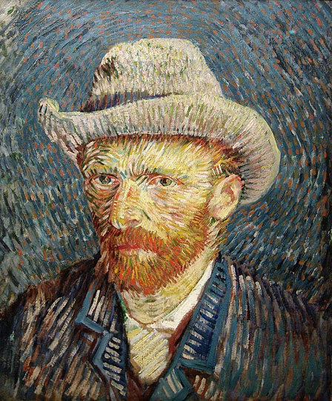
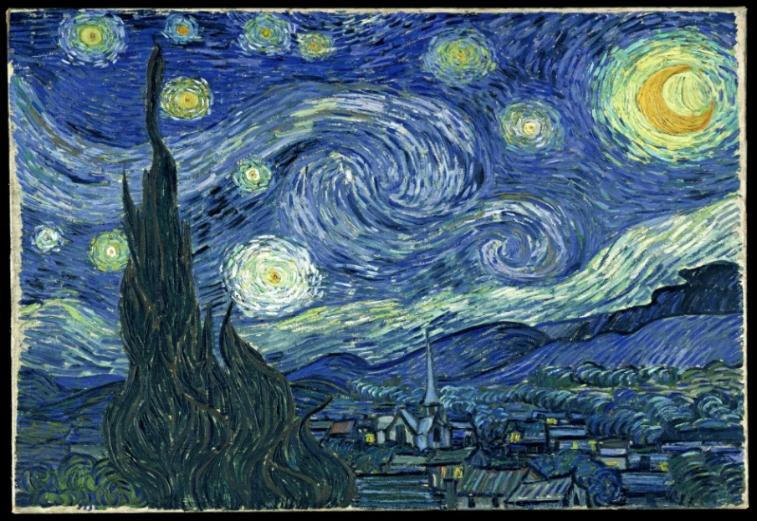
Poetry and Painting

Vincent van Gogh
1. Listen to the song by Don McLean and watch the slides. What feelings are conveyed in the song?
Sadness, quietude, depression, tolerance, longing, balance, calmness, desire,
disturbance, friendship, understanding, contemplation, sympathy, turbulence, grief, despair…

2. Read the biographical notes on van Gogh, then listen to the song once again. Find all the references to van Gogh’s life in the lyrics and underline them in blue.

3. After watching the slides underline all the references to the paintings in yellow.

4. Briefly explain the references to van Gogh’s life and works in the margin.

5. Who do you think is the “I” in the song? (Van Gogh himself, a friend, a lover, his brother Theo, Sien, an art dealer, his father or mother?)

6. What do you think is van Gogh’s favorite color?

7. Would you like to make any further comments on the song?
VINCENT by Don McLean
Starry starry night
paint your palette blue and grey
look out on a summer's day
with eyes that know the
darkness in my soul.
Shadows on the hills
sketch the trees and the daffodils
catch the breeze and the winter chills
in colors on the snowy linen land.
And now I understand what you tried to say to me
how you suffered for your sanity
how you tried to set them free.
They would not listen
they did not know how
perhaps they'll listen now.
Starry starry night
flaming flowers that brightly blaze
swirling clouds in violet haze
reflect in Vincent's eyes of China blue.
Colors changing hue
morning fields of amber grain
weathered faces lined in pain
are soothed beneath the artist's loving hand.
For they could not love you
but still your love was true
and when no hope was left in sight
Write a very short ARTICLE for a „news in brief“ column in a quality paper.
The title of your article is:
“VanGogh’s Starry Night sold for record price”.
Write about 100 – 150 words. High quality expressions, no sloppy errors!


on that starry starry night.
You took your life as lovers often do;
But I could have told you Vincent
this world was never
meant for one
as beautiful as you.
Starry starry night
portraits hung in empty halls
frameless heads on nameless walls
with eyes that watch the world and can't forget.
Like the stranger that you've met
the ragged men in ragged clothes
the silver thorn of bloody rose
lie crushed and broken
on the virgin snow.
And now I think I know what you tried to say to me
how you suffered for your sanity
how you tried to set them free.
They would not listen
they're not list'ning still
perhaps they never will.

Van Gogh’ Biography
Read the brief biographical notes and highlight important words. Then use this text as your “toolbox” and write a FOUND POEM about Vincent van Gogh.
Van Gogh lived from 1853 - 1890. He was born in Holland as the eldest son of a Dutch pastor. He tried out numerous professions, working as an art dealer, a teacher, a lay preacher and a bookseller before he finally decided to become an artist.
He studied briefly at the Antwerp Academy from 1885-6, before moving to Paris where, under the influence of the impressionists, the colour and mood of his work lightened.
In 1888 he moved to Arles in the South of France. Gauguin visited him there that year and violent disagreements between them provoked van Gogh's first mental crisis. Their disagreement and Gaugin's mockery ended in a physical fight. And van Gogh feeling so guilty about it cut off part of his right ear and gave it to a prostitute.
His subsequent emphasis on expressing his emotional state in his work was to earn him the title Post-Impressionist. He spent some time at an asylum at St. Remy where he suffered from hallucinations of sight and hearing and "lack of strength and courage to live in freedom". In 1890 he moved north to 'Auvers-sur-Oise, where he committed suicide at the age of 37.
Pisarro, the great impressionist, predicted that "this man will either go mad or he will outpace us all," he was to prove right on both counts.
All his life, however, van Gogh remained a solitary and despairing figure, and his self-destructive nature drove him, in his later years, to the brink of madness.
He never got married and the few intimate relationships he had with women ended more or less in catastrophes. He first fell in love with his landlady's daughter in London, he suffered so terribly from this unhappy and unfulfilled relationship that he could hardly work anymore. He was deeply depressed. His second love, Kee Vos, did not believe his fervent vows and left him. Later in his life when he was living in The Hague, he became involved with Sien, a prostitute and set up house with her and her children for a year. He savoured his family life until the day when Theo, his brother, urged him to break up the relationship.
Alone with himself and the world, his only true friend and source of moral and financial support was his brother Theo, who looked after his welfare all his life and who ultimately followed him, just half a year later, to the grave. After completing 70 canvases in 70 days at Auvers, he borrowed a revolver, went for a walk into the fields and shot himself in the stomach. The suicide attempt was, at first, unsuccessful. He lay dying for two days and finally died on July 29, 1890. He had fought bravely with disease, isolation and his own excessively sensitive and ardent nature. The recognition and admiration for which van Gogh had fought so bitterly all his life came only after his tragic death. And the energy that for him was exhausted at Auvers, is happily available to us in hundreds of radiant canvases and extraordinary drawings.
Today he is not only considered the most important pioneer of 20th-century art, but is widely regarded as one of the most significant and best-loved painters in the entire history of art.

The Artist, Arles 1890

Yellow, yellow
Watch the yellow always,
Fascinated, from the corner of your eye.
Its terrible intensity has sting
To bleach the brain, to take the skin
From off your inner eye. To drive you back
Against a buckled wall that echoes yellow, yellow,
Pain. You cannot let it from 'our mind.
Colin Rowbotham
Just Passing
A scene
Seen
Is captured
In a painter's
Head
Is captured
Frozen and colourful
Mr. Gogh
Shot his head
To fragments
But the scene
Seen
Remains. Francis Barker

Secret Thoughts of Modern Art: Nighthawks A
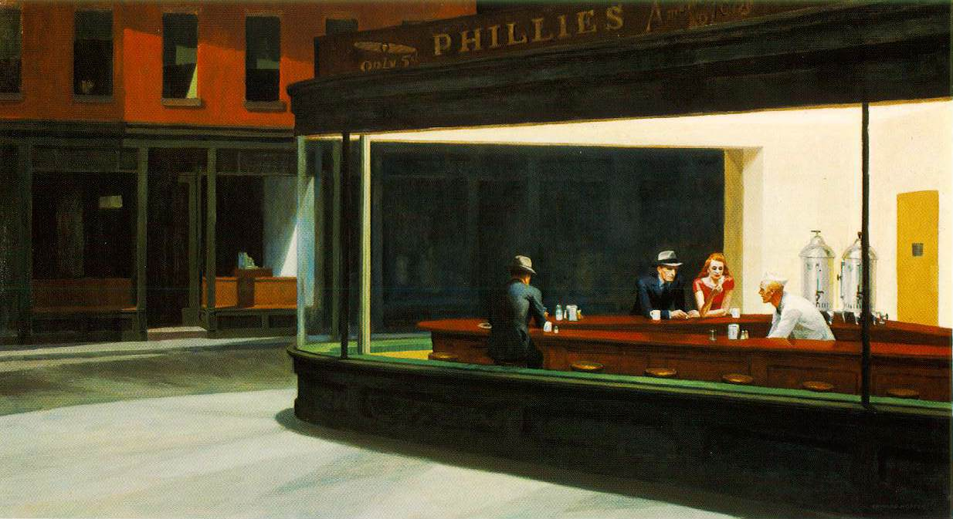

Look at the painting very closely.
Describe the place and atmosphere.

Who are the people in the painting? What are their relationships? What are their secret thoughts?

http://www.artchive.com/artchive/h/hopper/nighthwk.jpg
http://mydailyartdisplay.files.wordpress.com/2011/01/boulevard-of-broken-dreams.jpg

Secret Thoughts of Modern Art: Nighthawks B

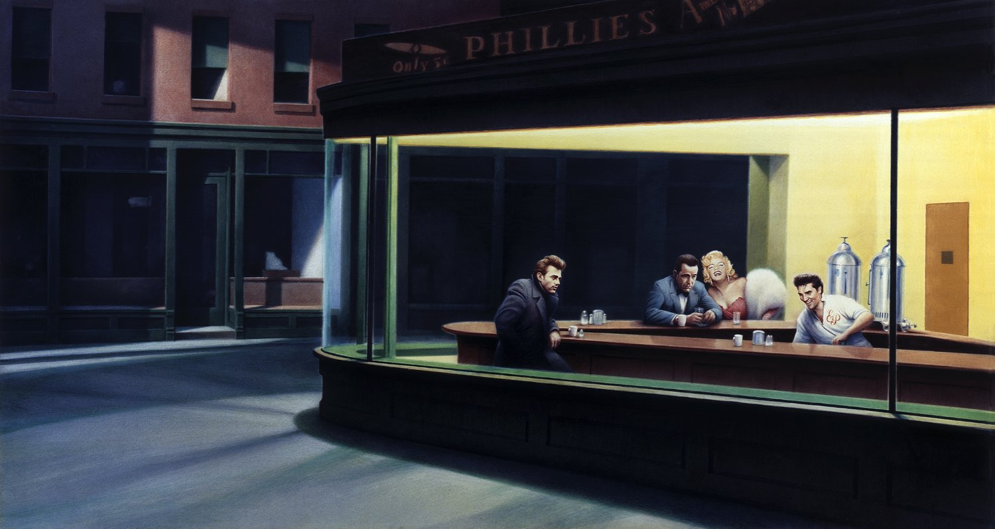
Look at the painting very closely.
Describe the place and atmosphere.

Who are the people in the painting? What are their relationships? What are their secret thoughts?

http://www.artchive.com/artchive/h/hopper/nighthwk.jpg
http://mydailyartdisplay.files.wordpress.com/2011/01/boulevard-of-broken-dreams.jpg

Nighthawks groupwork
Secret thoughts of modern art
- Work in groups of 4 and compare your findings. What are the similarities and differences between the paintings?
- Then read Joyce Carol Oates’ poem and find out which of the two paintings is Edward Hopper’s and which one is Gottfried Helnwein’s version. While reading mark the character’s thoughts in different colors.

Edward Hopper’s Nighthawks, 1942

- Joyce Carol Oates
The three men are fully clothed, long sleeves,
even hats, though it’s indoors, and brightly lit,
and there’s a woman. The woman is wearing
a short-sleeved red dress cut to expose her arms,
a curve of her creamy chest; she’s contemplating
a cigarette in her right hand, thinking that
her companion has finally left his wife but
can she trust him? Her heavy-lidded eyes,
pouty lipsticked mouth, she has the redhead’s
true pallor like skim milk, damned good-looking
and she guesses she knows it but what exactly
has it gotten her so far, and where?—he’ll start
to feel guilty in a few days, she knows
the signs, and actual smell, sweaty, rancid, like
dirty socks; he’ll slip away to make telephone calls
and she swears she isn’t going to go through that
again, isn’t going to break down crying or begging
nor is she going to scream at him, she’s finished
with all that. And he’s silent beside her,
not the kind to talk much but he’s thinking
thank God he made the right move at last,
he’s a little dazed like a man in a dream—
is this a dream?—so much that’s wide, still,
mute, horizontal, and the counterman in white,
stooped as he is and unmoving except to sip
his coffee; but he’s feeling pretty good,
it’s primarily relief, this time he’s sure
as hell going to make it work, he owes it to her
and to himself, Christ’s sake. And she’s thinking
the light in this place is too bright, probably
not very flattering, she hates it when her lipstick
wears off and her makeup gets caked, she’d like
to use a ladies’ room but there isn’t one here
and Jesus how long before a gas station opens?—
it’s the middle of the night and she has a feeling
time is never going to budge. This time
though she isn’t going to demean herself—
he starts in about his wife, his kids, how
he let them down, they trusted him and he let
them down, she’ll slam out of the goddamned room
and if he calls her Sugar or Baby in that voice,
running his hands over her like he has the right,
she’ll slap his face hard, You know I hate that: Stop!
And he’ll stop. He’d better. The angrier
she gets the stiller she is, hasn’t said a word
for the past ten minutes, not a strand
of her hair stirs, and it smells a little like ashes
or like the henna she uses to brighten it, but
the smell is faint or anyway, crazy for her
like he is, he doesn’t notice, or mind—
burying his hot face in her neck, between her cool
breasts, or her legs—wherever she’ll have him,
and whenever. She’s still contemplating
the cigarette burning in her hand,
the counterman is still stooped gaping
at her, and he doesn’t mind that, why not,
as long as she doesn’t look back, in fact
he’s thinking he’s the luckiest man in the world
so why isn’t he happier?

Homework:
Based on Joyce Carol Oates’ model write your own poem/short-story about Gottfried Helnwein’s painting or any other painting you find interesting and suitable.

La Repasseuse (Woman Ironing) by Degas.
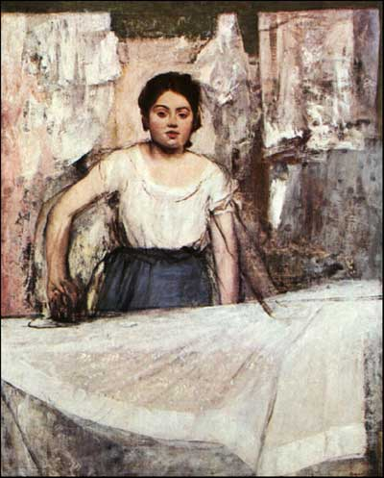
Secret thoughts of modern art
1. Look at the picture carefully. In pairs or small groups discuss the following:
What interests you about this painting?
Is there anything unusual about the way the woman has been pictured?
2. Imagine you are the woman in the picture. Write down a few thoughts about how you feel about the way you have been represented in the painting.

If you could speak to Degas about the painting what would you say? Write down your thoughts.

Now read Fanthorpe’s poem and answer questions 1-7 in note-form.

Woman Ironing - U.A.Fanthorpe  I thought I knew what was coming when he said  He wanted to do my likeness at the ironing.  I live in the city, people tell you things. Me looking at him,  It would be, across the ironing board, my hair and my eyes  In a good light, and something a bit off the shoulder  But it wasn't. He rushed around drawing curtains.  Made it hard to iron. O yes, I had to keep ironing.  He need to see the strength, he said. Kept on  About my dynamic right shoulder, then left it out  Though you can see where he ought to have put it.  Come on, what's-your-name, he kept saying,  Show us that muscle power! That's what I'm after.  I might've been an engine, not a person  No, I didn't take to him. I'm used to rudeness,  But he was making such a sketch of me.  If someone's paying you, it isn't easy  To speak your mind. Still, Sir, I said,  I really don't want to see my hair like that,  all scraped back, like a hot person's hair,  And anyone can tell that under my arms I'm sweating.  Hair? Sweat? That's how it is when you iron,  Says he. You're not here to tell me what to do.  I'll make you permanent, the way you look  When you're ironing. O yes, he says, I'll show you  The way you look when no one's watching. | - What does the poet think would be a more appropriate title for this painting and why?  - How does Fanthorpe imagine the experience of being painted was different from the woman’s expectations?  - Look back at the painting. Can you explain the comment about the woman’s right shoulder in the second stanza?  - How does Degas treat the woman ironing according to the poem?  - What does the woman think about how she has been represented in the painting and why does she find it difficult to express her feelings to Degas?  - What is revealed about Degas’ aims for the painting in the last stanza?  - Discuss the language and tone of the poem.

Tom’s Diner
Work with a partner. Read the lyrics of Suzanne Vega’s song and try to complete them.
Then listen to the song and check your answers.

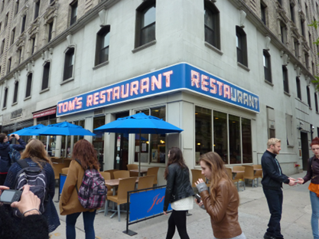

Tom's Diner"
I am ………………
In the morning
At the …………….
On the corner
I am waiting
At the …………….
For the man
To ………….. the coffee
And he fills it
Only ……………….
And before
I even ……………….
He is looking
Out the window
At somebody
Coming in
"It is always
Nice to see you"
Says the man
Behind the ……………..
To the woman
Who has come in
She is ………………..
Her umbrella
And I look
The other way
As they are ……………..
Their hellos
I'm …………………
Not to see them
Instead
I ……………… the milk
I open
Up the paper
There's a story
Of an actor
Who ……………………
While he was drinking
It was no one
I ………………. of
And I'm turning
To the horoscope
And looking
For the funnies
When I'm feeling
Someone watching me
And so
I ……………… my head
There's a woman
On the ……………….
Looking inside
Does she see me?
No she does not
Really see me
Cause she sees
Her own …………………
And I'm trying
Not to notice
That she's ………………..
Up her skirt
And while she's
Straightening her stockings
Her hair
Has gotten ……….
Oh, this rain
It will ……………..
Through the morning
As I'm listening
To the bells
Of the cathedral
I am thinking
Of your voice...
And of the midnight picnic
Once upon a time
Before the rain began...
I finish up my coffee
It's time to ………….. the train

Homework:
Secret thoughts of modern art

From painting to poem to short story
Automat  I thought when I came here  I'd get as rich as a secretary  and marry my boss.  I dreamt about that so long  I thought it would happen.  Maybe I should go back.  I hate small places though,  and when I sit eating in the automat  I pretend I'm a celebrity  and all those walls of plastic doors  are really crowds of camera lenses  waiting to take my picture.  Julie O'Callaghan | 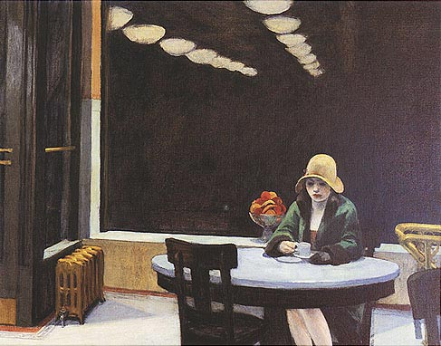

Slip into the young woman’s role and write an original short story based upon her experience.
Remember: Good short stories focus on a short moment that is somehow important in a character’s life. Don’t tell the girl’s life story. Paint a snapshot of her using words.
Choose your point of view (outside narrator, 1st person narrator)

Tips: Describe the setting in detail. Be specific, use names (place names, brand names…)
What mood is the main character in? How do we see this? Describe her behavior (“bring her on stage”) rather than naming her emotions. Use colorful verbs.
Why is this moment relevant in her life? Is it a turning point?

Solutions:Tom's Diner"
I am sitting
In the morning
At the diner
On the corner
I am waiting
At the counter
For the man
To pour the coffee
And he fills it
Only halfway
And before
I even argue
He is looking
Out the window
At somebody
Coming in
"It is always
Nice to see you"
Says the man
Behind the counter
To the woman
Who has come in
She is shaking
Her umbrella
And I look
The other way
As they are kissing
Their hellos
I'm pretending
Not to see them
Instead
I pour the milk
I open
Up the paper
There's a story
Of an actor
Who had died
While he was drinking
It was no one
I had heard of
And I'm turning
To the horoscope
And looking
For the funnies
When I'm feeling
Someone watching me
And so
I raise my head
There's a woman
On the outside
Looking inside
Does she see me?
No she does not
Really see me
Cause she sees
Her own reflection
And I'm trying
Not to notice
That she's hitching
Up her skirt
And while she's
Straightening her stockings
Her hair
Has gotten wet
Oh, this rain
It will continue
Through the morning
As I'm listening
To the bells
Of the cathedral
I am thinking
Of your voice...
And of the midnight picnic
Once upon a time
Before the rain began...
I finish up my coffee
It's time to catch the train.

