1st test 7b Nov. 2014

TEXT I: Newspaper Article
Write a short newspaper article based upon the story told in the poem “Incendiary”. Your text should…
- give all the important facts and ideas of the poem
- be written for a quality paper and use formal language and clear paragraphing
- be about 200 words long.
- have a catchy title and a lead.

Incendiary
That one small boy with a face like pallid cheese
And burnt-out little eyes could make a blaze
As brazen, fierce and huge, and red and gold
And zany yellow as the one that spoiled
Three thousand guineas worth of property
And crops at Godwin's Farm on Sunday
Is frightening – as fact and metaphor:
An ordinary match intended for
The lighting of a pipe or kitchen fire
Misused may set a whole menagerie
Of flame-fanged tigers roaring hungrily.
And frightening, too, that one small boy should set
The sky on fire and choke the stars to heat
Such skinny limbs and such a little heart
Which would have been content with one warm kiss
Had there been anyone to offer this.
Vernon Scannell

TEXT II: From painting to short story

Look at the painting “Nighthawks” by Edward Hopper. Try to imagine the atmosphere as if you were there, sitting on the other side of the bar, watching and thinking. Who are the characters?

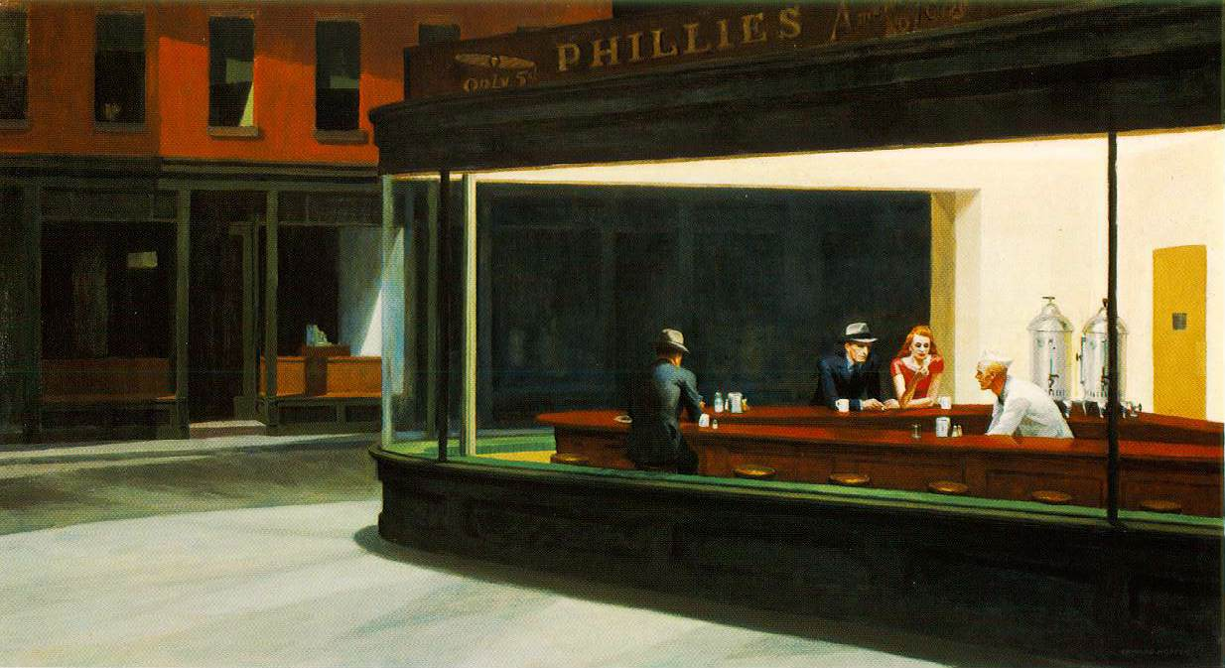
Look at the picture on the big screen for a better quality print of the painting

Joyce Carol Oates has written a short story based upon this painting.
Copy her opening onto your test-sheet and continue the story in the same style.
Write about 300 words.

The three men are fully clothed, long sleeves, even hats, though it’s indoors, and brightly lit, and there’s a woman. The woman is wearing a short-sleeved red dress cut to expose her arms, a curve of her creamy chest; she’s contemplating a cigarette in her right hand, thinking that …

