WRITING TASK
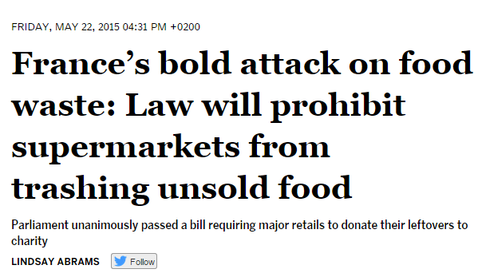 | 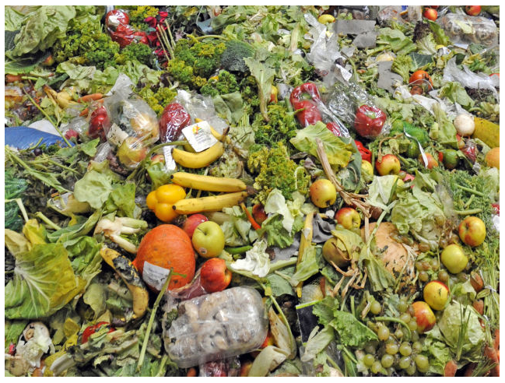

A few facts:
In the US
40% of the food in the US goes uneaten
Fruits and vegetables worth $15 billion thrown away unsold every year
In Austria
650 000 tons of food thrown away in stores, restaurants and homes every year
+ 350 000 tons of food thrown away on farms/during agricultural production
only 11 000 tons go to charity organizations

Let’s waste less...
Write a leaflet in order to support the recent movement against the waste of food. In your leaflet
- inform the readers about the current situation
- suggest ways how this waste could be reduced on a political/legal level
- give tips how to reduce the waste of food on a personal level (family, school, eating out…)
Write about 250 words.

