3rd Test: 7b June 1st, 2015

Listening

Listening 1: 7pts
You are going to listen to a recording about a new era in comic book design. First you will have 45 seconds to study the task below, then you will hear the recording twice. While listening, complete the sentences (1-7) using a maximum of 4 words. Write your answers in the spaces provided on the answer sheet. The first one (0) has been done for you.

After the second listening, you will have 45 seconds to check your answers.

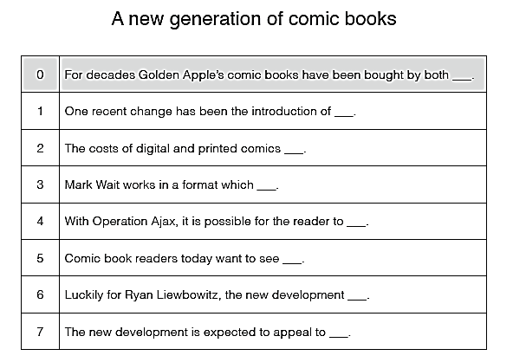

Listening file: https://www.bifie.at/system/files/dl/KL14_PT3_AHS_ENG_HO_B2_SF.mp3

Listening 2: 7pts

You are going to listen to Steven Johnson explaining how a “hunch”, a feeling that something is true or will happen, develops into an idea. First you will have 45 seconds to study the task below, then you will hear the recording twice. While listening, choose the correct answer (A, B, C or D) for questions 1-6. Tick he correct solution The first one (0) and the last one 7) have been done for you.
After the second listening, you will have 45 seconds to check your answers.

Where good ideas come from

0 Finding out how good ideas originate is
A relevant for everybody.
B a challenging task.
C very important for some people.
D a creative act.
1 When investigating where good ideas come from, the speaker
A found out about unusual historical events.
B was surprised by the creativity involved.
C learned that spontaneity is important.
D frequently came across similar processes at work.
2 According to the speaker, revolutionary ideas
A sometimes provide surprising insights.
B are seldom taken seriously.
C usually remain hidden over a lengthy period.
D often turn up rather unexpectedly.
3 When Berners-Lee first began his research, he
A was short of time.
B had no clear goal in mind.
C doubted that he would succeed.
D imagined a quick breakthrough.
4 Once ideas gradually start to develop, they
A have to meet and blend with each other.
B should be well-balanced.
C rarely disappear altogether.
D need to be placed in a clear context.
5 Lately there has been discussion about how
A to improve our ability to multi-task.
B to cope with the dangers of the Internet.
C the Internet affects our minds.
D people’s reading skills could be improved.
6 Progress in science and technology is mainly due to
A highly developed empirical methods.
B expanding opportunities for communication.
C the invention of the computer.
D the increased speed of life.
7 The speaker says that modern communication technology enables us to
A make friends more easily.
B recover lost information immediately.
C find the sources of essential ideas quickly.
D put the finishing touch to our ideas.

Reading:

Reading 1: 9pts
Read the interview with pilot Silvia Barter about Amelia Earhart, the famous female US pilot.
Some parts are missing. Choose the correct part (A-L) for each gap (1-9). There are two extra
parts that you should not use. Write your answers in the boxes provided on the answer sheet.
The first one (0) has been done for you.
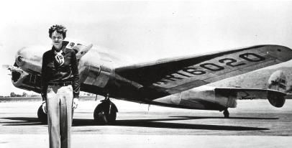
Remembering Amelia Earhart
Did you know Amelia Earhart? What was she like?
I didn't know Amelia Earhart. I was in high school when Amelia Earhart disappeared, but I (0) ___
because of the women's pilots groups I belong to. She's very much a model for us. She's a role
model because of her willingness to complete the job (1) ___ – not only in the beginning, but when
she decided to fly around the world. Even though she (2) ___, she was still a role model. She carried
herself very well, with dignity.

What do you think happened to Amelia Earhart when she disappeared over the Pacific Ocean,
near Hawaii?
I really wish I knew, along with the rest of the world! I do think though that they (3) ___ and went
into the sea. I can't even speculate. There are so many different versions about what people think
happened. But I feel like we shouldn't dwell on her disappearance, (4) ___. She was definitely on
a trip that she felt was very important. I think it's like what other modern-day aviators are trying to
prove – you can do (5) ___.

Did Amelia have any backup crew to help her on that last flight?
Her only backup crew was Fred Noonan, her navigator. She was the pilot in command and he was
along as her navigator. It was not unusual to have a navigator when flying a twin-engine aircraft. It was
also not unusual that (6) ___.

What were people's reactions to Amelia Earhart's disappearance?
I think the mystery of it was the same as it is today. We all wondered what happened. The whole navy
was out there searching for her, but didn’t find any trace. We were all concerned. I was especially
concerned, being a woman knowing that one day I was going to fly. At first it was not a catastrophe,
though, because we kept thinking they would find her. We thought for years that they would find her,
or at least (7) ___.

We have read about a number of other women pilots that flew when Amelia did. Why do you think she
became so popular compared with the others?
Because the other women were instructors and (8) ___. She was also setting records – and a
newsworthy item all the time. But she was not flamboyant at all in the way she carried herself. Her
personality (9) ___. Even in her speeches she was quiet in her approach to everything. I don't think
she wanted the publicity – but I think she was proud that as a woman she was doing the job she set
out to do.

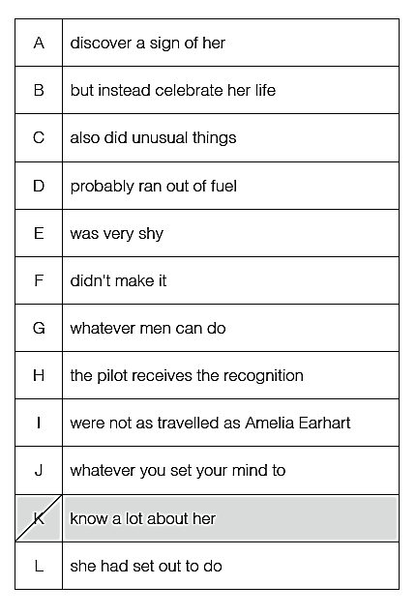

Reading 2: 9pts
Read the text about different ways of dealing with alcohol-related problems in England. First
decide whether the statements (1-9) are true or false and write T or F at the end of the correct line.
Then identify the sentence in the text which supports your decision.
Highlight or underline the first 4 words of this sentence. There may be more than one
correct answer; highlight only one. The first one (0) has been done for you.

Drinking at an early age
Alcohol is part of life for children and young people growing up in the North East and a recent national
survey showed that children in the region drink alcohol at younger ages and in greater quantities than
their peers anywhere else in the country.

However, efforts by frontline organisations have been successful in helping to reduce the number of
youngsters tempted to drink. Recent studies show the overall number of children and young people
drinking alcohol has reduced since 1995.

To further this success a number of events will be taking place to help raise awareness across the
region.

Drop-in sessions will be running to help people of all ages understand units and levels of safer levels
of consumption.

Also posters and leaflets with information, as well as a confidential helpline number have been
distributed to accident and emergency departments and to youth facilities.

Information will also be available from a stall at North Tyneside Council, The Quadrant, Silverlink.

Balance, the North East of England’s alcohol office, is working with schools in Gateshead and
Newcastle to produce a large-scale artwork to demonstrate the impact that alcohol advertising has on
children and young people.

The organisation is working with a local artist who will be undertaking art sessions with children to see
what, if anything, they recall from alcohol adverts and using art to capture the results.

Acts, a multi-agency partnership which involves Newcastle Primary Care Trust, GPs, hospitals, mental
health services and the voluntary sector as well as Sub 21 – which targets young people in North
Tyneside – has been playing a vital part in raising awareness of the dangers of excessive alcohol
consumption.

Acts staff currently work with people in settings including schools, communities and hospitals, to
understand their thoughts, feelings and behaviour towards alcohol and to offer early intervention,
screening and advice.

Lynda Seery, alcohol public health lead for NHS North of Tyne said: “We aim to use Alcohol Awareness
Week to encourage young people to enter into safer recreational activities by raising their knowledge
of how drinking can damage their health.

“Acts aims to promote a safe, sensible drinking culture and ensure that everyone with an alcohol
problem is able to access the treatment and support they need and this includes young people.

“NHS North of Tyne has had a significant impact on the levels of binge drinking across the region
through joint working and a three-pronged approach of prevention, early intervention and working in
partnership with Northumbria Police and local councils to address the issues of licensing.

“We want to strengthen people’s understanding about their relationship with alcohol; the effect it has
on them and services they can access for help with alcohol-related issues such as self-harming and
social exclusion.”

Last year Newcastle had the second highest level of alcohol-related hospital admissions, second only
to Liverpool, but the roll-out of Acts from Newcastle to North Tyneside and Northumberland, has been
successful in getting the message across.

As part of the implementation, more staff received intervention and advice training across health,
social care and education while awareness of the service was promoted through local involvement
networks, overview scrutiny committees, community and voluntary sector groups, and MPs.

But the efforts continue. The results of a survey of 1,000 residents throughout the North of Tyne area
conducted by Balance, discovered:

More than eight in 10 of the region’s parents said they had not purchased alcohol for their children
aged 17 and under.

Three in five said they had never given alcohol to their children, aged 17 or under.
The survey reported the common consensus of respondents who said that children and young people
drinking alcohol is most definitely unacceptable, with 80% agreeing that young people between the
ages of 13 and 15 shouldn’t be drinking.

The survey also revealed that adults misusing alcohol around children is frowned upon – with four in
five agreeing that adults should never drink too much in front of children.

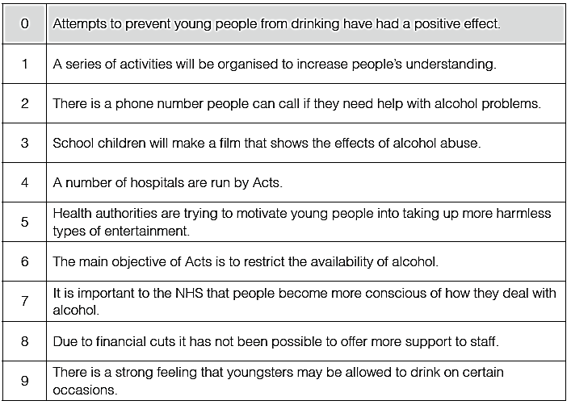
T

Language in Use

LIU1: 12pts
Read the text about whether it is right to keep pets. Some words are missing from the text. Use
the words in brackets to form a word that fits in the gap (1-12). Write your answers in the spaces
provided on the answer sheet. The first one (0) has been done for you.


Pros and Cons of Keeping Pets
Because of pet overpopulation, just about all animal activists would (0) ___ (probable) agree
that we should spay and neuter our cats and dogs. But there would be some (1) ___ (agree)
if you were to ask whether we should breed cats and dogs if all the shelters (2) ___ (be)
empty and there were good, loving homes available.

Animal (3) ___ (industry), such as the fur industry and factory farms, try to discredit animal
(4) ___ (protect) groups by claiming that activists want to take people’s pets away. While
some animal rights activists do not (5) ___ (belief) in keeping pets, I can assure you that no
one wants to take your dog away from you.
What are the arguments for keeping pets?

Many people consider their pets to be (6) ___ (member) of the family, and treat them with love
and respect. The feeling often appears to be mutual, as our dogs and cats seek us out to
play, to be (7) ___ (pet), or to just simply sit in our laps. They provide (8) ___ (condition) love
and devotion. To deny them and us this (9) ___ (relate) seems unthinkable to some.

Also, keeping pets does not "use" the animals in the same way that factory farms, animal
testing labs or circuses use and (10) ___ (use) the animals.

The Humane Society of the US argues that we should keep pets.

So, should we have pets? Of course. Pets are (11) ___ (create) with whom we share a world,
and we rejoice in their companionship. You don’t have to anthropomorphize to recognize that
the feelings are (12) ___ (turn). If we are wise enough to see, they teach us about humility and
empathy and loyalty. Their eyes hold the spark of life, the same as ours. Let us be close and
cherish each other always.

The vast majority of animal activists advocate spaying and neutering. However, most will
say that the reason is the millions of cats and dogs who are killed in shelters every year, as
opposed to any basic opposition to the keeping of pets.
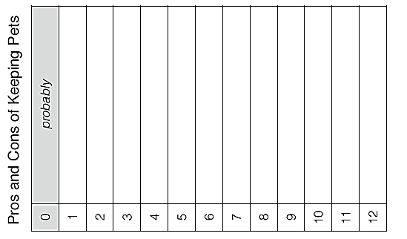

Language in Use 2: 10pts

Read the text about how one person started smoking. Some words are missing from the text
(1-10). Complete the text using one word in the spaces provided on the answer sheet. The first
one (0) has been done for you.
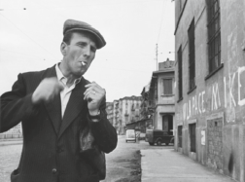

What made me become a smoker

The thing is, on reading the news that children who have watched films featuring smoking are
more likely to take it up themselves, I tried to think which film had started me off on the habit.

We have to go (0) ___ a long way, although strictly speaking the first "cigarettes" I "smoked"
were sweets. They were called (1) ___ like "Junior Fags" and were white sticks of sweet stuff
with red dye on the end to look like a lit cigarette. Aged nine, I was on about 10 of those a
day, and I believe I actually (2) ___ leave a "stub" and stand on it before entering a friend's
house, not that there weren't adults puffing away inside.

It was possibly (3) ___ I saw – late one night on louche BBC2 – Jean-Pierre Melville's film
Le Samouraï (1967) that I realised it was (4) ___ to move on from smokeless smoking to
something more carcinogenic. In it, Alain Delon plays Jef, a Paris-based assassin (5) ___ an
admirably minimal lifestyle. When Jef wants a car, he steals (6) ___ else's, always going for
grey Citroens. In his flat, there is nothing (7) ___ a bed, numerous bottles of mineral water
(Evian), and numerous packets of cigarettes (Gitanes). (8) ___ is also a bird in a cage as a
metaphor for something or other. I marvelled that Jef really had got life sussed, because that
was all you needed, when you really thought (9) ___ it.

Or was it watching Elliott Gould in Robert Altman's version of The Long Goodbye (1973)?
Gould was a superbly adept smoker, and they should show his performance in drama
schools because they're going to have to (10) ___ teaching smoking, just as they teach
another anachronistic art, fencing. They should have smoking coaches – rheumy old actors
down on their luck. (For an example of completely unconvincing smoking, see Colin Firth in
The King's Speech)

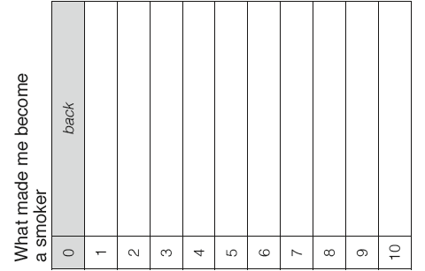

WRITING TASK
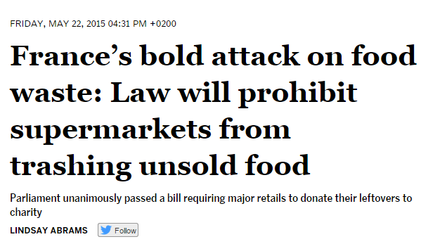 | 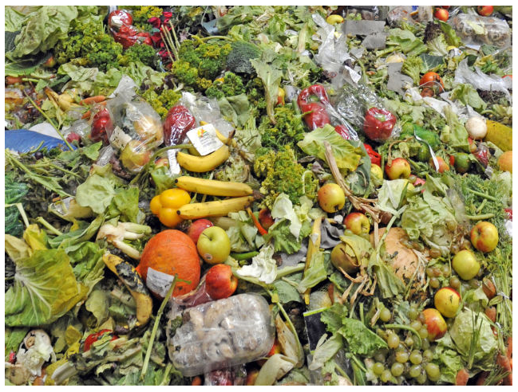

A few facts:
In the US
40% of the food in the US goes uneaten
Fruits and vegetables worth $15 billion thrown away unsold every year
In Austria
650 000 tons of food thrown away in stores, restaurants and homes every year
+ 350 000 tons of food thrown away on farms/during agricultural production
only 11 000 tons go to charity organizations

Let’s waste less...
Write a leaflet in order to support the recent movement against the waste of food. In your leaflet
- inform the readers about the current situation
- suggest ways how this waste could be reduced on a political/legal level
- give tips how to reduce the waste of food on a personal level (family, school, eating out…)
Write about 250 words.

