Citizenship
Discussion questions
- What are your most important rights as a citizen in Austria?
- What are your duties as a citizen in Austria?
- What should all citizens in Austria know about citizenship, politics, values, etc.?
- What does it mean to be a global citizen and an active citizen?
- What are the five most important human rights for you?
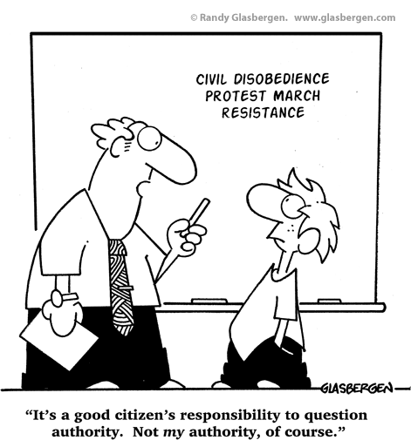
- What are the main problems our world is facing today?
- Do you feel like you can make change happen?
- How would you define democracy?
- What is respect?
- What makes you you?

Tasks

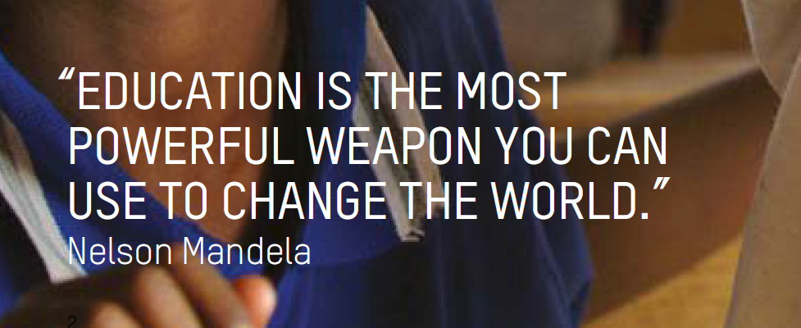
Analyse the quote and the cartoon and give your opinion.
http://www.glasbergen.com/wp-content/gallery/education-and-teacher-cartoons/edu61.gif
http://www.oxfam.org.uk/education/global-citizenship/global-citizenship-guides

Discuss the importance of the following key elements of global citizenship education. What would you consider as especially important?
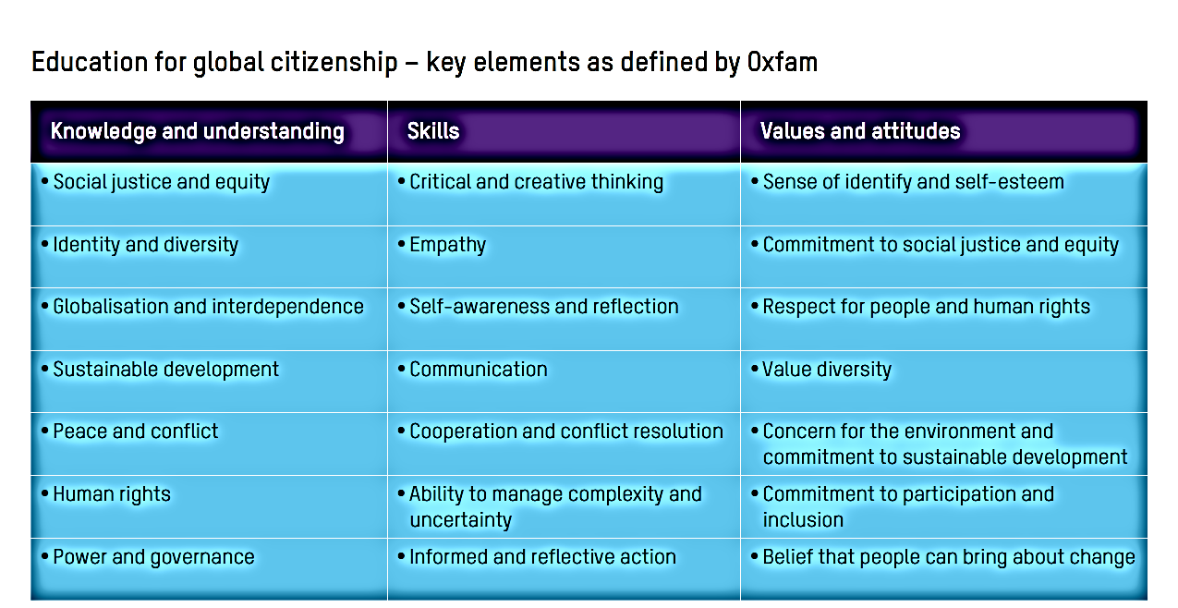

Read this text on the “big ideas” and reflect on the impact they have on school and your classroom experiences so far.
Discuss these questions with a partner and take notes. Record a 4-minute audio-file in which you reflect about these five issues. Plan your monologue and use appropriate, advanced vocabulary.
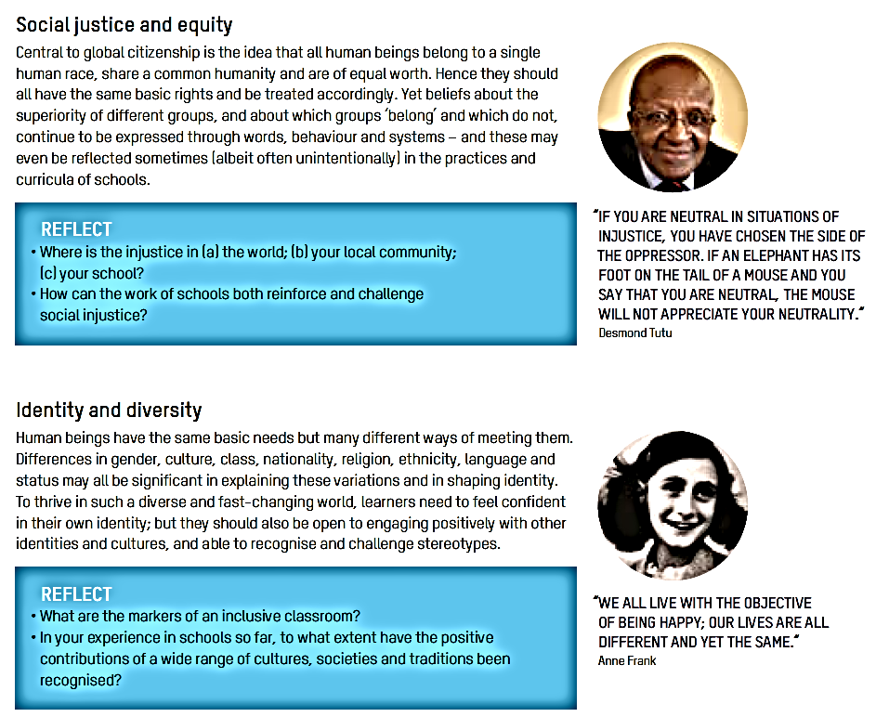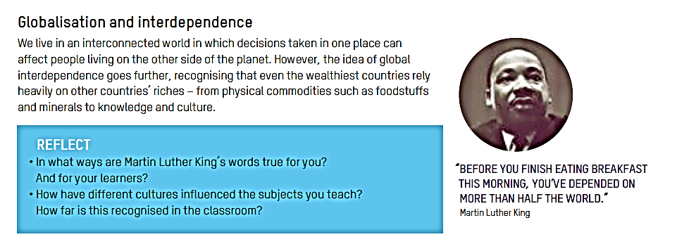

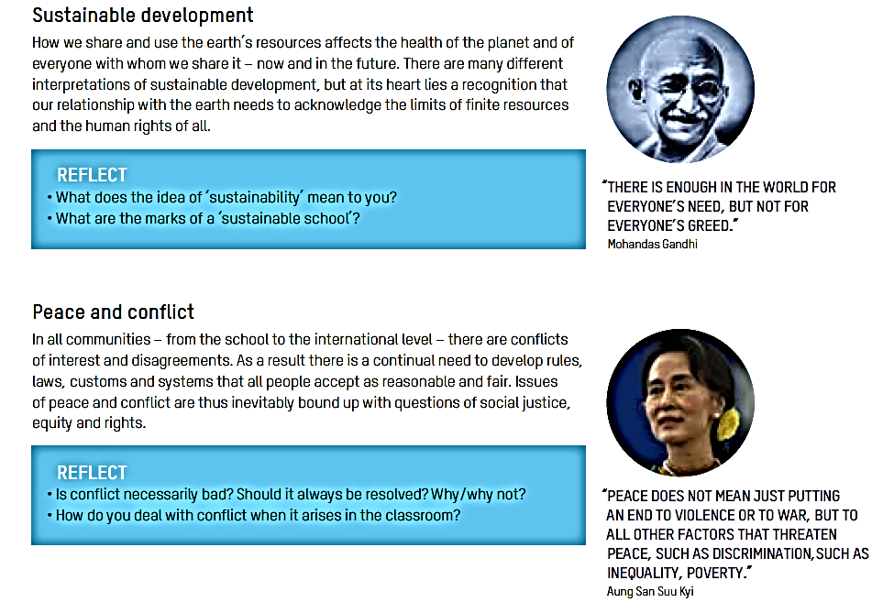
http://www.oxfam.org.uk/education/global-citizenship/global-citizenship-guides p6ff

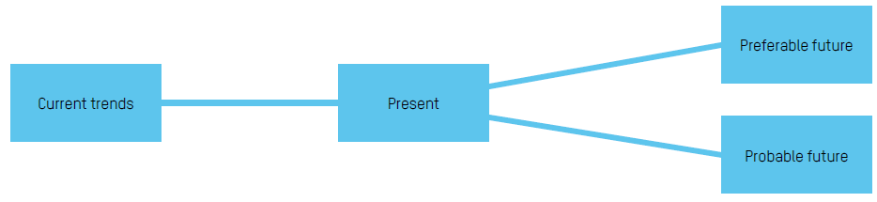
Get active. Do either the “Issue Tree” or the “Ideal Future” activity.
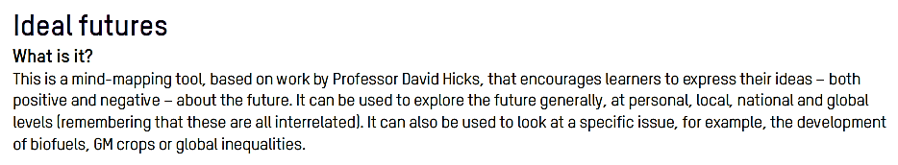
(http://www.oxfam.org.uk/education/global-citizenship/global-citizenship-guides , p 13
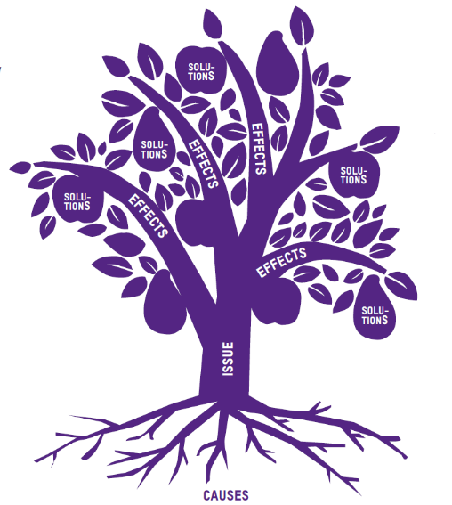

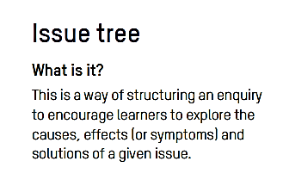

Important terms

Global and local issues and the relationships between them/  Local, national and global  governance systems and structures/  Issues affecting interaction and connectedness/  Underlying assumptions and power dynamics | ▪ citizenship, employment, globalization, immigration, interconnections, interdependence, migration, mobility, North-South relationships, politics, power relations
 | ▪ access to justice, age of consent, decision-making, democracy, democratic processes, food security, good governance, freedom of expression, gender equality, humanitarian law, peace, peace-building, public good, responsibilities, rights (children’s rights, cultural rights, human rights, indigenous rights, right to education, women’s rights), rule of law, rules, transparency, well-being (individual and collective)
 | ▪ atrocities, asylum seekers, child labour, child soldiers, censorship, conflict, diseases (Ebola, HIV & AIDS) economic disparities, extremism, genocide, global poverty, inequality, intolerance, nuclear power, nuclear weapons, racism, refugees, sexism, terrorism, unemployment, uneven resources, violence, war
 | ▪ civil society, corporate social responsibility, multi-national corporations, private sector, religious vs secular, stakeholders, state responsibility, youth
 | ▪ biodiversity, climate change, disaster risk reduction, emergencies, emergency responses, environment, natural disasters, sustainable development, water quality
 | ▪ geography, history, legacy of colonialism, legacy of slavery, media literacy, social media
Cultivating and managing identities, relationships  and respect for diversity | ▪ community, country, diasporas, family, indigenous populations, minorities, neighbourhood, school, self and others, world
 | ▪ attitudes, behaviours, beliefs, culture, cultural diversity, diversity, gender, identity (collective identity, cultural identity, gender identity, national identity, personal identity), intercultural dialogue, language(s) (bilingualism/ multilingualism), religion, sexuality, value systems, values
 | ▪ care, compassion, concern, empathy, fairness, honesty, integrity, kindness, love, respect, solidarity, tolerance, understanding, worldmindedness
 | ▪ assertiveness, communication, conflict resolution, dialogue, inclusion, intercultural dialogue, life skills, managing difference (e.g. cultural difference), managing change, mediation, negotiation, partnership skills (international and local), prevention (conflict, bullying, violence) relationships, reconciliation, transformation, win-win solutions
 | ▪ animal cruelty, bullying, discrimination, racism, violence (including gender-based violence, school-related gender-based violence (SRGBV)
Engagement, action and ethical responsibility | ▪ consumption habits, corporate social responsibility, ethical questions, ethical responsibility, fair trade, humanitarian action, social justice
Engagement, action and ethical responsibility | ▪ entrepreneurship, financial skills, innovation
UNESCO Citizenship, online information (p 39)

