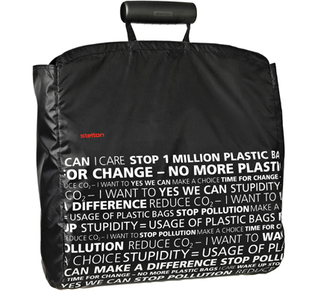

Italy Dumps Plastic Bags with Europe's First Nationwide Ban
By Jonathan Bardelline
Published January 05, 2011
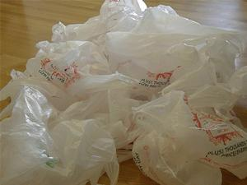
371diggsdigg
ROME, Italy — [Editor's note: A previous version of this story's headline incorrectly said Italy's ban was the world's first nationwide ban. It is the first such ban in Europe.]
The only plastic bags that will be available in Italy will soon be biodegradable versions, since a ban on plastic bags went into place Jan. 1.
Stores in Italy, which uses 20 billion bags a year (one-fifth of all European use), will be able to give out their remaining plastic bags, but once they're gone, they can only offer paper, biodegradable plastic or cloth bags.
Of the more than 8,000 municipalities in Italy, around 200 already has plastic bag bans.
News reports from European outlets are rife with concern that the country won't be able to handle such a sudden change, and they also worry the biodegradable and paper alternatives will be an annoyance if they are seen as weaker than plastic bags.
Reports the Guardian:
"We are not prepared to face such a cultural change," says Florence lawyer Giampaolo Pagnini. "We should take it slowly, because we do not have the cultural background to know how to deal with this. It took us ages to adapt to wearing a seatbelt when that law came into effect." Antonella d'Antoni, who works for a bank in Rome, echoes the sentiment: "This is the same, it will take time."
In banning plastic bags, Italy joins the ranks of other countries and cities like Mexico City, San Francisco and other various cities in California, and elsewhere in the U.S. like Westport, Conn. and Edmonds, Wash.
Others, like China, have found success in plastic bag fees. Earlier this year, Washington, D.C., saw plastic bag use drop by 85 percent one month after a five-cent fee for bags went into effect. Ireland saw a similar cut in plastic bag use after a fee imposed in 2002.
After implementing a 5 pence fee for plastic bags in early 2008, U.K. retailer Marks & Spencer was giving out 80 percent fewer bags after a few months.
IKEA weaned customers off of plastic bags by charging for them, and then eliminated them entirely from stores the same year that Whole Foods Market dumped plastic bags as well.
Read more: http://www.greenbiz.com/news/2011/01/05/italy-dumps-plastic-bags-world-first-nationwide-ban#ixzz1BCAnl8l2

Italy Carries Out Plastic Bag Ban

Italy has banned the distribution of non-biodegradable plastic bags at shops and retail points.
The plastic bag ban in Italy, adopted Dec. 22, went into effect Jan. 1 for the country. However, retail stores and supermarkets will be allowed to use up their stock of plastic bags, which they will have to hand out for free, rather than the traditional practice of charging a small fee, reports plasticnews.com.
Italy, one of Europe’s top consumers of plastic bags, according to Deutsche Welle’s report, uses more than 300 of them per person per year, or about a fifth of the 100 billion plastic bags used annually across Europe.
“This marks a step forward in the fight against pollution and it makes us all more responsible in terms of recycling,” said Environment Minister Stefania Prestigiacomo. Prestigiacomo said the government was launching a public awareness campaign along with the ban to promote the use of bags made out of natural fibers and other recyclable materials, reports Deutsche Welle.
According to plasticnews, More than 100,000 citizens had petitioned the government for a ban. A number of Italian cities, including Venice and Turin, had previously enacted plastic bag bans. Stores in Italy now will only be able to offer biodegradable, cloth or paper.
Similar bans have been enacted elsewhere around the world, CNN reports. In France and Mexico City, shops may only distribute bio-degradable bags, while cities in Australia, South Africa and Taiwan have imposed bans or surcharges. Plastic bags have been outlawed in Mumbai, India, since 2000.
In California, a plastic bag bill collapsed in September due to fierce opposition from the plastic bag manufacturing industry, which spent heavily on ads attacking the measure as a jobs killer. But California is among a growing handful of states and cities Delaware and cities that have passed laws requiring stores to take back plastic bags and film for recycling.

Italy Bans Plastic Shopping Bags
25 Oct 2010
By Sustainable Life Media at Sustainable Life Media
Tue Jan 11, 2011 2:50pm EST
by Thomas Miner
The government of Italy has become the first in the European Union to outlaw the use of plastic bags by all retailers, signaling a large shift in a country which uses over 20 billion bags per year (400 per person) - an amount equal to 25 percent of the total produced and used in the entire EU.
The Italian environmental organization Legambiente estimates that the ban will save 180,000 metric tons of CO2 emissions per year and help save many of the 100,000 marine mammals that the UN Environmental Program estimates are killed every year by improper disposal of the bags.
In a recent poll conducted by Legambiente which surveyed 20,000 consumers in 80 locations, more than 73 percent of respondents said they would prefer reusable bags if they could not use plastic. Only 16 percent said they would prefer bio-plastic, and 10 percent said they would prefer paper.
While there are only a few cities (and few, if any, countries) with plastic bag bans in place, many businesses have reduced bag use significantly in the past year. IKEA has reduced plastic bag use by 90 percent by replacing free, plastic bags with low-cost reusable bags and the UK's Marks & Spencer has reduced bag usage by 80 percent in less than one year.
Reprinted with permission from Sustainable Life Media

Can Italy carry off its plastic bag ban?
Environmentalists may welcome the government's decision, but many Italians say they're unprepared for such a 'cultural change'
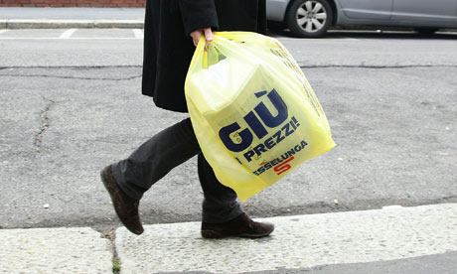According to Italy's Environment League, Italians have been using a total of 20bn plastic bags per year. Photograph: Vittorio Zunino Celotto/Getty Images
The plastic bags ban in Italy has provoked a mixed reaction, but Stefania Prestigiacomo, the environment minister, has said there is no going back on the government's decision: "Sustainability is made of little changes to our lifestyle that don't cost us anything and can save the planet."
Some say it's about time and that we are finally aligning ourselves to the rest of Europe – and that this should have happened a long time ago. But while this is the position shared by those who consider banning the distribution of nondegradable plastic bags to be the only "civilised" way forward in terms of taking steps to protect the environment, not all Italians agree with the cabinet's decision.
"We are not prepared to face such a cultural change," says Florence lawyer Giampaolo Pagnini. "We should take it slowly, because we do not have the cultural background to know how to deal with this. It took us ages to adapt to wearing a seatbelt when that law came into effect." Antonella d'Antoni, who works for a bank in Rome, echoes the sentiment: "This is the same, it will take time."
Although a television campaign has informed citizens about the ban and about environmentally friendly alternatives, many are still unaware of it. The waiter behind the counter at a busy coffee bar in a Rome square said he knew nothing of the ban. As for stores and supermarkets, they will be allowed to use up their stocks but must give them out free of charge.
"I do not agree with the banning of plastic shopping bags," says Luigi Taragni, a Rieti paediatrician. "I think they are preferable and much better than paper ones or nondegradable ones, which are more difficult to handle, hold less, break more easily and cost more. I'll adapt to this decision, just like I was forced to adapt to rubbish recycling, but I am not sure I agree with these limited measures." Some, such as Stefano Germani from Rome, fear this is just going to turn into a new business: "All this is about is increasing the cost of new degradable bags that consumers will be forced to purchase if they do not want to face fines."
Women who go to the shops on a daily basis say there is only one solution and everyone will have to grow accustomed to it: "We have to change our habits. We need to bring our own bags from home every time we go shopping. It's a change of mentality that is needed," says Daniela Lo Castro, mother of three boys.
According to Italy's Environment League, citizens have been using a total of 20bn plastic bags per year, that's more than 300 per capita. It says there will only be positive effects on pollution if these are replaced with 10 reusable shopping bags. The outcome will be more than 180,000 tons of oil saved and as many CO2 emissions, and in addition there will be no dispersion of indestructible plastic in fields, rivers and seas.
While there is no doubt in my mind that a change in mentality is needed and change always takes some time, it is also true that our children will learn not to use plastic bags because these will no longer be available. Consequently, a benefit to their environment not in the short-term but certainly in the long-term will be assured.

