Decoding Woody Allen’s ‘Midnight in Paris’
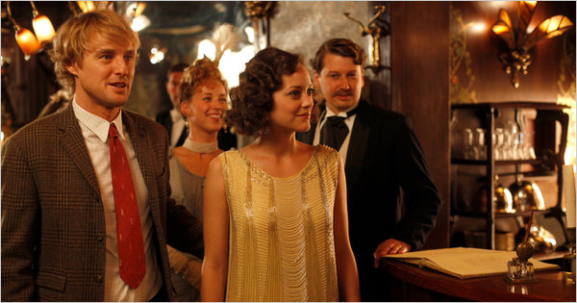
Roger Arpajou/Versitil Cinema & Gravier Productions, Courtesy of Sony Pictures Classics
Owen Wilson, left, is Gil, who travels back in time to 1920s Paris, and Marion Cotillard is Adriana, a fictional mistress of Picasso's who catches Gil's eye.

By JOSEPH BERGER Published: May 27, 2011
Many a writer or artist has longed to travel back in time to the sizzling Paris of the 1920s, to sip absinthe with Hemingway at Les Deux Magots or dine on choucroute garnie with Picasso at La Rotonde. Imagine the conversation! What has beguiled audiences about the new Woody Allen movie, “Midnight in Paris,” is that the protagonist, Gil, a disenchanted Hollywood screenwriter played by Owen Wilson, gets to live exactly that fantasy.
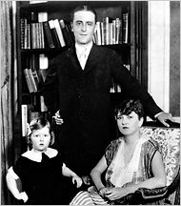  F. Scott Fitzgerald, center, with his daughter Scottie, left and his wife Zelda in Paris in 1925. | Roger Arpajou/Versatil Cinema & Gravier Productions, Courtesy of Sony Pictures Classics Alison Pill and Tom Hiddleston as Zelda and F. Scott Fitzgerald in "Midnight in Paris."  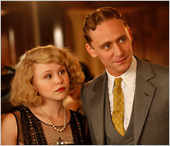 | 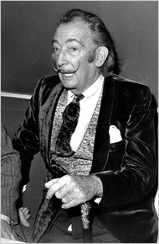  Salvador Dalí in 1971.

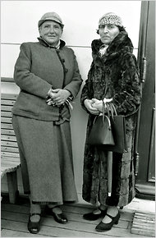  Gertrude Stein and Alice B. Toklas in 1934 | 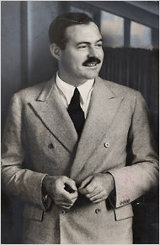Ernest Hemingway, around 1937. | 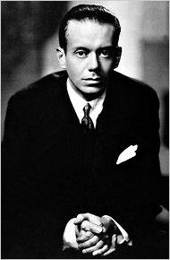  Cole Porter, around 1910

Gil runs into Scott and Zelda Fitzgerald at an elegant soiree, where he hears Cole Porter crooning “Let’s Do It (Let’s Fall in Love).” He gets writing advice from a laconic Hemingway, persuades Gertrude Stein to read the manuscript of his novel, and falls in love with Picasso’s mistress. He meets Salvador Dalí, T. S. Eliot, Djuna Barnes, Josephine Baker, Luis Buñuel, Man Ray and others in the enormously talented cast of expatriates and bohemians that peopled Jazz Age Paris. Reeling from the folly of World War I and so offering fodder for novels and paintings dripping with disillusionment, Paris was the center of the artistic universe then, and those legends really did converge on Paris around the same time.
“If you are lucky enough to have lived in Paris as a young man then wherever you go for the rest of your life, it stays with you, for Paris is a moveable feast," Hemingway wrote in “A Moveable Feast,” his memoir that was posthumously published in 1964.
The movie sometimes assumes viewers know the details of these luminous lives, so it may be helpful to understand some of the complicated relationships that made Paris in that era both a dream and often something less.
In 1922 Hemingway and his first wife, Hadley, took a two-room flat near the Sorbonne that had no hot water and no indoor toilet. He also rented a room around the corner to write, something like the “attic with a skylight” Gil craves. It had a view of the smokestacks and rooftops that Mr. Allen captures in worshipful shots of the city.
Hemingway also discovered Shakespeare & Company, a bookstore near the Jardin du Luxembourg owned by Sylvia Beach that became a crossroads for Americans in Paris. It’s where he borrowed books by Turgenev and Tolstoy, and it makes a cameo in the film.
Gil meets Hemingway in a run-down cafe not unlike the legendary Dingo, where Hemingway’s less than beautiful friendship with Fitzgerald began with the latter’s drunken near-blackout. Hemingway, who is parodied in the film with dialogue like “no subject is terrible if the story is true and if the prose is clean and honest,” was envious of the seemingly effortless lyricism of Fitzgerald’s writing in works like “The Great Gatsby.” In “Midnight in Paris,” Hemingway tells Fitzgerald that Zelda, a writer herself, sees her husband as a competitor. But “A Moveable Feast” offers a more full-throated account. Hemingway grew to despise Zelda, partly because she had betrayed Fitzgerald with a French aviator and partly because he blamed her decadent tempestuousness for ruining her husband’s productivity.
Picasso and Matisse, who appear in the film, also had a rivalry, barely acknowledged in the film, with the two artists echoing — some critics say swiping — each other’s themes. Both gained the attention of the art collector Leo Stein and his sister, Gertrude. In the film Gil hears that Gertrude Stein has bought a Matisse for 500 francs and, in the hope of making a time-bending killing, asks her if he could pick up “six or seven” Matisses as well. The twice-married Picasso was famous for mistresses, and in the film Marion Cotillard plays Adriana, a capricious, if melancholy stand-in for all of Picasso’s lovers, models and muses. She claims to have been the lover of Modigliani and Braque as well. In actuality, Picasso’s mistresses were relatively constant. Marie-Thérèse Walter, who was 17 when she met Picasso, was with him for eight years, bearing him a daughter, Maya. Dora Maar, whom he met around 1935, was his lover for at least eight years as well.
The Indiana-born Cole Porter maintained an elegant apartment, where he gave hedonistic parties that were daring for their mingling of gay and straight friends. Porter met and married Linda Lee Thomas, a divorcée from Louisville who was eight years older and aware that Porter was gay. They set up an even more lavish apartment — walls covered in zebra hide — near Les Invalides, a home that seems like the setting for the on-screen party where Porter entertains his guests at the piano.
The film recounts how many Porter songs were hommages to Paris —“I Love Paris” and “C’est Magnifique,” among them — and indeed Porter wrote a musical, “Paris,” for the chanteuse Irene Bordoni. One of the show’s songs was “Let’s Do It,” with teasingly suggestive lines including: “In shallow shoals English soles do it./Goldfish in the privacy of bowls do it.”
When Gil sits down in a cafe with Dalí and Man Ray, he confides to those artists his shock at being catapulted back in time. Man Ray is delighted with the idea, but Gil tells him that’s because “you’re a Surrealist and I’m a normal guy.”
Dalí, played here by Adrien Brody, first visited Paris in 1926, grew the mustache that would become his trademark, and met his idol and fellow Spaniard, Picasso. Experimenting with many forms, Dalí fell in with a circle of Surrealists in Montparnasse whose members were probing the Freudian depths of their psyches for what they regarded as a new expressive frontier. He met his future wife, Gala, who was inconveniently married to a Surrealist poet.
Dalí collaborated with Buñuel on the short avant-garde film "Un Chien Andalou." In "Midnight in Paris," Gil suggests to Buñuel that he make a film about a dinner party gone haywire. Buñuel, of course, took up the suggestion. The film was "The Exterminating Angel," released in 1962.

Chinese Whispers
to travel back in time
the sizzling Paris of the 1920s
to sip absinth
a disenchanted Hollywood screenwriter
an enormously talented cast of expatriates
the movie assumes viewers to know these details
the room had a view of the smokestacks and rooftops
the bookstore became a crossroads for Americans in Paris
they met in this run-down café
he is parodied in the film
she had betrayed him

