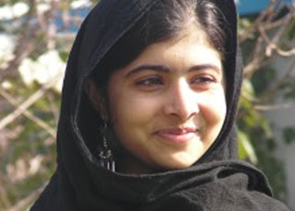
- Diary of a Pakistani schoolgirl – 2009

BBC Blog GUL MAKAI
Private schools in Pakistan's troubled north-western Swat district have been ordered to close in a Taleban edict banning girls' education. Militants seeking to impose their austere interpretation of Sharia law have destroyed about 150 schools in the past year. Five more were blown up despite a government pledge to safeguard education, it was reported on Monday. Here a seventh grade schoolgirl from Swat chronicles how the ban has affected her and her classmates. The diary first appeared on BBC Urdu online.
THURSDAY JANUARY 15: NIGHT FILLED WITH ARTILLERY FIRE
The night was filled with the noise of artillery fire and I woke up three times. But since there was no school I got up later at 10 am. Afterwards, my friend came over and we discussed our homework.
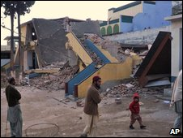
The Taleban have repeatedly targeted schools in Swat

Today is 15 January, the last day before the Taleban's edict comes into effect, and my friend was discussing homework as if nothing out of the ordinary had happened.
Today, I also read the diary written for the BBC (in Urdu) and published in the newspaper. My mother liked my pen name 'Gul Makai' and said to my father 'why not change her name to Gul Makai?' I also like the name because my real name means 'grief stricken'.
My father said that some days ago someone brought the printout of this diary saying how wonderful it was. My father said that he smiled but could not even say that it was written by his daughter.
WEDNESDAY 14 JANUARY: I MAY NOT GO TO SCHOOL AGAIN
I was in a bad mood while going to school because winter vacations are starting from tomorrow. The principal announced the vacations but did not mention the date the school was to reopen. This was the first time this has happened.
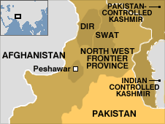
In the past the reopening date was always announced clearly. The principal did not inform us about the reason behind not announcing the school reopening, but my guess was that the Taleban had announced a ban on girls' education from 15 January.
Since today was the last day of our school, we decided to play in the playground a bit longer. I am of the view that the school will one day reopen but while leaving I looked at the building as if I would not come here again.
MONDAY 5 JANUARY: DO NOT WEAR COLOURFUL DRESSES
I was getting ready for school and about to wear my uniform when I remembered that our principal had told us not to wear uniforms - and come to school wearing normal clothes instead. So I decided to wear my favourite pink dress. Other girls in school were also wearing colourful dresses and the school presented a homely look.
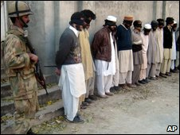
Swat has been a centre of militant activity
SATURDAY 3 JANUARY: I AM AFRAID
I had a terrible dream yesterday with military helicopters and the Taleban. I have had such dreams since the launch of the military operation in Swat. My mother made me breakfast and I went off to school. I was afraid going to school because the Taleban had issued an edict banning all girls from attending schools.
Only 11 students attended the class out of 27. The number decreased because of Taleban's edict. My three friends have shifted to Peshawar, Lahore and Rawalpindi with their families after this edict.
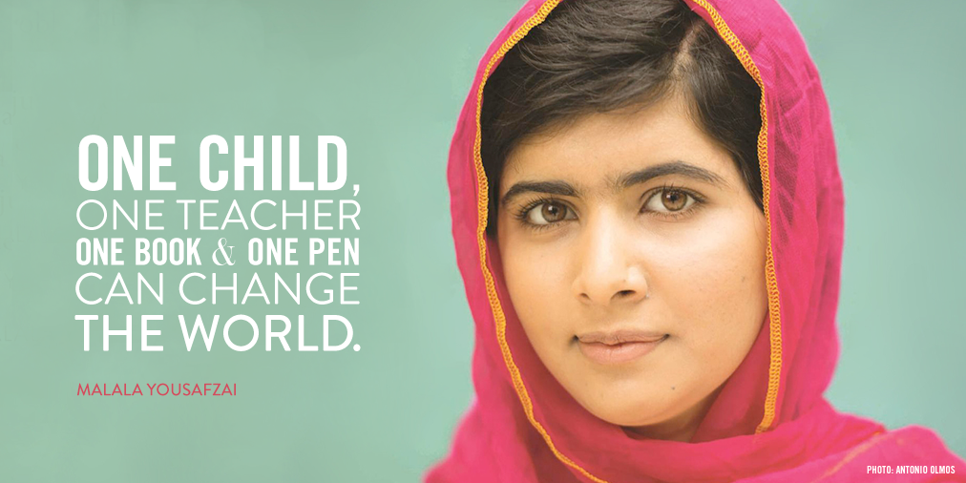
On my way from school to home I heard a man saying 'I will kill you'. I hastened my pace and after a while I looked back if the man was still coming behind me. But to my utter relief he was talking on his mobile and must have been threatening someone else over the phone.
http://www.filmstarts.de/nachrichten/18494217.html
- Saudi Arabia – 2012

BBC Blog RAIF B ADAWI

Raif Badawi was flogged in public 50 times in January 2015.
He has 950 lashes and nearly a decade in prison left to serve - simply for blogging about free speech.

Just after Friday prayers on 9 January, Raif Badawi was led by Saudi officials out of a bus and into the middle of the square in front of al-Jafali mosque in Jeddah. A large crowd had gathered to see the flogging.
Raif stood in the middle of the crowd, handcuffed and shackled by his ankles, his face uncovered. A security officer approached Raif and began caning him across the back and legs, until he had been beaten 50 times. A witness told us it took just five minutes to cane Raif 50 times; the lashes were constant and quick.
On 21 January, two days before he was due to be publicly lashed another 50 times in a Jeddah square, doctors deemed Raif too unwell to be flogged. The week before, the authorities had postponed his scheduled 50 lashes after a prison doctor advised that Raif was unfit to be lashed, and that the flogging should be postponed for a week on medical grounds.
Raif is not a criminal – he is a prisoner of conscience who called for free speech on his website. His treatment by authorities in Saudi Arabia has been nothing short of a vicious act of cruelty. Ask them to release Raif now.
Reflecting on the role of the Muslim religious establishment on 12 August 2010, Badawi warned about the stifling of creativity:
As soon as a thinker starts to reveal his ideas, you will find hundreds of fatwas that accused him of being an infidel just because he had the courage to discuss some sacred topics. I’m really worried that Arab thinkers will migrate in search of fresh air and to escape the sword of the religious authorities.
In May 2012, shortly before his arrest, Badawi addressed the nature of liberalism.
For me, liberalism simply means, live and let live. This is a splendid slogan. However, the nature of liberalism – particularly the Saudi version – needs to be clarified. It is even more important to sketch the features and parameters of liberalism, to which the other faction, controlling and claiming exclusive monopoly of the truth, is so hostile that they are driven to discredit it without discussion or fully understanding what the word actually means. They have succeeded in planting hostility to liberalism in the minds of the public and turning people against it, lest the carpet be pulled out from under their feet. But their hold over people’s minds and society shall vanish like dust carried off in the wind.

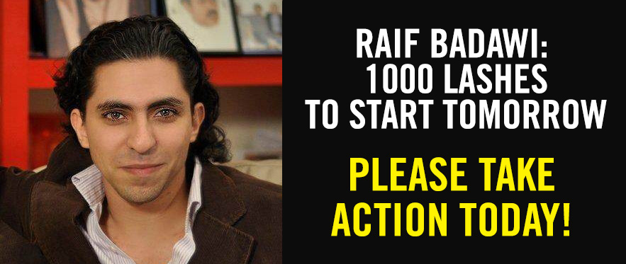
http://www.raifbadawi.org/
http://www.aljazeera.com/news/2015/10/jailed-saudi-blogger-awarded-europe-rights-prize-151030044921182.html
3. Mark Zuckerberg Person of the Year 2010 by Time Magazine
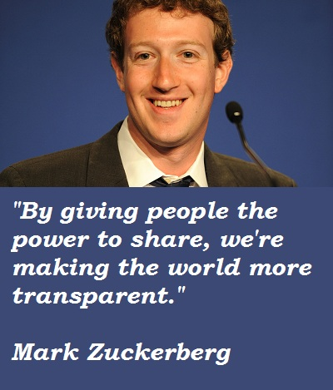
By Lev GrossmanWednesday, Dec. 15, 2010
On the afternoon of Nov. 16, 2010, Mark Zuckerberg was leading a meeting in the Aquarium, one of Facebook's conference rooms, so named because it's in the middle of a huge work space and has glass walls on three sides so everybody can see in. Conference rooms are a big deal at Facebook because they're the only places anybody has any privacy at all, even the bare minimum of privacy the Aquarium gets you. Otherwise the space is open plan: no cubicles, no offices, no walls, just a rolling tundra of office furniture. Sheryl Sandberg, Facebook's COO, who used to be Lawrence Summers' chief of staff at the Treasury Department, doesn't have an office. Zuckerberg, Facebook's CEO and co-founder and presiding visionary, doesn't have an office.
Almost seven years ago, in February 2004, when Zuckerberg was a 19-year-old sophomore at Harvard, he started a Web service from his dorm. It was called Thefacebook.com, and it was billed as "an online directory that connects people through social networks at colleges." This year, Facebook — now minus the the — added its 550 millionth member. One out of every dozen people on the planet has a Facebook account. They speak 75 languages and collectively lavish more than 700 billion minutes on Facebook every month. Last month the site accounted for 1 out of 4 American page views. Its membership is currently growing at a rate of about 700,000 people a day.
What just happened? In less than seven years, Zuckerberg wired together a twelfth of humanity into a single network, thereby creating a social entity almost twice as large as the U.S. If Facebook were a country it would be the third largest, behind only China and India. It started out as a lark, a diversion, but it has turned into something real, something that has changed the way human beings relate to one another on a species-wide scale. We are now running our social lives through a for-profit network that, on paper at least, has made Zuckerberg a billionaire six times over.
Facebook has merged with the social fabric of American life, and not just American but human life: nearly half of all Americans have a Facebook account, but 70% of Facebook users live outside the U.S. It's a permanent fact of our global social reality. We have entered the Facebook age, and Mark Zuckerberg is the man who brought us here.
Zuckerberg is part of the last generation of human beings who will remember life before the Internet, though only just. He was born in 1984 and grew up in Dobbs Ferry, N.Y., the son of a dentist — Painless Dr. Z's slogan was, and is, "We cater to cowards." Mark has three sisters, the eldest of whom, Randi, is now Facebook's head of consumer marketing and social-good initiatives. It was a supportive household that produced confident children. The young Mark was "strong-willed and relentless," according to his father Ed. "For some kids, their questions could be answered with a simple yes or no," he says. "For Mark, if he asked for something, yes by itself would work, but no required much more.
4. The Choice

They risked and persisted, sacrificed and saved. Editor Nancy Gibbs explains why the Ebola Fighters are TIME's choice for Person of the Year 2014, Dec. 10, 2014
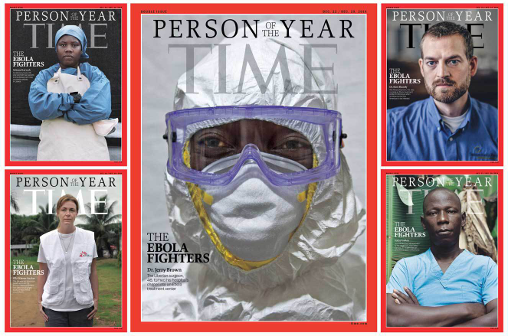
by Nancy Gibbs
Not the glittering weapon fights the fight, says the proverb, but rather the hero’s heart.
Maybe this is true in any battle; it is surely true of a war that is waged with bleach and a prayer.
For decades, Ebola haunted rural African villages like some mythic monster that every few years rose to demand a human sacrifice and then returned to its cave. It reached the West only in nightmare form, a Hollywood horror that makes eyes bleed and organs dissolve and doctors despair because they have no cure.
But 2014 is the year an outbreak turned into an epidemic, powered by the very progress that has paved roads and raised cities and lifted millions out of poverty. This time it reached crowded slums in Liberia, Guinea and Sierra Leone; it traveled to Nigeria and Mali, to Spain, Germany and the U.S. It struck doctors and nurses in unprecedented numbers, wiping out a public-health infrastructure that was weak in the first place. One August day in Liberia, six pregnant women lost their babies when hospitals couldn’t admit them for complications. Anyone willing to treat Ebola victims ran the risk of becoming one.
Which brings us to the hero’s heart. There was little to stop the disease from spreading further. Governments weren’t equipped to respond; the World Health Organization was in denial and snarled in red tape. First responders were accused of crying wolf, even as the danger grew. But the people in the field, the special forces of Doctors Without Borders/Médecins Sans Frontières (MSF), the Christian medical-relief workers of Samaritan’s Purse and many others from all over the world fought side by side with local doctors and nurses, ambulance drivers and burial teams.
Ask what drove them and some talk about God; some about country; some about the instinct to run into the fire, not away. “If someone from America comes to help my people, and someone from Uganda,” says Iris Martor, a Liberian nurse, “then why can’t I?” Foday Gallah, an ambulance driver who survived infection, calls his immunity a holy gift. “I want to give my blood so a lot of people can be saved,” he says. “I am going to fight Ebola with all of my might.”
MSF nurse’s assistant Salome Karwah stayed at the bedsides of patients, bathing and feeding them, even after losing both her parents—who ran a medical clinic—in a single week and surviving Ebola herself. “It looked like God gave me a second chance to help others,” she says. Tiny children watched their families die, and no one could so much as hug them, because hugs could kill. “You see people facing death without their loved ones, only with people in space suits,” says MSF president Dr. Joanne Liu. “You should not die alone with space-suit men.”
Those who contracted the disease encountered pain like they had never known. “It hurts like they are busting your head with an ax,” Karwah says. One doctor overheard his funeral being planned. Asked if surviving Ebola changed him, Dr. Kent Brantly turns the question around. “I still have the same flaws that I did before,” he says. “But whenever we go through a devastating experience like what I’ve been through, it is an incredible opportunity for redemption of something. We can say, How can I be better now because of what I’ve been through? To not do that is kind of a shame.”
So that is the next challenge: What will we do with what we’ve learned? This was a test of the world’s ability to respond to potential pandemics, and it did not go well. It exposed corruption in African governments along with complacency in Western capitals and jealousy among competing bureaucrats. It triggered mistrust from Monrovia to Manhattan. Each week brought new puzzles. How do you secure a country, beyond taking passengers’ temperatures at the airport? Who has the power to order citizens to stay home, to post a guard outside their door? What will it take to develop treatments for diseases largely confined to poor nations, even as this Ebola outbreak had taken far more lives by mid-October than all the earlier ones combined?
The death in Dallas of Thomas Eric Duncan, the first Ebola patient diagnosed on U.S. soil, and the infection of two nurses who treated him, shook our faith in the ability of U.S. hospitals to handle this kind of disease. From there the road to full freak-out was a short one. An Ohio middle school closed because an employee had flown on the same plane as one of Duncan’s nurses. Not the same flight, just the same plane. A Texas college rejected applicants from Nigeria, since that country had some “confirmed Ebola cases.” A Maine schoolteacher had to take a three-week leave because she went to a teachers’ conference in Dallas. Fear, too, was global. When a nurse in Spain contracted Ebola from a priest, Spanish authorities killed her dog as a precaution, while #VamosAMorirTodos (We’re all going to die) trended on Twitter. Guests at a hotel in Macedonia were trapped in their rooms for days after a British guest got sick and died. Turned out to have nothing to do with Ebola.
The problem with irrational responses is that they can cloud the need for rational ones. Just when the world needed more medical volunteers, the price of serving soared. When nurse Kaci Hickox, returning from a stint with MSF in Sierra Leone with no symptoms and a negative blood test, was quarantined in a tent in Newark, N.J., by a combustible governor, it forced a reckoning. “It is crazy we are spending so much time having this debate about how to safely monitor people coming back from Ebola-endemic countries,” says Hickox, “when the one thing we can do to protect the population is to stop the outbreak in West Africa.”
Ebola is a war, and a warning. The global health system is nowhere close to strong enough to keep us safe from infectious disease, and “us” means everyone, not just those in faraway places where this is one threat among many that claim lives every day. The rest of the world can sleep at night because a group of men and women are willing to stand and fight. For tireless acts of courage and mercy, for buying the world time to boost its defenses, for risking, for persisting, for sacrificing and saving, the Ebola fighters are TIME’s 2014 Person of the Year.
Read more:
TIME’s 2014 Person of the Year: The Ebola Fighters

DISCUSS THE FOLLOWING ASPECTS WITH YOUR PARTNER
You and your partner are writing an article for the school magazine about people that young people admire. You have done research about all different kinds of characters. Now you have to decide which three inspirational characters to include in your article. Discuss the following categories and some specific examples with your partner

- people who risked their own lives for their ideas

- celebrities that won prizes for their involvement

- people who care for human rights

- entrepreneurs who have changed the world with their inventions

- movie stars

Agree with your partner on three inspirational characters to include in your article for the school magazine.

